Copper Nanoclusters at Electrode Interfaces:
The Role of Ligand Chemistry

Agnieszka Wieckowska, Konstanty Zdunek
University of Warsaw, Faculty of Chemistry,
Pasteura 1 str. 02-093 Warsaw, Poland
awiec@chem.uw.edu.pl

Copper nanoclusters have attracted considerable interest as functional materials for sensing, catalysis and energy-related applications. [1] Their physicochemical properties are strongly influenced by the ligand shell, which determines not only cluster stability but also the nature of interactions occurring at the electrode/electrolyte interface. While numerous studies have focused on the synthesis and optical properties of copper nanoclusters, the role of ligand-shell composition in controlling interfacial electrochemical processes remains insufficiently understood. [2, 3]
In this work, copper nanoclusters stabilized by chemically distinct ligands, including proteins, lipoic acid, hexanethiol and phosphines, were immobilized on electrode surfaces to investigate how the ligand environment affects the properties of electrified interfaces. These ligands differ substantially in size, charge distribution, hydrophilicity and structural flexibility, providing a broad spectrum of interfacial architectures around a copper core.
The obtained results reveal pronounced ligand-dependent differences in electrochemical behavior, indicating that the ligand shell actively governs electron-transfer processes and interfacial accessibility. Protein-stabilized and small-molecule-protected nanoclusters generate markedly different electrochemical interfaces despite sharing the same metallic component. The observations suggest that the electrochemical response of copper nanoclusters is determined not only by the structure of the metal core but also by the physicochemical characteristics of the surrounding ligand layer.
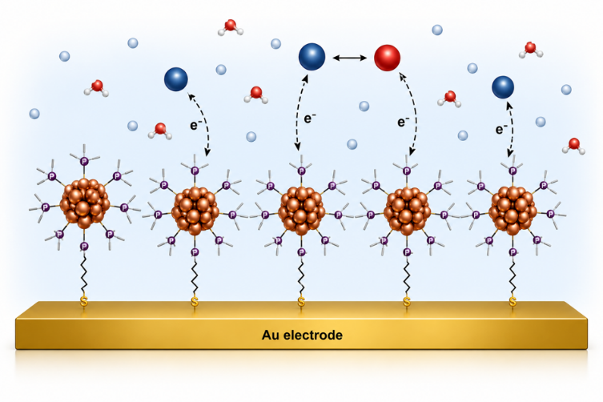
This study highlights the crucial role of ligand engineering in tailoring electrified interfaces and provides new insight into the design of copper nanocluster-based materials for electrochemical applications. The results further demonstrate that the ligand shell should be considered an integral functional element of the interface rather than merely a stabilizing component of the nanocluster structure.

Fig. Scheme of the system

1. R. Jin, C. Zeng, M. Zhou, Y. Chen; Chem. Rev. 2016, 116, 10346
2. M. Chen, C. Guo, L. Qin, L. Wang, L. Qiao, K. Chi, Z. Tang; Nano-Micro Lett. 2025, 17, 83
3. A. Baghdasaryan, T. Bürgi; Nanoscale, 2021, 13, 6283

