Understanding the Interface of Co₃O₄ under Electrochemical Oxidation of Ethylene Glycol by Surface-Sensitive Spectroscopy

Oliver Trost¹, Maximilian Jaugstetter², Yannick Weidemann¹, Nina Kosian³, Felix Hiege¹, Marius Spallek¹, Lilian Vogl³, Kristina Tschulik¹
¹Chair of Analytical Chemistry, Ruhr University Bochum, Universitätsstraße 150, 44801 Bochum, DE
²Physics of Complex Fluids, University of Twente, Drienerlolaan 5, 7522NB Enschede, NL
³Max Planck Institute for Sustainable Materials, Max-Planck-Straße 1, 40237 Düsseldorf, DE
oliver.trost@ruhr-uni-bochum.de

Green hydrogen is widely recognized as a promising solution for energy storage, offering a way to mitigate the intermittent nature of renewable energy sources. To date the efficiency of electrochemical water splitting is limited by the high potentials necessary to overcome the sluggish kinetics of the oxygen evolution reaction. Using the electrochemical oxidation of alcohols as the anode reaction not only requires lower potentials but may also provide value-added products.¹ The oxidation of ethylene glycol for example can produce glycolic acid for the production of biodegradable products and may be obtained in large quantities from PET recycling.^{2,3} While transition-metal-oxide-based catalysts, such as Co₃O₄, have garnered significant interest as catalysts for the oxidation of ethylene glycol under alkaline conditions, the mechanistic details and associated catalyst transformations remain scarcely studied. Gaining insight into the processes occurring on the surface of Co₃O₄ under operation conditions necessities operando techniques with high surface sensitivity. In our work, we collected operando electron-yield X-ray absorption spectra (EY-XAS) of the Co L and O K edges via the drain current, enabling us to probe the transformation of the interface under realistic conditions. By conducting measurements of a reactive-gas-sputtered Co₃O₄ thin film in KOH in the absence and in the presence of ethylene glycol the influence of alcohol oxidation on the materials potential-dependent transformations could be investigated. To deepen our understanding of the liquid side of the interface, operando electrochemical surface-enhanced infrared absorption spectroscopy (EC-SEIRAS) was conducted to obtain information of the reaction intermediates adsorbed to the surface of the catalyst under applied potential. These insights were further complemented by product analysis utilizing high-performance liquid chromatography (HPLC) to quantify the electrolysis products. The combination of both operando electron-yield XAS and SEIRAS hence allowed us to gain a novel understanding of the interface of the Co₃O₄ electrocatalyst under ethylene glycol oxidation.
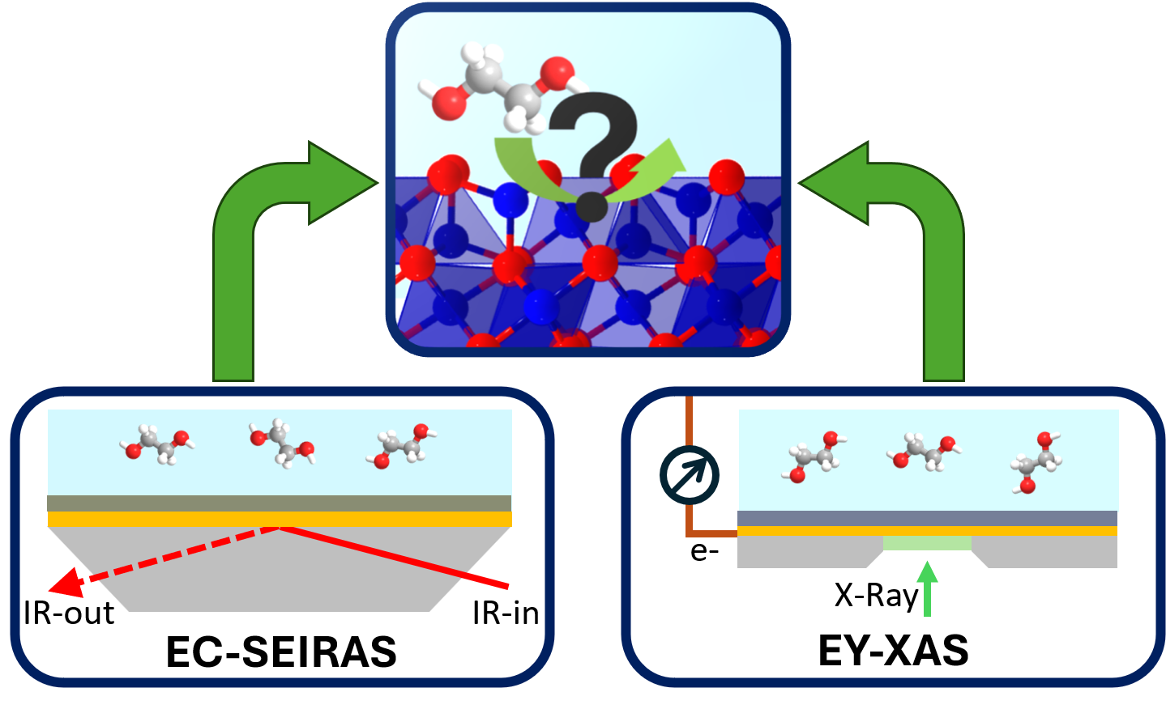
Figure 1: Schematic showing electrochemical ethylene glycol oxidation on Co₃O₄ and EC-SEIRAS and electron-yield XAS that are employed to investigate the system.

References
(1) Najafishirtari, S.; Friedel Ortega, K.; Douthwaite, M.; Pattisson, S.; Hutchings, G. J.; Bondue, C. J.; Tschulik, K.; Waffel, D.; Peng, B.; Deitermann, M.; Busser, G. W.; Muhler, M.; Behrens, M. A. Chemistry 2021, 27 (68), 16809–16833. DOI: 10.1002/chem.202102868.
(2) Muringayil Joseph, T.; Azat, S.; Ahmadi, Z.; Moini Jazani, O.; Esmaeili, A.; Kianfar, E.; Haponiuk, J.; Thomas, S. Case Studies in Chemical and Environmental Engineering 2024, 9, 100673. DOI: 10.1016/j.cscee.2024.100673.
(3) Qi, J.; An, Z.; Li, C.; Chen, X.; Li, W.; Liang, C. Current Opinion in Electrochemistry 2022, 32, 100929. DOI: 10.1016/j.coelec.2021.100929.

