Operando Small-Angle X-Ray Scattering (SAXS) on Proton Exchange Membrane Fuel Cells (PEMFC)

Clément Seron¹, Sandrine Lyonnard¹, Frédéric Maillard², Pierre Toudret³, Benoît Gouze³, Arnaud Morin³
- Univ. Grenoble Alpes, CEA IRIG, SyMMES, 38000 Grenoble
- Univ. Grenoble Alpes, LEPMI, 38000 Grenoble
- Univ. Grenoble Alpes, CEA LITEN, 38000 Grenoble
17 Avenue des Martyrs, 38000 Grenoble
Clement.seron@cea.fr

The hydrogen sector, crucial for decarbonisation, is experiencing rapid growth particularly in the deployment of low-temperature proton exchange membrane fuel cells (PEMFCs) for transport applications across Europe. The core of a PEMFC is the membrane electrode assembly (MEA), which consists of platinum or platinum-alloy nanoparticles supported on carbon, combined with a PFSA-based ionomer in the electrodes, along with a PFSA membrane. These components are prone to degradation, which limits the efficiency and durability of PEMFCs. However, the degradation mechanisms affecting these critical components under realistic operating conditions remain poorly understood.
This work investigates the structural evolution of the membrane, the anode, and the cathode under operando conditions using micro focused SAXS/WAXS. A specially designed cell enables experiment at temperatures up to 95°C. The study monitors changes in the membrane’s nano- and semi-crystalline structure, the platinum catalyst, and the humidity-dependent ionomer nanostructure, with differentiation between rib and channel regions. To bridge this gap, this study provides the first simultaneous investigation into the structural evolution of both the membrane and the electrodes under operating conditions. More specifically, we reveal how the ionomer structure within the electrodes relates to electrochemical performance under high temperature and varying humidity, an insight that has not yet been reported in the literature.
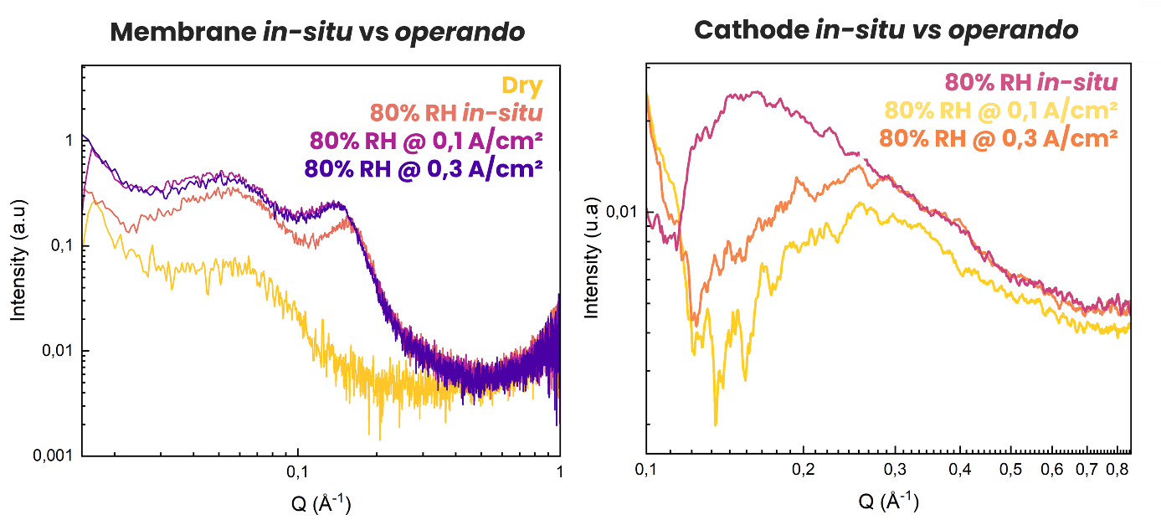
Our results, obtained from operando experiment conducted at ID13 at the European Synchrotron (ESRF), reveal a clear evolution of the membrane structure, and thus water content under varying operating conditions. While changes in the SAXS profiles of the electrodes were not immediately apparent, advanced data processing identified consistent trends linked to electrode hydration. Figure 1 illustrates the structural evolution within the membrane and the cathode under both in-situ and operando conditions. Developed by Toudret et al. (1), this data treatment clearly tracks and the difference of hydration of the electrodes which appears to be different in operando conditions compared to in-situ references notably ionomer hydration and pores filling.
Figure 1 : SAXS profiles of Nafion membrane comparison between in-situ references and operando (left) and same within the cathode catalyst layer (right)

- Toudret, P.; Wolanin, J.; Gebel, G.; Morin, A. Investigation of Ionomer Hydration and Local Relative Humidity in Platinum and Non-Noble Based Catalyst Layers in Proton Exchange Membrane Fuel Cells Using SAXS. J. Power Sources 2023, 586, 233671. https://doi.org/10.1016/j.jpowsour.2023.233671

