HiPIMS-Engineered Mn on Laser-Induced Graphene for Scalable Pseudocapacitive Supercapacitor Electrodes
Sourav Sain¹, Michal Sobaszek¹, Robert Bogdanowicz¹
¹Department of Optoelectronics, Gdańsk University of Technology, Narutowicza 11/12, 80-233 Gdańsk, Poland
Abstract
Laser-induced graphene (LIG) has emerged as a promising electrode material for next-generation energy storage because of its porous structure, conductivity, low-cost fabrication, and scalability.[1] RF sputtering shows strong potential for scalable and uniform thin-film engineering in energy storage applications.[2] In this work, manganese (Mn) was deposited on LIG at room temperature using high-power impulse magnetron sputtering (HiPIMS) to develop binder-free supercapacitor electrodes with enhanced electrochemical performance. Compared with conventional DC or RF sputtering, HiPIMS provides highly ionised plasma and energetic species, enabling improved film quality and better crystallinity even at room temperature. Such systems also come with its own flaws, high power tends to oxidize the surface at an extreme rate rendering the electrode material unusable. This work shows optimization of deposition through various parameters and its effects. Finally, the Mn-coated LIG electrodes exhibited strong pseudocapacitive behaviour with enhanced charge storage characteristics of 8 mF/cm² due to the synergistic combination of conductive graphene networks and electroactive Mn species compared with the pristine electrochemical double-layer capacitance of 4 mF/cm². The FESEM images has confirmed uniform coating of MN on the surface of LIG. The study highlights the advantage of HiPIMS in achieving crystalline and electrochemically active coatings without thermal treatment, which is difficult to realise through conventional sputtering methods. This shows the potential of HiPIMS for graphene-metal oxide hybrids for energy storage systems.
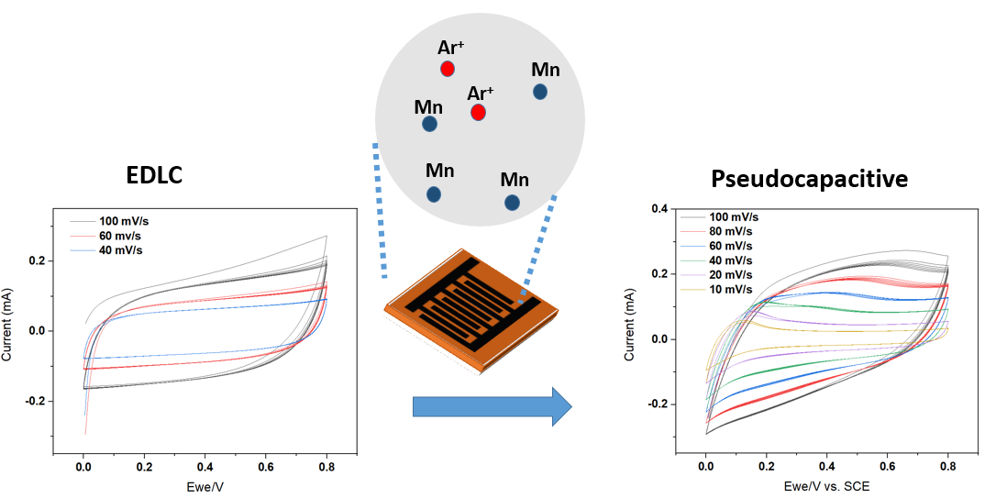
Figure 1. HiPIMS deposition of Mn for pseudocapacitive performance of LIG/MnO2.
References
1. Deshmukh, Sujit, Pawel Jakobczyk, Mateusz Ficek, Jacek Ryl, Dongsheng Geng, and Robert Bogdanowicz. "Tuning the laser‐induced processing of 3D porous graphenic nanostructures by boron‐doped diamond particles for flexible microsupercapacitors." Advanced Functional Materials 32, no. 36 (2022): 2206097.
2. Sain, Sourav, Suman Chowdhury, Sayantan Maity, Gurupada Maity, and Susanta Sinha Roy. "Sputtered thin film deposited laser induced graphene based novel micro-supercapacitor device for energy storage application." Scientific Reports 14, no. 1 (2024): 16289.

