Surfactant Doping Effect on the Performance of Gold Nanocluster Modified Electrodes for CO₂ Electroreduction

Mostafa Torabi, Michalina Zaborowska-Mazurkiewicz, Renata Bilewicz*
University of Warsaw, Faculty of Chemistry, Pasteura 1, 02-093 Warsaw, Poland
m.torabi@uw.edu.pl

Electrochemical CO₂ reduction (CO₂RR) is a promising approach for converting CO₂ into valuable chemicals while mitigating its atmospheric accumulation. Advancing this technology requires precise surface engineering strategies that improve reaction selectivity, maximize active-site utilization, and suppress the competing hydrogen evolution reaction (HER). In this work, HOPG electrodes were modified with atomically precise Au₂₅(SC₄)₁₈ nanoclusters (AuNCs) co-assembled with the cationic surfactant didodecyldimethylammonium bromide (DDAB) using the Langmuir–Schaefer (LS) deposition technique. By tuning the AuNCs/DDAB molar ratio and deposition surface pressure, this strategy enables independent control over nanocluster spatial distribution, interfacial charge environment, and electrode hydrophobicity.

Surface pressure–area isotherms, surface potential measurements, contact angle analysis, and AFM imaging revealed that DDAB content critically governs film organization and morphology. At low doping levels (≤10 mol%), DDAB promotes uniform nanocluster dispersion into compact monolayers with well-preserved hydrophobicity, conditions that locally enrich CO₂ concentration near the electrode and reduce water interference. At higher DDAB fractions, surfactant-dominated packing progressively displaces nanoclusters, forming multilayered aggregates and disrupting the hydrophobic microenvironment important for CO₂RR selectivity.

Electrochemical characterization in CO₂-saturated 0.1 M NaHCO₃ confirmed that the AuNCs/DDAB 95/5% film deposited at 10 mN/m delivers the best CO₂RR activity, achieving a 19-fold reduction in charge-transfer resistance relative to bare HOPG and the highest double-layer capacitance among all tested compositions. At 5% DDAB, the surfactant optimally balances two complementary roles: preventing nanocluster aggregation during LS transfer to maximize exposed active sites and sustaining a hydrophobic microenvironment that enriches CO₂ at the surface and suppresses HER. These results demonstrate that combining Au₂₅(SC₄)₁₈ nanoclusters with a judiciously doped cationic surfactant is an effective strategy for engineering the electrode microenvironment and enhancing electrocatalytic CO₂ reduction performance.

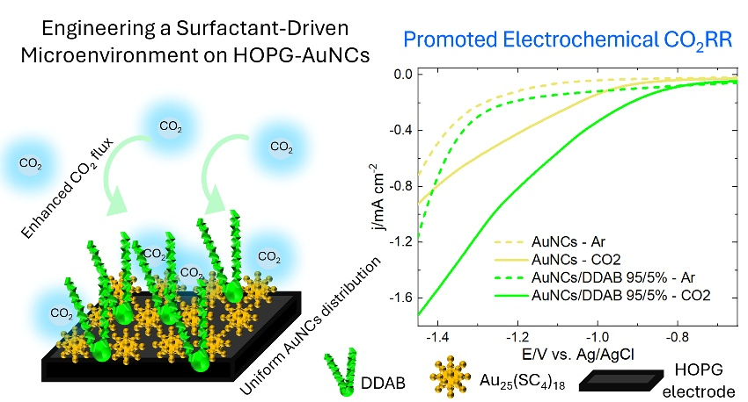

Keywords: Gold nanoclusters; CO₂ electroreduction; Langmuir–Schaefer films; Surface hydrophobicity; DDAB surfactant; Electrochemical impedance spectroscopy.

References
[1] Torabi, M. et al. Langmuir 2026, 42, 6983–6993.
[2] Ge, W. et al. J. Am. Chem. Soc. 2022, 144, 6613–6622.
[3] Li, S. et al. Angew. Chem. Int. Ed. 2021, 60, 6351–6356.

