Template for the OWTNM 2025 Workshop (14 pt bold)
A. Author^{1,*},, B. Author¹, C. Author² (12 pt)
¹George Green Institute for Electromagnetics Research, University of Nottingham, Nottingham NG7 2RD, UK (11 pt italic)
²Theoretical Electrical Engineering, University of Paderborn, Warburger Str. 100, 33098 Paderborn, Germany (11 pt italic)
*conferences@iop.org
Precede the paper by a brief abstract that fits within three lines. You might wish to replace conventional titles like “Summary”, “Introduction”, or “Results” by headings that relate to your actual contents.

Introduction
To ensure a reasonably uniform appearance of the papers in the proceedings volume, we ask all authors to follow these formatting instructions. Be aware that your paper will appear online (hyperlinks can be included).

Results
The expected and maximum length of the contribution is 1 page. Prepare the document for A4 paper size, with margins of 2 cm (sides), and of 2.5 cm and 3.2 cm (top and bottom). Application of a single font of the type Times New Roman throughout the whole paper is strongly recommended. The authors’ name(s), affiliation(s) and the e-mail address of the corresponding author should be centered and placed 12 pt below the title. Maximum 1 Figure could be included and cited in the paper as (Fig. 1). The abstract (11 pt font size) has to be placed 12 pt below the affiliations and e-mail address(es). The text of the contribution should then follow single-spaced, of 12 pt size. References should be formatted as shown below [1]. Displayed equations should be centered.

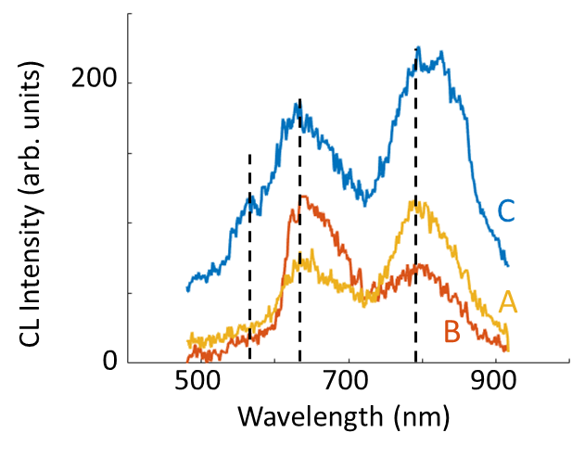
Fig. 1. The recommended font size is 11 pt (normal) for the figure caption.
Number figures, tables, and equations only when actually required. Omit page numbers.
Conclusion
Submit your paper in .pdf-format online https://iop.eventsair.com/owtnm2025/abstract-submission, before 17 January 2025. Please indicate your preference for an oral or a poster presentation.
References
- D. Michaelis, F. Lederer, An Example of a Properly Formatted Abstract for the OWTNM 2009 Workshop, OWTNM 2009, Jena, Germany, 2009.

