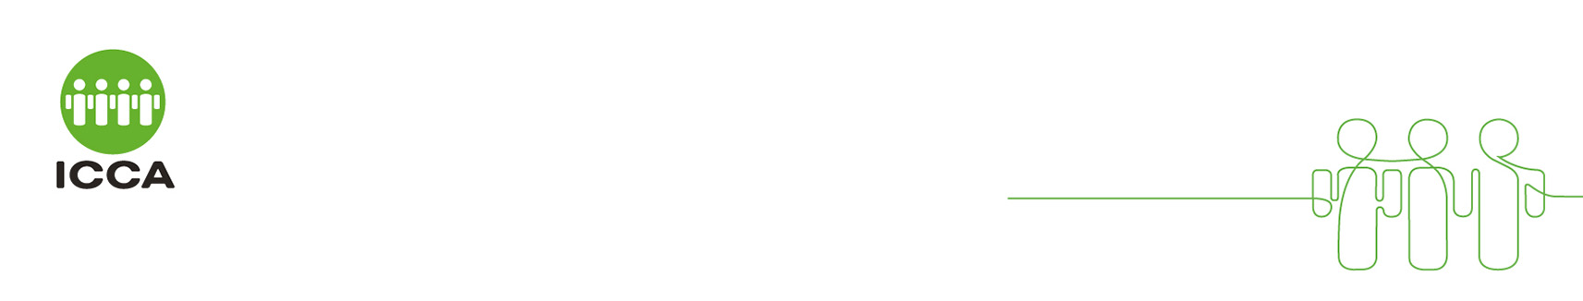Bureau Profile

*Please answer all the questions as required. If you do not have an answer available, please state N/A.*

#### Bureau Details

|  |  |  |  |  |
| --- | --- | --- | --- | --- |
| **Title:** |  | **Photo** (click to insert a photo) | |  |
| **First name:** |  | | |
| **Last name:** |  | | |
| **Job title:** |  | | |
| **Bureau name:** |  | | |
| **Address:** |  | | |
| **Postcode:** |  | **Telephone:** |  | |
| **City:** |  | **Mobile number:**  **(+country code)** |  | |
| **Country:** |  | **Website:** |  | |
| **Email:** |  | | | |
| **Type of Bureau:**  **(choose applicable)** | Convention Bureau  Part of Regional or National Tourist Board  Part of National, Regional or Local Government  Part of City Marketing & promotion body  Part of City Council  Part of Chamber of Commerce | | | |
| **Services provided by bureau free of charge:** |  | | | |
| **Services provided by bureau with a charge attached:** |  | | | |

#### Association Invited

|  |  |
| --- | --- |
| **Name of the Organisation** |  |

#### Destination Details

|  |  |  |  |
| --- | --- | --- | --- |
| **Largest conference the destination can host:** |  | **Number of Congress Centres in destination:** |  |
| **Number of unusual venues in destination:** |  | **Max. no. of delegates largest conf. ctr. holds:** |  |
| **Max. exhibition space of largest conf. centre:** |  | **Max. exhibition space of the largest plenary:** |  |
| **Nearest International airport:** |  | **Time taken to city centre from airport:** |  |
| **Special features:** |  | | |
| **Please list a few International events hosted by your city/destination (no more than two or three events):** |  | | |

#### Hotel Rooms in the City

|  |  |  |  |  |  |
| --- | --- | --- | --- | --- | --- |
| **Hotel rooms** | **3 Stars** | **4 Stars** | **5 Stars** | **Other Types** | **Total No. of hotel rooms** |
| **Number of rooms** |  |  |  |  |  |

#### Other Requirements and Designs

|  |  |
| --- | --- |
| **Technical / Hybrid Requirements**  Please describe how your destination/Bureau supports clients with their hybrid event requirements. |  |
| **Sustainability Requirements**  Please describe how your destination/Bureau incorporates sustainability practices and how you support your clients with this. |  |
| **Legacy Requirements**  Please explain how your destination/Bureau can support your client’s legacy programmes. Please include any examples on legacy programmes you have supported for clients in the past. |  |
| **Innovative Event Design**  Please include any example of how your destination/Bureau has supported innovative event design for your clients. |  |

*Thank you for your participation.*

*If you have any questions, please contact the Associations Team at* [*associations@iccaworld.org*](mailto:associations@iccaworld.org)*.*