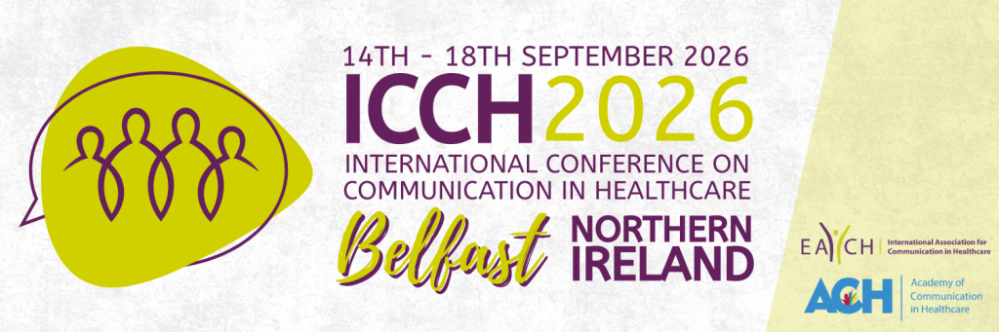

SCHOLARSHIP APPLICATION FOR EACH MEMBERS WITH RESTRICTED FUNDING

Applications are invited to the EACH Scholarship Fund, which provides a limited number of scholarships giving 50% discount on the EACH member conference registration fee for EACH members with restricted funding.

Please note that one-day conference registrations will be given 30% discount.

These scholarships are available to EACH members who are not able to afford the ICCH registration fee and have an accepted submission to present (e.g. oral, poster, workshop, symposium, roundtable) at the EACH-hosted ICCH 2026 in Belfast, September 2026.
EACH members already benefit from a reduced conference registration fee, but we wish to provide further support for members who are unable to afford this fee and whose institutions do not provide financial support for the conference.
Interested members should fill out the form below and email it to info@each.international prior to registering for the conference, together with an accompanying letter from your institution explaining that they are unable to provide financial support for you to attend the conference.
The final deadline for applications is midnight (UK time) Sunday 12 July 2026. If you are selected to receive a scholarship you will be contacted by 31 July 2026.

Scholarship funds are limited. All applications will undergo an eligibility review, and scholarship awards will be determined based on the review process and availability of funds.

SCHOLARSHIP APPLICATION FOR PRE-QUALIFICATION STUDENTS
Applications are invited to the EACH Scholarship Fund, which provides a limited number of scholarships giving 50% discount on the EACH member conference registration fee.
Please note that one-day conference registrations will be given 30% discount.
These scholarships are available to pre-qualification* students who are not able to afford the ICCH registration fee and have an accepted submission to present (e.g. oral, poster, workshop, symposium, roundtable) at the EACH-hosted ICCH 2026 in Belfast, September 2026.
Students already benefit from a reduced conference registration fee, but we wish to provide further support for students who are unable to afford this fee and whose institutions do not provide financial support for the conference.
Scholarships will be allocated on a first-come first-served basis, once applications have been screened for eligibility.
Interested students should fill out the form below and email it to info@each.international prior to registering for the conference, together with an accompanying letter from a senior colleague at your institution (e.g. supervisor, departmental manager) confirming that you are a pre-qualification student and that your institution is unable to provide full financial support for you to attend the conference.
The final deadline for applications is midnight (UK time) Sunday 12 July 2026. If you are selected to receive a scholarship you will be contacted by 31 July 2026.

*Pre-qualification includes students undertaking undergraduate, masters and doctoral qualifications, in any discipline, e.g. medicine, nursing, dentistry, allied health professionals, linguistics, social sciences etc, in order to qualify as a professional in that discipline.

Scholarship funds are limited. All applications will undergo an eligibility review, and scholarship awards will be determined based on the review process and availability of funds.

Date of application:
Type of application:  (Delete as required) | - SCHOLARSHIP FOR EACH MEMBERS WITH RESTRICTED FUNDING  - SCHOLARSHIP FOR PRE-QUALIFICATION STUDENTS
Is this for a one-day conference registration? | YES / NO (delete as applicable)
Name:
Institution:
Country:
Email address:
Abstract title:
Paper reference number:

