**Urology Quiz** 



What are some of the tests or investigations that you may wish to carry out on a male patient with significant bothersome urinary symptoms?

……………………………………………………………………………………………………………………………………………………………………………………………………………………………………………………………………………………………………………………………………………………………………………………………………………..

What is BPH? Please briefly explain.

………………………………………………………………………………………………………………………………………………………………………………………………………………………………………………………………………………………………………………………………………………………………………………………………………………

What are the non-surgical options that may help with BPH?

…………………………………………………………………………………………………………………………………..……………………………………………………………………………………………………………………………………………………………………………………………………………………………………………..………………………….

What are some of the surgical options for BPH?

……………………………………………………………………………………………………………………………………………………………………………………………………………………………………………………………………………………………………………………………………………………………………………………………………………..

What tests or investigations would you do on somebody who presents with a raised PSA? ……………………………………………………………………………………………………………………………………………………………………………………………………………………………………………………………………………………………………………………………………………………………………………………………………………...

What are some of the tests or investigations that may you be required for somebody with haematuria?

………………………………………………………………………………………………………………………………………………………………………………………………………………………………………………………………………………………………………………………………………………………………………………………………………………

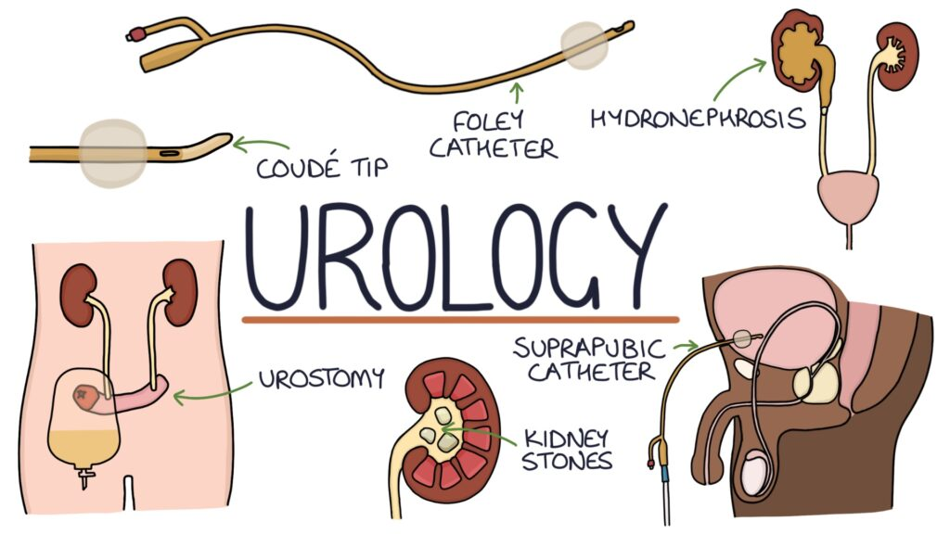What are the treatment and management options for kidney stones?

………………………………………………………………………………………………………………………………………………………………………………………………………………………………………………………………………………………………………………………………………………………………………………………………………………

What are the treatment / management options for kidney cancer?

………………………………………………………………………………………………………………………………………………………………………………………………………………………………………………………………………………………………………………………………………………………………………………………………………………

What are the treatment / management options for bladder cancer?

………………………………………………………………………………………………………………………………………………………………………………………………………………………………………………………………………………………………………………………………………………………………………………………………………………

What are the treatment / management options for Prostate cancer? ………………………………………………………………………………………………………………………………………………………………………………………………………………………………………………………………………………………………………………………………………………………………………………………………………………

What are some of the preventive measures / advice we may give to patients who are suffering with recurrent urinary tract infections (rUTI)?

………………………………………………………………………………………………………………………………………………………………………………………………………………………………………………………………………………………………………………………………………………………………………………………………………………

How can we manage over-active bladder (OAB), what treatments are available?

……………………………………………………………………………………………………………………………………………………………………………………………………………………………………………………………………………………………………………………………………………………………………………………………………………..