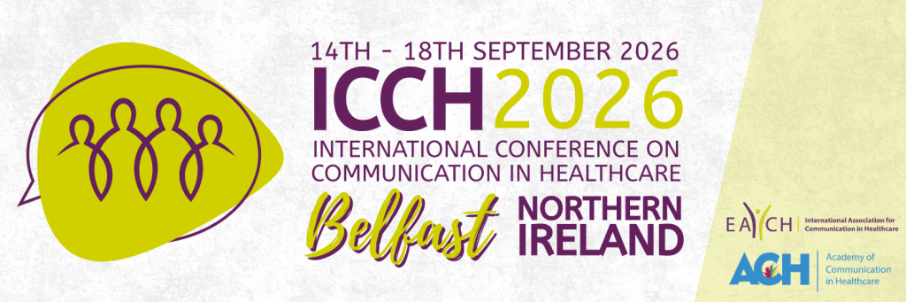

SCHOLARSHIP APPLICATION FOR EACH MEMBERS WITH RESTRICTED FUNDING

Applications are invited to the EACH Scholarship Fund, which provides a limited number of scholarships giving 50% discount on the EACH member conference registration fee for EACH members with restricted funding.
These scholarships are available to EACH members who are not able to afford the ICCH registration fee and have an accepted submission to present (e.g. oral, poster, workshop, symposium, roundtable) at the EACH-hosted ICCH 2026 in Belfast, September 2026.
EACH members already benefit from a reduced conference registration fee, but we wish to provide further support for members who are unable to afford this fee and whose institutions do not provi de financial support for the conference.
Scholarship funds are limited. All applications will undergo an eligibility review, and scholarship awards will be determined based on the review process and availability of funds.
Interested members should fill out the form below and email it to info@each.international prior to registering for the conference, together with an accompanying letter from your institution explaining that they are unable to provide financial support for you to attend the conference.
The final deadline for applications is Sunday 28th June 2026. If you are selected to receive a scholarship you will be contacted by Friday 10th July 2026.

Date of application:
Name:
Institution:
Country:
Email address:
Abstract title:
Paper reference number:

