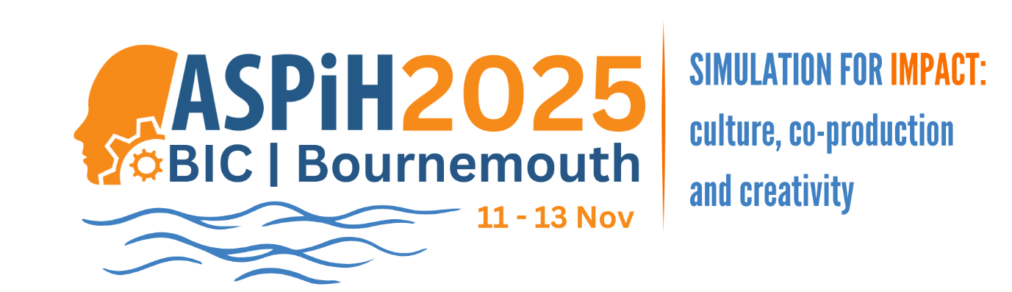

Association for Simulated Practice in Healthcare (ASPiH) Conference 2025
11 - 13 November 2025 , BIC, Bournemouth
https://fitwise.eventsair.com/aspih2025
Overview:
ASPiH conference is one of the leading simulation events in UK and Europe, attracting professionals, students, simulated practitioners, innovators and colleagues in industry across a wide range of health and social care fields.
This year’s conference is taking place from the 11th – 13th November 2025 at the BIC, Bournemouth.
The conference starts on Tuesday the 11th with our pre-event The ASPiH X-perience featuring expert lead workshops, specialist dialogue and an exclusive evening reception. The main conference and exhibition takes place on the 12th and 13th.

Delegate Registration Open:
Explore our flexible registration packages and pricing options tailored to meet your needs.
Did you know that it’s a lot cheaper to join ASPiH and come to conference as a member than as a non-member! Make sure you sign up to membership before completing your conference registration.

The conference key dates:
- Delegate registration: Open
- Member Super EarlyBird Registration Deadline: 31 May (BST at midnight)
- EarlyBird Registration Deadline: 31 August (BST at midnight)

We look forward to welcoming you to Bournemouth later this year

