Enhanced CO₂ Uptake in Cement: A Novel Sequestration Approach

Introduction

Cement production is a major contributor to global CO₂ emissions, accounting for nearly 8% of anthropogenic output (Wu et al., 2022). With the construction sector responsible for 39% of global carbon emissions, there is an urgent need for sustainable solutions. While CO₂ curing and the use of supplementary cementitious materials (SCMs) have shown promise (Gupta et al., 2018; Liu et al., 2022; L. Wang et al., 2020), challenges remain—particularly the low solubility of CO₂ in water and its tendency to reduce cement alkalinity, which can compromise hydration and strength (Alyousef et al., 2025; Fatah et al., 2020; Pravalika & Rao, 2018).

Recent studies have explored chemical additives to enhance CO₂ uptake and stabilize pH during carbonation (Kim et al., 2024; H. Wang et al., 2024). Among these, amine-based compounds have demonstrated potential, but often require high concentrations or interfere with hydration. This study introduces 1,6-hexamethylenediamine (HMDA) as a novel additive that enhances CO₂ solubility while maintaining a mildly alkaline environment (~pH 6), favorable for cement hydration (Figure 1) (Dinda et al., 2010; Singh et al., 2011). By integrating CO₂ directly into the mixing water, this approach enables uniform internal carbonation, offering a scalable pathway for producing high-performance, low-carbon cement materials.

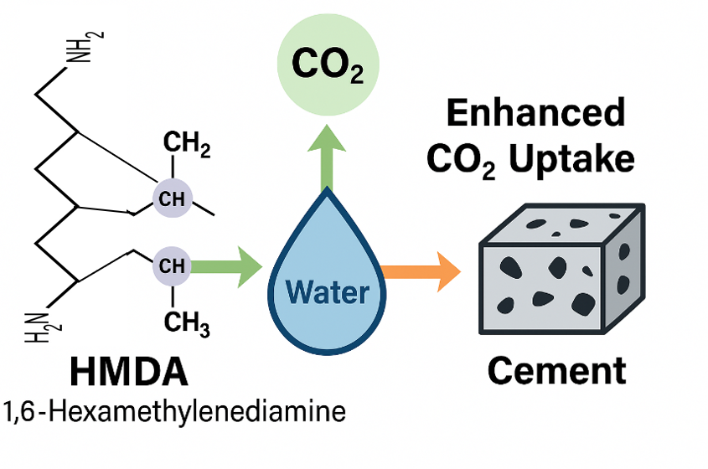
Figure 1 Illustration of HMDA-enhanced CO₂ uptake and integration within the cement matrix, supporting improved carbonation and mechanical stability.

Method and/or Theory

Four mixing solutions were prepared: tap water (W1), carbonated water (W2), and carbonated water with 0.1% and 0.6% HMDA (W3, W4). CO₂ was dissolved using a pressurized reactor at 35 bars. Cement pastes were cast at varying water-to-cement (w/c) ratios and cured under standard conditions. Analytical techniques included total inorganic carbon (TIC), pH, X-ray diffraction (XRD), Fourier-transform infrared spectroscopy (FTIR), micro-computed tomography (μCT), and mechanical testing. HMDA’s bifunctional amine groups react with dissolved CO₂ to form carbamates and bicarbonates, enhancing retention and promoting uniform carbonation.

Results

The integration of HMDA into CO₂-saturated mixing water led to a substantial enhancement in CO₂ uptake and pH stabilization across all tested cement formulations, as shown in Table 1. In the control carbonated water (W2), CO₂ uptake was measured at 0.74 g/L, whereas the addition of HMDA at 0.6 wt% (W4) increased this value dramatically to 8.2 g/L. This improvement is attributed to HMDA’s bifunctional amine groups, which react with dissolved CO₂ to form stable carbamate and bicarbonate species. These reactions not only increase the solubility of CO₂ in water but also buffer the solution, maintaining a mildly alkaline pH around 6. Such pH stabilization is critical, as it mitigates acid-induced degradation of cement phases and supports favorable conditions for hydration. The buffering effect of HMDA ensures that carbonation occurs without compromising the integrity of hydration products, enabling deeper and more uniform CO₂ integration into the cement matrix.

Table 1. Properties of the prepared solutions, including TIC, CO₂ uptake, and pH levels
Solution | TIC, g/L | CO₂ Uptake, g/L | pH Levels |  | Density, g/cc
Solution | TIC, g/L | CO₂ Uptake, g/L | Before CO₂ | After CO₂ | Density, g/cc
W1 (Normal Tab water) | 0 | N/A | 7.1 | N/A | ≈ 2.35
W2 (Tab water +CO₂) | 0.2 | 0.74 | 8.0 | ≈ 4 | ≈ 2.40
W3 (Tab water +CO₂ +0.1wt% HMDA) | 0.53 | 1.97 | 9.65 | 5.58 | ≈ 2.42
W4 (Tab water +CO₂ +0.6wt% HMDA) | 2.24 | 8.21 | 10.01 | 6.08 | ≈ 2.41

Mechanical testing revealed that although HMDA-treated samples exhibited lower early-age strength, they significantly outperformed the control samples at 28 days (Figure 2). The W3 formulation (0.1 wt% HMDA) achieved the highest compressive strength of 113.8 MPa at a w/c ratio of 0.3, surpassing both the tap water (W1) and carbonated water (W2) mixes. This strength gain is likely due to the gradual release of CO₂ from HMDA-carbamate complexes, which promotes sustained carbonation and densification over time. Ultrasonic wave velocity measurements further confirmed the mechanical enhancement, with HMDA-treated samples showing increased P-wave and S-wave velocities, indicative of improved stiffness and cohesion. The dynamic elastic modulus also increased in HMDA mixes, reflecting a more compact and resilient microstructure.

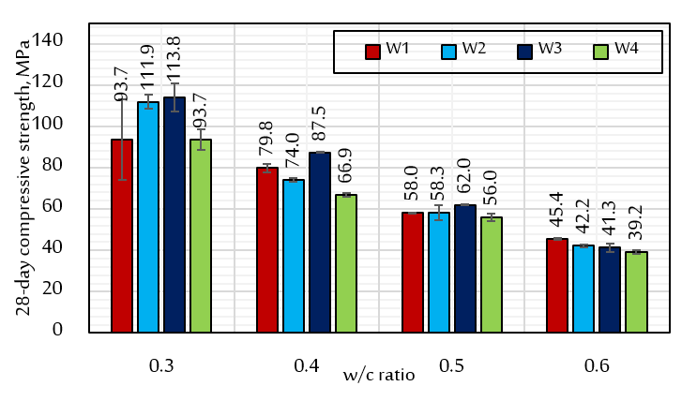
Figure 2 Effect of HMDA on the 28-day compressive strength of cement paste samples at various w/c ratios.

Microstructural analysis using μCT and pore size distribution (PSD) techniques revealed significant refinement in the internal architecture of HMDA-treated cement. Porosity decreased from 0.99% in the control sample (W1) to 0.3% in W3, indicating a denser matrix with fewer interconnected voids. The PSD shifted toward smaller pore sizes, with W4 exhibiting a mean equivalent diameter of just 7.4 µm, compared to 28.8 µm in W1. These findings suggest that HMDA not only enhances CO₂ uptake but also facilitates the formation of calcite within the pore network, contributing to pore filling and structural consolidation. FTIR spectra supported this interpretation, showing intensified carbonate peaks in the 1420–1470 cm⁻¹ region and a corresponding reduction in portlandite signals, confirming deeper carbonation. XRD analysis corroborated these results, with increased calcite content and reduced portlandite in HMDA-treated samples, further validating the chemical transformation induced by HMDA-enhanced carbonation (Figure 3).

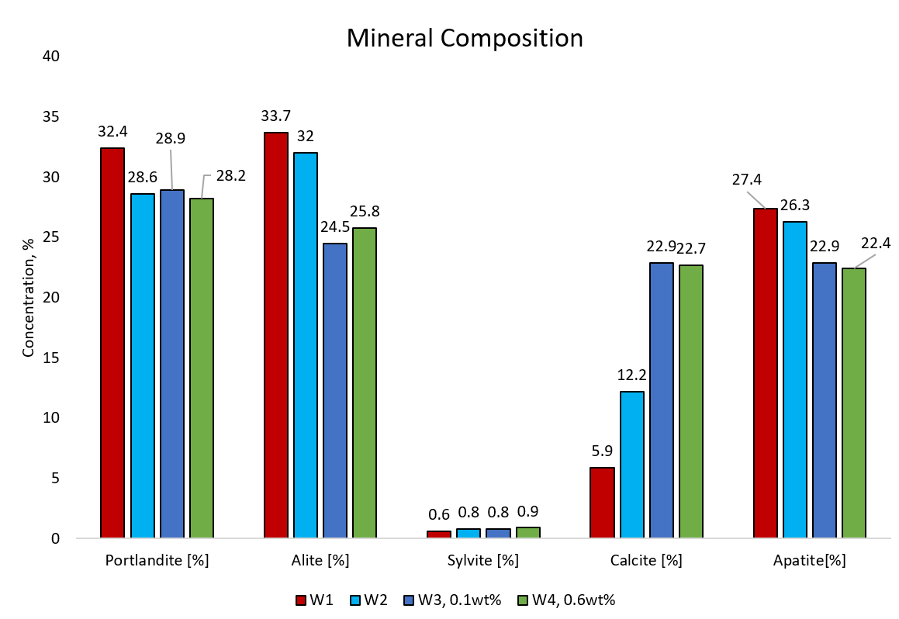
Figure 3 Mineral composition based on XRD analysis of the cement samples with a w/c ratio of 0.5.

Conclusions

This study demonstrates that HMDA is a promising additive for CO₂ sequestration in cement. It enhances CO₂ solubility, stabilizes pH, and promotes internal carbonation without compromising mechanical integrity. The W3 formulation (0.1 wt% HMDA) offers optimal performance, balancing early hydration and long-term strength. This approach is cost-effective, scalable, and compatible with existing cement workflows, making it ideal for precast applications and low-carbon construction.

Acknowledgments

The authors gratefully acknowledge the support provided by the Center for Integrative Petroleum Research (CIPR) and the Interdisciplinary Research Center for Construction and Building Materials at King Fahd University of Petroleum and Minerals (KFUPM).

References

Alyousef, M. H., Alshammari, S., & Al-Yaseri, A. (2025). Synergy of CO Mineralization in Produced Water with Enhanced Oil Recovery: An Experimental

Study. Fuel, 382, 133694. https://doi.org/10.1016/j.fuel.2024.133694

Dinda, S., Goud, V. V., Patwardhan, A. V., & Pradhan, N. C. (2010). Kinetics of reactive absorption of carbon dioxide with solutions of 1,6-hexamethylenediamine in polar protic solvents. Separation and Purification Technology, 75(1), 1–7. https://doi.org/10.1016/J.SEPPUR.2010.07.002

Fatah, A., Bennour, Z., Ben Mahmud, H., Gholami, R., & Hossain, Md. M. (2020). A Review on the Influence of CO2/Shale Interaction on Shale Properties: Implications of CCS in Shales. Energies, 13(12), 3200. https://doi.org/10.3390/en13123200

Gupta, S., Kua, H. W., & Low, C. Y. (2018). Use of biochar as carbon sequestering additive in cement mortar. Cement and Concrete Composites, 87, 110–129. https://doi.org/10.1016/J.CEMCONCOMP.2017.12.009

Kim, T., kuppusamy, M., Velmurugan, K., Park, S.-D., Kim, S.-W., Park, S.-S., & Kim, W.-J. (2024). Study of CO2 absorption by cement paste containing amine compounds: a comparative study of diethylamine, dimethylamine and isopropylamine. Innovative Infrastructure Solutions, 10(1), 15. https://doi.org/10.1007/s41062-024-01813-x

Liu, J., Liu, G., Zhang, W., Li, Z., Xing, F., & Tang, L. (2022). Application potential analysis of biochar as a carbon capture material in cementitious composites: A review. Construction and Building Materials, 350, 128715. https://doi.org/10.1016/J.CONBUILDMAT.2022.128715

Pravalika, A., & Rao, N. V. (2018). Effect of carbonation on the properties of concrete. International Journal of Civil Engineering and Technology, 9(7), 1605–1611. https://doi.org/10.32861/sr.512.205.214

Singh, P., van Swaaij, W. P. M., & Wim Brilman, D. W. F. (2011). Kinetics study of carbon dioxide absorption in aqueous solutions of 1,6-hexamethyldiamine (HMDA) and 1,6-hexamethyldiamine, N,N′ di-methyl (HMDA, N,N′). Chemical Engineering Science, 66(20), 4521–4532. https://doi.org/10.1016/J.CES.2011.06.008

Wang, H., Cai, T., Liang, S., & Hou, P. (2024). Improving the Hydration and Carbonation of Reactive MgO Cement with Amino Acids and the Influencing Mechanisms. Journal of Thermal Analysis and Calorimetry, 149(12), 5995–6006. https://doi.org/10.1007/s10973-024-13092-w

Wang, L., Chen, L., Tsang, D. C. W., Guo, B., Yang, J., Shen, Z., Hou, D., Ok, Y. S., & Poon, C. S. (2020). Biochar as green additives in cement-based composites with carbon dioxide curing. Journal of Cleaner Production, 258, 120678. https://doi.org/10.1016/J.JCLEPRO.2020.120678

Wu, T., Ng, S. T., & Chen, J. (2022). Deciphering the CO2 emissions and emission intensity of cement sector in China through decomposition analysis. Journal of Cleaner Production, 352, 131627. https://doi.org/10.1016/J.JCLEPRO.2022.131627

