**Abstract title**

**Introduction**

Click ONCE and select this paragraph, you will replace this text with your own text and it will be automatically formatted. All styles for this template are formatted for you.

Here is the second paragraph of the introduction. The font for this template is 11pt Times New Roman. The Section Headings are bold. The paragraphs are justified and separated by a blank line.

Abstracts will be printed on the conference publication and online exactly as they are submitted. EAGE staff will not edit or retype the copy.

Your abstract should be within 2-4 (two to four) long including all figures and references (Please do not count the cover page).

AUTHORS, AFFILIATIONS and the SUMMARY ARE NOT PART OF THE EXTENDED ABSTRACT. The extended abstract (without cover page) must be within 2-4 (two to four) full pages.

If your extended abstract does not meet the requirements, it will NOT be included in the review process!

**Method and/or Theory**

Requirements for extended abstract (the extended abstract must meet the requirements):

* Extended abstract must be within 2-4 (two to four) full pages, paper size A4 and include a presentation title;
* Within this mandatory template;
* Do not modify the header or footer of the template. If your company adds the company name by default, please remove it from the header/footer;
* Do not include the summary, authors or affiliations in the pages of the extended abstract;
* Include the title of the extended abstract on top of the first page (title only!);
* Font ‘Times New Roman’, font size 11pts for all text with single line space and use the standard Word outline level (body text);
* Start the body text of your extended abstract directly under the event logo;
* NO additional empty lines to fill up the page;
* Margins 2.54 cm on all sides (1”);
* Including references and at least 1 graphic/figure;
* Save as PDF or print to PDF;
* Ensure that the PDF-paper size is **A4** as well.

Additional instructions for composition are:

* Please write your abstract in English.
* Authors are responsible for sizing and positioning of their illustrations.
* Figures can be in black and white or colour.
* Embed into the text of the paper figures, equations, charts, graphics, etc.

These bulleted items are used as examples and should be deleted so they do not appear in your document.

**Sample section (Optional)**

This is the first sentence of a sample section. Each of the paragraphs and section headings appear shaded in this template, with the exception of the bulleted items above and the text in the following figure.

These text boxes appear shaded on the screen only. It will disappear as you select each paragraph to replace with your own text, or just delete.

If you have a chart, graphic, equation, etc. you will need to embed them in the document. You can insert an external file. Here is an example of a figure.

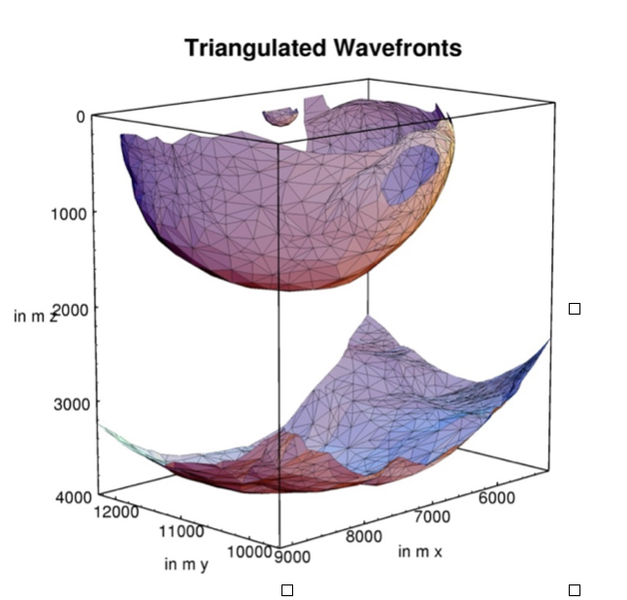

***Figure 1*** *This is an example of a figure imported from jpeg (courtesy of Gilles Lambaré). Left click on Insert on the menu bar and then select Picture. You can also select to embed an object instead of a picture. You can either embed an existing file or create your object at that point. Number the figures sequentially, according to their appearance in the text, and check that each figure is cited in the text. Supply a short* ***caption*** *for each figure; more detailed discussion of the figure can be reserved for the text. In this template figure captions are 11pt italic Times New Roman. Further information about the use of figure captions and figure numbering can be found in* [*the* First Break guidance to authors*.*](https://www.earthdoc.org/content/journals/fb?page=submit-a-paper)

**Examples (Optional)**

Example text, please delete if you don't use it.

**Conclusions**

This is the first sentence of the conclusion.

**Acknowledgements (Optional)**

The submission deadline is mentioned on the website. NO EXCEPTIONS!

**References**

This is the first sentence of the References section. The lay-out of the references should be consistent with the style guide for references in the First Break guidance to authors. Please ensure every citation has a reference and vice versa.