Compositional Simulator for CO₂ Storage Simulation with Geochemical Reactions

Introduction
Geological CO₂ sequestration (GCS) is a critical strategy for mitigating anthropogenic CO₂ emissions. It involves tightly coupled multiphase flow, chemical reactions, geomechanics, and thermal effects across multiple spatial and temporal scales. In reactive transport modeling, the first two processes are central, as they govern long‑term CO₂ trapping and the evolution of reservoir properties. Accurate representation of these coupled processes is essential for assessing the security and efficiency of GCS operations.
A reactive transport simulator integrates two main components: a flow module that computes saturation and pressure distributions, and a geochemical package for species consumption and production due to chemical reactions. Developing such a multiphysics model requires coupling fluid flow, solute transport, and reaction equations in the two modules into a unified simulator (Fan, Durlofsky, & Tchelepi, 2012). Ahusborde et al. (Ahusborde, Amaziane, & El Ossmani, 2018) categorized the approaches for solving this strongly coupled problem into two main families: the sequential (or operator‑splitting) method and the global implicit method.
In the sequential method, transport and chemistry are advanced separately within each time step. The advection–dispersion equations are solved first, followed by local geochemical calculations in each grid cell. This modular structure is relatively straightforward to implement and allows efficient parallel computations of chemical reactions, but it introduces operator-splitting errors and can become inefficient for stiff or tightly coupled processes unless very small time steps or advanced splitting schemes are used (Carrayrou, Mosé, & Behra, 2004). In contrast, the global implicit method discretizes and solves transport and reaction terms simultaneously at each time step, yielding a single nonlinear algebraic system that consistently represents advection, dispersion, and reactions at the new time level. This method eliminates operator-splitting errors and offers improved robustness for tightly coupled problems. Its main drawback lies in the need to assemble large Jacobian matrices and solve correspondingly large linear systems, which increases both implementation difficulty and computational costs compared to sequential alternatives (Ahusborde et al., 2018).
In this study, we develop a reactive transport simulator based on the global implicit method. Our simulator integrates an in‑house compositional reservoir simulator with a proprietary chemical‑phase equilibrium (CPE) package. The CPE module employs the modified‑RAND algorithm, as described in Paterson et al. (Paterson, 2019), which solves the chemical and phase equilibrium problem simultaneously by minimizing the Gibbs free energy. This non‑stoichiometric approach enables fast and robust equilibrium calculations, making it well suited for integration into large‑scale reactive transport simulations.
Method and Theory
The developed multi-physics simulator is composed of two key parts: a mass flow simulator and a chemical-phase equilibrium package. Together, they model the reactive flow of large-scale CO₂ storage in porous media. The current version supports CO₂-water systems without restrictions on the number of components and equilibrium reactions. The effects of kinetic reactions will be added in future developments.
Transport Equations
To simulate large‑scale, multi‑phase, multi‑component flow in CO₂-water systems, the reactive transport simulator was built by extending an existing in‑house compositional reservoir simulator originally developed for oil-gas-water systems. The governing equations consist of a mass conservation equation for each component c, coupled with a saturation constraint equation:
$$\frac{∂}{∂t} \left(ϕ \sum_{p=1}^{N_{Ph}}{x_{c, p}}{\overline{ρ}}_{p}S_{p}\right)+ ∇ . \left(\sum_{p=1}^{N_{Ph}}{x_{c, p}}{\overline{ρ}}_{p}u_{p}\right)-q_{c}- \sum_{r=1}^{N_{r}}{v_{c,r}}r_{r}=0$$ | 1
$$\sum_{p=1}^{N_{Ph}}{S_{p}}=1$$ | 2
where $ϕ$, $x_{c, p}$, $\overline{ρ}$, $S$, $u$, $q$, $v_{c,r}$, and $r_{r}$ stand for porosity, the mole fraction of component c in phase p, molar density, phase saturation, phase velocity, source/sink term, stoichiometric coefficient of c in reaction r, and reaction rate, respectively. The governing equations are discretized in space using the finite volume method and in time using a fully implicit scheme. The transport and reaction calculations are fully coupled within this implicit framework. The derivatives required to assemble the Jacobian matrix for Equations (1) and (2), along with other chemical and phase equilibrium properties, are computed directly by the coupled CPE module.
CPE module
The current reactive transport simulator incorporates a robust and efficient CPE engine originally developed by Medeiros et al. (Medeiros, Yan, & Stenby, 2020) based on Gibbs energy minimization. The underlying methodology for solving CPE problems is the RAND algorithm, a non-stoichiometric formulation applicable to both phase equilibria and electrolyte systems. In this method, for a given temperature, pressure, and feed composition the CPE solution is defined through the Lagrangian of the reduced Gibbs energy, $L$, as follows:
$$L\left(n, λ\right)=\frac{1}{RT}\sum_{p=1}^{N_{Ph}}{n_{p}μ_{p}}-λ\left(A\sum_{p=1}^{N_{Ph}}{n_{p}}-b\right)$$ | 3

where $n_{ p}$, $R$, $T$, $μ$, $A$, $λ$and $b$ represent the moles of components in phase p, the gas constant, temperature, chemical potential, the formula matrix, the Lagrange multiplier of elements, and the moles of elements in the feed, respectively. A comprehensive description of the method and its detailed formulation can be found in (Medeiros et al., 2020; Paterson, 2019). In the present simulator, chemical potentials for components in the CO₂-rich phase are computed using fugacity coefficients from the Peng-Robinson (PR) equation of state, while those in the aqueous phase are obtained from activity coefficients using Pitzer's equation, with the necessary parameters from the PHREEQC Pitzer database.
Global Implicit Reactive Transport Algorithm
In this study, the global implicit method was implemented to fully couple the transport and reaction processes described above. This method solves the component transport and geochemical reaction equations together within a single time step in an implicit manner. The coupling is achieved by computing, at each equilibrium state, the derivatives of component amounts, phase mole fractions, and phase volumes from the CPE module with respect to the primary variables of Equations (1) and (2), namely the moles of each component and the pressure in each grid cell. The simulation domain is assumed to be closed at the boundaries, so that mass exchange occurs only through injection and production wells.
Simulation Examples
In this section, the application of the developed compositional reactive transport simulator is demonstrated through a 2D case study of CO₂ injection into a water‑invaded reservoir. The simulation domain was discretized into 20×20×1 grid cells in the x, y, and z directions, respectively, with uniform cell dimensions of 10×10×1 meters. Permeabilities were uniformly set to 10, 10, and 1 md in the x, y, and z directions, while porosity was constant at 0.2. The 2D domain was configured as a quarter five spot injection-production system, with the injection well placed at grid cell (1, 1, 1), and the production well at grid (20, 20, 1). Assuming a well radius of 0.1524 ft for both wells, the well index was calculated as 2.42×10⁻¹³ using Peaceman's well model. Both wells were operated under constant pressure constraints, with the injection well set at 5500 psi and the production well at 1000 psi.
The initial pressure and temperature throughout the domain were 1000 psi and 77 °C, respectively. Relative permeability curves for the CO₂‑rich and aqueous phases were generated using Corey's correlation, from which derivatives computed with respect to phase saturations. Irreducible saturations were set to 5% for the CO₂‑rich phase and 10% for the aqueous phase, with Corey exponents of 2.0 and 1.2, respectively. A constant viscosity model was employed for both phases, with viscosities fixed at 0.4 cP for the CO₂‑rich phase and 0.37 cP for the aqueous phase.
Based on this grid, well, and rock property setup, two simulation cases were defined, differing only in initial fluid composition. The first fluid is pure water in equilibrium with its dissociation products (H⁺ and OH⁻). The second uses an aqueous solution containing 0.5 molal NaCl and 5.75×10⁻⁵ molal CaCO₃, chosen to keep the solution undersaturated and all species in the aqueous phase. Equilibrium constants, temperature dependencies, and partial molar volumes were obtained from the PHREEQC Pitzer database. The first case includes only the first three reactions below, while the second includes all five:
$$H_{2}O_{\left(aq\right)}⇌ OH_{(aq)}^{-}+ H_{(aq)}^{+ }$$  $${CO_{3}^{2-}}_{\left(aq\right)}+ H_{(aq)}^{+ }⇌ {HCO_{3}}_{(aq)}^{-}$$  $${CO_{3}^{2-}}_{\left(aq\right)}+ {2H}_{(aq)}^{+ }⇌C{O_{2}}_{\left(aq\right)}+H_{2}O_{\left(aq\right)}$$  $$NaCl_{(S)}⇌Na_{(aq)}^{+}+Cl_{\left(aq\right)}^{-}$$  $${CaCO_{3}}_{(S)}⇌{CO_{3}}_{(aq)}^{2-}+{Ca}_{\left(aq\right)}^{2+}$$ | 4
Upon running the two simulation cases with the developed reactive transport simulator, a comprehensive set of results was obtained, including spatial and temporal distributions of pressure, CO₂ and water saturations, component moles, pH, and pOH across the domain. To illustrate the simulator’s capabilities, a representative subset of results is presented. Since the only difference between Case 1 and Case 2 is the presence of small amounts of dissolved NaCl and CaCO₃ in the aqueous phase, the resulting pressure and saturation fields were nearly identical. Accordingly, Figure 1 shows the saturation field after 3 and 5 months of continuous CO₂ injection, corresponding to cumulative injected masses of 15.1 and 18.9 tons of CO₂, respectively.
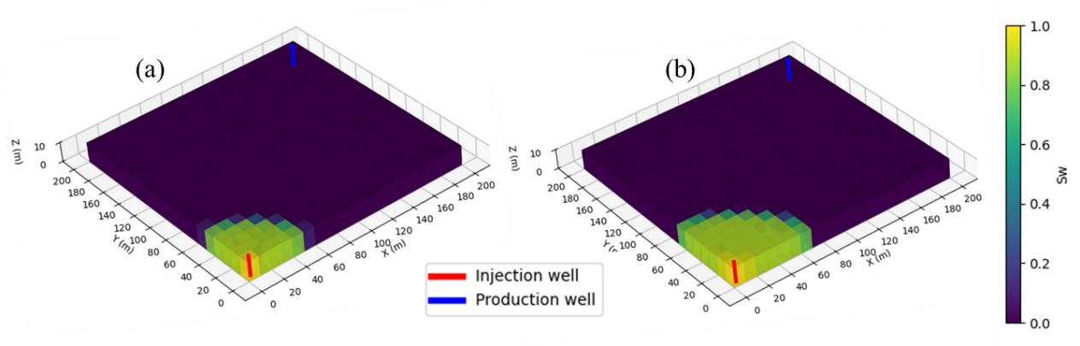
Figure 1: 3D illustration of the CO₂-rich phase saturation at (a) t = 3 months, and (b) t = 5 months
Acidity is a sensitive indicator of the key geochemical processes occurring during CO₂ injection, as it governs aqueous speciation, mineral dissolution and precipitation, porosity and permeability evolution, and ultimately CO₂ trapping through dissolution and mineralization. Therefore, among the various outputs produced by the simulator, the temporal evolution of pH for both cases is shown in Figure 2 for several grid cells along the x‑direction. The results indicate that the initial pH of the solution was 6.32 for Case 1 and 6.45 for Case 2. As the injected CO₂ contacts the fluid in each grid cell, acidity increases, and each cell is progressively driven toward a CO₂‑saturated state, with final pH values of approximately 3.0 for Case 1 and 3.2 for Case 2. Overall, the general trend of pH evolution is similar in both cases; however, pH values in Case 2 remain consistently higher by about 0.2 units throughout the simulation. This increase can be attributed to two primary factors: first, the addition of calcite introduces CO₃²⁻ ions, which act as a base and consume H⁺ through the formation of bicarbonate; second, the presence of NaCl increases the ionic strength of the solution, reducing the activity coefficient of H⁺ and thereby resulting in higher measured pH values.
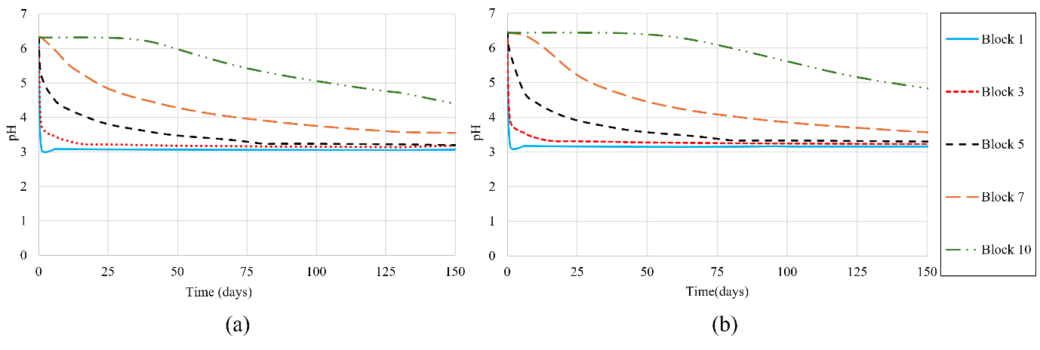
Figure 2: pH versus time for some blocks in x direction and y=1: (a) case 1, and (b) case 2
Conclusions
In this work, an in‑house compositional reactive transport simulator was successfully developed using the global implicit method, enabling fully coupled simulation of multiphase flow and geochemical reactions for large‑scale CO₂ storage. The simulator integrates a compositional reservoir simulator with a robust CPE module employing the modified‑RAND algorithm. A key achievement is the direct coupling between transport and chemistry through Jacobian derivatives computed from the CPE module, eliminating operator‑splitting errors. Two 2D test cases comparing pure water and a saline solution containing NaCl and CaCO₃ demonstrated the simulator's capabilities in capturing the influence of brine chemistry on pH evolution. Results showed that dissolved salts and calcite consistently elevated pH by approximately 0.2 units due to carbonate buffering and increased ionic strength. These findings confirm the simulator's ability to model complex equilibrium reactions affecting CO₂ trapping mechanisms, providing a foundation for future extensions incorporating kinetic mineral reactions.
References
Ahusborde, E., Amaziane, B., & El Ossmani, M. (2018). Improvement of numerical approximation of coupled multiphase multicomponent flow with reactive geochemical transport in porous media. Oil & Gas Science and Technology–Revue d’IFP Energies Nouvelles, 73, 73.
Carrayrou, J., Mosé, R., & Behra, P. (2004). Operator-splitting procedures for reactive transport and comparison of mass balance errors. Journal of Contaminant Hydrology, 68(3), 239–268. doi:https://doi.org/10.1016/S0169-7722(03)00141-4
Fan, Y., Durlofsky, L. J., & Tchelepi, H. A. (2012). A fully-coupled flow-reactive-transport formulation based on element conservation, with application to CO2 storage simulations. Advances in Water Resources, 42, 47–61.
Medeiros, F. D. A., Yan, W., & Stenby, E. H. (2020). Modified RAND Algorithms for Multiphase Geochemical Reactions. In ECMOR XVII (Vol. 2020, pp. 1–15). European Association of Geoscientists & Engineers.
Paterson, D. (2019). Modified RAND Framework for Phase Split Calculations. In Flash Computation and EoS Modelling for Compositional Thermal Simulation of Flow in Porous Media (pp. 83–124). Springer.

