Artificial Intelligence for CO₂ Storage Capacity Assessment and Uncertainty Analysis

Extended Abstract
1. Introduction
The successful implementation of carbon capture and storage (CCS) projects depends on precise geological CO₂ storage capacity evaluation together with its corresponding uncertainty assessment. The current methods for capacity estimation depend on geological data analysis and volume measurements and numerical modeling of reservoirs and statistical methods to handle uncertainty. AI and machine learning (ML) techniques have increased their usage for supporting these activities during the previous decade. The extended abstract reviews existing published research which demonstrates AI-based methods for CO₂ storage capacity assessment and uncertainty analysis and screening process optimization. The research aims to combine existing methods instead of developing fresh computational or analytical techniques.
2. AI in Storage Capacity Estimation
The studied research papers show how ML models analyze geological and petrophysical and simulation-based data to predict storage capacity measurements. Numerical models produce capacity estimates which supervised learning methods use to create maps between reservoir attributes including porosity and permeability and thickness and depth. The research studies present AI as a screening tool which uses surrogate functions to speed up capacity assessment for extensive regional data sets. Existing work consistently emphasizes that AI-derived estimates are calibrated against physics-based calculations rather than replacing them.
3. Uncertainty Quantification and Screening Studies
AI serves as a reviewed instrument which helps experts perform uncertainty analysis during their storage assessment work. Research studies show that ML models generate probabilistic simulation results which allow users to assess different parameter combinations and various simulation scenarios through quick processing. The application of AI-based classification and clustering techniques in regional screening studies enables researchers to evaluate storage sites through their capacity indicators and risk proxies which produce ranking results. The systems function as entry-level decision-support tools which activate at the beginning of project development.
4. Integration with Geological and Simulation Workflows
The existing research demonstrates how AI technology can be used to merge with geological modeling and reservoir simulation operations. AI-based models function to predict subsurface data from limited available information while they detect storage performance relationships with geological features and they minimize the need for running numerous simulation models. The research results show that hybrid workflows which unite AI systems with traditional modeling methods remain the most popular choice because they allow users to understand physical models and meet regulatory standards.
5. Limitations and Practical Considerations
The reviewed publications show that researchers face four main obstacles which include working with scarce data and training data that contains biases and the challenge of using models between different geological areas and the challenge of understanding AI system results. Research shows that AI systems used for capacity assessment require results which need validation procedures and developers must explain all uncertain factors to users because this fulfills regulatory needs and supports future infrastructure development.
6. Conclusions
The review shows that AI technology enables professionals to evaluate CO₂ storage capacity while reducing their assessment uncertainties through its assistance capabilities. The system provides two main advantages through its fast operation and its ability to detect more patterns. The system requires both geological expertise and physics-based modeling to achieve long-term reliability.

References:
Asante J, Ampomah W, Rose-Coss D, Cather M, Balch R. Probabilistic Assessment and Uncertainty Analysis of CO₂ Storage Capacity of the Morrow B Sandstone—Farnsworth Field Unit. Energies. 2021; 14(22):7765. https://doi.org/10.3390/en14227765

Hedley BJ, Davies RJ, Mathias SA, Hanstock D, Gluyas JG. Uncertainty in static CO₂ storage capacity estimates: case study from the North Sea, UK. Greenhouse Gases Sci Technol. 2013;3(3):212-230.

Aminaho, Efenwengbe & Aminu, Nuruddeen & Aminaho, Faith. (2025). ARTIFICIAL INTELLIGENCE BASED SOLUTIONS FOR MONITORING CO2 STORAGE RESERVOIRS: A REVIEW. 10.2139/ssrn.5265630.

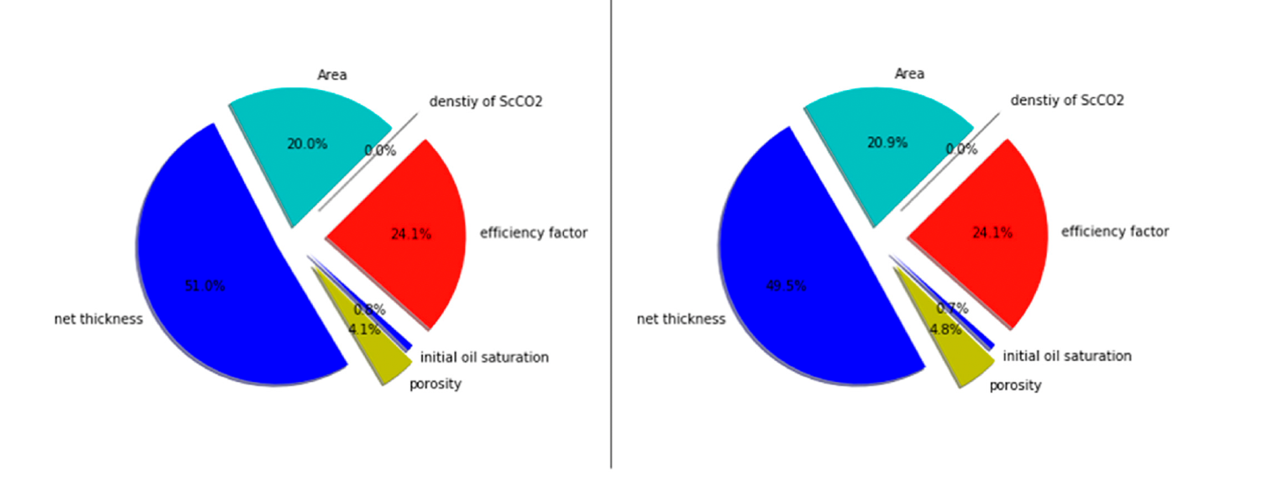
Figure - Pie chart showcasing impact of the input parameters to the total uncertainty in percentages. The left and right charts represent the results generated by the Monte Carlo simulation and the parametric method, respectively.
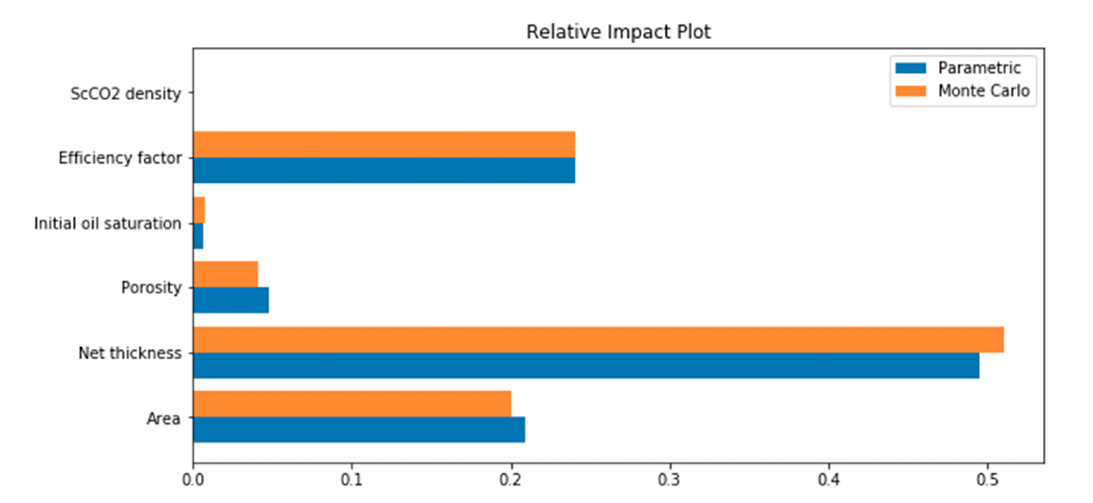
Figure - Relative impact plot illustrating the contribution of the input parameters to the total
uncertainty.

Summary of the Extended Abstract
The research evaluates existing studies which use artificial intelligence and machine learning to determine geological CO₂ storage capacity while analyzing their produced uncertainty results. The research combines existing findings about AI applications for capacity estimation and probabilistic analysis and regional screening. The review demonstrates how AI functions as a substitute tool which helps users make decisions by speeding up storage potential assessments through analysis of geological data and simulation-based information. The implementation of AI technology for uncertainty quantification and site screening operations demonstrates its value by handling complex parameter combinations which enables projects to move forward through their development stages. The research document identifies the three most common research barriers which result from restricted data availability and the need to adapt findings between different geological settings and the challenge of interpreting AI system outputs. The review demonstrates AI functions as an effective method to improve conventional capacity assessment techniques yet it establishes that physical modeling together with expert evaluation should remain essential components.

