Combining Calcium Looping with In-situ Dry Reforming of Methane Using CeO₂-Modified Ni/CaO Dual Functional Materials

Introduction
Calcium looping-dry reforming of methane (CaL-DRM) is a promising carbon neutral technology. Conventional Ni/CaO dual functional materials (DFMs) suffer from sintering and carbon deposition. In this study, novel Ni/Ni₁CeO₂CaO DFMs were synthesized via urea-assisted hydrothermal pre-doping of minor Ni and CeO₂ into CaO, followed by impregnation. The incorporated Ni acts as both catalytic sites and pore-forming agents, creating mesopores. CeO₂ enhances sintering resistance and introduces oxygen vacancies, improving carbon resistance. The modified materials exhibit mesoporous structures, higher surface area, increased oxygen vacancies, and improved reducibility. The optimized Ni4/Ni1CeO₂5CaO achieves a CO₂ capture capacity of 12.5 mmol·g⁻¹ DFM and syngas production of 44 mmol·g⁻¹ DFM at 650°C under GHSV = 36 L·g⁻¹·h⁻¹DFM with <5 wt% carbon deposition after 10 cycles. DFT calculations revealed the synergistic mechanism in the CaL-DRM reaction where *CH₂ species facilitate the decomposition of CaCO₃, thereby clarifying the reaction pathway. This work offers a novel strategy for integrated CO₂ capture and in-situ conversion.

Method and/or Theory
A simplified synthesis procedure for Ni-CeO₂-CaO materials, such as Ni1CeO₂5CaO and Ni1CeO₂5, is described as follows. The appropriate metal nitrate precursors, citric acid monohydrate, and ethylene glycol were dissolved in deionized water and stirred at 70°C. Urea was then added to the mixture. The resulting solution was subjected to a hydrothermal treatment in a Teflon-lined autoclave at 130°C. The solid product was subsequently collected by filtration, washed, and dried under vacuum. A final calcination step was performed at 800°C. Different compositions were obtained by adjusting the initial feed ratios of the metal nitrates.

Results and Discussion
Incorporating CeO₂ into the Ni/CaO DFM via a urea-assisted method transformed its morphology into a layered structure and significantly improved Ni dispersion as shown in Fig 1. This modification decreased the crystallite sizes of Ni and CaO, enhancing the material stability and CO₂ adsorption capacity. The observed structural changes, including a shift in the CaO XRD peak, indicate lattice integration of Ni and Ce species, which anchors active sites and introduces oxygen vacancies to promote CO₂ migration.
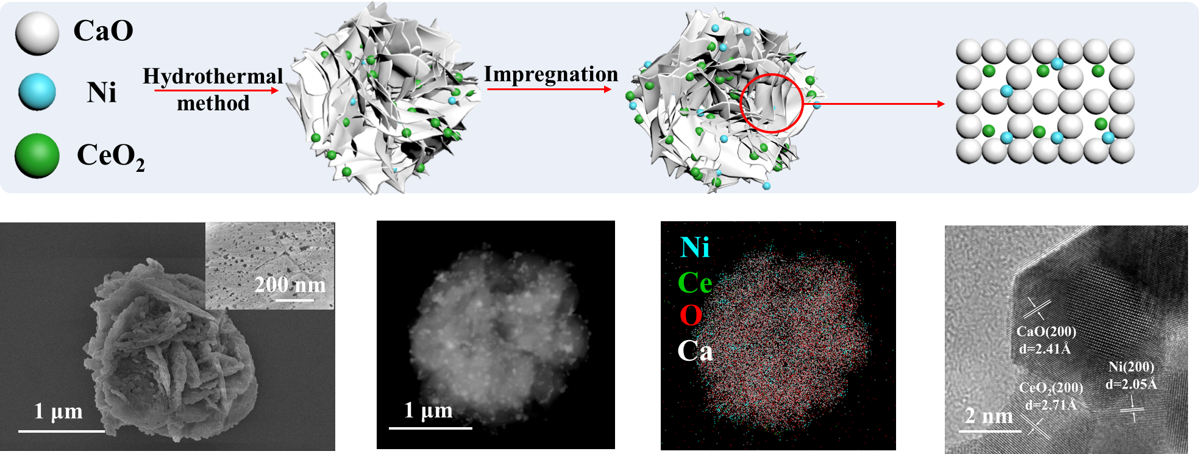
Figure 1 Synthesis and morphology characterization diagrams of the catalyst.
The performance of CeO₂-modified Ni/CaO dual-functional materials (DFMs) was evaluated in the calcium looping dry reforming of methane (CaL-DRM) process as conform in Fig 2. An optimal CeO₂ content of 5 wt.% resulted in the highest CO₂ capture capacity of 12.5 mmol·g⁻¹ and improved CH₄ and CO₂ conversions (78% and 73%, respectively), attributed to enhanced gas activation via oxygen vacancies. Higher CeO₂ loading reduced capacity due to dilution of CaO. Similarly, varying Ni content revealed that 5 wt.% Ni provided a balance between high capture capacity (12.5 mmol·g⁻¹) and conversion rates, while minimizing carbon deposition and active site agglomeration. Temperature screening showed that 650°C optimized CO₂ capture (12.5 mmol·g⁻¹) and syngas yield (58 mmol·g⁻¹), though higher temperatures increased the H₂/CO ratio due to methane cracking. Thus, the Ni/CeO₂/CaO system with 5 wt.% of both Ni and CeO₂ at 650°C delivered the best trade-off among capture efficiency, reaction activity, and syngas quality.
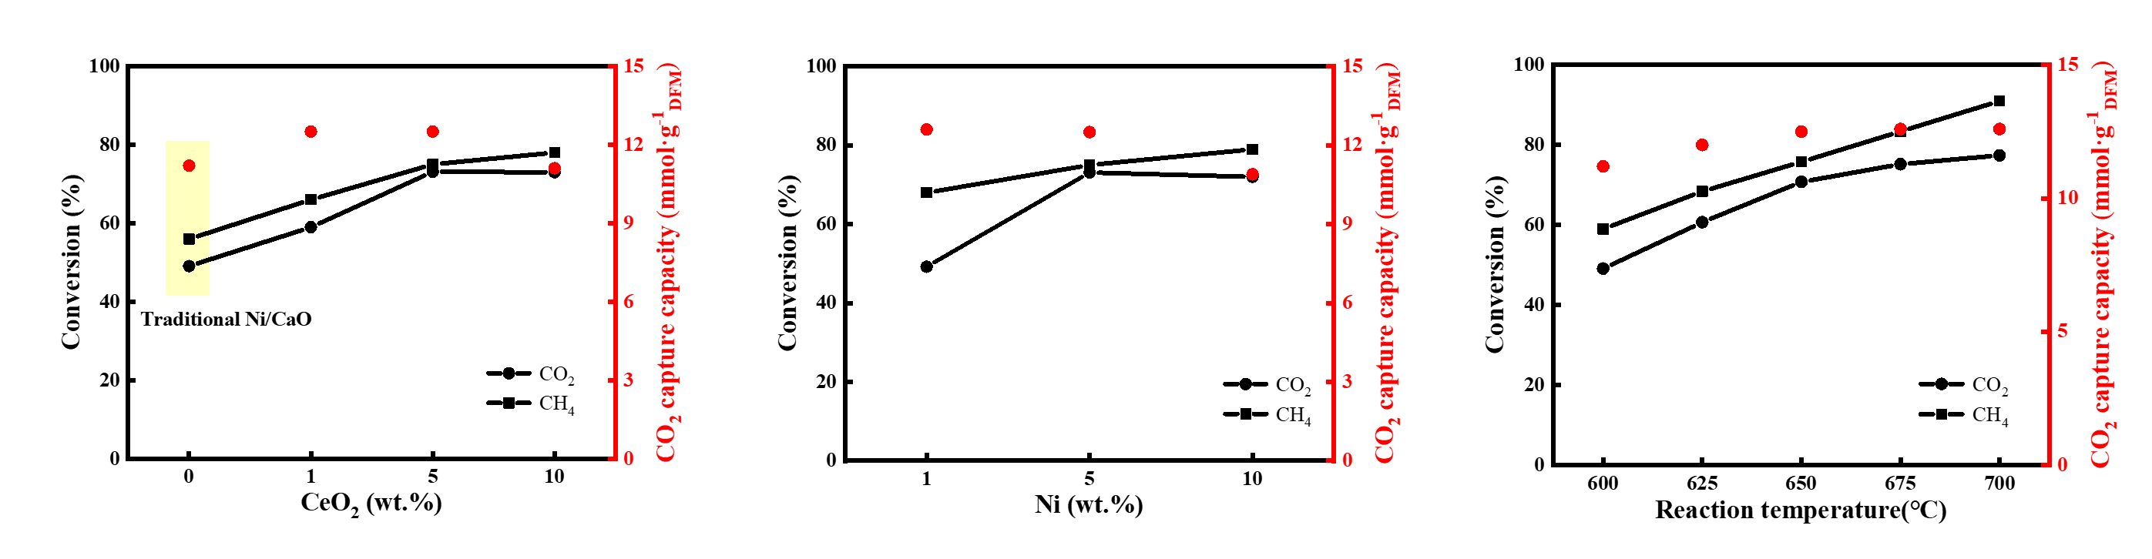
Figure 2 Performance of catalyst.
DFT calculations on a Ni/NiCeO₂CaO dual-functional material (DFM) model revealed key reaction pathways in the CaL-DRM process as shown in Fig 3. CO₂ was found to preferentially adsorb at the CaO-CeO₂ interface. The decomposition of CH₄ on Ni sites generated *H species, which favored participating in *CO₂ activation over H₂ formation due to a lower energy barrier (Shao et al, 2023). Between the two identified pathways for *H-assisted *CO₂ activation, the *COOH route was more favorable than the *HCOO route.
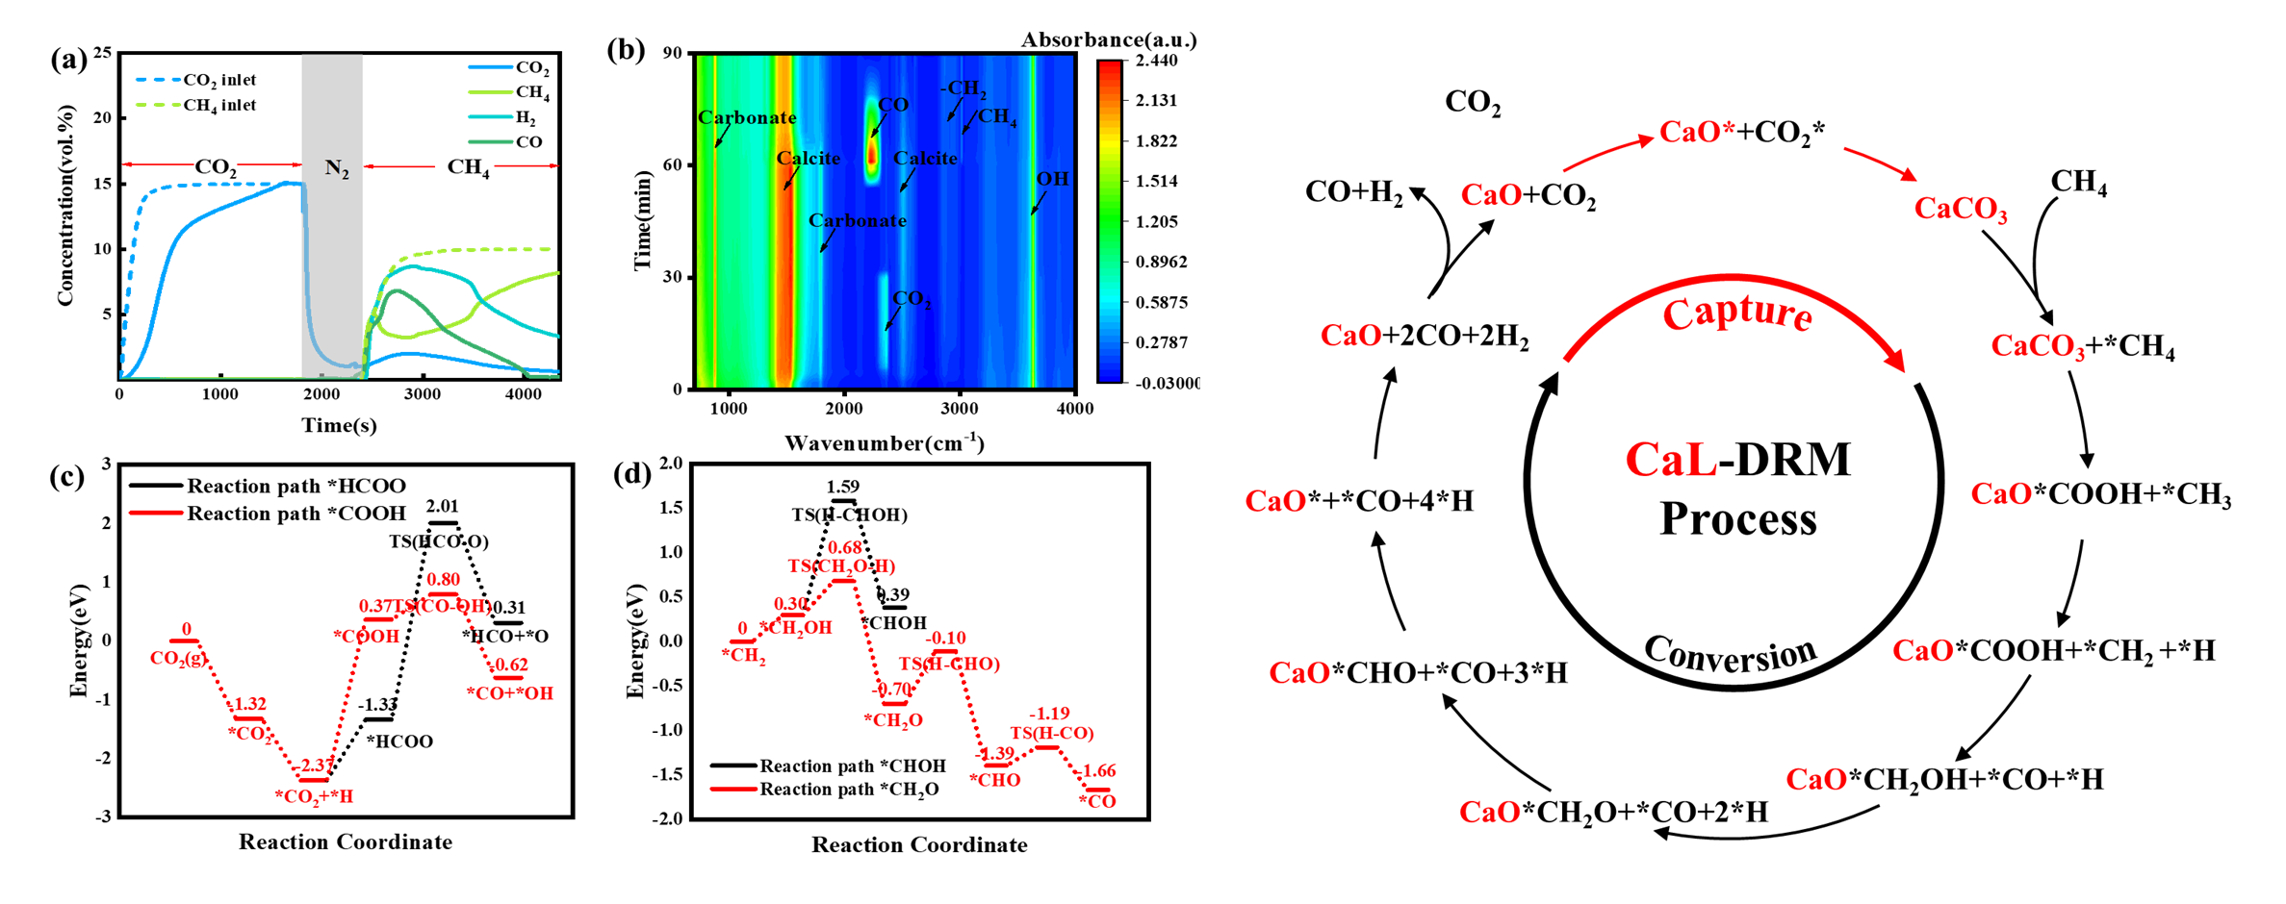
Figure 3 Mechanism of reaction.

Conclusions
This study demonstrates the feasibility of a Ni/NiCeO₂CaO dual-functional material (DFM) for the CaL-DRM process, where CaO serves as the CO₂ adsorbent and support, Ni acts as a catalyst and pore-former, and CeO₂ inhibits sintering and carbon deposition. The optimized Ni4/Ni1CeO₂5CaO composite maintained stable performance over 10 cycles, with deactivation primarily due to CaO sintering and Ni carbon deposition. The inclusion of CeO₂ significantly enhanced morphological stability. Furthermore, DFT calculations verified a synergistic reaction pathway where CH₄ dehydrogenation assists CO₂ activation, providing a strategic basis for designing high-performance DFMs and advancing the CaL-DRM technology.

Acknowledgements (Optional)
This work was supported by the National Natural Science Foundation of China (NSFC-No. W2512003), National Key Research and Development Program of China (No. 2025YFE0101800) and Hebei Provincial Natural Science Foundation of China(B2024105009).

References
B. Shao, Z.-Q. Wang, X.-Q. Gong, H. Liu, F. Qian, P. Hu, J. Hu.[2023]. Synergistic promotions between CO₂ capture and in-situ conversion on Ni-CaO composite catalyst. Nature Communications, 14, 996.

