The Effect of CO₂-Saline Cyclic Injection on Permeability Change of Sandstone

- Introduction

Geological carbon storage in deep saline sandstone formations is considered a key pathway for long-term CO₂ emission mitigation due to their large storage capacity and favorable reservoir properties. However, CO₂ injection into high-salinity sandstones introduces coupled hydro–mechanical–chemical processes that may significantly influence injectivity and long-term reservoir performance (Nooraiepour et al., 2024). Dissolution of CO₂ in brine forms carbonic acid (Kou et al., 2022), which can trigger mineral dissolution and secondary precipitation, altering pore geometry and permeability. In addition, high NaCl concentrations may promote salt precipitation during two-phase flow and brine dry-out, leading to pore-throat clogging and injectivity impairment (Cui et al., 2023). These processes pose practical engineering challenges in CCS operations, particularly near the injection wellbore where permeability impairment and pressure buildup can limit storage efficiency. Although previous studies have examined stress sensitivity, mineral reactions, or salt precipitation separately, the coupled effects of varying NaCl concentration and cyclic CO₂–brine injection on sandstone matrix permeability under reservoir stress conditions remain insufficiently constrained. To address this gap, this study conducts stress-dependent cyclic core-flooding experiments with controlled NaCl concentrations to quantify permeability evolution and distinguish mechanical compaction, chemical alteration, and precipitation-driven effects.

- Purpose of the Study

  - Permeability evolution under cyclic CO₂-brine injection: This study aims to quantify the evolution of sandstone permeability during cyclic CO₂–saline injection and to clarify the coupled mechanical and displacement mechanisms governing injectivity. Attention is given to CO₂ breakthrough behavior, two-phase flow dynamics, and their implications for long-term carbon storage performance.

  - Understanding the potential mineral dissolution/participation caused by brine carbonic acidification: The research investigates mineral dissolution and precipitation triggered by CO₂-induced brine acidification and their impact on pore geometry, porosity, and permeability. The study evaluates how reactive carbonate and clay phases influence mechanical integrity and permeability evolution under coupled chemical–mechanical conditions.

  - Investigation of potential salt participation due to high-salinity brine dry-out: The study further examines salt precipitation during cyclic gas–brine injection under high-salinity conditions, with emphasis on its role in permeability reduction and injectivity impairment. The aim is to distinguish precipitation-driven effects from purely mechanical stress responses.

- Method and/or Theory

Step 1. Residual pore-water removal & static experiment: Residual formation water is removed to prevent mixed-salinity effects prior to synthetic brine injection. Core samples are oven-dried and subsequently vacuum-treated until mass stabilization is achieved to ensure minimal residual saturation.

Step 2. Powder-scale static brine-rock experiment: Parallel powder-scale batch experiments are conducted in brine of varying salinity to assess mineral reactivity under static conditions. pH evolution is monitored, effluent samples are analyzed using ICP-MS, and reacted solids are characterized by XRD to evaluate dissolution and mineralogical changes.

Step 3. Brine-rock interaction phase (core-flooding experiment): Sequential brine flooding is performed under progressively increasing effective stresses (2–19 MPa) to examine permeability evolution and stress sensitivity. The initial stress stage is maintained for extended stabilization, while subsequent stages continue until steady pressure conditions are reached. A stress-conditioning procedure is applied prior to testing, and the loading path is reversed to evaluate stress relaxation and reproducibility (Hashemi et al., 2022).

Step 4. 𝑁₂/𝐶𝑂₂-brine-rock interaction phase (cyclic core-flooding experiment): Cyclic gas–brine flooding is conducted to distinguish mechanical and reactive effects on sandstone matrix permeability. N₂ injection establishes a non-reactive baseline, followed by CO₂ flooding under identical stress conditions. Each gas stage is followed by brine flushing to reassess permeability. The protocol is repeated on two cores with contrasting mineral compositions to evaluate the influence of carbonate and clay reactivity.

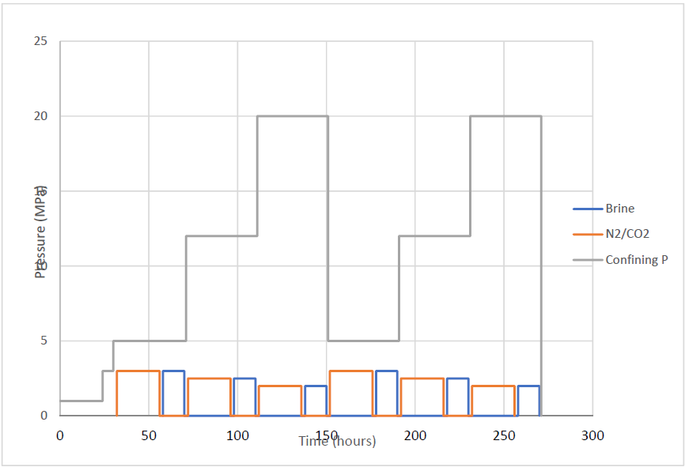
Figure 1. Demonstration of designated N₂-brine and 𝐶𝑂₂-brine injection cycle.

Step 5. Effluent sampling & Trace-element analysis: Effluent brine is periodically collected during flooding experiments. Sampling frequency is guided by pH variation. Trace-element concentrations are determined using ICP-MS to quantify dissolution–precipitation processes and support permeability evolution analysis.

- Conclusions

This study establishes an experimental framework to evaluate sandstone matrix permeability evolution under cyclic CO₂–saline injection. Core samples are first characterized through brine flooding to determine intrinsic permeability, followed by inert N₂ injection to establish a mechanical baseline prior to reactive CO₂ cycles. Combined with stress-dependent loading, mineral reactivity assessment, and trace-element analysis of effluent fluids, the framework enables systematic differentiation between mechanical pore-structure alteration, CO₂-driven chemical reactions, and salt precipitation effects. Preliminary observations suggest that salinity-dependent precipitation may induce partially irreversible permeability reduction under cyclic injection. The results provide experimental insights into injectivity impairment mechanisms in high-salinity formations and support improved evaluation of long-term CO₂ storage performance.

References

- Nooraiepour, M., Krzysztof Polański, Masoudi, M., Szymon Kuczyński, Derluyn, H., Nogueira, L.P., Bahman Bohloli, Nagy, S. and Helge Hellevang (2024). Potential for 50% Mechanical Strength Decline in Sandstone Reservoirs Due to Salt Precipitation and CO2–Brine Interactions During Carbon Sequestration. Rock Mechanics and Rock Engineering. doi:https://doi.org/10.1007/s00603-024-04223-8.

- Kou, Z., Wang, H., Alvarado, V., Nye, C., Bagdonas, D.A., McLaughlin, J.L. and Quillinan, S. (2022). Effects of Carbonic Acid-Rock Interactions on CO2/Brine Multiphase Flow Properties in the Upper Minnelusa Sandstones. pp.1–14. doi:https://doi.org/10.2118/212272-pa.

- Cui, G., Hu, Z., Ning, F., Jiang, S. and Wang, R. (2022). A review of salt precipitation during CO2 injection into saline aquifers and its potential impact on carbon sequestration projects in China. Fuel, 334, pp.126615–126615. doi:https://doi.org/10.1016/j.fuel.2022.126615.

- Hashemi, S.S., Kovscek, A.R. and Zoback, M.D. (2022), September. Effect of supercritical CO2 on the poroelastic characteristics of poorly cemented sandstone reservoirs during depletion and injection. In SPE Annual Technical Conference and Exhibition (p. D011S011R005). SPE.

