Presentation Title, max 16 words (NO authors or affiliations!)

Introduction

Click ONCE and select this paragraph, you will replace this text with your own text and it will be automatically formatted. All styles for this template are formatted for you.

Here is the second paragraph of the introduction. The font for this template is 11pt Times New Roman. The Section Headings are bold. The paragraphs are justified and separated by a blank line.

Abstracts will be printed on the conference publication and online exactly as they are submitted. EAGE staff will not edit or retype the copy.

Your abstract should be 4 pages (four) long including all figures and references (Please do not count the cover page).

AUTHORS, AFFILIATIONS AND SUMMARY MUST NOT BE INCLUDED IN THESE FOUR (4) PAGES! This information is provided on a cover page, automatically generated from the information you provide on the on-line submission form.

If your extended abstract does not meet the requirements, it will NOT be included in the review process!

Method and/or Theory

Requirements for extended abstract (the extended abstract must meet the requirements):
- 4 full pages, A4 size;
- Within this mandatory template;
- Do not modify header, footer or font size of the template;
- Include the title in the 4 pages of the extended abstract (title only!);
- Do not include the summary, authors or affiliations in the pages of the extended abstract;
- Use font ‘Times New Roman 11pts’ for all text with single line space and use the standard Word outline level (body text);
- Start the body text of your extended abstract directly under the event logo;
- NO additional empty lines to fill up the page;
- Margins 2.54 cm on all sides (1”);
- Including at least 1 graphic/figure;
- Including references;
- Save as PDF or print to PDF;
- Ensure that the PDF-paper size is A4 as well.

Additional instructions for composition are:
- Please write your abstract in English.
- Authors are responsible for sizing and positioning of their illustrations.
- Figures can be in black and white or colour.
- Embed into the text of the paper figures, equations, charts, graphics, etc.

These bulleted items are used as examples and should be deleted so they do not appear in your document.

Examples (Optional)

This is the first sentence of a second sample section. Each of the paragraphs and section headings appear shaded in this template, with the exception of the bulleted items above and the text in the following figure.
These text boxes appear shaded on the screen only. It will disappear as you select each paragraph to replace with your own text, or just delete.

If you have a chart, graphic, equation, etc. you will need to embed them in the document. You can insert an external file. Here is an example of a figure.

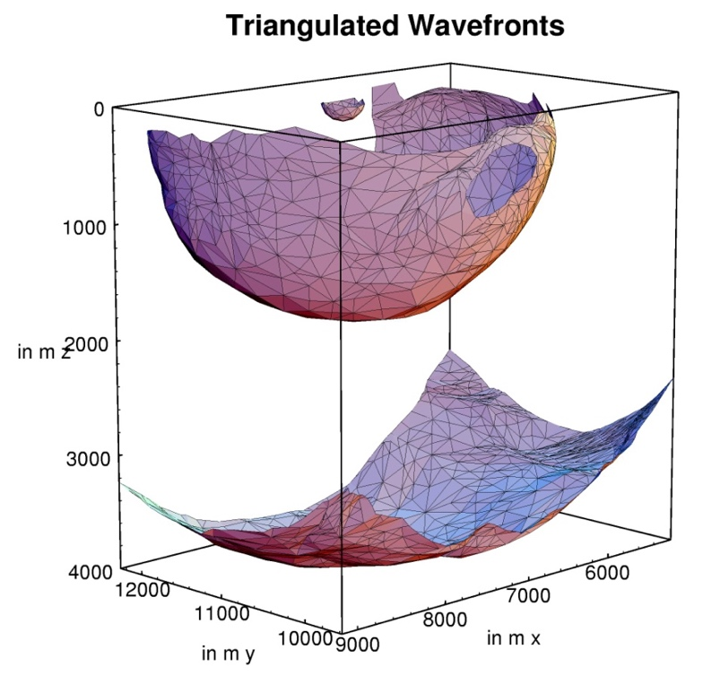
Figure 1 This is an example of a figure imported from jpeg (courtesy of Gilles Lambaré). Left click on Insert on the menu bar and then select Picture. You can also select to embed an object instead of a picture. You can either embed an existing file or create your object at that point. Number the figures sequentially, according to their appearance in the text, and check that each figure is cited in the text. Supply a short caption for each figure; more detailed discussion of the figure can be reserved for the text. In this template figure captions are 11pt italic Times New Roman. Further information about the use of figure captions and figure numbering can be found in the First Break guidance to authors.

Examples (Optional)

Example text, please delete if you don't use it.

Conclusions

This is the first sentence of the conclusion.

Acknowledgements (Optional)

The submission deadline is 1 May 2021 (23:59. CET)!

References

This is the first sentence of the References section. The lay-out of the references should be consistent with the style guide for references in the First Break guidance to authors. Please ensure every citation has a reference and vice versa.

