**Reservations Form for Groups**

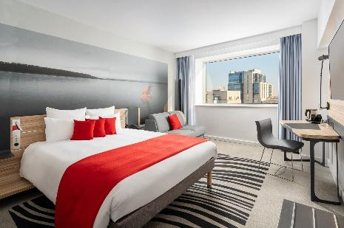



**Room types:**

**Queen or Twin Rooms**: **modern decor and ergonomic standard room comfort**: queen-size bed or twin beds, working desk, LCD, minibar, bath & shower, hairdryer, tea&coffee making facilities, laptop-size safe, FREE Wi-Fi internet and access to the Wellness Centre.

**Rate for single room: 139 euro Rate for double room: 154 euro**

☐ **Single use** (1 person/ room) ☐ **Double use** (2 persons-1 bed/ room) **OR** ☐ **Twin use** (2 beds/ room)

The rates are per room, per night & inclusive of **FREE wireless INTERNET, access to the Wellness Centre** (indoor swimming pool, hammam, fitness centre). Rates are inclusive of breakfast, 9% VAT and 1% city tax.

**Option date:** mentioned special rates are applicable only by completing and sending this reservation form to the hotel and congress organizer by e-mail **corina.matei@accor.com**

The offer is valid until **14.07.2025** and the availability will be confirmed upon receiving the reservation form.

For no-shows the credit or debit card will be charged with the first night of accommodation.

No cancellation or modification of the reservation can be made within 15 days in advance.

**All reservations must be guaranteed.** Accepted Credit Cards: American Express, Visa and MasterCard



☒Credit Card: ……… No: ……………… Expire Date: ………………….

Card holder’s name: ……………………………. Signature: ______________

**Payment:** Guest at the reception

**Preferences:**

Special Request: ☐Non – Smoking ☐Handicap Accessible

Bed request: ☐Two beds ☐One Single Bed

Additional Special Requests:

Expected Arrival Time: …………….

**Transportation** canbe assured with private car at the price of 39 euros/person/way. Kindly fill in below if the transfer is needed:



☐ Pick up Arrival time: Flight number:

☐ Drop off Departure time: Flight number:

**Guest Contact details** for confirmation:

Email: …………………………………………. Phone: ………………. Fax: _____________ Date: …………

**THANK YOU FOR CHOOSING NOVOTEL BUCAREST CITY CENTRE!**