Carbon Storage screening in continental Europe

Introduction

Carbon sequestration has a vital role to play in a global net zero emissions future. In the EU, the Net-Zero Industry Act (NZIA) has set ambitious decarbonization targets for 2030 which further emphasizes the need for Carbon Capture and Storage (CCS). Geological CO₂ storage is seen as the ultimate endpoint of CCS (Ma et al. 2022), therefore thorough screening and assessment of the subsurface is a foundational aspect of a successful CCS project. In continental Europe, away from the maturing North Sea storage hubs, industrial CO₂ emitters are faced with a dilemma about where the captured CO₂ should be stored: Is it more efficient and cost-effective to transport the CO₂ over long distances for storage at one of the North Sea hubs? Or is there a competitive local solution? Countries in mainland Europe are putting legislation in place to support and regulate onshore storage of CO₂, hence enabling the local storage solution.

Viridien’s carbon storage screening studies have been utilized globally to help screen at both the regional and basin scale, including South-East Asia (Shepherd et al. 2024) and more recently over continental Europe. To assess areas for their carbon storage suitability, these screening workflows rely mainly on a rich legacy digital geological database, built on decades of fieldwork, studies, data collection and transformation. This database facilitates cross-border screening, limiting any inconsistency arising from country-specific data methods, formats and data vintages. Use of this consistent database to create screening studies ensures they contain the quality-controlled data and significantly reduces the time taken by optimizing data harvesting and allowing direct focus on key factors. The approach presented here aims to provide a single workflow across the basins of continental Europe to identify and map the best aquifer stores.

From regional to local scale

Using the geological data from the database together with the latest public domain information, a series of regional filters were applied, including water depth, seismicity and sediment thickness.

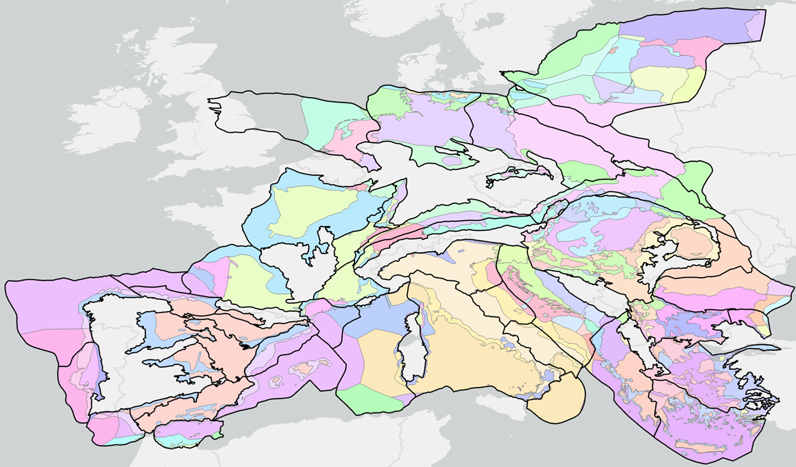

Figure 1 Basin-sectors across continental Europe assessed in the study. Sectors are divided by country, onshore/shelf and sediment thickness >1000m.

Following those initial filters, basin-sectors were defined and scored on a range of parameters important for carbon storage (Bachu 2003) including areal extent, leakage potential, geothermal regime, geological knowledge, as well as surface accessibility factors such as environmental restrictions, population density, distance to ports, road networks and emissions sites. A simple weighted scoring and ranking enables the best basin-sectors to pass through to a subsurface play analysis. Here, we define a play (or aquifer store) as a reservoir rock coupled with cap rock (or top seal) present over the larger part of a sedimentary basin.

For the selected basin-sectors, potential aquifer intervals were identified, and then each of these was assessed and scored on lithology, reservoir facies, depth, area, reservoir properties and seal thickness, using internally developed cut-offs and scores.

The final screening outputs can identify subsurface aquifers with storage potential, and this can be used to rank emissions sites in a portfolio for CCUS investment, or to focus in on an individual emission location to narrow down the potential areas for further investigation. This workflow will be illustrated by analysis of a selected emissions site.

Screening for local storage opportunities

Once an area with potential for storage has been identified or a capture site is pushed to look for local a nearby storage solution (e.g. within a radius of 20-40km), the next step usually requires subsurface data (seismic and well data) to refine the subsurface analysis and delineate an area for potential storage license application. This example looks at the Bohemian Basin in the Czech Republic, where historic exploration efforts have focused on coal mining on the basin margins. Interpretation of well log and sparse 2D seismic data from the CGS, integrated with information derived from public domain references enabled the construction of individual property maps for the identified aquifer of interest, comprising:
- Aquifer Gross Depositional Environment (GDE), lithology
- Top depth-structure
- Aquifer porosity, permeability, net thickness
- Aquifer temperature
- Seal GDE, lithology
- Seal thickness

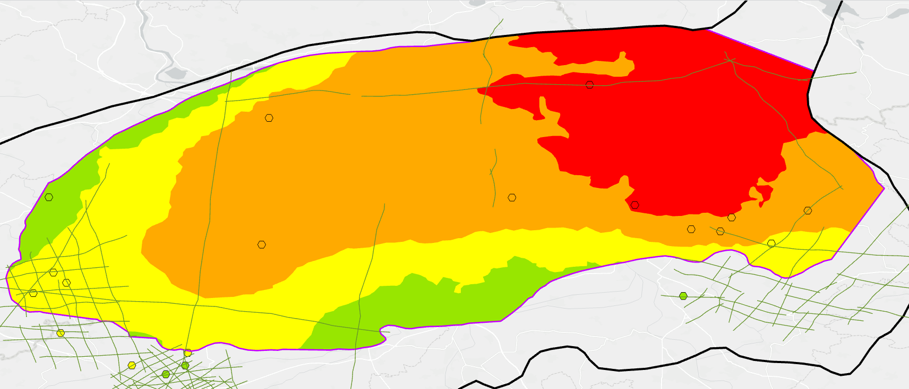

Figure 2 Interpreted categories for aquifer permeability for part of the Bohemian Basin, showing an increase from red (poor) to green (good) strongly linked to porosity and depth. Available seismic lines (green) and well data (hexagons).
These maps use categories defined by Duval et al. (2022) and Callas et al. (2024) and were then convolved into storage potential maps with associated first-pass capacity estimates.

Note that this workflow focuses on subsurface static parameters, whilst the final modelling phase (not presented here) focuses on a preliminary 3D dynamic CO₂ plume model to support a future storage permit application and delineate its extent.

Conclusions

Screening built on a rich, robust and globally consistent geological database helps quickly focus on the analysis of key storage parameters for rapid and sound business decisions and prioritization of opportunities in a CCS investment portfolio for storage developers and CO2 emitters. It enables the identification of areas of high potential for suitable storage sites and aims to support, accelerate and increase CO₂ storage permit applications in continental Europe and around the world, to ensure CCS project lead times are decreased and that a net-zero 2050 is achieved, including the NZIA 2030 targets.

References

Bachu, S. [2003]. Screening and ranking of sedimentary basins for sequestration of CO₂ in geological media in response to climate change. Environmental Geology, 44, 277-289.
Callas, C., Davis, J.S., Saltzer, S.D., Hashemi, S.S., Wen, G., Gold, P.O., Zoback, M.D., Benson, S.M. and Kovscek, A.R. [2024]. Criteria and workflow for selecting saline formations for carbon storage. International Journal of Greenhouse Gas Control, 135, 104138.
Duval, G., Booth, M., Porjesz, R., Otto, S., Park, P., Olivares, C., Satterley, A., Calvert, S., Abukarova, A., Polyakova, L., Khalid, A. and Nassir, M. [2022]: Geological Data and Tools for Basin-Scale Screening of CO₂ Storage Potential - Northern North Sea. EAGE GET 2022, Extended Abstracts.
Ma, J., Li, L., Wang, H., Du, Y., Ma, J., Zhang, X. and Wang, Z. [2022] Carbon Capture and Storage: History and the Road Ahead. Engineering, 14, 33-43.
Shepherd, E., Otto, S. and Duval, G. [2024]: Carbon Storage Screening Study of Southeast Asia: A case study from Offshore Sarawak. 3rd EAGE Conference on Carbon Capture and Storage Potential, Extended Abstracts.

