Cement Alteration Modelling to Predict Cement Performance in Carbon Capture and Storage (CCS) Wells

Introduction

Long-term cement integrity is an important part of ensuring safe and secure carbon storage. Cementing is a critical operation in well construction as the cement sheath provides the primary hydraulic seal between the casing and the formation. If that seal is compromised, CO₂ can migrate along several pathways, including the cement–casing interface, the cement–formation interface, or through defects such as fractures within the cement.

When CO₂ is injected into geological formations, such as depleted hydrocarbon reservoirs and deep saline formations, it dissolves in the formation brine, forming carbonic acid and lowering the pH. Depending on temperature, pressure, CO₂ concentration, and the chemistry of the brine, this acidic environment can drive cement alteration. Major constituents of hardened Portland cement, including calcium hydroxide (portlandite, Ca(OH)₂) and calcium silicate hydrates (C-S-H), undergo dissolution and decalcification in the presence of CO₂–rich brine. Calcium released from the cement matrix reacts with dissolved CO₂ to precipitate calcium carbonate (CaCO₃), a dense carbonated layer with reduced porosity. The formed carbonated layer can have a “self-healing” effect slowing CO₂ diffusion deeper into cement (Liteanu and Spiers, 2011).

Over longer exposure times, depending on temperature, pressure, and salinity, the carbonate layer may dissolve. This can lead to the formation of soluble calcium bicarbonate, which can be washed away by fluid flow, leaving behind the amorphous silica layer. The amorphous silica has a higher porosity and lower mechanical strength than the unaltered cement, and thus this process of dissolution mixed with flow can impact the cement integrity in a negative manner (Walsh et al., 2013). Due to competing changes in the mechanical properties of cement in the presence of CO₂–rich brine, it is important to understand the transfer of CO₂ and the chemical reactions associated with cement exposed to CO₂–rich brine in geological CO₂ storage projects.

Several geochemical models have been proposed to investigate cement alteration in the presence of CO₂ and to study the impact of alteration processes on cement properties under geological conditions (Shen et al., 2013; Choi et al., 2016; Hernández-Rodríguez et al., 2017; Alsubaih et al., 2025). These studies have provided valuable insights into carbonation reactions and mineralogical evolution in wellbore environments. However, many existing modeling approaches treat individual components of the problem in isolation, such as batch geochemical calculations, equilibrium–based simulations, or reactive transport models that rely on assumed or literature–derived reaction rates without prior kinetic validation. In several cases, the connection between reaction kinetics, transport processes, and spatially resolved alteration is not explicitly documented, making it difficult to systematically assess model assumptions or extend results to long–term CCS conditions. Therefore, there is a need for a structured and transparent modeling workflow that progresses from kinetic validation to spatial reactive transport, enabling consistent and reproducible prediction of cement alteration over relevant time and length scales.

This study aims to develop and validate a reactive transport modeling framework to predict cement alteration under CO₂–rich brine conditions relevant to CCS wells. Building on validated reaction kinetics (Basafa et al., 2025), a one–dimensional diffusion–reaction model was developed to simulate carbonation fronts in Portland cement over extended time scales. The model captures the coupled effects of aqueous geochemistry, CO₂ transport, and cement mineralogy, enabling quantitative prediction of carbonation depth and mineralogical evolution. This work contributes a predictive tool for long–term cement integrity assessment and provides a workflow that progresses from batch kinetics to spatial reactive transport which is often treated separately in prior studies.

Methodology
In the first step, a geochemical reaction path model was built to simulate the bulk mineralogical changes in a cement plug in the presence of a CO₂–rich brine under high temperature high pressure (HTHP) conditions. A reaction path model simplifies the system by assuming it is perfectly mixed, with no spatial gradients, tracking mineral dissolution/precipitation and fluid composition over time. This approach is especially useful for simulating well–mixed batch experiments and short–term geochemical processes, making it a practical first step before moving to more complex spatial models. The output of the reaction path model was then compared with experimental data. The focus here was mineralogical changes during carbonation. Once this alignment was confirmed, we then developed the 1-dimensional (1D) reactive transport model to evaluate cement alteration depth over time.

An experiment where a cement cylinder (2.54 cm diameter, 5.08 cm length, and 25.74 cm³ volume) is immersed in 385 mL CO₂–saturated brine in a 600 mL pressure vessel at 20.68 bar (3000 psi) and 65°C with 80 mL CO₂ headspace was simulated using PFLOTRAN. Input parameters included brine pH, salinity, and concentrations of major ions (e.g., Na⁺, Ca²⁺, Cl⁻, HCO₃⁻, and SO₄²⁻). Correlations from Duan and Sun (Duan and Sun, 2003) were used for CO₂ solubility in brine at high pressure. The list of primary minerals considered in the cement and the kinetic parameters for each mineral is shown in Table 1. All precipitation and dissolution reactions of minerals were considered kinetically controlled, and the kinetic rate expression was based on the following equation (Parkhurst and Appelo, 2013):
$rate= kS_{A} {\left(M/{M_{0}}\right)}^{2/3}{\left(1-\left(SI\right)\right)}^{n}$ (Eq. 1)
where k is the rate constant, S_{A} is the reactive surface area, M₀ and M are the respective initial and current moles of the mineral, and n is the reaction order.

Table 1
Primary cement minerals, their respective dissolution reactions, and kinetic parameters considered in the geochemistry model
Mineral | Chemical Formula | Reactive Surface Area  (m²/g) | Rate Constant (mol/m²/s) | Reaction
Calcite | CaCO₃ | 0.01 | 6.80e-7 | $$CaCO_{3}+H^{+}={Ca}^{2+}+{HCO_{3}}^{-}$$
Portlandite | Ca(OH)₂ | 16.50 | 7.20e-8 | $$Ca{(OH)}_{2}+2H^{+}={Ca}^{2+}+2H_{2}O$$
Tobermorite-11A (CSH) | Ca₅Si₆H₁₁O_{22.5} | 41.00 | 7. 92e-11 | $${Ca}_{5}{Si}_{6}H_{11}O_{22.5}+10H^{+}={5Ca}^{2+}+6SiO_{2}+10.5H_{2}O$$
Aragonite | CaCO₃ | 1.00 | 2.80e-5 | $$CaCO_{3}+H^{+}={Ca}^{2+}+{HCO_{3}}^{-}$$
Hatrurite | Ca₃SiO₅ | 4.00 | 7.90e-10 | $${Ca}_{3}SiO_{5}+6H^{+}+2H_{2}O=3{Ca}^{2+}+3H_{2}O+H_{4}SiO_{4}$$
Ettringite | Ca₆Al₂(SO₄)₃(OH)₁₂.26H₂O | 9.80 | 1.10e-11 | $${Ca}_{6}{Al}_{2}{(SO_{4})}_{3}{(OH)}_{12}.26H_{2}O+12H^{+}=2{Al}^{3+}+6{Ca}^{2+}+3{SO_{4}}^{2-}+38H_{2}O$$
Tetracalcium aluminoferrite | 4CaO.Al₂O₃.Fe₂O₃ | 10.00 | 1.6e-18 | $${\left(CaO\right)}_{4}\left({Al}_{2}O_{3}\right)\left({Fe}_{2}O_{3}\right)+20H^{+}=2{Al}^{3+}+4{Ca}^{2+}+2{Fe}^{3+}+10H_{2}O$$
Katoite | Ca₃Al₂(SiO₄)₁(OH)₈ | 2.40 | 7.25e-10 | $${{Ca}_{3}{Al}_{2}\left(SiO_{4}\right)}_{1}{(OH)}_{8}+12H^{+}=3{Ca}^{2+}+2{Al}^{3+}+H_{4}SiO_{4}+8H_{2}O$$
Amorphous Silica | SiO₂ | 0.01 | 1.5e-11 | $$SiO_{2}+2H_{2}O=H_{4}SiO_{4}$$
Amorphous Aluminum | Al(OH)₃ | 10.00 | 8.0e-10 | $$Al{(OH)}_{3}+3H^{+}={Al}^{3+}+3H_{2}O$$

Following validation of the cement–brine–CO₂ reaction kinetics using reaction path simulations, spatial transport was incorporated to simulate carbonation penetration into the cement matrix. As shown in Figure 1, the model domain represents a vertical slab extracted from a cylindrical cement plug. The domain was discretized into finite grid cells, with initial mineralogy and porosity assigned to each cell based on the unaltered cement composition. A nonuniform grid was employed to better resolve steep chemical gradients near the exposed surface. For cement exposed to CO₂–rich brine, transport of species through the cement matrix was assumed diffusion–dominated due to low permeability of hydrated cement. Under these assumptions, the governing reactive transport equation reduces to a second-order equation in space and first-order in time (Equation 2). At the exposed cement face, a Dirichlet boundary condition was applied, fixing the chemical state to that of the CO₂–rich reservoir brine and representing continuous exposure. At the interior boundary, a symmetry (zero-flux) boundary condition was imposed, ensuring no mass transfer across the boundary.
$\frac{∂}{∂t}\left(ϕC_{i}\right)=\frac{∂}{∂x}\left(D_{i}\frac{∂C_{i}}{∂x}\right)+R_{i}$ (Eq. 2)
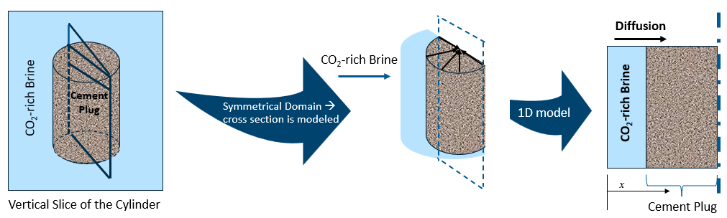
Figure 1: Schematic of 1D geometry used in the simulations

Results

The cement mineralogical changes based on the reaction path model over 180 days in the presence of CO₂–rich brine and compared with experimental data is shown in Figures 2 and 3, respectively. Portlandite dissolves quickly, disappearing within 12 days due to its high reactivity. CSH and katoite completely dissolve over approximately 40 days, while hatrurite continues dissolving until fully consumed after 70 days. These differing dissolution timescales are governed by mineral-specific dissolution kinetics and reactive surface areas (Table 1), with kinetic parameters adopted from literature and validated through comparison of reaction path simulations with experimental mineralogical trends. At the same time, carbonate minerals form. Aragonite precipitates rapidly at early times but starts to dissolve after approximately 80 days, indicating it is a transient phase. Calcite, on the other hand, continues to precipitate throughout the simulation and becomes the dominant long–term carbonate. As shown in Figure 3, the model reproduced the same trends observed experimentally; Rapid portlandite dissolution, and strong carbonate phases (calcite and aragonite) precipitation.

The rate of the interaction between wellbore cement and CO₂ is usually described by the propagation of the carbonate layer (i.e., carbonation depth) in the exterior region of the cement. Many studies show that once an initial carbonate layer forms, its lower porosity reduces CO₂ transport, and therefore carbonation slows with time depending on the temperature, pressure, salinity, and cement composition (Lu et al., 2022; Teune et al., 2023). According to the results of the developed 1D reactive transport model, carbonation depth after 180 days of cement exposure to CO₂–rich brine was estimated as 0.6 mm, which is within the range of 0.3–2 mm observed in the experiment. In addition, calcite precipitation at the interface of cement domain and CO₂-rich brine was obtained from the model results. Furthermore, total mineral volume fraction was increased across the first few grid cells at the exposed face of the cement domain indicating a decrease in porosity and therefore, self–healing behavior (Figure 4).

Conclusions

This study developed and validated a structured reactive transport modeling framework to predict cement alteration under CO₂–rich brine conditions relevant to CCS wells. Reaction path simulations reproduced experimentally observed mineralogical trends, validating the selected kinetic parameters. A one–dimensional diffusion–reaction model captured carbonation front development, yielding carbonation depths consistent with experiments. The framework provides a robust predictive tool for assessing long–term cement integrity in CO₂ storage wells.

Acknowledgements

This project is supported by the Hebron and Hibernia Projects and is managed by Energy Research & Innovation Newfoundland & Labrador (ERI). Any opinions, findings, and conclusions or recommendations expressed in this publication are those of the author(s) and do not necessarily reflect the views of the Hebron Project, Hibernia Project or ERI.

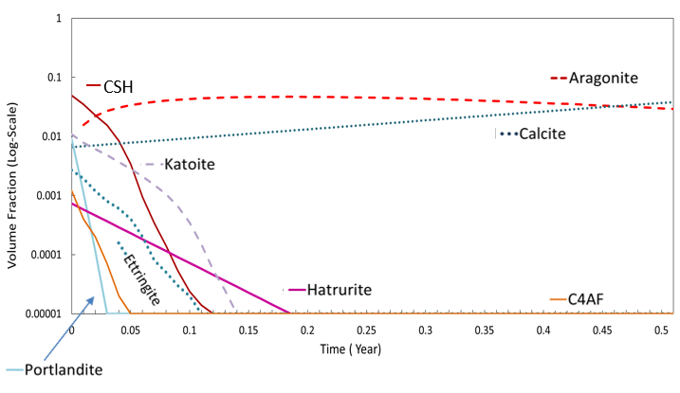
Figure 2: Mineralogical changes of cement exposed to CO₂-rich brine (reaction path model)
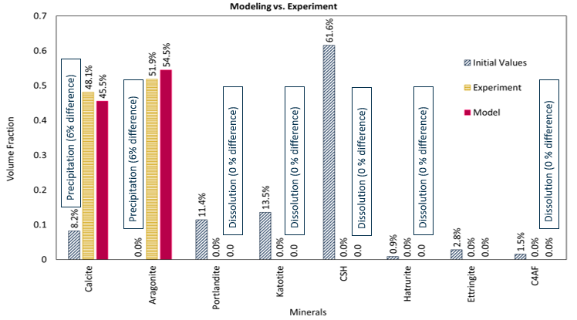
Figure 3: Reaction path model results compared with experimental data (180 days)
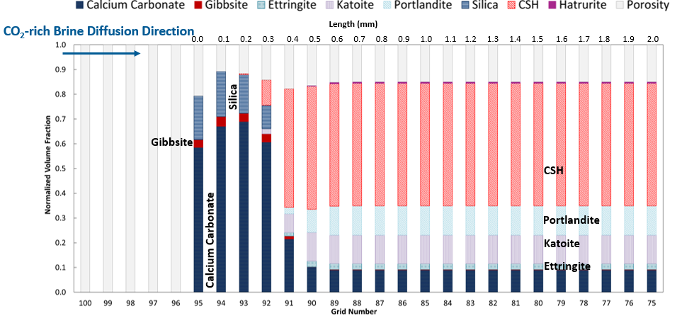
Figure 4: Cement alteration in CO₂-rich brine after 180 days (1D reactive transport model)

References
Alsubaih, A., Sepehrnoori, K., Delshad, M. [2025]. Applied Sciences, 15, 5428.
Basafa, M., Reisi, F., Azmy, K., James, L., Wu, Q., Sublett, D.M. [2025]. World CCUS Conference, 2025, 1 – 5.
Choi, B.Y., Lee, H., Chae, G.T., et al. [2016]. Chemie der Erde, 76, 597-604.
Duan, Z., Sun, R. [2003]. Chemical Geology, 193, 257 – 271.
Hernández-Rodríguez, A., Montegrossi, G., Huet, B., Vaselli, O., [2017]. Applied Geochemistry, 86, 13-25.
Liteanu, E., Spiers, C. J. [2011]. Chemical Geology, 281, 195-210.
Lu, B., Drissi, S., Liu, J., Hu, X., Song, B., Shi, C. [2022]. Cement and Concrete Research, 157, 106827.
Parkhurst, D.L. and Appelo, C.A.J. [2013]. U. S. Geological Survey Techniques and Methods, Book 6, Chapter A43, 132-138.
Shen, J., Dangla, P., Thiery, M. [2013]. International Journal of Greenhouse Gas Control, 18, 75-87.
Teune I.E., Schollbach, K., Florea, M.V.A., [2023]. Journal of Building Engineering, 79, 107785.
Walsh, S.D.C., Du Frane, W.L., Mason, H.E., Carroll, S.A. [2013]. Rock Mechanics and Rock Engineering, 46, 455-464.

