Geochemical effect on the dynamics of relative permeability: Implications for CO₂ storage

Introduction
The secure and efficient geological storage of carbon dioxide (CO₂) is a key technology for mitigating greenhouse gas emissions. A major uncertainty in predictive modeling of subsurface CO₂ storage systems arises from the treatment of multiphase flow properties, particularly relative permeability. While most reservoir simulations employ static, time-invariant relative permeability functions, reactive transport processes can significantly alter pore structure, wettability, and fluid flow behavior over time. This effect is particularly important in carbonate formations, where acid–rock reactions induced by injected CO₂ can modify pore connectivity and permeability.
This study focuses on the time-dependent evolution of CO₂/water relative permeability in Indiana limestone subjected to controlled geochemical aging. The experimental investigation and simulation integration presented herein aim to improve the representation of reactive processes in CO₂ storage modeling, providing a more realistic assessment of injectivity, trapping efficiency, and long-term storage security.
Experimental Methodology
To capture the dynamic coupling between geochemical reactions and multiphase flow, a series of core-flooding, acoustic, and nuclear magnetic resonance (NMR) measurements were performed on Indiana limestone samples. The samples were exposed to supercritical CO₂ and formation brine under reservoir-representative conditions of 2000 psi and 21°C for durations of 1 month and 2 months, simulating the early stages of CO₂ injection and storage.
After each exposure period, the samples were analyzed for changes in porosity, permeability, and pore structure. Relative permeability curves for the CO₂–water system were determined using unsteady-state core-flooding experiments. Acoustic velocity measurements provided insights into elastic property changes, while NMR data revealed pore-size distribution evolution. Figure 1 illustrates the experimental workflow, highlighting the combined use of geochemical aging and petrophysical analysis to characterize the evolving rock properties.
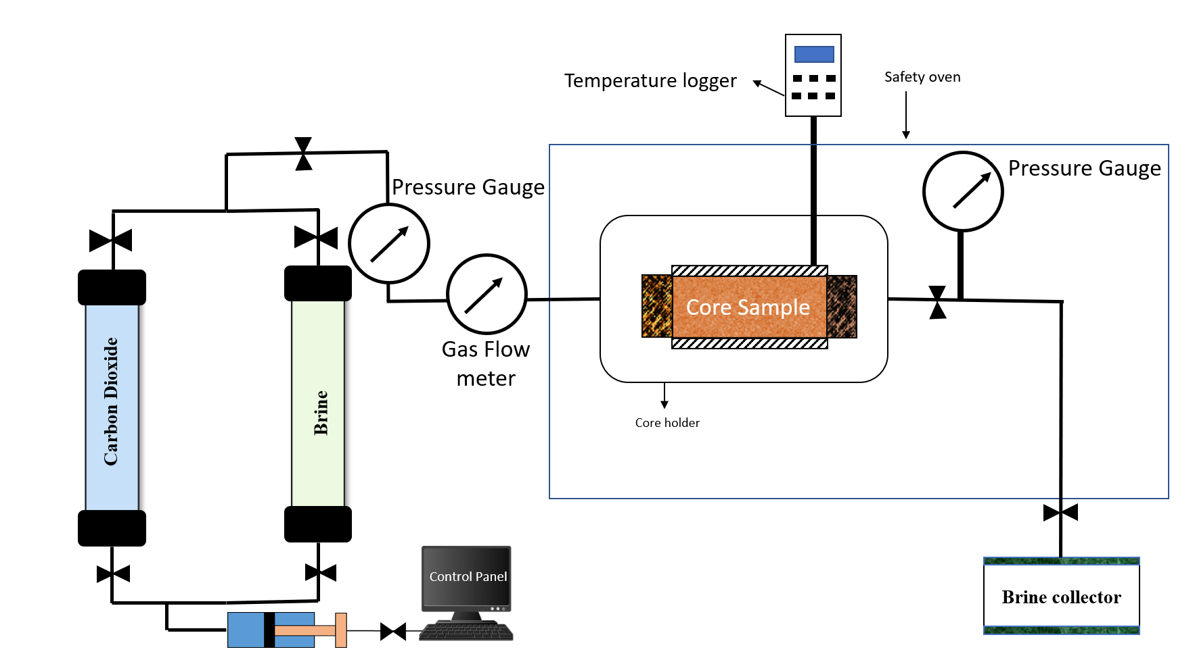
Fig. 1 – Schematic coreflooding set up for unsteady injection
.
Results and Discussion
The results show that progressive dissolution of carbonate minerals during CO₂–brine–rock interactions enhances pore connectivity and alters flow pathways. This dissolution led to measurable increases in both porosity (by up to 8%) and absolute permeability (by up to 25%) after two months of exposure.
The evolution of relative permeability curves demonstrated that the CO₂ relative permeability increased with time, whereas the water relative permeability decreased, indicating a shift in wettability and saturation-dependent flow behavior. Figure 2 presents the relative permeability curves for the CO₂–water system at different aging times.

Fig. 3 – NMR distribution curves for three samples
These changes were attributed to microscale dissolution features that enhanced pore connectivity, as confirmed by NMR T₂ distributions showing broader pore-size spectra after aging. The acoustic measurements supported these findings by revealing a decrease in P-wave velocity, consistent with mineral dissolution and microstructural weakening. When incorporated into reservoir simulation models, the experimentally derived time-dependent curves produced significant differences in predicted CO₂ plume migration compared to conventional static models. The dynamic model captured increased plume advancement and reduced residual trapping in early stages, followed by greater dissolution trapping at later times. This demonstrates that time-evolving flow parameters directly influence large-scale CO₂ storage performance.
Implications for Reservoir Modeling
The integration of experimental results into dynamic reservoir simulations revealed critical implications for injectivity, storage capacity, and trapping mechanisms. Static relative permeability assumptions can lead to under- or over-estimation of injectivity and storage efficiency, particularly in carbonate reservoirs with reactive mineralogy. By contrast, simulations using time-dependent relative permeability captured subtle yet important transitions in the CO₂ plume morphology, including increased mobility during early injection and enhanced dissolution trapping during post-injection stabilization. These insights emphasize the necessity of coupling geochemical reactivity and petrophysical evolution in reactive transport models.
Conclusions
This study demonstrates that geochemical reactions significantly influence the time evolution of CO₂/water relative permeability in carbonate rocks. The experimental results show that dissolution-induced pore structure modification alters flow properties in a manner that can be captured only through time-dependent modeling. When implemented into reservoir simulations, these data reveal that time-evolving relative permeability functions yield more realistic predictions of CO₂ migration and trapping behavior. Therefore, consideration of reactive transport and aging effects is essential for accurate forecasting of CO₂ storage capacity, injectivity, and containment security.

References
1. Bennion, D.B. & Bachu, S. (2008). Drainage and imbibition relative permeability relationships for supercritical CO₂/brine and H₂S/brine systems in intergranular sandstone, carbonate, shale, and anhydrite rocks. SPE Reservoir Evaluation & Engineering, 11(03), 487–496.
2. Xu, T., Apps, J.A., & Pruess, K. (2004). Numerical simulation of CO₂ disposal by mineral trapping in deep aquifers. Applied Geochemistry, 19(6), 917–936.
3. Gaus, I. (2010). Role and impact of CO₂–rock interactions during CO₂ storage in sedimentary rocks. International Journal of Greenhouse Gas Control, 4(1), 73–89.
4. Krevor, S. et al. (2012). Relative permeability and trapping of CO₂ and water in sandstone rocks at reservoir conditions. Water Resources Research, 48(2), W02532.

