Artificial Intelligence for CO₂ Injectivity, Well Performance, and Pressure Management

Extended Abstract
1. Introduction
The technical success of carbon dioxide (CO₂) geological storage projects depends on two essential elements which are injectivity and pressure management systems. The storage capacity becomes limited when injectivity fails to operate correctly because uncontrolled pressure increase endangers the caprock structure which could lead to fault movements and seismic events. The application of artificial intelligence (AI) and machine learning (ML) techniques has become more prevalent during the last few years for studying injectivity behavior and well performance and pressure changes in CO₂ storage and CCUS operations. The extended abstract reviews existing AI research which has been completed and published for these specific fields to show how data-based methods enhance traditional reservoir engineering and geomechanical methods.
2. AI Applications in Injectivity Analysis
The studied research shows how AI systems analyze injection data through time series analysis of pressure and rate and temperature measurements to detect injectivity patterns and identify operational changes. Machine learning models have been used to detect patterns which cause injectivity decline because of salt precipitation and fines migration and near-wellbore geochemical effects and situations where injectivity remains stable or improves. These applications function as diagnostic tools which help engineers analyze big data sets but they do not replace physical well models.
3. Well Performance Monitoring and Interpretation
The system uses AI to monitor CO₂ injection well performance by conducting time-based assessments of the wells. Research publications demonstrate how ML methods detect anomalies and identify operational well types and assess their actual performance against simulated reservoir behavior. AI-based clustering and pattern recognition tools in multi-well storage projects help operators detect patterns between wells which enables them to make better operational choices and determine which wells need thorough evaluation.
4. Pressure Management and Risk Considerations
The storage capacity and structural integrity of the system depend on how pressure levels change throughout time. Research studies have shown that AI systems analyze pressure propagation patterns and generate approximate simulation results and support pressure buildup uncertainty analysis. AI-based surrogate models function as evaluation tools which enable researchers to conduct quick scenario assessments and sensitivity tests for injection strategy and pressure management system evaluations. The methods operate as individual components which form part of complete physics-based systems which help users achieve both understandable results and official approval.
5. Limitations and Practical Challenges
The existing research shows that three main problems persist in the field which include the scarcity of good training data and the need to adapt models for specific sites and the challenge of making AI results understandable to operators and regulators. The research studies show that validation transparency together with uncertainty disclosure and governance structures form the core elements for validation.
6. Conclusions
The review demonstrates that AI technology now supports three main applications for CO₂ storage projects which include injectivity analysis and well performance monitoring and pressure management. The system delivers its main value through data consolidation and pattern identification and fast processing operations but storage system performance evaluation still depends on traditional engineering and geomechanical methods.

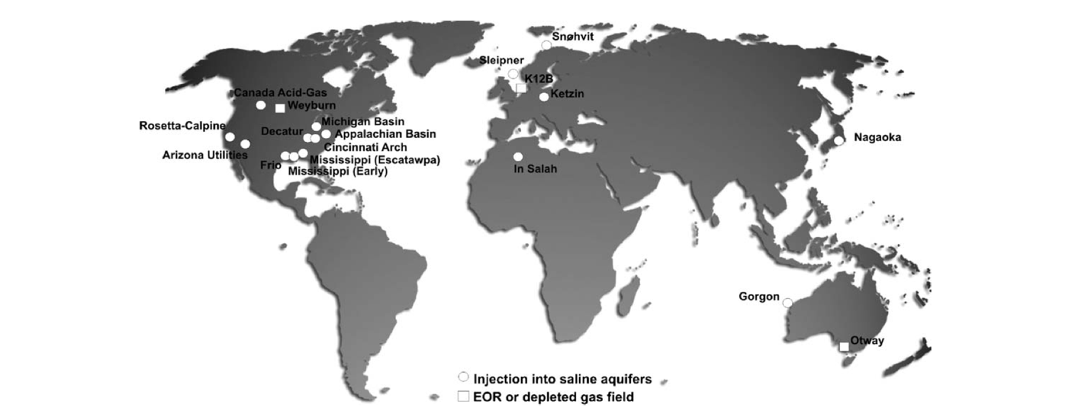
Figure - Map showing projects injecting or having injected CO2 into deep saline aquifers. Also shown are projects in an advanced planning stage (see text for details) as well as
the Weyburn (EOR), Otway and K12B (depleted gas reservoirs) pilot projects. Otway Phase 2, starting in 2010, will include small-scale injection into a saline aquifer.
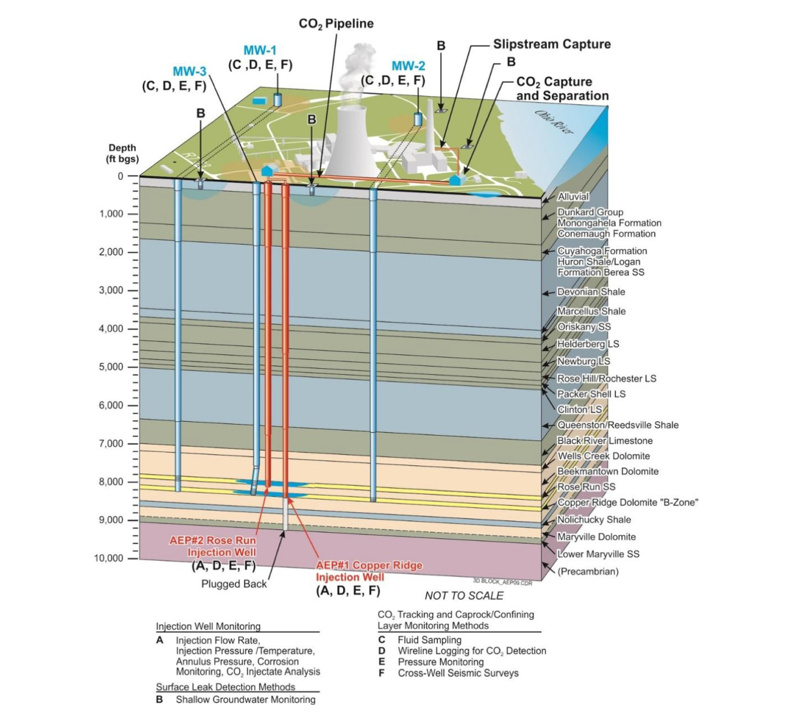
Figure - EP PVF well network and monitoring diagram

References:
Valluri, M., Mishra, S., & Ravi Ganesh, P. (2021). Injectivity index: A powerful tool for characterizing CO₂ storage reservoirs—A technical note. Greenhouse Gases: Science and Technology, 11(2), 251–265.
https://doi.org/10.1002/ghg.2046
Liebscher A, Möller F, Bannach A, Köhler S, Wiebach J, Schmidt-Hattenberger C et al., Injection operation and operational pressure-temperature monitoring at the CO₂ storage pilot site, Ketzin, Germany: design, results, and recommendations. Int J Greenhouse Gas Control 15: 163–173 (2013).
Streibel M, Finley RJ, Martens S, Greenberg S, Möller F and Liebscher A, From pilot to demo scale: comparing Ketzin results with the Illinois basin Decatur project. Energy Procedia 63: 6323-6334 (2014).
Hansen O, Gilding D, Nazarian B, Osdal B, Ringrose P, Kristoffersen J-B et al., Snøhvit: The history of injecting and storing 1 Mt CO₂ in the fluvial Tubåen Fm. Energy Procedia 37: 3565–3573(2013).
Grude S, Landrø M and Dvorkin J, Pressure effects caused by CO₂ injection in the Tubåen Fm., the Snøhvit field. Int J Greenhouse Gas Control 27: 178–187 (2014).
Michael K, Golab A, Shulakova V, Ennis-King J, Allinson G, Sharma S and Aiken T, Geological storage of CO₂ in saline aquifers: a review of the experience from existing storage operations. Int J Greenhouse Gas Control 4: 659–667 (2010).
Meckel TA and Hovorka SD, Results from continuous downhole monitoring (PDG) at a field-scale CO₂ demonstration project, Cranfield, MS. Paper SPE 127087 presented at the 2009 SPE International Conference on CO2 Capture, Storage, and Utilization held at San Diego, CA, November 2–4.

Summary of the Extended Abstract
The research assesses current studies which employ artificial intelligence and machine learning to study CO₂ injectivity and track well performance and maintain pressure control in geological storage systems. The research investigates AI system performance for pattern injection detection and injection data anomaly detection under conditions of pressure-related uncertainty. The review demonstrates AI functions as a screening tool which improves reservoir engineering and geomechanical modeling to aid decision-making but does not substitute these systems. AI systems in multi-well storage environments use their ability to process big data to detect patterns which help them understand well operation behavior. The research document shows common research problems which affect both data precision and researchers' ability to interpret findings and maintain data consistency between different studies. The review shows AI systems help CCUS operations through analytical support for pressure control and injectivity management yet operators need to maintain their physical knowledge and professional skills.

