From Laboratory Screening to Mini-Pilot Validation of Water-Lean CO₂ Capture Solvents

Introduction

The urgent requirement for negative carbon technologies has positioned Bioenergy with Carbon Capture and Storage (BECCS) as a pivotal strategy for climate mitigation. While chemical absorption using aqueous amines is the most mature carbon capture pathway, its wide implementation is often hindered by high parasitic energy demands. Water-lean solvents, which replace a significant portion of the aqueous phase with organic cosolvents, represent a transformative approach to reducing the energy penalty of regeneration^{1,2}. By lowering the specific heat capacity and minimizing the latent heat of vaporization, these systems theoretically offer a more efficient alternative to conventional aqueous blends in terms of energy duties. However, despite promising laboratory-scale findings, a significant gap remains between fundamental solvent screening and validation under realistic continuous operating conditions. Laboratory measurements often focus on equilibrium capacity, reaction kinetics, and calorimetric data under controlled batch conditions, which do not fully reflect hydrodynamics, heat integration, solvent circulation, foaming behavior, or long-term stability in continuous absorber–stripper systems. Bridging this gap is essential to accelerate solvent development from conceptual design to industrial implementation.

This study addresses this critical challenge by presenting a comprehensive evaluation framework that connects high-throughput laboratory screening with continuous mini-pilot validation under representative BECCS conditions. The work demonstrates how thermodynamic and kinetic advantages identified at laboratory scale translate into real process energy performance.

Method and/or Theory

The first phase of the study involved systematic high-throughput laboratory screening of a large pool of water-lean solvent formulations. The objective was to deconstruct the relationship between molecular structure, diluent properties, and macroscopic thermodynamic behavior. Candidate systems consisted of selected amines combined with organic diluents exhibiting varied polarity, hydrogen-bond donor/acceptor capacity, and dielectric constants.

Each formulation was characterized in terms of:

- CO₂ absorption capacity (mol CO₂/mol amine)

- Initial absorption rate and kinetic constant

- Heat of absorption (via calorimetry)

- Thermal stability under regeneration temperatures

- Phase behavior and viscosity

Particular emphasis was placed on understanding solute–diluent interactions and hydrogen-bonding disruption mechanisms, which strongly influence CO₂ solvation and carbamate stabilization. Reduced solvent heat capacity and suppressed water evaporation were evaluated as key contributors to potential energy savings.

Based on a multi-criteria decision matrix integrating capacity, kinetics, enthalpy, and stability, five water-lean solvent candidates (denoted WS-1 to WS-5) were selected for pilot validation. These candidates demonstrated superior laboratory performance compared to conventional 30 wt% MEA.

Nevertheless, laboratory-scale measurements inherently neglect critical factors such as mass transfer limitations, solvent circulation stability, entrainment losses, and thermal integration efficiency. Therefore, pilot-scale validation was essential to determine industrial viability.

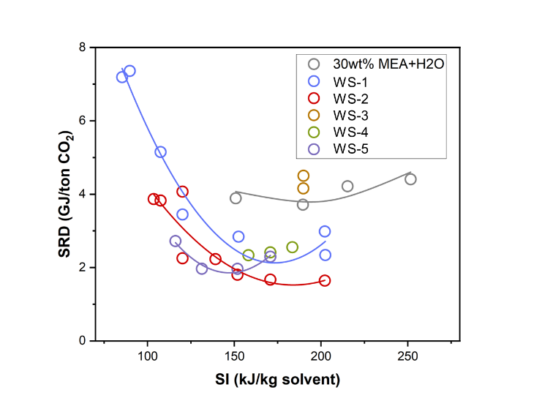
Figure 1 Figure 1. Specific reboiler duty (SRD) of water-lean solvent (WS) candidates tested at mini-pilot in relation to stripper intensity (SI) compared to 30wt% MEA aqueous solvent.

Conclusions

These results confirm that the kinetic and thermodynamic advantages from laboratory measurements can translate into CO₂ capture performance at pilot scale by appropriate solvent design. The rational development of water-lean solvents requires a holistic screening methodology that integrates fundamental solvent properties with continuous process performance. By correlating laboratory screening results with pilot-scale performance, this work provides a robust framework for the scale-up of water-lean solvent technologies. The findings offer critical guidance for the deployment of high-efficiency carbon capture solvents and support the realization of the theoretical energy saving of next-generation solvents in practical large-scale and negative-emissions applications.

Acknowledgements

The authors gratefully acknowledge the financial support from Innovation Fund Denmark (Innovationsfonden) and Technical University of Denmark (DTU).

References

1. Wanderley, R. R. & Knuutila, H. K. Mapping Diluents for Water-Lean Solvents: A Parametric Study. Ind. Eng. Chem. Res. 59, 11656–11680 (2020).
2. J. Heldebrant, D. et al. Water-Lean Solvents for Post-Combustion CO2 Capture: Fundamentals, Uncertainties, Opportunities, and Outlook. Chem. Rev. 117, 9594–9624 (2017).

