Robust Algorithms for Multiphase Chemical and Phase Equilibrium in Geological CO₂ Storage

Introduction

The dynamic numerical simulation of geological carbon dioxide storage requires an accurate and highly reliable description of the distribution of components across gas, liquid and solid phases. This is achieved through simultaneous chemical and phase equilibrium (CPE) calculations, crucial for predicting the long-term fate of injected gases into underground reservoirs and complex mineral structures. Compositional geochemical simulators often rely on successive substitutions to handle non-ideal mixtures. However, it is critical to have a reliable inner module which can solve the CPE problem at constant fugacity and activity coefficients.
This work presents a systematic, robust solution for solving the CPE problem at fixed fugacity coefficients utilizing the method of Lagrange multipliers. The algorithms presented are an extension of the foundational work of Michelsen (1989), who worked on ideal solution chemical equilibrium, and of Tsanas (2017), working on the non-ideal multiphase extension. The convergence issues that can be encountered in complex multiphase geological systems are addressed in the improved algorithms with a customized optimization procedure to allow for the dynamic appearance and disappearance of phases.

Method and Theory

The presented algorithms belong to the non-stoichiometric chemical equilibrium algorithms. In contrast to stoichiometric methods, which use the extents of reactions as independent variables, the non-stoichiometric approach minimizes the Gibbs energy with elemental abundance constraints, leading to a smaller system of equations to be solved if there are many reactions and multiple phases.
The basis of this methodology is the duality transformation of the Gibbs energy minimization subject to mass conservation constraints, leading to the formulation of the Q-Function to solve the problem. In a system with N_{C} components, N_{P} phases, and N_{E} elements, the objective function Q is defined as:
$$Q\left(λ\right)= \sum_{k=1}^{N_{P}}{β_{k}\left(\sum_{i=1}^{N_{C}}{x_{ik}-1}\right)-\sum_{j=1}^{N_{E}}{λ_{j}b_{j}}}$$
where β_{k} is the total phase amount of phase k, b_{j} are the total moles of element j in the feed, and λ_{j} the Lagrange multipliers (also representing the elemental chemical potentials).
The mole fractions x_{ik} in each phase are intrinsically connected to the elemental chemical potentials via the following relationship:
$$lnx_{ik}=\sum_{j=1}^{N_{E}}{A_{ji}λ_{j}-\frac{μ_{ik}^{0}}{RT}-ln{\hat{ϕ}}_{ik}}$$
where A_{ji} is the formula matrix relating elements to components, µ⁰_{ik} is the standard state chemical potential, and $\hat{ϕ}$_{ik} the fugacity coefficient (assumed constant for the Q-function algorithm).

Two-Step Newton Algorithm

The overall Q-Function is a saddle point problem, the attempt to solve all variables simultaneously could lead to divergence. To ensure a safe convergence, the problem can be separated into a two-step optimization procedure, also illustrated in the first flow chart of figure 1.
- Step 1: In first step the total phase amounts (β_{k}) are kept constant, while the system is minimized only for the elemental chemical potentials (λ_{j}). This provides a strictly convex sub-problem, in contrast to the full saddle point problem. With the stationary condition requirement ∂Q/∂λ_{j} = 0 we have the following system to be solved via Newton updates:

$$J^{A}Δλ=-F^{A}$$

Using line searches, this sub-problem is guaranteed to converge to a unique minimum, providing the elemental chemical potentials for the second step in the procedure.
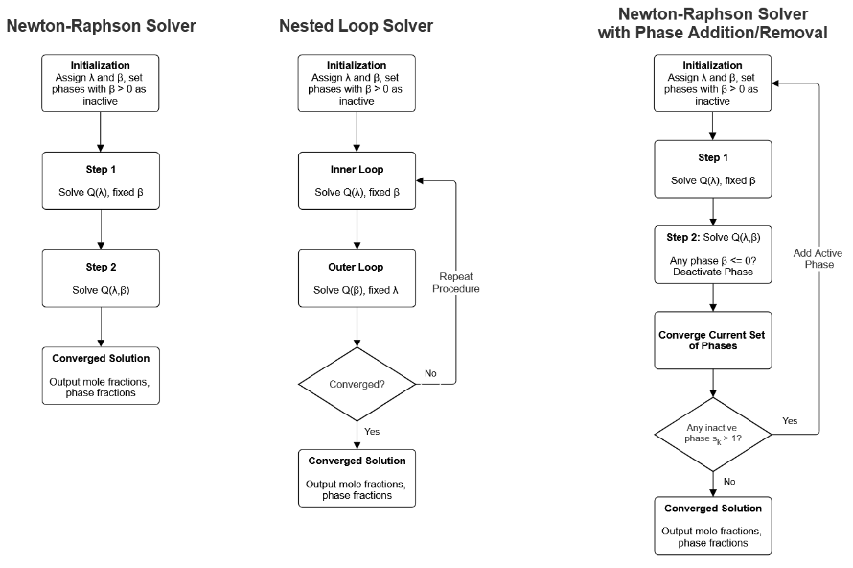
- Step 2: Following the first step, the phase amounts are now included in the Newton updates, and the full system is solved for both the elemental material balances and the phase summation equations (s_{k} = Σx_{ik} = 1) simultaneously, providing second-order quadratic convergence. In case the Newton-Raphson algorithm does not converge, the possibility to fall back to the nested loop solver exists.

Figure 1 Flow charts for NR solver, NL solver and NR solver including phase removal and addition.
Nested Loop Algorithm

Should a case arise where the full Newton-Raphson solver struggles to converge, either caused by poor initial estimates or extreme non-idealities, the algorithm can fall back to the nested loop approach. Because of the Q-function being a saddle point problem, the separation into minimization and maximization steps in the nested loop algorithm guarantees convergence. A flow chart for the algorithm is shown as the second flow chart in figure 1.
- Inner Loop: The system undergoes an unconstrained minimization of the Q-function with respect to the elemental chemical potentials (λ_{j}), while the phase amounts (β_{k}) stay constant. In the inner loop the first set of equations in the system J^{A}Δλ = -F_{A} is solved to find a unique minimum for λ. It is mathematically equivalent to step 1 of the Newton-Raphson solver.
- Outer Loop: Once the inner loop converges to a set of λ_{j}, the phase amounts (β_{k}) are updated in the outer loop. This is done by maximizing the Q-function with respect to β_{k}, satisfying the phase summation constraints s_{k} – 1 = 0. If a convergence should not be achieved, the procedure is repeated with the updated phase amounts in the inner loop.

Dynamic Phase Removal and Addition

One of the critical contributions of this work is the automated integration of phase removal and addition inside of the solution procedure. The third flow chart in Figure 1 shows the process in more detail for the case of the Newton-Raphson solver.
- Phase Removal: During the Newton iterations of the second step of the procedure, the phase amounts of all phases are monitored. Should one or more phase amount become negative (β_{k} <= 0), the update step length is reduced so that only one phase amount becomes exactly zero. The respective phase is now designated to be “inactive” and removed from the list of active phases. The iteration then continues until convergence with a reduced number of active phases.
- Phase Addition: When the algorithm converged for all active phases, the sum of the mole fractions of inactive phases is checked to judge if a phase should be added back to the set of active sets. If the sum of the mole fractions s_{k} > 1, the introduction of the phase would lower the system´s Gibbs energy. Therefore, the phase should be re-activated or added to the set of active phases, initialized with a small positive amount, and the algorithm restarted from the first step.
For a Nested-Loop solver, phase removal happens in the outer loop whereas the check for phase addition is conducted after the outer loop. The converged solution where no phases can be re-activated is taken as the final solution.

Examples

The first example is an 11 component, 6 reaction, 5 element system at 393.15 K and 250 atm, the second Example a 21 component, 11 reaction, 10 element system at 298.15 K and 100 atm. For both examples the reactions are shown in table 1, and the feeds are shown in tables and together with the respective results.

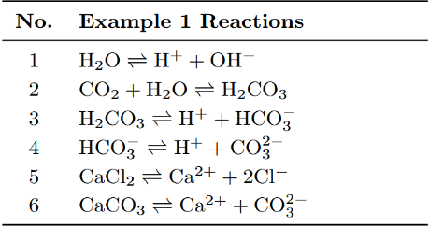
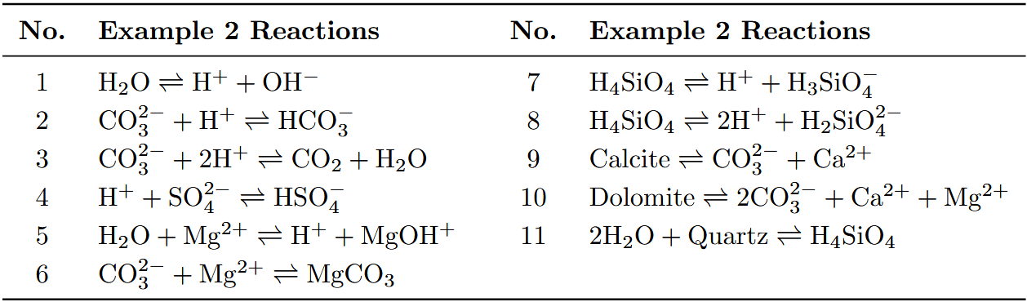
Table 1 Reactions included in the first and second example cases.

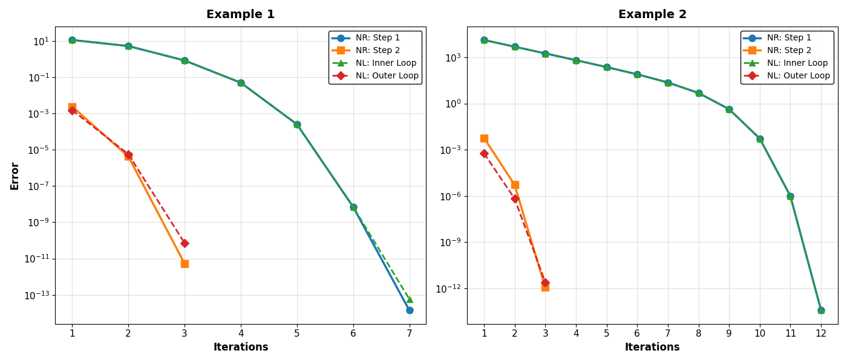
Figure 2 shows the convergence behavior of both cases and both algorithms. It can be recognized that in all cases the convergence is quadratic. For the first inner loop of the nested loop solver and the first step in the Newton-Raphson solver the convergences are almost identical, while for the outer loop and the second step they differ slightly. However, both methods achieve convergence withing reasonable iterations for both cases.
Figure 2 Iteration behavior for both algorithms and both examples. For the nested loop solver, the iterations and errors are shown for the first inner loop convergence.

The second table shows the converged phase fractions and phase amounts for both example cases and both the Newton-Raphson and the nested loop solver. The converged results for both solvers are the same, showing reasonable results for both cases. Also, the resulting mole numbers, shown in tables 3 and 4, show the same behavior with matching results.

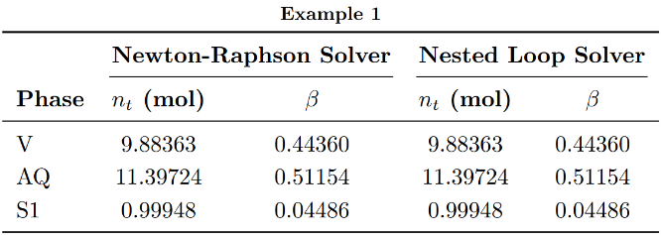
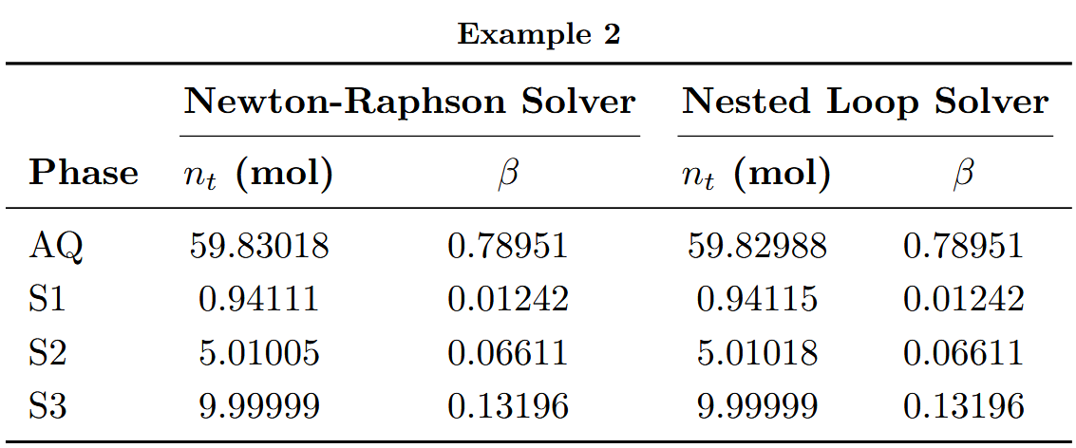
Table 2 Results of phase amounts and fractions for both examples and solvers.
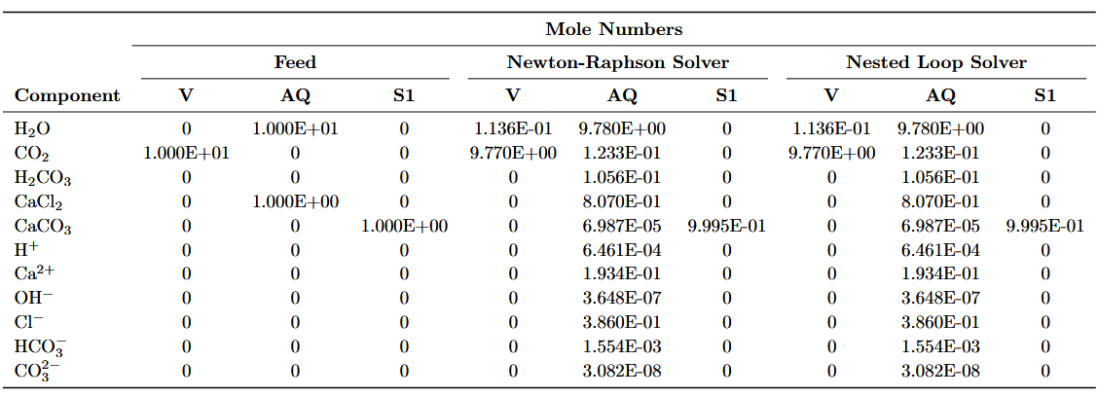
Table 3 Mole numbers for feed, Newton-Raphson, and nested loop solver for example 1.

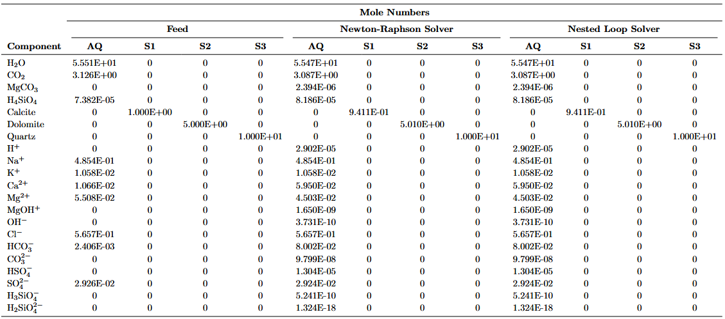
Table 4 Mole numbers for feed, Newton-Raphson, and nested loop solver for example 2.

Conclusions

This study presents robust, non-stoichiometric algorithms tailored for multiphase chemical and phase equilibrium calculations. Geological CO₂ storage, a complex, dynamic system where minerals and fluid phases frequently precipitate or dissolve, demands a solver capable of handling extreme phase instabilities without diverging. Using duality transformation, we get the non-stoichiometric Q-function. The complexity of the inherent saddle point nature of the problem is addressed by isolating the strictly convex part. Solving only for the elemental chemical potentials with fixed phase amounts provides a stable initialization for the full Newton update. The nested loop algorithm functions as a convergence safeguard. Furthermore, the addition of automated phase addition and removal to the algorithms prevents non-physical negative phase amounts and provides a possibility to judge for stable physical states. The discussed algorithms provide quadratic convergence and robustness needed for the integration into large-scale compositional numerical simulation software, enabling the accurate prediction of geochemical processes during underground CO₂ storage.

References

Michelsen, M.L. [1989]. Calculation of multiphase ideal solution chemical equilibrium. Fluid Phase Equilibria, 53, 73-80.

Tsanas, C., Stenby, E.H., & Yan, W. [2017]. Calculation of simultaneous chemical and phase equilibrium by the method of Lagrange multipliers. Chemical Engineering Science, 174, 112-126.

