ABSTRACT TITLE (ALL CAPS). MAXIMUM LENGTH OF ABSTRACT TITLE IS TWO LINES, NOT MORE!

List of authors, seperated by comma, initials first name(s), surname, numbered company reference.

List of companies, instututes, universities, etc of authors. Only include name and country, NOT the department or address!

Introduction (Use of sections is optional)

Click ONCE and select this paragraph, you will replace this text with your own text and it will be automatically formatted. All styles for this template are formatted for you.

Here is the second paragraph of the introduction. The font for this template is 12pt Times New Roman. The Section Headings are bold. The paragraphs are justified and separated by a blank line.

Abstracts will be included in the proceedings as they are submitted. Your abstract will not be edited or retyped.

Results (Use of sections is optional)

Additional instructions for composition are:
- Your abstract must be in English
- Your abstract may NOT exceed 2 pages, paper size A4).
- Optional: you may include one graphic and/or one table in the abstract.
- Figures can be in black and white or colour.
These bulleted items are used as an example and should be deleted so they do not appear in your document.

Conclusions (Use of sections is optional)

This is the first sentence of a third sample section. The paragraphs and section headings appear shaded in this template (on screen only). As you replace the text with your own, the shading will disappear.

If you have a graphic, you will need to embed it in the document, see example below.

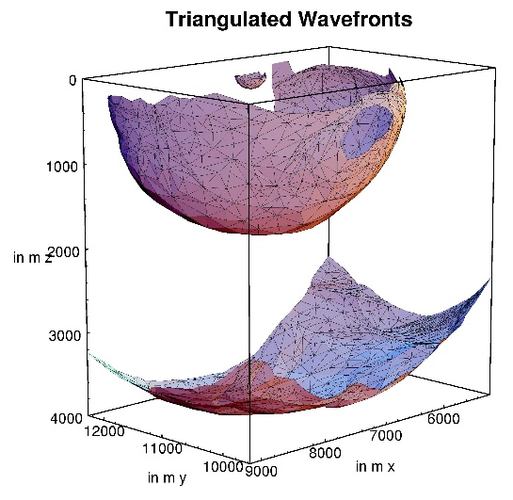
Figure 1 This is an example of a figure imported from jpeg (courtesy of Gilles Lambaré). Left click on Insert on the menu bar and then select Picture. Supply a short caption (in Italics) for the figure; more detailed discussion of the figure can be reserved for the text.

Your abstract MUST not exceed 2 pages, A4 sized. Font point sizes and line spacing should not vary from this template. Abstracts received after after the deadline (see event website) will not be considered for an oral presentation.

References (Use of sections is optional)

Please keep in mind to use references when applicable.

