The Role of Standardisation in Advancing CCUS Commercialisation

Introduction

This paper analyses the influence of technical standards on the evolution and governance of CCUS, with a particular focus on the body of standards developed within the International Organization for Standardization Technical Committee 265 (ISO/TC 265) covering CCS and CO₂-EOR and the European Committee for Standardization Technical Committee 474 (CEN/TC 474). Standards have been incorporated into regulatory regimes and relied upon in commercial and demonstration projects. Through concrete examples, the paper illustrates how standards advance the commercialisation of CCUS by e.g. establishing harmonised technical specifications, strengthening investor confidence, promoting infrastructure interoperability, and facilitating the integration of CO₂ value chains across jurisdictions.

At the European level, the European Commission is actively evaluating how technical standards can be more systematically integrated into EU frameworks related to CCUS. This includes consideration of how standards may be referenced in the forthcoming legislative initiative on CO₂ transport infrastructure and markets. Such integration could help reduce costs, streamline projects, and enhance interoperability of CO₂ networks across Member States, thereby supporting the development of a coordinated and cost-efficient European market for CCUS.
Method and contributions

ISO/TC 265 is made up of subject matter experts from various sectors, with 31 countries participating and 17 holding observer status. TC 265 is currently organised into seven working groups that address the entire CCS value chain, including capture, pipeline transportation, storage, cross-cutting issues, CO₂-EOR, ship transportation, and ex-situ storage of CO₂. Working groups are established as market needs emerge and mature, demonstrating a demand for technical standards. Working Group 7 was established in 2022, and Working Group 8 on ex-situ in 2025.
ISO/TC 265 has published 17 documents, including standards and technical reports. Some of these standards have been referenced or used in regulatory frameworks and processes, such as the Norwegian CO₂ safety regulation guidelines, the EU taxonomy and CCS Directive guidance documents, a taxonomy framework for ASEAN, and the U.S. Internal Revenue Service 45Q tax credit framework. Standards have also been used in demonstration projects such as Longship, Greensand, and Porthos.
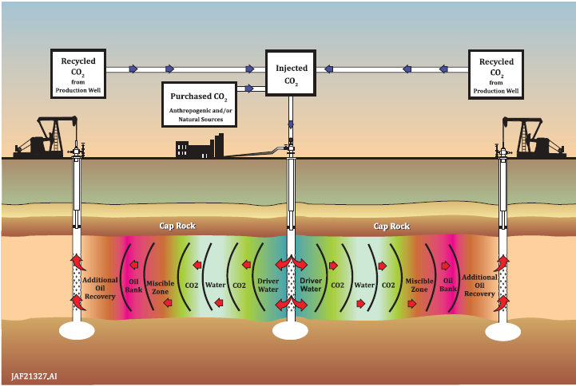
The example of U.S. 45Q is useful in demonstrating how standards may benefit the industry directly. ISO:27916 has been referenced in the 45Q as one of two optional methodologies to quantify and verify anthropogenic CO₂ stored as part of a CO₂-EOR project to enable carbon credits under 45Q. The standard provides a comprehensive methodology for quantification, verification, and reporting of CO₂ injected and stored as part of an EOR project, taking into account factors of commingled streams, a mixture of in-situ and injected CO₂ embedded in the produced petroleum, as well as separation and recycling of such volumes with the ultimate goal of quantifying the net volume of injected CO₂ stored.
Figure 1 ISO:27916:2019, Annex A, p. 17.

Their relevance has recently been strengthened as new countries adopt these standards, integrate them into national frameworks, and/or use them as a foundation for developing their own national standards. For example, Indonesia has adopted four ISO/TC 265 standards and technical reports “focusing on geological storage, setting foundational benchmarks to ensure projects meet global credibility and bankability criteria” (ICCSC). National and international standards are referenced in the national CCS regulations as benchmarks for compliance.

Moreover, China is drafting national standards based on ISO standards, such as 27914 (geological storage) and 27916 (CO₂-EOR). The final versions of both standards will be published once stakeholder feedback has been incorporated.
CEN/TC 474, which represents 34 European countries, has so far established working groups focused on CO₂ stream specifications, pipeline transport, accounting, and storage. Its primary objective is to adopt existing ISO/TC 265 standards and complement them with standards tailored to European needs. Whereas ISO maintains regulatory neutrality, CEN operates with greater flexibility to incorporate regulatory considerations. Also, CEN/TC 474 addresses topics that fall outside ISO’s current remit, such as CO₂ utilisation. Over time, this approach is expected to create a more comprehensive framework of standards, supporting the growing development of CCS hubs and clusters at both national and cross-border levels.

At the EU level, the European Commission is assessing how technical standards might be used in EU policy and legislative frameworks governing CCS. As part of these efforts, the European Commission established a Working Group on CO₂ Standards in 2023, comprising subject-matter experts. The working group was tasked with “[providing] clarity on the need for and issues associated with setting specifications for the CO₂ stream entering a transport and storage system” (Working Group on CO₂ Standards, 2025). The European Commission published the final report from the working group in March 2025. The report analysed standardising CO₂ stream composition, highlighting the benefits and challenges, and both concluded there was a need for such standards, while emphasising that timing matters, that ongoing research and development are still needed, and that overly prescriptive standards might be hindering the industry. The report also highlighted the need for additional standards to support CCS. CEN/TC 474 is now developing a standard on CO₂ specifications, independent of this report.

The European Commission has launched a legislative initiative for CO₂ transportation infrastructure and markets, scheduled for the third quarter of 2026. To address barriers for cross-border transportation of CO₂, the proposal may, inter alia, foster cross-border interoperability and establish CO₂ standards to avoid market fragmentation, and ensure that equivalent rules apply to infrastructure in and to interconnected non-EU countries. These requests will likely go to CEN/TC 474. It remains to be seen exactly how the standards will be used by the Commission.

It has been indicated to CEN/TC 474 that standardisation requests may come from the European Commission sometime in 2026, implying that the European Commission will instruct the TC to develop standards for CCUS. These standards may consequently be referenced directly in the European legal framework for CCUS. Without having more information about the contents of these future requests, it is still a reasonable assumption that they will relate to the scope of the above-mentioned working group, and that they may serve to bridge technical gaps in the regulatory efforts on infrastructure to further streamline and commercialise access to and use of infrastructure for CCUS.

Conclusions

Technical standards play an important role in the maturation of CCUS. Rather than operating solely as voluntary technical guidance, standards developed within ISO/TC 265, and more recently CEN/TC 474, are being integrated into regulatory frameworks, taxonomies, certification schemes, and project permitting processes. This integration gives them significant practical and normative weight, even where they remain formally voluntary.

By establishing common methodologies for e.g. site characterisation, CO₂ stream composition, monitoring, quantification, and verification, standards create a shared technical foundation that regulators, operators, and project developers can rely on. Internationally recognised benchmarks help reduce uncertainty, strengthen investor confidence, and facilitate compatibility between CO₂ transport and storage infrastructure across borders. In this way, standards not only support national regulatory frameworks but also enable the development of interconnected CO₂ value chains operating under comparable technical expectations.

References

CEN/TC 474 Work programme: https://standards.cencenelec.eu/ords/f?p=205:22:::::FSP_ORG_ID,FSP_LANG_ID:3356655,25&cs=11E4C08C2C7F35435692AAE50EB02783D

Drescher et al., ICM Forum Working Group on CO₂ Standards, Towards EU-wide CO₂ specifications (February 2025) p. 6 Available at: https://circabc.europa.eu/ui/group/75b4ad48-262d-455d-997a-7d5b1f4cf69c/library/c5cd0d90-d0a6-4fc6-b259-ad7124f83a22/details?open=true

European Parliament, Legislative Train Schedule ‘Development of the CO₂ transportation infrastructure and markets’ Carriages preview | Legislative Train Schedule accessed 13 February 2026.

Global CCS Institute & CNPC Research Institute of Safety and Environmental Technology, ‘Policy Recommendations for Achieving CO₂ Geological Storage with Environmental Integrity in China’ (January 2026) p. 16 https://www.globalccsinstitute.com/wp-content/uploads/2026/01/China-Policy-Report-16-January-2026.pdf accessed 13 February 2026.

ICCSC, ‘Defining High-Integrity Carbon Credits: Indonesia’s Path to Climate Leadership’ (26 November 2025) https://iccscenter.com/defining-high-integrity-carbon-credits-indonesias-path-to-climate-leadership/ accessed 26 February 2026.

ISO:27916:2019 Carbon dioxide capture, transportation and geological storage — Carbon dioxide storage using enhanced oil recovery (CO₂-EOR)

Julian Isaac, ‘Indonesia focuses on NZE, new standardization for CCS’ (Indonesia Business Post, 07 January 2025) https://indonesiabusinesspost.com/3503/business-and-investment/indonesia-focuses-on-nze-new-standardization-for-ccs accessed 26 February 2026.

United States Code of Federal Regulations, 26 CFR 1 §45Q

