Introduction

Click ONCE and select this paragraph, you will replace this text with your own text and it will be automatically formatted. All styles for this template are formatted for you.

Here is the second paragraph of the introduction. The font for this template is 11pt Times New Roman. The Section Headings are bold. The paragraphs are justified and separated by a blank line.

Abstracts will be printed on the USB and online exactly as they are submitted. EAGE staff will not edit or retype the copy.

Your abstract should be 2 - 4 pages long including all figures and references (Please do not count the cover page).

TITLE, AUTHORS AND SUMMARY MUST NOT BE INCLUDED IN THESE TWO - FOUR (2 -
4) PAGES! This information is provided on a cover page, automatically generated from the information you provide on the on-line submission form.

Method and/or Theory

Additional instructions for composition are:
- Please write your abstract in English.
- Authors are responsible for sizing and positioning their illustrations.
- Figures can be in black and white or colour.
- Embed into the text of the paper figures, equations, charts, graphics, etc.
These bulleted items are used as an example and should be deleted so they do not appear in your document.

Examples (Optional)
This is the first sentence of a second sample section. Each of the paragraphs and section headings appear shaded in this template, with the exception of the bulleted items above and the text in the following figure.
These text boxes appear shaded on the screen only. It will disappear as you select each paragraph to replace with your own text, or just delete.
If you have a chart, graphic, equation, etc. you will need to embed them in the document. You can insert an external file. Here is an example of a figure.
LANGUAGE: Abstracts may be submitted in ENGLISH only. The Technical Programme will be in English.

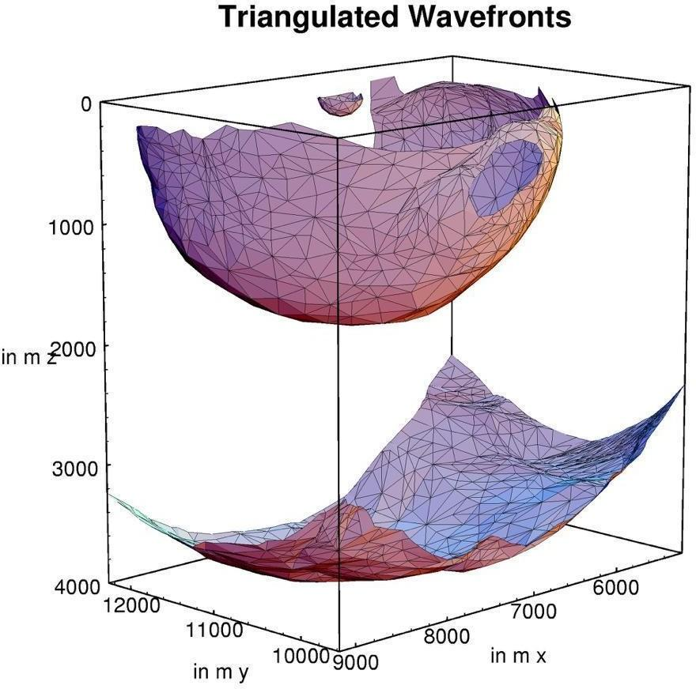

Figure 1 This is an example of a figure imported from jpeg (courtesy of Gilles Lambaré). Left click on Insert on the menu bar and then select Picture. You can also select to embed an object instead of a picture. You can either embed an existing file or create your object at that point. Number the figures sequentially, according to their appearance in the text, and check that each figure is cited in the text. Supply a short caption for each figure; more detailed discussion of the figure can be reserved for the text. In this template figure caption are 11pt italic Times New Roman. Further information about the use of figure captions and figure numbering can be found in the First Break Guidelines for authors.

Examples (Optional)

Example text, please delete if you don't use it. Example text, please delete if you don't use it. Example text, please delete if you don't use it. Example text, please delete if you don't use it.

Conclusions

This is the first sentence of the conclusion.

Acknowledgements (Optional)

Your abstract MUST be 2-4 pages long, A4 sized, and MUST include at least one figure and references. Font point sizes and line spacing should not vary from this template.

References

This is the first sentence of the References section. The lay-out of the references should be consistent with the style guide for references in the First Break guidance to authors. Please ensure every citation has a reference and vice versa.

