**Objectives**:

Histoplasmosis is a major AIDS-defining illness, leading to thousands of HIV-related deaths worldwide (1). The standard of care (SOC) treatment for disseminated histoplasmosis is liposomal amphotericin (L-AmB) for 2 weeks; however, access to this drug is limited in most countries where histoplasmosis is endemic (2). A recent phase II randomized trial demonstrated that a single high dose of liposomal amphotericin B (L-AmB) may be non-inferior to standard L-AmB therapy (3). Based on data from the phase II trial, we aimed to utilize a hiearchical endpoint via the desirability of outcome ranking (DOOR) and Win-Ratio analysis to assess whether there were differences between SOC and short-course regimens in toxicity, rehospitalization and mortality.

**Materials & Methods:**

We developed and applied a hierarchical endpoint via the desirability of outcome ranking (DOOR) approach (4) aiming to evaluate how a shorter course regimen (single dose 10 mg/kg of L-AmB) compared to the SOC induction regimen (3 mg/kg of L-AmB for two weeks). The analyses were applied to data derived from a completed phase II clinical trial (3). The DOOR score, incorporating death, severe adverse event, laboratory abnormalities and lost-to-follow-up has five ordered and mutually exclusive categories, from 1 - Death at 12 weeks or loss of follow up at 2 weeks, to 5 - Alive at 12 weeks without any events. Wilcoxon-rank-sum-test was used to compare the DOOR score between the two arms. The Better DOOR Probability was calculated for both the overall DOOR score, as well as marginally for each component of the DOOR score. We also conducted sensitivity analysis using the Win Ratio statistic (5), which takes into account the time-to-event aspect of data.

**Results**:

A total of 118 patients were included in the phase II trial. For the DOOR and Win-Ratio analyses, 79 patients (40 in the single high-dose arm, 39 in the SOC arm) were evaluated as these two arms are being evaluated in a phase III trial. The probability of more favorable DOOR outcome for single high dose vs SOC was 0.4 (95% CI, 0.28 - 0.53), p= 0.12. The Win-Ratio for single high-dose LAmB vs SOC was 0.64 (95% CI 0.35 - 1.16), p-value = 0.14. We found non-significant trends of lower toxicity and rehospitalization in the SOC arm using both Win Ratio and DOOR analyses (Table 1 and Figure 1).

**Conclusions**:

Both single high-dose and conventional durations of L-AmB provided comparable clinical outcomes when using Win-Ratio and DOOR to consider benefits and risks of induction treatment for HIV-related disseminated histoplasmosis, providing findings that are consistent with the phase II trial. However, limitations of the phase II study include its small sample size and non-comparative design, which constrain the robustness of comparisons between single high-dose and standard liposomal amphotericin B regimens. Using DOOR and Win-Ratio analyses, non-significant trends of lower toxicity and rehospitalization in the SOC arm were noted. This demonstrates the need for a phase III trial in order to better evaluate non-inferiority for both survival and toxicity.

|  |  |  |  |
| --- | --- | --- | --- |
|  | Single High-Dose, N=401 | SOC, N=391 | P-value2 |
| DOOR |  |  | 0.122 |
| 1 | 11 (28%) | 8 (21%) |  |
| 2 | 6 (15%) | 3 (7.7%) |  |
| 3 | 18 (45%) | 18 (46%) |  |
| 4 | 1 (2.5%) | 2 (5.1%) |  |
| 5 | 4 (10%) | 8 (21%) |  |
|  |  |  |  |

Table 1. Distribution of patients according to DOOR score in single high dose vs. standard of care. Categories of the DOOR score are: 1 - Death at 12 weeks or loss of follow up at 2 weeks; 2 - severe adverse event; 3 - grade IV laboratory abnormalities at 2 weeks; 4 - grade III laboratory abnormalities at 2 weeks or loss of follow up at 12 weeks; 5 - alive at 12 weeks.

1 n(%); 2 Wilcoxon rank sum test; DOOR: desirability of outcome ranking; SOC: standard of care.

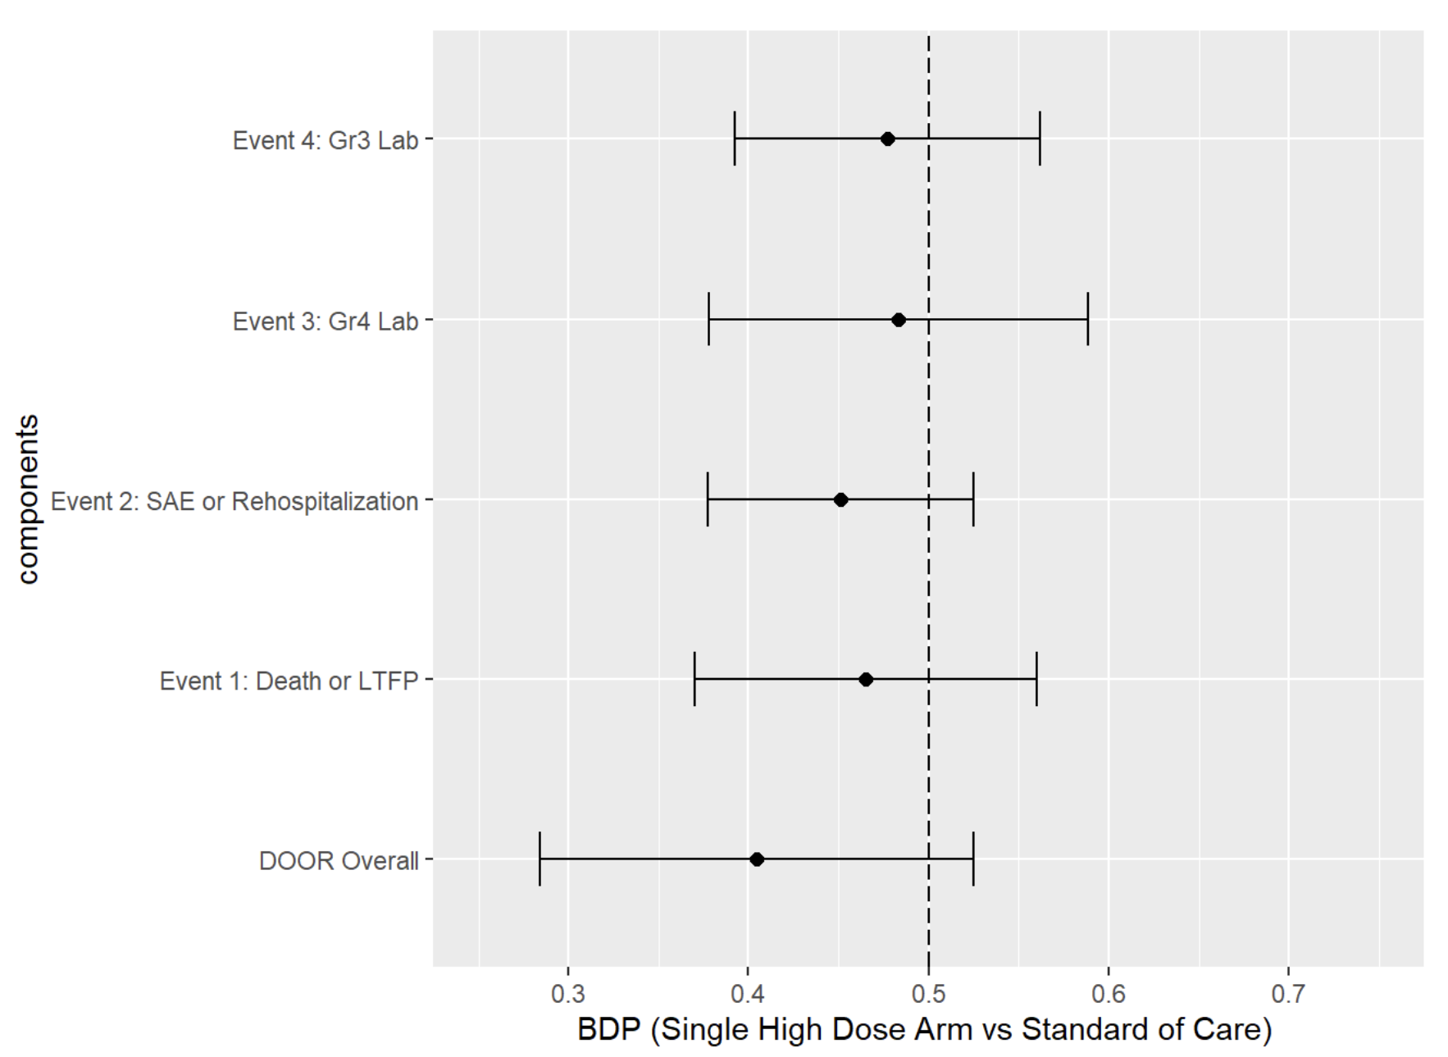

Figure 1. Forest plot for composite better door probability (BDP) and Component-wise BDP. The component-wise BDP is calculated marginally for each component. That is, a patient can appear in several categories. For each event type, the comparison is modeling having the event (worse) vs not having the event (better). Data points located to the left of the vertical line indicate outcomes that favor the standard of care.

**References**:

1. Adenis AA, Valdes A, Cropet C, et al. Burden of HIV-associated histoplasmosis compared with tuberculosis in Latin America: a modelling study. Lancet Infect Dis. 2018;18(10):1150-1159. doi:10.1016/S1473-3099(18)30354-2
2. Pasqualotto AC, Queiroz-Telles F, Chebabo A, et al. The "Histoplasmosis Porto Alegre manifesto"-Addressing disseminated histoplasmosis in AIDS [published correction appears in PLoS Negl Trop Dis. 2023 Jan 31;17(1):e0011106. doi: 10.1371/journal.pntd.0011106.]. PLoS Negl Trop Dis. 2023;17(1):e0010960. Published 2023 Jan 5. doi:10.1371/journal.pntd.0010960
3. Pasqualotto AC, Lana DD, Godoy CSM, et al. Single High Dose of Liposomal Amphotericin B in Human Immunodeficiency Virus/AIDS-Related Disseminated Histoplasmosis: A Randomized Trial. Clin Infect Dis. 2023;77(8):1126-1132. doi:10.1093/cid/ciad313
4. Evans SR, Rubin D, Follmann D, Pennello G, Huskins WC, Powers JH, Schoenfeld D, Chuang-Stein C, Cosgrove SE, Fowler VG Jr, Lautenbach E, Chambers HF. Desirability of Outcome Ranking (DOOR) and Response Adjusted for Duration of Antibiotic Risk (RADAR). Clin Infect Dis. 2015 Sep 1;61(5):800-6. doi: 10.1093/cid/civ495. Epub 2015 Jun 25. Erratum in: Clin Infect Dis. 2023 Jan 6;76(1):182. doi: 10.1093/cid/ciac352. PMID: 26113652; PMCID: PMC4542892.
5. Pocock SJ, Ariti CA, Collier TJ, Wang D. The win ratio: a new approach to the analysis of composite endpoints in clinical trials based on clinical priorities. Eur Heart J. 2012 Jan;33(2):176-82. doi: 10.1093/eurheartj/ehr352. Epub 2011 Sep 6. PMID: 21900289.