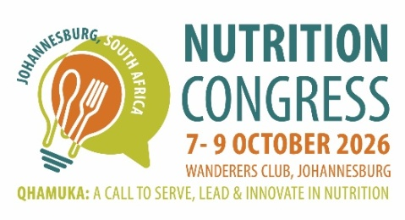
2026 Nutrition Congress
WORKSHOP APPLICATION FORM

Kindly return the completed application and a proposed draft programme to kristy@confpartner.co.za
The information shared will be used for the congress website and marketing

- Deadline date for submission: 19 January 2026
- Notification of continuation, shared with workshop submitter/hosts: 26 January 2026
- Launch of workshops: 6 February 2026

INFORMATION:
- Include logos (if applicable) to this document or email it to kristy@confpartner.co.za
- The workshops will be hosted on 9 October 2026, 13h00-16h15 which includes a tea break of 15 minutes at 15h00
- 3 workshops will be hosted – based on the information provided, the scientific committee will review and allocate accordingly.
- Financial Support: A venue, catering and audio visual (AV) equipment (Screen, projector, laptop, PA system & microphone and a technician) will be provided. The congress will make R 2500 (maximum) available to the workshop host to pay for expenses ie photocopies, workshop materials needed, fuel costs.
- The organising committee will set the workshop fee (Less than R 1000 – TBC) the fees will be allocated towards the Venue hire, catering and AV expenses
- A minimum of 20 delegates must register in order for a workshop to be financially viable. By 9 September 2026, the registration numbers will be communicated with workshop hosts and a decision can be made on this date regarding the continuation, based on registrations received.

Title
Type | Workshop |  | Update |  | Master Class
Participant Limit
Organizers
Target Audience
Short Summary
Speakers
Programme Chairs
Sponsors / Co-Sponsors
Additional Comments

