Abstract template for MD-GAS WG1 & WG2 MEETING 2021
A. One^{(a)}, B. Two^{(b)}, C. Three^{(a)}
^{(a)} Institute of Physical Chemistry, Polish Academy of Sciences, Kasprzaka 44/52, 01-224, Warsaw, Poland.
^{(b)} Deutsche Elektronen-Synchrotron DESY, Hamburg, Germany.
This is a sample abstract for the WG1 & WG2 online meeting of the MD-GAS COST Action. You should email your abstract to dpiekarski@ichf.edu.pl by 17 February for Young Scientific Forum speaker selection and 28 February for Poster Presenters.
Abstracts should be written in English. Templates for Microsoft Office Word are available on the registration webpage.
Abstracts must contain a title, the authors’ list and their affiliations. Among the authors, the corresponding author, attending WG1 & WG2 meeting, should be underlined. The total abstract length should not exceed one A4 page, including figures and tables; the text length might be less than 2000 characters (spaces included). We encourage authors to include a figure (graphical abstract). The following figure formats are acceptable: jpeg, png, gif, eps, pdf. References in the text must be given by numbers in square brackets [1]. The list of references is placed at the end of the abstract text.
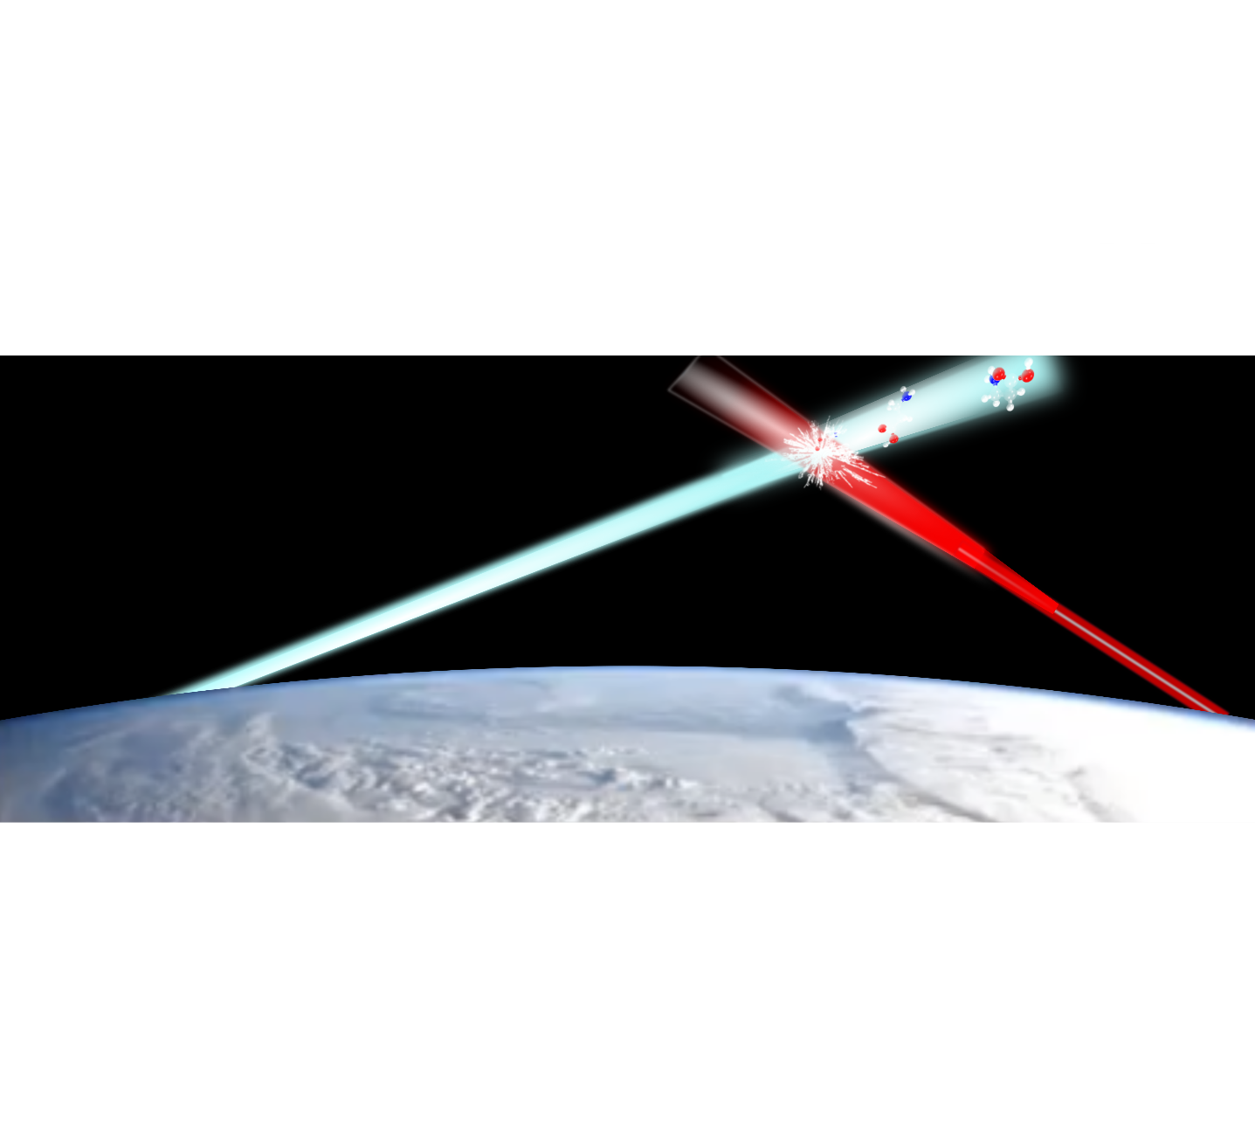
Figure 1: MD-GAS WG1 & WG2 2021 figure.

 | Title | Authors names | Affiliations | e-mail | Body text | Captions | Ref.
Size | 14 pt | 12 pt | 10 pt | 10 pt | 12 pt | 10 pt | 10 pt
Table 1: Font sizes for MD-GAS WG1 & WG2 2021 abstracts.
References
[1] H. S. W. Massey and R. A. Smith, Proc. Roy. Soc. A 142, 142 (1933).

dpiekarski@ichf.edu

