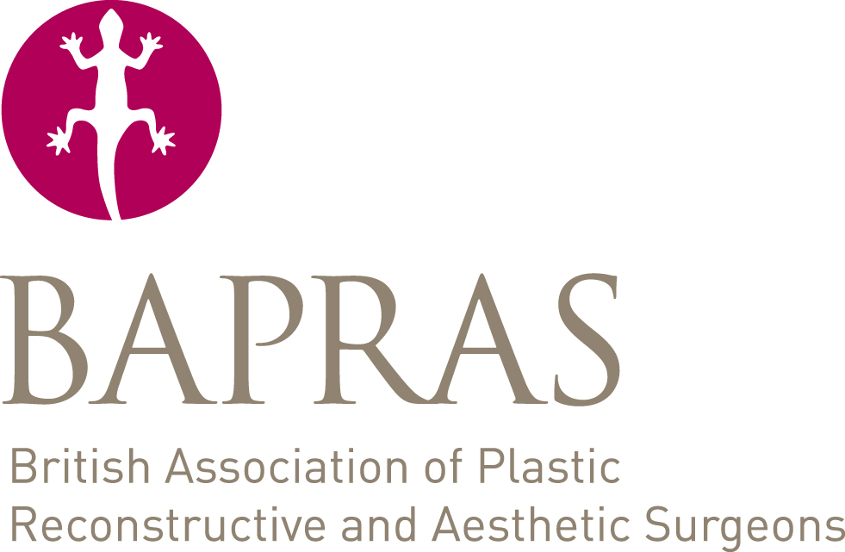

**Statement of Sponsorship- Membership Application**

In order to assist the BAPRAS Council's deliberations as to the suitability of those wishing to become Members of the Association, it is requested that sponsors provide comments on the candidate.

Particular reference should be made to the applicant's training, his/her clinical and operative abilities and how you have been able to assess these qualities.

In the case of interspecialty membership applications, please comment on your knowledge of how the applicant works within multidisciplinary teams with plastic surgeons.

|  |
| --- |
| Applicant’s name: |
| Sponsor’s name: |
| Statement of sponsorship: |