Multi-disciplinary Collaborative Simulation System for Launch Vehicle Design

S. Y. Li¹; J. H. Liu¹; B. Qiao^{2*}

¹Institute of Aerospace System Engineering Shanghai, Shanghai, China
²Nanjing University of Aeronautics and Astronautics, Nanjing, China, bqiao@nuaa.edu.cn

A multi-disciplinary collaborative simulation policy for the overall design of launch vehicle is presented. The multi-disciplinary processes and their relationships for launch vehicle design are first examined to determine the function modules of the co-simulation platform, which can be depicted in Figure 1.
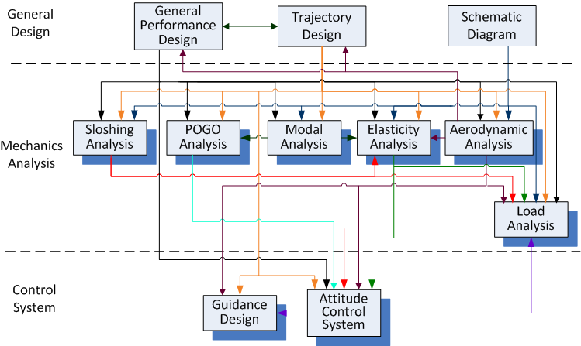
Figure 1: Multi-disciplinary processes of launch vehicle design
An architecture of multi-disciplinary collaborative simulation for launch vehicle design is established based on the supporting software framework as demonstrated in Figure 2, in which the overall design process of launch vehicle that covers the task allocation, data transfer and design simulation is formed through customised workflow to achieve the customization of task, the automation of data transfer and the modularization of computation.
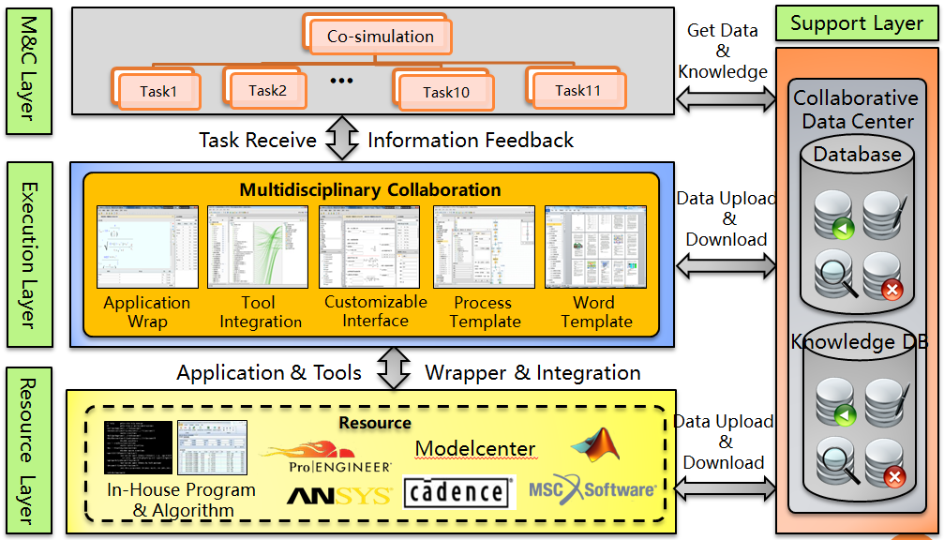
Figure 2: Co-simulation support software framework
The application scenario of the multi-disciplinary collaborative simulation system and its implementation in launch vehicle designs are presented in the paper, which indicates that the system not only obviously improves the efficiency of the overall design of the launch vehicles, but also shortens the cycle of design and guarantees the accuracy of the data exchange.
References
[1] Zhang, W. D., Li, S. Y. and Zhen, Y.: Digital engineering of launch vehicle, Beijing mechanical industry publishing house, 2017
[2] Robinson, J. S.: An overview of NASA's integrated design and engineering analysis (IDEA) environment. April 11, 2011, Langley Research Centre

