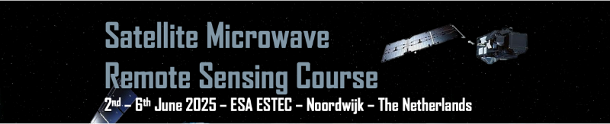

**Student Sponsorship Application**

**What**: Satellite Microwave Remote Sensing Course

**When**: 2-6 June 2025

**Where**: ESA-ESTEC, Keplerlaan 1, 2201 AZ, Noordwijk (NL)

* Required

1. First Name *

Double-click and entry your first name

1. Last Name *

Double-click and entry your family name

1. Email address *

Double-click and entry your email

1. Age *

Double-click and entry your age

1. Gender *

Man

Woman

O ther

1. Nationality(ies) *

Double-click and entry your first nationality

1. University Name *

Double-click and entry your University name

1. University Country *

Double-click and entry your University country

1. Level of Study *

Bachelor

Master

PhD

Other

1. Field of Study (Science, Engineering, Legal, Business, ...) *

Double-click and entry your field of Study

1. Is this course embedded in your academic programme? *

Yes

No

1. Have you ever been sponsored by ESA? *

Yes

No

1. If you have, which activity/ies did you participate to? *

Double-click and entry your answer

1. Do you have less than 2 years of professional experience? *

Yes

No

1. If you have more than 2 years’ experience, who was your last employer? *

Double-click and entry your answer

1. What is your justification for ESA Academy scholarship request? *

Double-click and entry your answer

1. Do you benefit from an overlapping financial support to attend this conference? *

Double-click and entry your answer

1. If you do, please describe the financial support *

Double-click and entry your answer

1. Do you agree with the with ESA Academy's Privacy Policy? *

Available here: <https://esamultimedia.esa.int/ESAAcademyPrivacyPolicy.pdf>

Yes