Straylight Modelling and Correction for the Infrared Sounder (IRS) on MTG-S
Guillaume Deschamps*, Pierre Dussarrat, Dorothee Coppens
EUMETSAT, Eumetsat Allee 1, 64295 Darmstadt, Germany
*guillaume.deschamps@eumetsat.int

Abstract
The Infrared Sounder (IRS) onboard the Meteosat Third Generation Sounding satellite (MTG-S) is the first European hyperspectral infrared sounder operating from geostationary orbit (GEO). Following a successful launch in July 2025 and a one-year commissioning phase, the first IRS instrument is now delivering operational data, processed by EUMETSAT and disseminated to weather centres and the scientific community across Europe.
IRS is an imaging Fourier Transform Spectrometer (iFTS) based on a Michelson interferometer, providing thermal infrared measurements with an unprecedented spatial sampling of 4 km at nadir. As an imaging instrument, IRS is sensitive to straylight arising from internal reflections and scattering. Within an iFTS, straylight may cause the mixing of interferograms with different phases, which complicates the measurement modelling and the correction at the level of the associated spectral radiances.
To address this, EUMETSAT has developed a comprehensive straylight model in collaboration with ESA and OHB. This model accounts for all parasitic reflections and includes components that back-propagate into the instrument and pass through the interferometer a second time. Building on this, an innovative post-processing approach has been implemented in the on-ground operational processor to mitigate the impact on calibrated radiances. The method consists of a two-step process: spectral response function uniformization followed by spatial deconvolution.
Dedicated commissioning activities of IRS, focusing on limb observations from the geostationary orbit, have finally enabled the optimization and validation of the straylight model, as well as the evaluation of the correction performance.
Keywords: hyperspectral infrared, Fourier transform spectrometry, infrared sounder, straylight correction.

Introduction
Straylight affects all Earth observation (EO) missions to some degree. It is generally constrained by dedicated specifications and accounted for in the instrument design, yet anticipating its impact on performance, characterizing it accurately, designing corrections and monitoring its in-flight level all remain challenging. Straylight consequently remains a major contributor to the final performance of the instruments and limits their exploitation.
For Fourier transform spectrometry (FTS) from space, the low-Earth orbit (LEO) missions — IASI [1], IASI-NG [2], CrIS [3] and HIRAS [4] — have been largely spared, owing to non-imaging designs and to the physical separation of the fields of view (FOV) by cold plates. The new generation of FTS in geostationary orbit (GEO) is of a different nature: these are imaging FTS (iFTS) delivering contiguous imagery of the Earth's disc — IRS [5] and GIIRS [6] — whose large detector arrays and open designs make them markedly more sensitive to spurious light reflections. Dedicated modelling, characterization and correction are therefore required to compensate for the radiometric impact of straylight on iFTS products.
The present paper addresses the Infrared Sounder (IRS) on board the Meteosat Third Generation Sounding satellite (MTG-S). The modelling, characterization and correction reported here are nevertheless transferable to the Chinese FY-4 GIIRS [6,7], to the future Japanese GHMS mission [8] and, more generally, to any imaging Fourier transform spectrometer.
Straylight has been studied extensively for conventional imagers [9], but FTS present two specificities that make it difficult to model. First, the primary measurements of an FTS are interferograms, that is, light modulations produced by an interferometer — a Michelson in the case of IRS — as a function of the optical path difference (OPD) between its two arms; straylight therefore mixes interferograms originating from different field angles, with uneven phases and frequency scales. Second, light can be reflected back towards the interferometer, cross it a second time and generate additional interference patterns. As a result, the associated straylight kernels may be partially negative at radiance level, which conventional imagery does not allow.
Straylight correction for IRS was introduced by the authors in [10]. The present manuscript goes considerably further: it details the design of the straylight model, the procedure to adjust it in flight, and the actual implementation of the correction on in-flight data.
The paper is organized as follows. Section 2 describes the optical modelling of IRS, section 3 the impact on the acquisitions, section 4 the model optimization, section 5 the correction methodology and section 6 the validation.

Optical modelling
As pictured in Figure 1 (extracted from [11]), the light path through IRS starts at the scan mirror, which feeds the front telescope towards the Michelson interferometer. The interferometer comprises a beam splitter and two arms with corner cubes, one fixed and one mobile, the latter covering approximately 8.25 mm in 9.7 s. The back telescope then guides the light into the cryostat, through the focusing optics and a dichroic that splits the LWIR and MWIR bands. The interferograms are finally recorded at the focal plane by a 160×160-pixel detector [12].

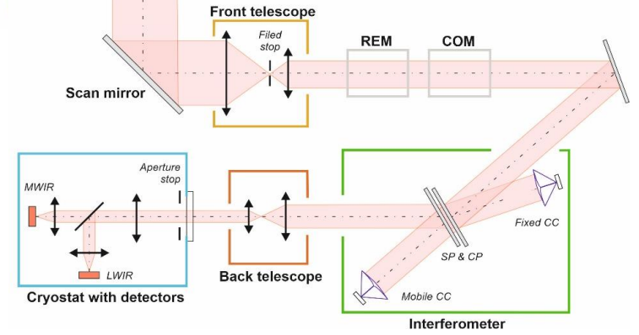
Figure 1. MTG-S IRS instrument optical design (extracted from [11])

The spatial response of the instrument is described by the inverse point spread function (iPSF), $iPSF\left(θ_{FOV}, θ_{det}, ν\right)$, which gives the angular distribution of the light received by each pixel of IRS as a function of the angular position in the field of view $θ_{FOV}$, the angular position of the pixel $θ_{det}$ and the wavenumber $ν$ (the inverse of the wavelength). For a perfect instrument, free of diffraction and of spurious reflections, the iPSF reduces to a Kronecker delta function, the $IPSF\left(θ_{FOV}, θ_{det}, ν\right)$ equals unity for the optical conjugation $θ_{FOV}=θ_{det}$ and vanishes elsewhere.
The iPSF is split into a short-range component, driven by diffraction and by the pixel shape, and a long-range component gathering all possible spurious reflections and scattering.

  - Diffraction
The short-range component is essentially set by the pixel size and the pupil shape. The "star" shape of the diffraction pattern, as shown in Figure 2, originates from the corner cubes of the interferometer: the edges between their three mirrors are non-reflective, so that the effective pupil is a disc crossed by three lines. The theoretical model is further adjusted on knife-edge sweeps (a cold edge in front of a hot blackbody) acquired during the thermal vacuum (TVAC) campaign [11]. Figure 2 shows the integrated PSF along the horizontal direction for several wavenumbers. The response is dominated by the pixel size, but it also broadens with wavelength, as expected from diffractive effects.

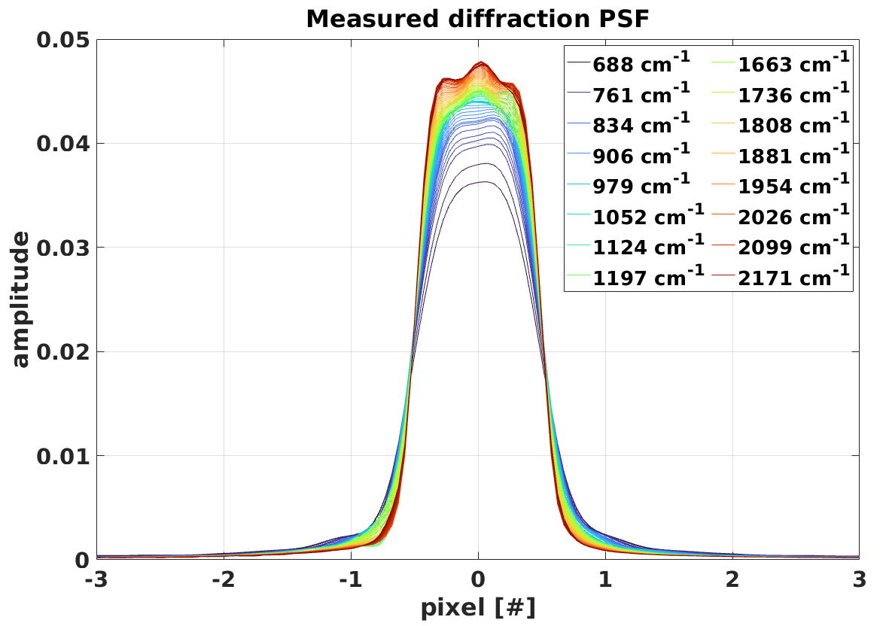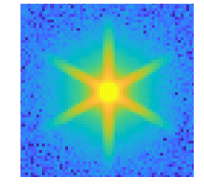
Figure 2. Measured integrated PSF for several wavenumbers (left) and illustration of the PSF modelling (right)

  - Ghosts
The long-range components gather all possible light paths within the instrument, since every surface of the transmissive optics can produce a spurious reflection, called hereafter a ghost.
A dedicated ray-tracing algorithm has been developed in-house at EUMETSAT. It starts from the detector and propagates rays up to the entrance of the instrument, applying the Snell–Descartes laws and accounting for every possible spurious reflection.
Millions of rays are traced for each straylight path, which is made tractable by the use of GPU acceleration. The simulation includes the interferometer, the back telescope, the cryostat entrance window, the aperture stop, the dichroic and the focalization optics (Figure 1). Mechanical mounts are not simulated, and a ray is terminated as soon as it falls outside an optical component or hit and optical baffle. The interferometer is treated as a simple partial reflector returning about 50 % of the light, and the front telescope is not modelled explicitly.
Counting the rays at the entrance yields the iPSF associated with each ghost. The straylight kernels are computed for the 160×160 pixels of the detector and for 196×196 FOV positions; the FOV grid is larger than the detector grid in order to include field angles up to the field stop, which admits angles 20 % larger than the detector.
Up to 100 ghosts are considered. Each has its own iPSF, scaled by the reflectivity of the optical components where the reflections occur. The scaling of the complete set therefore depends on only seven reflectivity values — the detector, the two focalization optics, the dichroic, the aperture stop, the cryostat entrance window and the interferometer — for all of which a priori values are available.

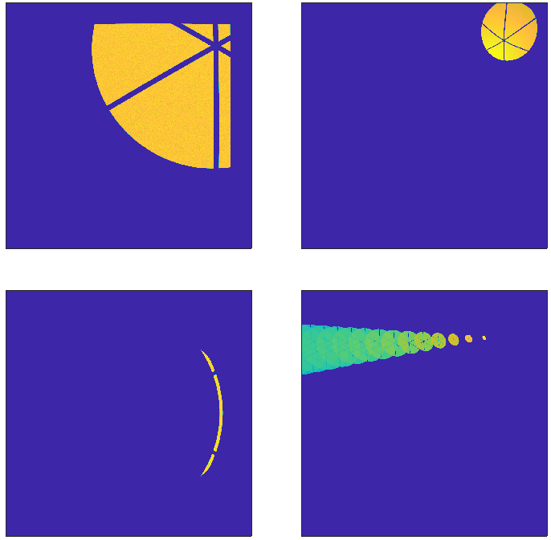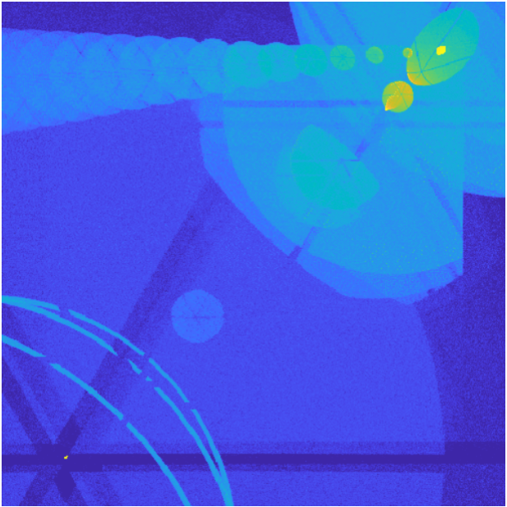
Figure 3: Example of iPSF associated to ghosts (left): detector reflection – cold optics, inside cold optics, cold optics – cold stop, dichroic bounces. Total iPSF for the top-right pixel (right)
Two iPSF representing scattering over all optical surfaces are further added, they are uniform over the FOV and identical for all pixels. One is accounting for the light paths crossing the interferometer once, and the other twice (see the discussion in section 3.3); their a priori amplitudes are null.
In summary, the instrument iPSF is built from its short-range and long-range components, and the complete iPSF definition, for all pixels, is constrained by only seven coating amplitudes and two scattering amplitudes.

Interference modelling
This section models the impact of straylight on the IRS acquisitions, that is, on the interferograms, and derives the resulting impact on the retrieved radiances. Two edge cases are used to split the problem into its spectral and spatial dimensions.

  - Perfect interferogram
A perfect interferogram, noted $I_{0}\left(x,θ_{det}\right)$ and free of diffractive effects and straylight, exhibits interferences depending on the displacement of the mobile corner cube along the optical axis and on the incoming light spectral distribution $Sp\left(ν, θ_{det}\right)$. The effective optical path difference between the two arms of the interferometer is noted $OPD\left(x, θ_{det}\right)$ with its reference value along the optical axis noted $x$ and the path balance at zero OPD is noted $ZPD\left(θ_{det}\right)$.
$$I_{0}\left(x,θ_{det}\right)=\int{dν Sp\left(θ_{det}, ν\right)×\cos\left(2πν \left[OPD\left(x,θ_{det}\right)+ZPD\left(θ_{det}\right)\right]\right)}$$
For a Michelson interferometer, the OPD is generally proportional to the cosine of the field angle within the interferometer, $OPD\left(x,θ_{det}\right)=x cos⁡(θ_{det})$. For IRS, this computation is refined using the exact trajectory of the corner cube derived from the on-board metrology lasers [10]. The ZPD depends on the beam splitter geometry and is likewise computed from the metrology beams.
Accounting for the on-board frequency filtering, which keeps only the positive frequencies of the cosine, and for the OPD resampling, which compensates for the difference of OPD across the FOV with respect to the optical axis, we find:
$${\tilde{I}}_{0}\left(x,θ_{det}\right)=\int{dν Sp\left(ν, θ_{det}\right)×\exp\left(2iπν\left[x+ ZPD\left(θ_{det}\right)\right]\right)}$$
The OPD along the optical axis $x$ and the wavenumber $ν$are conjugated variables through Fourier transform, so that the spectral distribution of the scene is simply recovered by Fourier transform of the interferogram — the very foundation of FTS. Only a phase term $\exp\left[2iπν ZPD\left(θ_{det}\right)\right]$ remains, which is generally removed by subsequent radiometric calibration.

  - Impact of straylight on the interferogram
In the presence of diffractive effects or of straylight, the interferogram $I_{stray}\left(x,θ_{det}\right)$ becomes spatially convoluted with the scene spatial distribution $Sp\left(ν, θ_{FOV}\right)$ as follows:
$$I_{stray}\left(x,θ_{det}\right)=\int{dν \sum_{θ_{FOV}}{iPSF\left(θ_{FOV}, θ_{det}, ν\right)×}Sp\left(ν, θ_{FOV}\right)×\cos\left(2πν \left[OPD\left(x,θ_{FOV}\right)+ZPD\left(θ_{FOV}\right)\right]\right)}$$

Accounting for the on-board processing, we find:
$${\tilde{I}}_{stray}\left(x,θ_{det}\right)=\int{dν \sum_{θ_{FOV}}{iPSF\left(θ_{FOV}, θ_{det}, ν\right)×}Sp\left(ν, θ_{FOV}\right)×\exp\left(2iπν\left[\begin{aligned}δOPD\left(x,θ_{FOV},θ_{det}\right)+x \\ + ZPD\left(θ_{FOV}\right)\end{aligned}\right]\right)}$$

The difference of OPD between the pixel and the FOV from which the straylight originates is defined as:
$$δOPD\left(x,θ_{FOV},θ_{det}\right)= OPD\left(x,θ_{FOV}\right)-OPD\left(x,θ_{det}\right)$$

To go further in the calculation, two extreme cases isolate each dimension of the problem: first spatially uniform scenes, then spectrally smooth scenes. Real acquisitions are always more complex — blackbody and deep space acquisitions excepted — but these limiting cases allow the problem to be disentangled and guide the design of the correction methodology presented in section 5.

- Spatially uniform scenes
In the case of a spatially uniform scene, the interferogram equation simplifies and the impact of straylight appears as a loss of contrast at interferogram level, called self-apodisation (SAF). For each detector and wavenumber, the interference is modulated by the following SAF:
$${\tilde{I}}_{stray}\left(x,θ_{det}\right)≅\int{dν Sp\left(ν, θ_{det}\right)×SAF\left(x,θ_{det},ν\right)}×\exp\left[2iπνx\right]$$
$$\boxed{SAF\left(x,θ_{det},ν\right)=\sum_{θ_{FOV}}{iPSF\left(θ_{FOV}, θ_{det}, ν\right)}×\exp\left(2iπν \left[δOPD\left(x,θ_{FOV},θ_{det}\right)+ ZPD\left(θ_{FOV}\right)\right]\right)} \left(1\right)$$

Self-apodisation is a well-known topic in the field of FTS. The SAF is the counterpart, in the interferogram domain, of the instrument spectral response function (SRF), to which it is related by Fourier transform, and dedicated algorithms exist to compensate for it, generally referred to as SRF uniformization [13,14]. One example is discussed in section 5.1.

- Spectrally smooth scenes
In the case of a spectrally smooth scene, taking the Fourier transform of the interferogram retrieves the impact at radiance level, ${Sp}_{stray}\left(ν,θ_{det}\right)$, which appears as a spatial convolution with a straylight kernel $K\left(θ_{FOV}, θ_{det}, ν\right)$:
$${Sp}_{stray}\left(ν,θ_{det}\right)=FT\left[{\tilde{I}}_{stray}\left(x,θ_{det}\right)\right]≅\sum_{θ_{FOV}}{K\left(θ_{FOV}, θ_{det}, ν\right)}×Sp\left(ν, θ_{FOV}\right)$$
$$\boxed{K\left(θ_{FOV}, θ_{det}, ν\right)= iPSF\left(θ_{FOV}, θ_{det}, ν\right)×\exp\left(2iπν ZPD\left(θ_{FOV}\right)\right)} \left(2\right)$$

At radiance level, straylight is therefore more than a convolution by the iPSF, as it would be for a conventional imager: the kernel also carries the ZPD in a complex exponential term, which relates to the difference of phases between the interferograms mixed by straylight.

  - Back-reflections into the interferometer
The components crossing the interferometer a second time are now also considered. By sorting out which interferences can affect the acquisitions, the SAF and the straylight kernel are updated by splitting the iPSF in two, $iPSF_{\#1}$ and $iPSF_{\#2}$, according to whether the light path crosses the interferometer once or twice. The SAF and straylight kernel become:

$$SAF\left(x,θ_{det},ν\right)=\begin{matrix}\sum_{θ_{FOV}}{iPSF_{\#1}\left(θ_{FOV}, θ_{det}, ν\right)}×\exp\left(2iπν \left[δOPD\left(x,θ_{FOV},θ_{det}\right)+ ZPD\left(θ_{FOV}\right)\right]\right) \\ + \sum_{θ_{FOV}}{iPSF_{\#2}\left(θ_{FOV}, θ_{det}, ν\right)}×\left\{\begin{aligned}\exp\left(2iπν \left[δOPD\left(x,θ_{FOV},θ_{det}\right)+ ZPD\left(θ_{FOV}\right)\right]\right) \\ -\exp\left(2iπν ZPD\left(θ_{det}\right)\right)\end{aligned}\right\}\end{matrix}$$
$$K\left(θ_{FOV}, θ_{det}, ν\right)=\begin{matrix} iPSF_{\#1}\left(θ_{FOV}, θ_{det}, ν\right)×\exp\left(2iπν ZPD\left(θ_{FOV}\right)\right) \\ + iIPSF_{\#2}\left(θ_{FOV}, θ_{det}, ν\right)×\left\{\exp\left(2iπν ZPD\left(θ_{FOV}\right)\right)-\exp\left(2iπν ZPD\left(θ_{det}\right)\right)\right\}\end{matrix}$$

The minus sign accounts for the fact that the second pass through the interferometer is performed “in reverse”, the light entering and leaving by the same port.

  - Radiometric calibration
The SAF and the straylight kernel can be adapted to include the radiometric calibration of the radiances, which is generally applied on ground. In the context of IRS, radiometric calibration relies on calibration targets — an on-board blackbody and deep space acquisitions — to correct the gain and the offset of the products.

The SAF and the straylight kernel to be considered when dealing with calibrated radiances then read:
$$\boxed{SAF_{C}\left(x,θ_{det},ν\right)=\frac{SAF\left(x,θ_{det},ν\right)}{SAF\left(x=0,θ_{det},ν\right)} \left(3\right) ; K_{C}\left(θ_{FOV}, θ_{det}, ν\right)=\frac{K\left(θ_{FOV}, θ_{det}, ν\right)}{\sum_{θ_{FOV}}{K\left(θ_{FOV}, θ_{det}, ν\right)}} \left(4\right)}$$

As a conclusion, straylight has a spectral impact, distorting the SRF of the instrument, as well as a convolutional effect spatially mixing the scene. The two aspects are captured by a SAF and a straylight kernel, both of which are extended to account for the double light path into the interferometer and adapted to calibrated radiances.

Model optimization on Limb views
The optical model provides the spatial optical response of the instrument, and the interference modelling provides the resulting impact on the interferograms and on the associated radiances. The modelling can be verified on ground, using TVAC acquisitions with knife edges and/or laser views, to validate and adjust the SAF and the straylight kernels. In the following, however, we present a methodology that can instead be run in flight, and which relies on limb views to optimize the straylight model.

IRS performs acquisitions up to and beyond the Earth limb — as GIIRS does— so that part of the detector array partly observes deep space. Forty limb views distributed all around the disc are analysed, and the signal leaking into deep space is measured; in the absence of straylight, this signal should be strictly null. Figure 4 shows an example of limb view in complex at 910 cm⁻¹. Changing the colour scale reveals leaked signal into space, and even negative values for the real part, which is impossible in conventional imagery.

  - First adjustment
The adjustment methodology starts by extracting the real calibrated radiances of the Earth side only, for all 40 limb views. These are then convoluted with the calibrated straylight kernel $K_{C}$ (section 3.4) to make a prediction of both the complex signal in deep space and the imaginary component on the Earth side.

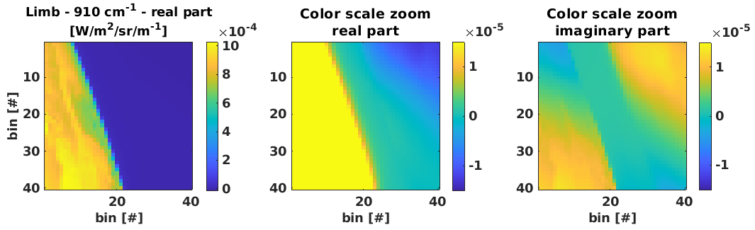
Figure 4. Limb view at 910 cm⁻¹ in [W/m²/sr/m⁻¹] real part (left and middle) and imaginary part (right), binned to 40×40 to reduce noise, color scale is zoomed to highlight straylight in deep space (middle and right)

For IRS, the adjustment is performed independently over 10 spectral sub-bands per band, of about 5000 m⁻¹ width, over which the radiances are averaged. Both the acquisitions and the predictions are also binned to 40×40 to reduce the noise and computational load.

The nine parameters — seven coating and two scattering amplitudes — are then adjusted, starting from their a priori values, to best match both the complex signal acquired in deep space and the imaginary values on the Earth side. The layer of atmosphere is excluded from the optimization to avoid that atmospheric signal interferes in the adjustment. The retrieved coating values are found close to their a-priori counterparts, although they may not be strictly physical, since the optimization also compensates for the limited representativeness of the model — missing ghosts, or an as-built geometry departing from the optical model.

Performing the optimization on complex rather than real values is paramount, as the imaginary component of the radiances carries additional information on straylight. But doing so requires a very stable ZPD (sub-nm variations), which is the case for IRS, to avoid phase fluctuations of the radiances.

  - Ad-hoc polynomials
Although the resulting modelling already matches well the patterns observed in space, additional 15 ad-hoc polynomials are added to the iPSF. They are used only to improve the spatial representation of straylight and are excluded from the SAF computation. The polynomials are of 2nd order maximum in the two spatial dimensions of the FOV noted $\left(y,z\right)$:

$$P\left(θ_{FOV}, θ_{det}\right)= θ_{FOV,y}^{n1}×θ_{FOV,z}^{n2}× θ_{det,y}^{n3}× θ_{det,z}^{n4} 0≤n1+n2+n3+n4 ≤2$$

This yields 15 independent monomials: one constant term, four of first order and ten of second order (four squares and six cross-products). Being purely empirical, these terms carry no physical optical path and hence no associated ZPD; they therefore complete the spatial description of straylight only, the SAF remaining entirely driven by the physical iPSF components.
The amplitude of each of the 15 polynomials are optimized to best match the real part of the signal in space, the nine previous parameters being kept unchanged. Figures 5 and 6 show the limb acquisitions together with the predictions of the adjusted model, for the real and the imaginary parts respectively, and normalized by the average real signal on the Earth side. The modelling achieves an outstanding match of all straylight patterns. It is worth recalling that such a match would be unachievable for IRS without the ZPD terms and the double light path in the interferometer as introduced in section 3.
Finally, Figure 7 compares the real signal measured in space for all 40 limbs with the predictions in terms of root mean square (RMS): first without any predicted straylight, then with the model using a-priori coating values — which is already quite effective — then with optimized coating values and, finally, adding the optimized ad hoc polynomials. The modelling allows to explain most of the signal acquired in space, reducing approximately the RMS by a factor of 4 to 5.

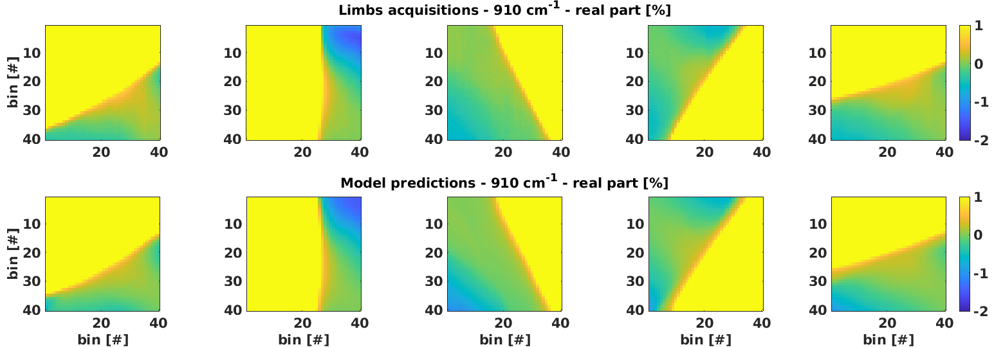
Figure 5. Selection of limb acquisitions (up) and associated model predictions (down), real part at 910 cm⁻¹ normalized by the average real signal on the Earth side.

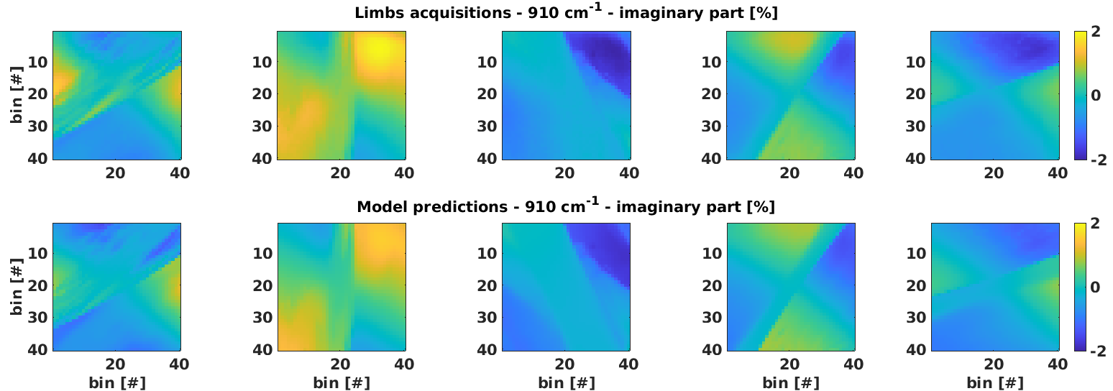
Figure 6. Selection of limb acquisitions (up) and associated model predictions (down), imaginary part at 910 cm⁻¹ normalized by the average real signal on the Earth side.

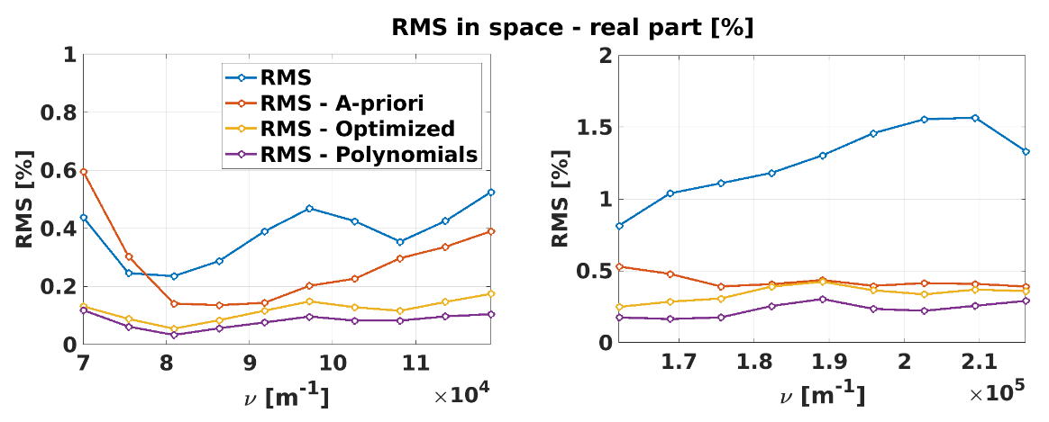
Figure 7. RMS between the acquisitions and the model predictions in space (real part): without any predicted straylight (blue), with the a-priori coating values (red), optimized coating values (yellow), optimized ad hoc polynomials (purple)

Straylight correction
Sections 2 to 4 provide a straylight model that is both physically grounded and adjusted in flight. This section describes how that model is turned into an actual correction of the radiances, applicable to all acquisitions and not only to limb views.
Section 3 suggests that the correction could be introduced directly at interferogram level, by spatial deconvolution. At that stage, however, the acquisitions are not yet radiometrically calibrated, which would considerably complicate the task. For IRS we have therefore developed a post-processing acting on calibrated radiances. A further benefit of this choice is that the method remains transferable to other instruments, whose calibration steps may be ordered or implemented differently.
As discussed in our previous paper [10], straylight can in principle be corrected exactly; because it mixes the spectral and the spatial dimensions, however, an exact inversion is computationally unreasonable — all the more so for IRS with its 160×160 pixels [18]. Our method therefore treats the two dimensions independently.
The correction is two-fold: first a correction of the SRF distortion, by SRF uniformization, then a deconvolution removing the spatial mixing of the scenes. As discussed in [10], the resulting correction is not exact, but it remains very effective, which is verified in section 6.

  - SRF uniformization
SRF uniformization is a recurrent processing in FTS, which aims at compensating the SRF distortions for all pixels and wavenumbers. To the authors' knowledge, such corrections are already applied for IASI, IASI-NG and CrIS [15].
For IRS, the processing is applied to all 160x160 pixels and 10 wavenumber sub-bands per band. We start by extracting 10 spectral sub-bands from the calibrated radiance noted $Sp_{k}\left(ν, θ_{det}\right)$ centered around $ν_{k}$ (with spectral overlaps) for which the straylight model has been optimized (section 4). Each piece is inverse Fourier transformed into the associated interferogram, from which the self-apodisation is removed by division by $SAF_{C}\left(x,θ_{det},ν_{k}\right)$. A direct Fourier transform then yields the corrected piece $Sp_{corr,k}\left(ν, θ_{det}\right)$, and the complete corrected spectrum is recovered by linear interpolation of the 10 sub-bands.
$$Sp_{corr,k}\left(ν, θ_{det}\right)= FT\left[\frac{FT^{-1}\left[Sp_{k}\left(ν, θ_{det}\right)\right]\left(x\right)}{SAF_{C}\left(x,θ_{det},ν_{k}\right)}\right]\left(ν\right)$$

Figure 8 shows the calibrated SAF computed for the central pixel of the array, at four wavenumbers of the LWIR band. Departures from unity are found, largest at 700 cm⁻¹, where the interferogram contrast is reduced by straylight by up to 3% at the largest OPD.

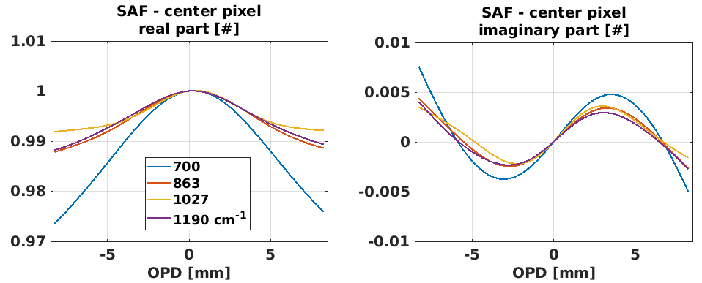
Figure 8. Calibrated SAF of IRS center pixel for 4 wavenumbers in the LWIR band, real (left) and imaginary part (right)

  - Deconvolution
The second step removes the spatial mixing of the scenes, by inversion of the calibrated straylight kernel. As discussed in section 3, the calibrated radiances measured over the array are related to the true scene through the equation below:
$${Sp}_{stray}\left(ν,θ_{det}\right)≅\sum_{θ_{FOV}}{K_{C}\left(θ_{FOV}, θ_{det}, ν\right)}×Sp\left(ν, θ_{FOV}\right)$$

The equation is formally a matrix multiplication, which can be inverted approximately to retrieve $Sp\left(ν, θ_{FOV}\right)$, following several processing steps.

First, as the field stop is larger than the detector field of view, an ideal spatial deconvolution would require information outside of the measured dwell. To avoid processing dependency on adjacent dwells, the area of the straylight kernels which are outside of the detector field of view are first “folded”. This is equivalent to making a symmetry of the scene on the edges as shown in Figure 9. As the amount of straylight is very small between the limit of the detector field of view and the field stop, this technic is being used allowing each dwell to be processed independently. The drawback is that for some cases, straylight is not perfectly corrected on the dwell edges.

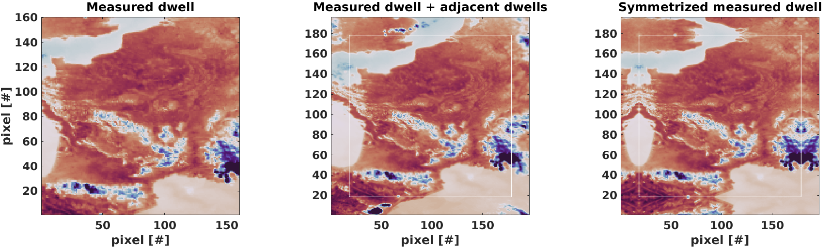
Figure 9: Illustration of the effect of straylight kernel folding on the edges of the dwell

Secondly, the straylight kernel is inverted for each spectral sub-band for which the model has been optimized (section 4), $K_{C}^{-1}\left(θ_{det}, θ_{FOV}, ν_{k}\right)$. Deconvolved radiances ${Sp}_{deconv,k}\left(ν,θ_{FOV}\right)$ are retrieved by matrix multiplication with the inverse kernels and the complete deconvolved spectrum is recovered by linear interpolation of the 10 sub-bands.
$${Sp}_{deconv,k}\left(ν,θ_{FOV}\right)=\sum_{θ_{det}}{K_{C}^{-1}\left(θ_{det}, θ_{FOV}, ν_{k}\right)}×Sp_{stray}\left(ν, θ_{det}\right)$$

To further improve the processing efficiency, the straylight deconvolution is performed on 4x4 spatial bins (processing not described in this paper). The correction is thereby restricted to the medium- and long-range effects of diffraction and ghosts: the spatial quality of the spectral response at the scale of a single pixel is not relevant for most applications of IRS, and a short-range deconvolution would in any case amplify the noise significantly. Binning to reduce the computational load of a ghost-dominated straylight inversion is the same trade-off reported for conventional imagers [9].

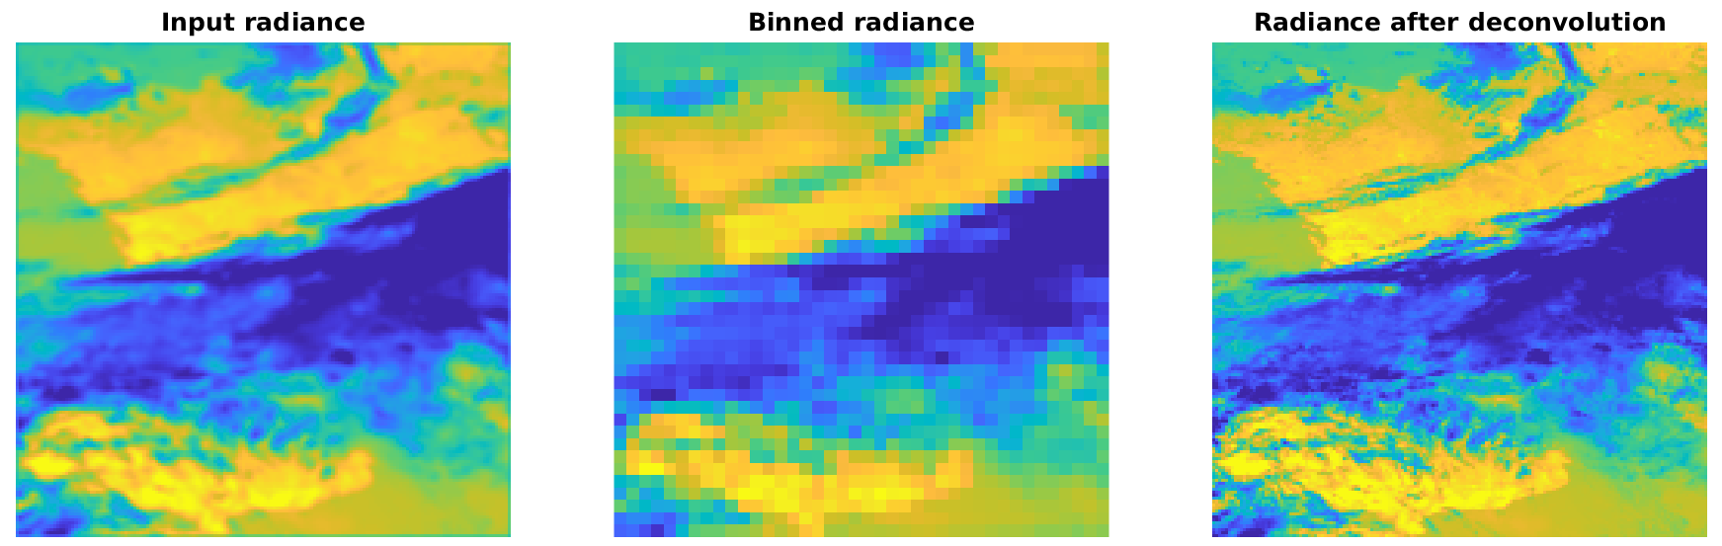
Figure 10: Deconvolution using binned straylight kernels (amplified illustration not representative of real IRS straylight)

Validation

  - TVAC Laser
We first validate the SAF model using laser acquisitions from the TVAC campaign [11]. The narrow spectral bandwidth of a laser allows the SRF of the instrument to be characterized accurately; taking the inverse Fourier transform of the measured SRF provides the associated measured SAF at the laser wavenumber, which can be compared to the model optimized on the limbs.
As shown for 3×3 pixels of the array in Figure 10, measured and modelled SAF are consistent at the LWIR laser wavenumber of 944 cm⁻¹, the model being computed as described in section 3.
It is worth noting that the model is optimized on the spatial patterns of straylight alone, yet it also reproduces the measured SAF over the detector array, which is a spectral feature of straylight. This confirms the theoretical interrelation between the spatial and spectral effects of straylight, and the consistency of the modelling.
The only discrepancy is a slight tendency of the model to over-estimate the SAF, by approximately 1 % on the real part at maximum OPD; this feature will be investigated further in the future.

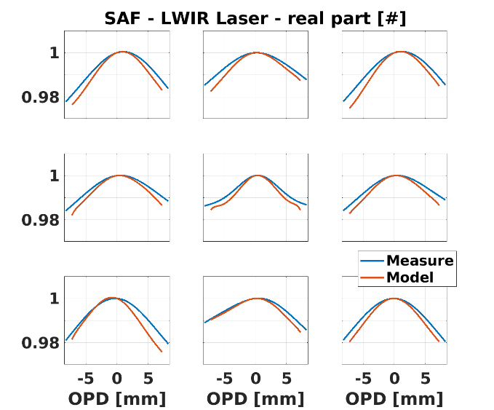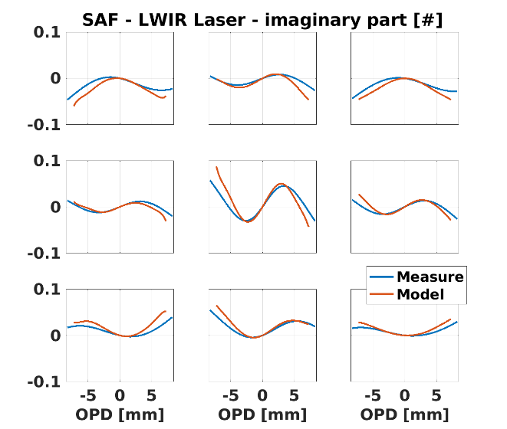
Figure 11. Measured and modeled SAF at the TVAC LWIR Laser wavenumber (944 cm⁻¹) for 3x3 pixels of the array, real (left) and imaginary part (right)

  - Limb views
The spatial deconvolution is then applied to the limb views, as shown in Figure 11. The straylight patterns are largely removed: at 910 cm⁻¹ the RMS of the signal in space is reduced by approximately a factor of 4. The corrected images exhibit a much sharper transition between Earth and space, and significant corrections are also made on the Earth side.
Several limb views for which the correction is not perfect are shown on purpose, some residual patterns remaining in space. These are likely to originate from straylight contributors that are not modelled.

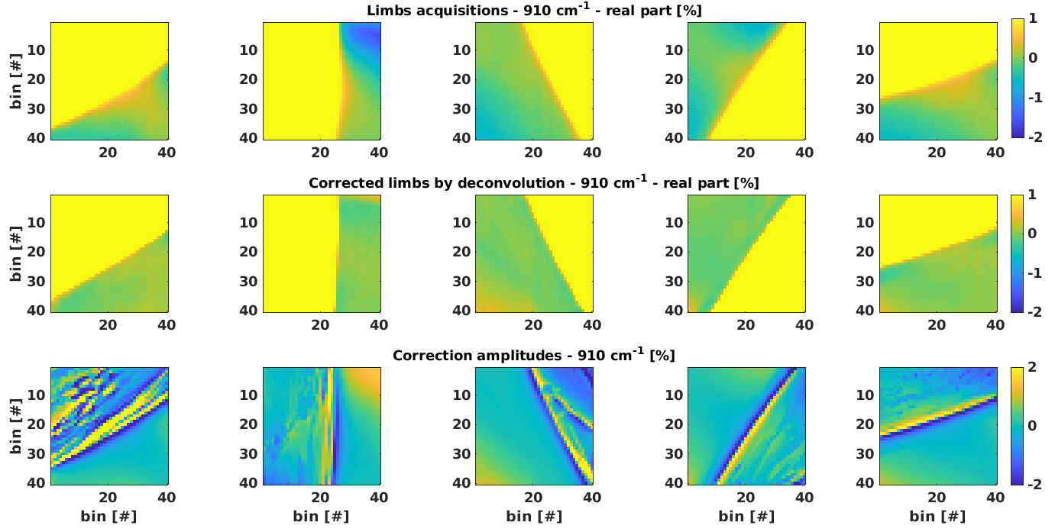
Figure 12. Limbs acquisitions (top), corrected by deconvolution (middle row) and the amplitude of the deconvolution correction (down), at 910 cm⁻¹ and normalized by the average real signal on the Earth side.
  - Comparison to IASI
Finally, the quality of the IRS radiances is evaluated against another instrument, using collocated acquisitions. IASI is taken as the reference, being widely recognized as an international radiometric standard for hyperspectral infrared sounding [1].
The spatial mixing induced by straylight is expected to degrade the contrast of the acquisitions, to reveal it we analyse the radiometric differences between IRS and IASI as a function of the scene temperature, before and after application of the deconvolution. The characterization is split into five classes of scene temperature, determined from the average IASI spectrum per band and defined so as to contain an equal number of elements. As shown in Figure 13, the deconvolution removes effectively the temperature-dependent component of the difference. The agreement after correction is at the 0.2 K level, well within the IRS absolute radiometric specification of 0.5 K.

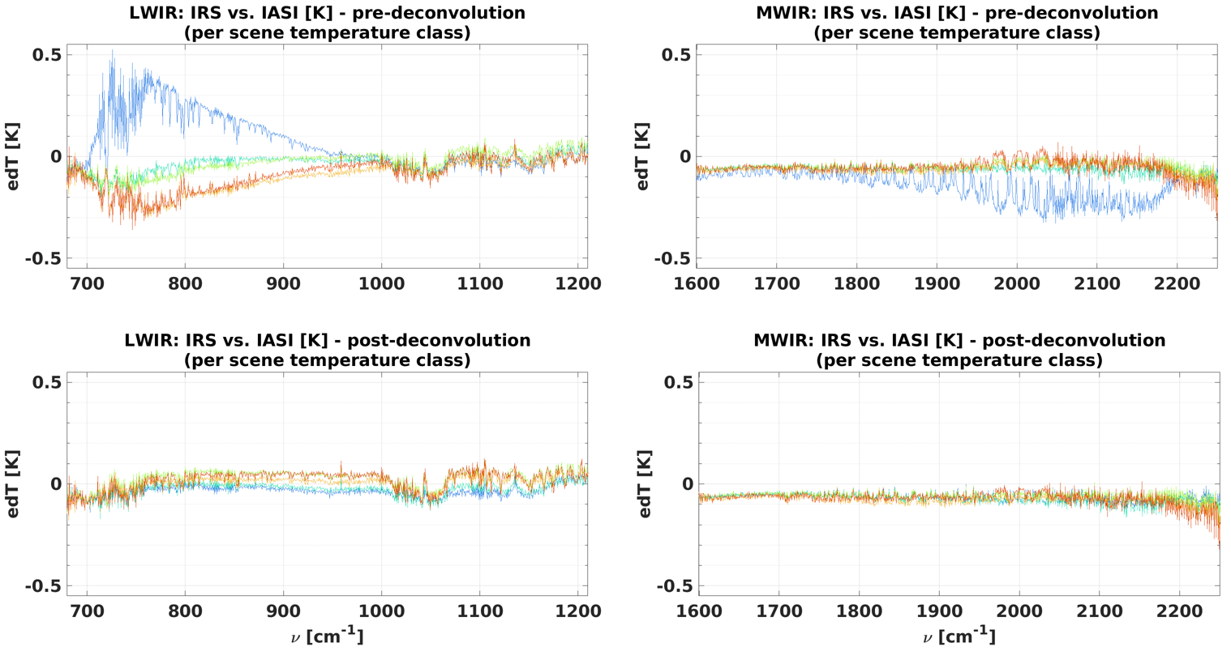
Figure 13. Radiometric calibration comparison between IRS and IASI, per class of scene temperature (cold to hot, blue to red). Before (up) and after (down) application of the deconvolution.

Conclusion
Straylight is a first-order limitation for imaging Fourier transform spectrometers in geostationary orbit, and IRS on MTG-S is the first European instrument of this class to face it operationally. This paper has presented the complete chain implemented at EUMETSAT, from optical modelling to in-flight optimization, correction and validation.
The optical model relies on an in-house, GPU-accelerated ray-tracing algorithm that propagates rays from the detector back to the instrument entrance and accounts for up to 100 ghosts, complemented by a diffraction term adjusted on TVAC knife-edge sweeps and by two scattering contributions. Although the resulting iPSF is defined over 160×160 pixels and 196×196 field positions, it is constrained by only nine physical parameters: seven coating reflectivities and two scattering amplitudes.
The interference modelling has shown that straylight in an iFTS cannot be reduced to the convolution by an iPSF that describes conventional imagers. Because the interferograms mixed by straylight carry uneven phases, the straylight kernel includes a complex exponential term in ZPD, and the components crossing the interferometer a second time contribute with an opposite sign. Both effects make the kernels partially negative at radiance level, and both proved indispensable to reproduce the observations.
The model has been optimized in flight on limb views, using deep space as a null reference and exploiting the imaginary part of the radiances, which carries additional information on straylight. The a priori coating values already provide an effective prediction, and the optimized parameters, complemented by ad hoc polynomials, reproduce the full set of straylight patterns observed all around the disc.
The correction implemented in the on-ground operational processor follows directly from this modelling and is applied to calibrated radiances, which makes it transferable to instruments whose calibration steps are ordered differently. It is split into two independent steps: a spectral one, the SRF uniformization, and a spatial one, the deconvolution by the inverse iPSF. This separation makes the correction computationally tractable for a 160×160 array while remaining highly effective. Its performance has been assessed by three independent means: laser acquisitions from the TVAC campaign, limb acquisitions, and comparisons with collocated IASI observations, the latter showing consistency at the 0.2 K level, well within the IRS absolute radiometric specification of 0.5 K.
Beyond IRS, the methodology presented here — a physical model constrained by a handful of coating amplitudes, adjusted in flight on limb views, and corrected by SRF uniformization followed by deconvolution — is applicable to any imaging Fourier transform spectrometer, and in particular to the current and forthcoming geostationary sounders GIIRS and GHMS.

Acknowledgements
The authors thank ESA, OHB System AG and Thales Alenia Space for their collaboration on straylight optical modelling.
The authors acknowledge the use of a generative artificial intelligence assistant (Anthropic's Claude) for language editing and for support in structuring and drafting parts of this manuscript. The tool was not used to generate, analyse or interpret any of the scientific results presented here. All content has been reviewed and validated by the authors, who take full responsibility for the accuracy and integrity of the paper.

References
- Blumstein, D., Chalon, G., Carlier, T., et al., "IASI instrument: technical overview and measured performances," Proc. SPIE 5543, Infrared Spaceborne Remote Sensing XII, 196–207 (2004). http://dx.doi.org/10.1117/12.560907
- Bermudo, F., Rousseau, S., Pequignot, E. and Bernard, F., "IASI-NG program: a new generation of Infrared Atmospheric Sounding Interferometer," IEEE Int. Geoscience and Remote Sensing Symposium (IGARSS), 1373–1376 (2014). http://dx.doi.org/10.1109/IGARSS.2014.6946690
- Han, Y., et al., "Suomi NPP CrIS measurements, sensor data record algorithm, calibration and validation activities, and record data quality," J. Geophys. Res. Atmos. 118, 12734–12748 (2013). http://dx.doi.org/10.1002/2013JD020344
- Qi, C., Wu, C., Hu, X., Xu, H., Lee, L., Zhou, F., Gu, M., Yang, T., Shao, C., Yang, Z. and Zhang, P., "High spectral infrared atmospheric sounder (HIRAS): system overview and on-orbit performance assessment," IEEE Trans. Geosci. Remote Sens. 58(6), 4335–4352 (2020). http://dx.doi.org/10.1109/TGRS.2019.2963085
- Holmlund, K., Grandell, J., Schmetz, J., et al., "Meteosat Third Generation (MTG): continuation and innovation of observations from geostationary orbit," Bull. Amer. Meteor. Soc. 102(5), E990–E1015 (2021). http://dx.doi.org/10.1175/BAMS-D-19-0304.1
- Yang, J., Zhang, Z., Wei, C., et al., "Introducing the new generation of Chinese geostationary weather satellites, Fengyun-4," Bull. Amer. Meteor. Soc. 98(8), 1637–1658 (2017). http://dx.doi.org/10.1175/BAMS-D-16-0065.1
- Liang, X., Zou, Y., Han, C., Li, L., Zhang, Y. and Yu, J., "Radiometric correction of stray radiation induced by non-nominal optical paths in Fengyun-4B Geostationary Interferometric Infrared Sounder based on pre-launch thermal vacuum calibration," Remote Sens. 17(16), 2828 (2025). http://dx.doi.org/10.3390/rs17162828
- Bessho, K., Andou, A., Sumida, Y. and Abe, M., "Himawari-10 project overview," SOLA 21, 251–257 (2025). http://dx.doi.org/10.2151/sola.2025-031
- Clermont, L., Michel, C. and Stockman, Y., "Stray light correction algorithm for high performance optical instruments: the case of Metop-3MI," Remote Sens. 14(6), 1354 (2022). http://dx.doi.org/10.3390/rs14061354
- Dussarrat, P., Deschamps, G., Dehnavi, S., Theodore, B. and Coppens, D., "Impact of straylight in Michelson Fourier transform spectrometers," Proc. SPIE 12777, International Conference on Space Optics — ICSO 2022, 127775A (2023). http://dx.doi.org/10.1117/12.2690995
- Lucas Carbó, F., et al., "The MTG-IRS instrument, technical overview and measured performances during environmental and thermal vacuum test campaigns," EUMETSAT Meteorological Satellite Conference (2023). https://www-cdn.eumetsat.int/files/2023-10/7.%20Francesc%20Lucas%20Carbo%2012.15.pdf
- Abdon, S., Gardette, H., Degrelle, C., Gaucel, J.-M., Astruc, P., Guiard, P., Accettura, A., Lamarre, D., Aminou, D. M. and Miras, D., "Meteosat Third Generation infrared sounder (MTG-IRS), interferometer and spectrometer test outcomes, demonstration of the new 3D metrology system efficiency," Proc. SPIE 11852, International Conference on Space Optics — ICSO 2020, 118521F (2021). http://dx.doi.org/10.1117/12.2599240
- Genest, J. and Tremblay, P., "Instrument line shape of Fourier transform spectrometers: analytic solutions for nonuniformly illuminated off-axis detectors," Appl. Opt. 38(25), 5438–5446 (1999). http://dx.doi.org/10.1364/AO.38.005438
- Bowman, K. W., Worden, H. M. and Beer, R., "Instrument line-shape modeling and correction for off-axis detectors in Fourier-transform spectrometry," Appl. Opt. 39(21), 3765–3773 (2000). http://dx.doi.org/10.1364/AO.39.003765
- Han, Y., Suwinski, L., Tobin, D. and Chen, Y., "Effect of self-apodization correction on Cross-track Infrared Sounder radiance noise," Appl. Opt. 54(34), 10114–10122 (2015). http://dx.doi.org/10.1364/AO.54.010114

