PDC2021
Vienna, Austria

Please submit your abstract at https://atpi.eventsair.com/7th-iaa-planetary-defense-conference-2021/abstractsubmission

You may visit https://iaaspace.org/pdc

(please choose one box to be checked)
(you may also add a general comment - see end of the page)

Key International and Political Developments
Advancements and Progress in NEO Discovery
NEO Characterization Results
Deflection and Disruption Models & Testing
Mission & Campaign Designs
Impact Consequences
Disaster Response
Decision to Act
Public Education & Communication

THE EFFECT OF PLANETARY FLYBYS ON SINGLY SYNCHRONOUS BINARY ASTEROIDS

Alex J. Meyer⁽¹⁾, Daniel J. Scheeres⁽²⁾
⁽¹⁾University of Colorado Boulder, 3775 Discovery Dr. Boulder, CO, 80303, alex.meyer@colorado.edu
⁽²⁾ University of Colorado Boulder, 3775 Discovery Dr. Boulder, CO, 80303, scheeres@colorado.edu

Keywords: Binary asteroid, Planetary flyby, Libration

ABSTRACT

Binary asteroids form a significant portion of near-Earth asteroids, comprising at least 15% of the population, and will be featured in upcoming planetary defense missions. The method of formation for these systems is understood to be caused by YORP spin-up and fission, which can eventually lead the system into a stable state with the secondary rotating synchronously and in a near circular orbit. While many binary asteroids have been seen to lie in such a state, there are a significant number that exist at different levels of excitation for unclear reasons. Specifically, some binary secondaries are seen to be asynchronous and can exhibit chaotic orbital and rotational behavior. We investigate the role planetary flybys have on the excitation of binary asteroids, particularly the libration of the secondary. A major roadblock to accurately modeling binary asteroid evolution is accounting for the fully coupled rotational and translational motion of the binary components. The General Use Binary Asteroid Simulator (GUBAS) code allows for relatively fast and accurate orbit propagation of this 3D fully coupled two body problem (Davis and Scheeres, Icarus 2020). We have added the capability to the GUBAS code to track the effect a gravitational third body has on the binary asteroid, allowing for the modeling of either planetary flybys or solar perturbations. The model accurately accounts for the effect of the third body on the rotational state and relative orbit of the binary components. Using this program, we have shown that a single distant planetary flyby can excite the binary asteroid secondary’s libration state, even causing it to break lock and circulate in closer encounters. Using these results, this talk will investigate the effect various planetary encounters have on the mutual binary orbit and libration of the secondary. A series of Monte-Carlo simulations provide a range of planetary flybys to perturb a stable, synchronous binary asteroid. Figure 1 shows the average changes from these simulations, detailing the mutual orbit elements and the maximum secondary libration angle over a range of closest approach distances and flyby speeds.
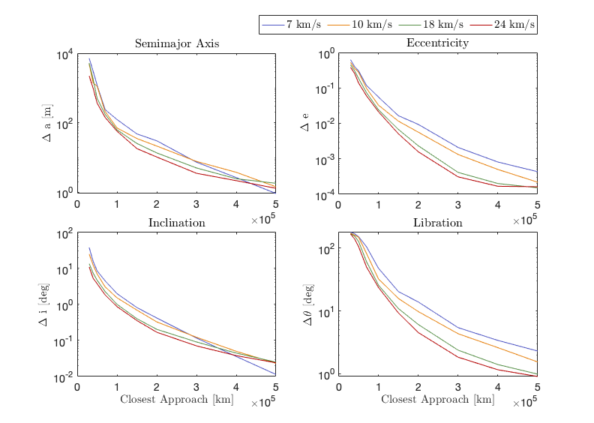
Figure 1. The average change in semimajor axis (top left), eccentricity (top right), inclination angle (bottom left), and libration angle (bottom right) at various closest approach distances for a variety of flyby speeds of an Earth encounter.

Longer simulations show the spin orbit coupling can take days to manifest after a flyby perturbation, causing the secondary to begin tumbling well after closest approach. Given past knowledge of a binary asteroid’s heliocentric orbit and planetary close approaches, the measurement of its current libration motion can be an important constraint on the rate of energy dissipation of the systems. This talk will present our current results in this topic.

**************************************
Comments:
Oral presentation

