FORUM C&C OGSE Laser Path: Speckle Angular Characterization

Juliana K. Abrantes*ª, José Pimentãoª, Nuno Francoª, João Ricarteª, Alessandra Contursi^{b}, Maxime Cortese^{b}
ªLusospace, Lisbon, Portugal
^{b}OHB-SE

Abstract
The FORUM (Far-Infrared Outgoing Radiation Understanding and Monitoring) mission aims to improve the understanding of Earth’s radiation budget by measuring the far-infrared radiation spectrum in the 6 μm to 100 μm wavelength range with high accuracy. To support the Calibration & Characterization (C&C) campaign of the FORUM Sounding Instrument (FSI) in vacuum environment, an Optical Ground Support Equipment (OGSE) has been developed, manufactured and integrated under the responsibility of Lusospace. The Vacuum OGSE comprises three separate sub-systems or illumination scenarios: (i) a laser plus integrating sphere (ISPH) path, (ii) an LN2-operated cold blackbody, (ii) a variable temperature blackbody.
The present paper focuses on the laser sub-system (i), used for spectral characterization of the Instrument at laser lines around 9 μm and 11 μm. The gas lasers (CO2 and isotope) are injected into PIR (Polycristalline Infra-Red) fibers and onto a large aperture integrating sphere, from which the OGSE exit pupil is almost 2 meters away.
The impact of output radiance speckle in the FSI performance has been an important topic of discussion between the teams invested in making its C&C (Calibration and Characterization) campaign a success. The primary impact of speckle concerns the characterization of the Instrument Spectral Response Function (ISRF). In the FSI, the detected signal results from the integration of interference fringes over the full detector field of view (FoV), where each incident angle corresponds to a different optical path difference (OPD). This angular dependence introduces a deterministic phase variation across the sensor, leading to a characteristic bell-shaped ISRF driven by geometric effects. Under nominal conditions, this behavior can be accurately modeled and corrected in post-processing. However, non-characterized speckle can introduce additional angular fluctuations in the radiance distribution at the instrument input, effectively disturbing the weighting across the FoV. This can distort the nominal ISRF shape, thereby degrading the accuracy of the spectral calibration.
For that reason, a speckle characterization test set-up that mimics both the pupil shape/size and the FoV of the Instrument and analyses the radiance content in the Fourier plane was implemented. The set-up consists of a large off-axis parabolic (OAP) mirror, masked to match the D-shaped Instrument pupil, a pinhole to define the proper angular resolution of the measurement system, a focusing lens, an MCT (Mercury Cadmium Telluride) detector and a 2-axis linear stage to scan the measurement set.
The OAP mirror maps the angular distribution of the ISPH source to linear position in its focal plane, and its focal length and diameter define the minimum observable speckle size; the pinhole is then dimensioned accordingly. The small ~25 μm pinhole creates a diffraction cone that needs to be re-focused onto the small detector area buried inside its windowed dewar mount.
The paper will explore the results of these tests and the assessment of Instrument C&C dependence on speckle field properties.
Keywords: OGSE, FORUM, spectral radiance, interferometer assembly, Speckle, Optical Testing

* jabrantes@lusospace.com, www.lusospace.com

INTRODUCTION
Over recent years, Lusospace has been developing OGSEs for different missions ([1], [2], [3]). Within the framework of the FORUM project, LusoSpace is responsible for the development of the OGSE used during the C&C campaign of the FORUM instrument. Two independent OGSEs are being developed to support the different test environments: an ambient OGSE ([7], [8]) and a vacuum-compatible OGSE ([4], [5], [6]).
FORUM is the ninth Earth Explorer mission of the ESA. The mission aims to improve the understanding of the Earth's radiation budget by providing measurements in the far-infrared spectral region, enabling a more accurate assessment of the role of far-infrared radiation in the Earth's climate system.
The FORUM payload consists of the FORUM FSI, a Fourier-transform spectrometer designed to perform atmospheric observations in the far-infrared spectral range between 6 µm and 100 µm. In addition, the FORUM Embedded Imager (FEI), which shares the same optical front-end as the FSI, provides complementary imaging capabilities.
The vacuum OGSE – intended to serve as reference for radiometric C&C and spectral performance C&C (FSI only) from 6.25µm to 100µm – supports three different illumination configurations (see Figure 1).

- Configuration #1: Integrating Sphere + Laser Sources
- Configuration #2: Cold Blackbody (CBB)
- Configuration #3: Variable Temperature Blackbody (VBB)

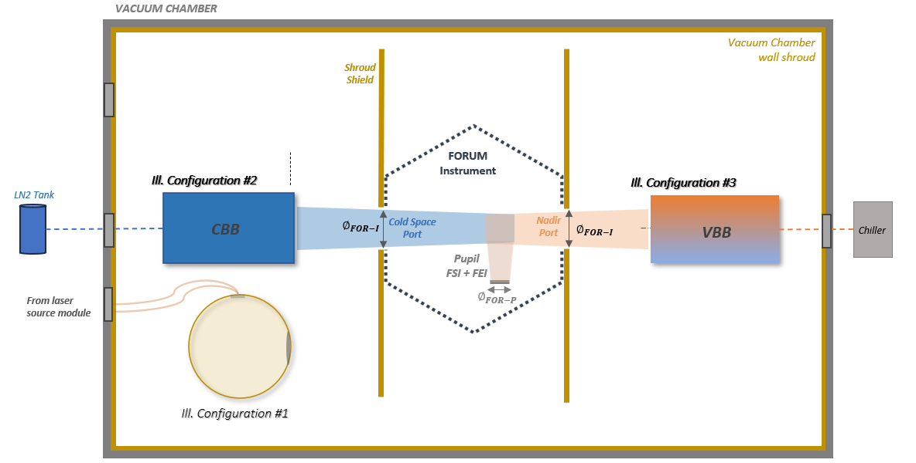
Figure 1. Schematic a vacuum chamber (TVAC) for FORUM Instrument C&C. Two of the three illumination sources are blackbodies – the VBB (variable temperature) and the CBB (cold temperature). The Instrument’s field of view towards the blackbodies is also represented.

The schematic setup of the OGSE – lasers table unit, optical path and integrating sphere – is depicted in Figure 2. There are two laser units, one CO₂ laser @ 9.271μm CWL and an isotope laser @ 11.435μm CWL. Each beam is then directed to their respective fiber couplers by a pair of mirrors forming a periscope, which allows linear and angular alignment to optimize light injection into the couplers and then into the optical fibers (NA = 0.3, 860 µm diameter core). A chopper, used for test measurements, is located in the laser module.

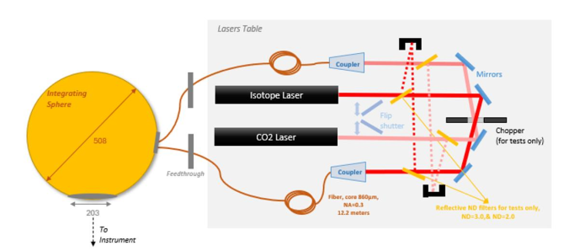
Figure 2 – OGSE layout: Illumination configuration #1 including test-related parts (chopper and filters).

As the speckle can degrade the SNR of the interferometric detection of the Instrument depending on its average angular size, a characterization test was needed. With these results, simulations can be performed to assess whether the impact is negligible or not.

Speckle Angular Characterization
The goal of the test was to statistically characterize the angular size of the speckle pattern within a FoV and entrance pupil size that are both the same as the Forum Instrument. Therefore, the setup needed to include a focusing optics with aperture that could contain the dimension of the D-shaped Forum Instrument pupil. A 90mm clear aperture (101.6 mm diameter) off-the-shelf off-axis parabolic (OAP) mirror was selected, falling slightly short compared to pupil dimension. This was considered acceptable given a time & cost versus test fidelity trade-off.

Figure 3 shows the setup schematic. The mirror (effective focal length $f =$ 516.8 mm maps the angular distribution of the ISPH source to position $(x,y)$ at the focal plane, $θ_{in}=2×\tan^{-1}\left(\frac{x}{2f}\right) .$

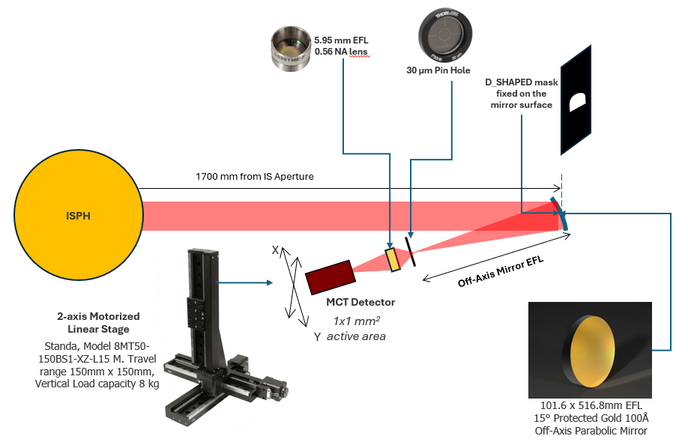
Figure 3 – Test setup schematic and components.

Measurement Linear Range at Fourier Plane
To sample the entire Instrument FoV of 0.507º, the required (full) linear$X$/ $Y$ range of the measurements is approximately $x=2×f×\tan{({0.507}^{o})}≈$ 10mm.

Pinhole Dimensioning
The OAP mirror acts as a low-pass filter, determining the minimum observable speckle size (diffraction limited) at the focal plane, $d_{speckle}≈2.44{λ f}/{D_{mirror}}≈$ 125 μm. A 30 μm pinhole was considered sufficiently small as it is about 25% of the spot.

Diffraction and Geometric Constraints
The pinhole creates a diffraction cone that must reach the 1mm x 1mm sensor buried inside the windowed Dewar mount. The diffraction full angle ≈ 2.44$λ/{d≈}$ 56º makes the beam footprint at sensor plane larger than the sensor area. This cannot happen because there would be speckle phase-induced clipping corrupting the statistical characterization of the average speckle cell. Therefore, an additional lens was used to collect the light and re-focus it onto the detector. The detector is a liquid nitrogen cooled MCT detector, used in locked-in mode with the equipment listed in Table 1.

Table 1 – MCT detector system configuration components.
Equipment | Description | Details
MCT detector | MCT detector housed in a LN2 dewar for high sensitivity IR radiance. | MCT-13.5-1.0 from Infrared Associates, Inc. with bandpass filter installed
MCT pre-amplifier | Embedded pre-amplifier | MCT 1000 from Infrared Associates, Inc.
Chopper | Optical chopper to modulate the light signal at a known frequency (out of the 1/f noise regime) and enable separation of the signal of interest from background and detector noise. | Variable speed rotating disk chopper, IR-860 Energy Modulator from Infrared Systems Dev. controller included.
Lock-in amplifier | Frequency selective amplifier; when synchronized to the chopper frequency, enhances SNR by filtering high-frequency background fluctuations and 1/f detector noise. | MFLI 500 kHz Lock-in Amplifier from Zurich Instruments

Table 2 – MCT-13.5-1.0 detector specifications.
Parameter | Value
Detector Area | 1 x 1 mm
Dewar | KR323, MLS-12 hours of LN2
Filter Bandwidth | 8 – 12.4 µm
Window | AR ZnSe
Detector Sensitivity (D*) ⁽¹⁾ | 9.67E10 $\text{cm}\sqrt{\text{Hz}}\text{/W}$ (at $f_{ch}$=1kHz, 21.4mA current)
Responsivity (@ 2V) | 45626 V/W
Raw Detector FoV | 30 deg centered w/ double baffle and filter
- from system characterization / calibration.

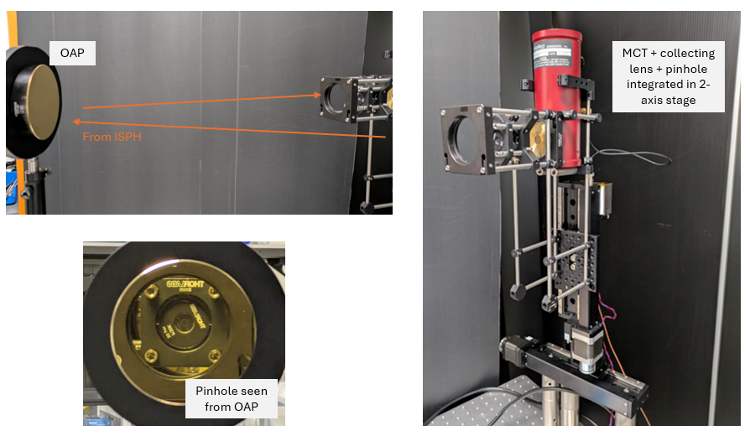
Figure 4 – Test setup at LusoSpace cleanroom.

Test Parameters
Table 3 shows the MCT detection and other test parameters. Figure 5 depicts the full Instrument FoV in linear terms of the test system, and the actual measurement regions. Even with the motorized automated scan, it takes a long time to complete the measurements, and it was verified that a 0.5 mm x 0.5 mm measurement region with 30μm resolution is sufficient to provide reliable results. This reduced measurement region scan was performed in two different field locations, corresponding to a center field and an extreme off-axis field area. These two measurement regions were scanned for each laser (CO2 and isotope).

Table 3 – Relevant test conditions and test setup parameters.
Parameter |  | Value | Unit
Chopper |  | 1000 | Hz
Lock-In Amplifier | Gain | 10 | kV/V
Lock-In Amplifier | Filter | 4 | Hz
Lock-In Amplifier | Order | 8
Lock-In Amplifier | Acquisition frequency | 800 | Hz
Lock-In Amplifier | Phase | 0 | deg
MCT | Volt | 2 | V
MCT | Calib | 60000 | V/W
Scan | Step | 30 | μm
Scan | Time | 3 | s

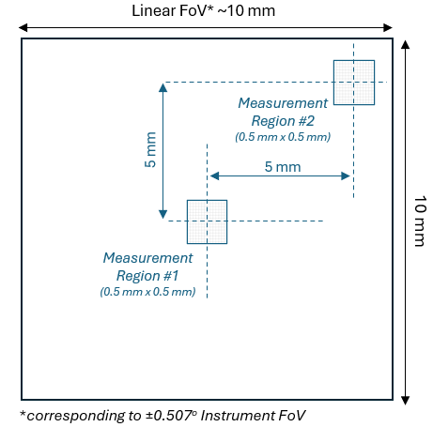
Figure 5 – Measurement /scanned regions of the FoV.

Data Processing and Results

Raw Scan Data Maps
The Fourier plane maps are shown in Figure 6. The color scale represents the normalized, envelope-removed intensity fluctuations $δI=\left(V/\left\langle V\right\rangle \right)-1$, where $V$ is the raw MCT detector voltage and $\left\langle V\right\rangle$ is the local spatially smoothed mean intensity. That is, from raw data, slow-varying structure (low order beam profile variations) was removed, isolating only speckle fluctuations. Coordinates values are expressed in angle space.

Laser | Central Field | Diagonal Field
CO2 | 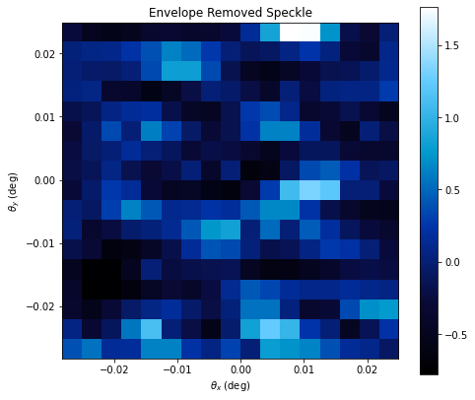 | 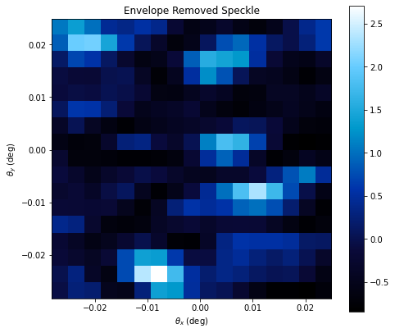
Isotope | 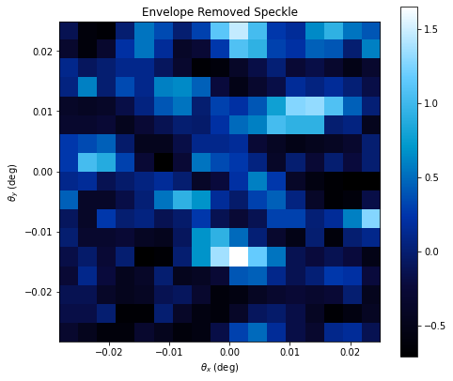 | 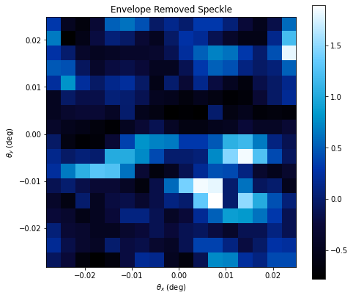
Figure 6 – Raw data maps across the focal / Fourier plane.

For visualization purposes only, cubic interpolation was applied to the maps (Figure 7).

Laser | Central Field | Diagonal Field
CO2 | 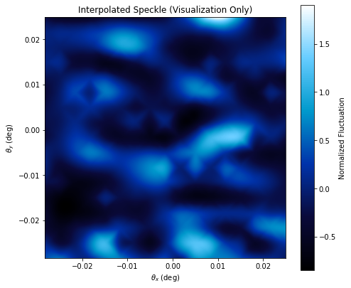 | 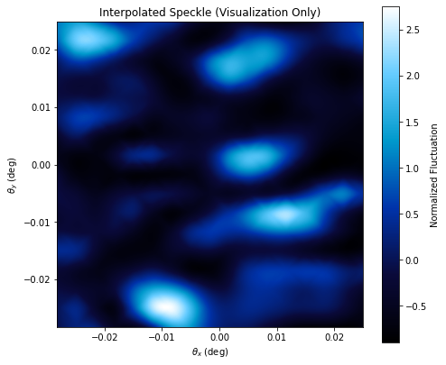
Isotope | 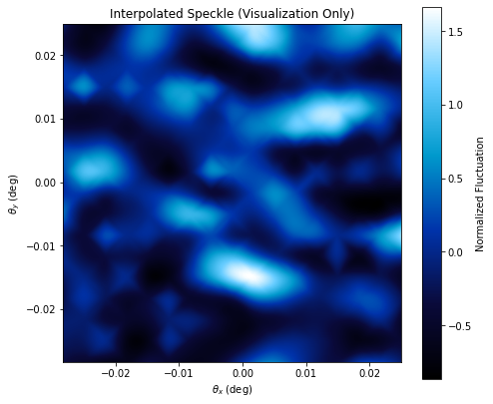 | 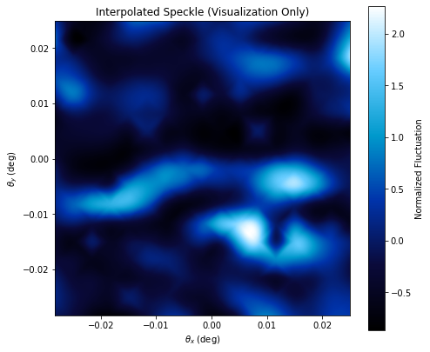
Figure 7 – Cubic interpolation of intensity distribution for better visualization.

From this data, 2D autocorrelation maps were then computed with FFT convolution, to estimate (i) how similar the speckle is when shifted in angle and (ii) the “average speckle cell” size, which is the final parameter of interest.

Laser | Central Field | Diagonal Field
CO2 | 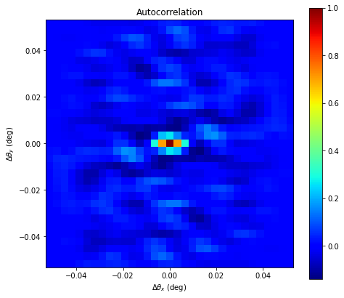 | 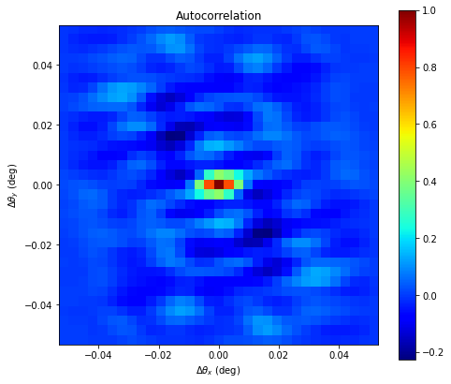
Isotope | 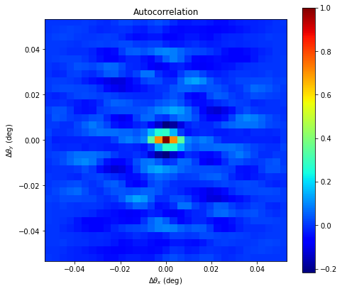 | 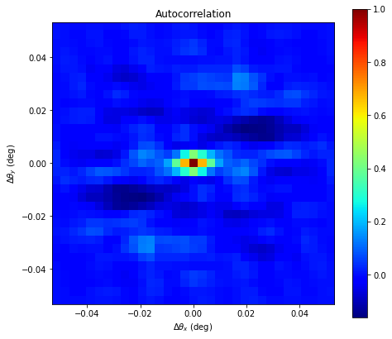
Figure 8 – 2D autocorrelation maps.

Orthogonal cuts were then taken in the autocorrelation map, a Gaussian profile was fitted, and the FWHM for each direction was evaluated. This corresponds to the statistical / average angular speckle size.

Laser | Central Field | Diagonal Field
CO2 | 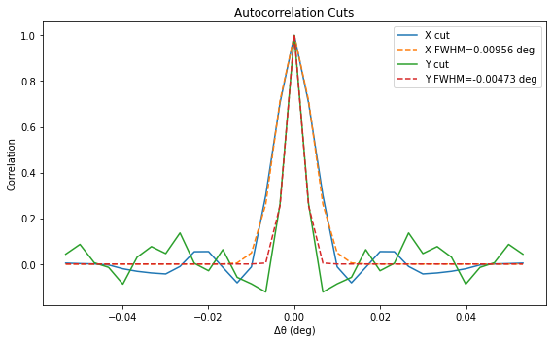 | 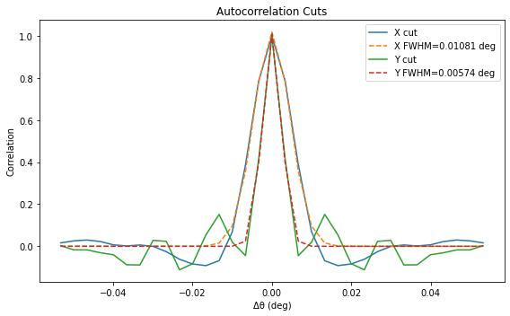
Isotope | 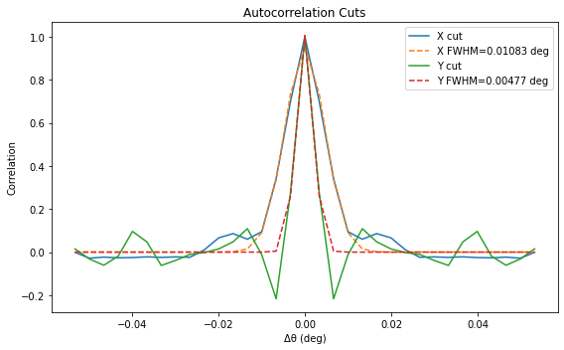 | 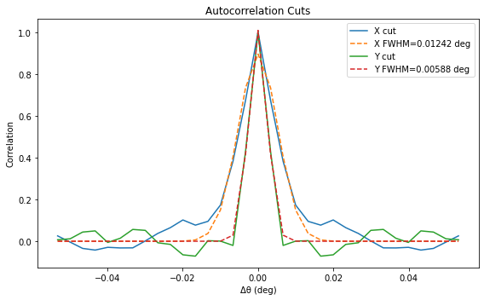
Figure 9 – Average angular speckle size evaluation from FWHM of orthogonal cuts in autocorrelation maps.

Results Summary and Conclusions
The presented test was quite successful in statistically evaluating the parameter of interest – speckle cell angular size. Although very low uncertainties are hard to achieve in this kind of analyses, data seems to be exceptionally sound and repeatable. Table 4 shows the quantitative summary of the evaluated angular size of the average individual speckle cell, for the approximate FoV center and diagonal extreme.

Table 4 – Quantitative summary of test results: angular speckle size estimated through FWHM of the Gaussian fit of the autocorrelation function cut in orthogonal directions.
Laser / Test case | Parameter | Central Field | Diagonal Field
CO2 | $X$ size (mdeg) | 9.6 | 10.8
CO2 | $Y$ size (mdeg) | 4.7 | 5.7
CO2 | Average | 7.2 | 8.2
Isotope | $X$ size (mdeg) | 10.8 | 12.4
Isotope | $Y$ size (mdeg) | 4.8 | 5.9
Isotope | Average | 7.8 | 9.2
CO2 (repeatability round) | $X$ size (mdeg) | - | 9.4
CO2 (repeatability round) | $Y$ size (mdeg) | - | 5.1
CO2 (repeatability round) | Average | - | 7.3
Isotope (repeatability round) | $X$ size (mdeg) | 9.2 | -
Isotope (repeatability round) | $Y$ size (mdeg) | 5.6 | -
Isotope (repeatability round) | Average | 7.4 | -

Some observations in light of this data:
- There is astigmatism/coma from the OAP, observed as asymmetry between the $X$ and $Y$ estimated angular sizes in all measurements (ratio $X$/$Y$ close to 2 for all sets). This is likely due to potential misalignments of the OAP wrt the ISPH aperture. The mean value was taken as the estimate.
- Results are very similar for both lasers, as well as for the repeatability round data set (performed on the isotope/central field and CO2/diagonal field).
- Speckle angular size seems to change very little throughout the full FoV.

More generically speaking, the average angular size of an individual speckle cell across the Forum Instrument FoV and considering its full pupil is estimated to be in the 7 to 10 mdeg range.
The primary impact of speckle concerns the characterization of the Instrument Spectral Response Function (ISRF). In the FSI, the detected signal results from the integration of interference fringes over the full detector field of view (FOV), where each incident angle corresponds to a different optical path difference (OPD). Under nominal conditions, this angular dependence introduces a deterministic phase variation across the sensor, leading to a characteristic bell-shaped ISRF driven by geometric effects that can normally be modeled and corrected in post-processing. However, because speckle introduces high-frequency spatial phase variations across the pupil, thousands of randomly phased sub-beams are integrated simultaneously. This introduces random angular fluctuations in the radiance distribution at the instrument input, potentially disturbing the weighting across the FOV and distorting the nominal ISRF shape, which can ultimately degrade the accuracy of the spectral calibration campaign.

References
[1] R. Henriques, J. K. Abrantes, J. Mendes-Lopes "Optical alignment, characterization, and testing through image-based output beam analysis: application to Sentinel 5 OGSE", Proc. SPIE 11852, International Conference on Space Optics — ICSO 2020, 118524D (11 Jun 2021); https://doi.org/10.1117/12.2599652
[2] J. Mendes-Lopes, J. Meyer, P. Borges et al. "Sentinel-5 OGSE: large aperture sun simulator", Proc. SPIE 11852, International Conference on Space Optics — ICSO 2020, 118524E (11 Jun 2021); https://doi.org/10.1117/12.2599653
[3] J. Pimentão, R. Henriques, J. Bonito, M. Catela, N. Franco, R. Santos “OGSE For Calibration and Characterization of the EnVision VenSpec-H Instrument”, International Conference on Space Optics — ICSO 2026, (2026)
[4] J.0 K. Abrantes, Y. Melenevskyi, J. Pimentão et al. "FORUM OGSE: highly emissive large-aperture blackbodies", Proc. SPIE 13699, International Conference on Space Optics — ICSO 2024, 136997J (28 Jul 2025); https://doi.org/10.1117/12.3075420
[5] J. K. Abrantes, C. Monte, M. Reiniger, D. Narezo-Guzman, D. Mesquita “FORUM C&C OGSE Vacuum Blackbodies: Spectral Characterization of Effective Emissivity”, International Conference on Space Optics — ICSO 2026, (2026)
[6] J. Ricarte. J. K. Abrantes et al “FORUM C&C OGSE LASER PATH: Speckle angular characterization”, International Conference on Space Optics — ICSO 2024 (2024); https://www.spiedigitallibrary.org/conference-proceedings-of-spie/13699/3072798/Forum-CC-OGSE-despeckle/10.1117/12.3072798.full
[7] R. Henriques, J. Pimentão, G. Feio et al. "OGSE for far-infrared calibration and characterization of FORUM instruments", Proc. SPIE 13699, International Conference on Space Optics — ICSO 2024, 136990R (28 Jul 2025); https://doi.org/10.1117/12.3075416
[8] R. Henriques, J. K. Abrantes et al. "Integration, alignment and testing of an Optical Ground Support Equipment for the FORUM Sounding Instrument (FSI)”, International Conference on Space Optics — ICSO 2026, (2026)

