**EO ONBOARD PROCESSING: FROM IMAGE ISSUES TO DATA**

**Manuel Montesino (1), Daniel del Pozo (1), Iñaki Salaverria (1), Santiago Serrano (1), Eric Pantin (1, 2), Marco Truglio (1), Aitor Conde (1), Rafael Guzman (1, 3)**

1. *Satlantis Microsats SL, Edif. SEDE – 2º planta, Parque Científico, Campus UPV Bizkaia, 48940 Leioa, (Spain) –* [*info@satlantis.com*](mailto:info@satlantis.com)
2. *AIM, CEA, CNRS, Université Paris-Saclay, Université Paris Diderot, Sorbonne Paris Cité, F-91191 Gif-sur-Yvette, France -* [*eric.pantin@cea.fr*](mailto:eric.pantin@cea.fr)
3. *Bryant Space Science Ctr., Univ. of Florida (United States) -* [*guzman@astro.ufl.edu*](mailto:guzman@astro.ufl.edu)

**ABSTRACT**

iSIM (integrated Standard Imager for Microsatellites) is an innovative camera developed by SATLANTIS. Major advances involve the optics, mechanics, and electronics including the hardware and software. The camera works as a stating imager producing a 2D field of view by means of CMOS sensor arrays. The sensors operate at a high frame rate and short exposure times, generating large numbers of overlapping images. Thus, applying part of the Ultra-High-Resolution (UHR) algorithm on-board solves both data quality and data volume issues. SATLANTIS proposes a mixed and flexible pipeline architecture that splits the processing chain between the satellite and on-ground processors. In orbit, the fusion of overlapping frames translates into a net reduction of number of measurements while compression reduces the file size. The new design may result saving 42-94% of memory space. A new generation of electronics enables the on-board processing through an increase in power efficiency and the computational and memory capabilities. Increasing memory efficiency could improve the number and length of acquisitions for the same available resources in terms of storage and transmission capacity.

**Keywords:** Image Processing, On-board processing, High-resolution, iSIM, Cubesats

**1 iSIM TECHNOLOGY**

iSIM, which stands for “integrated Standard Image for Microsatellites”, is a camera that provides multi-spectral high-resolution images using state-of-the-art technologies. The iSIM90 and iSIM170 are the two versions which are designed to go onboard 12U-16U CubeSats and in 50-100kg microsatellite respectively.

Figure 1. Design of an SIM90-12U camera.

iSIM90 (Figure 1) is a camera with a diffraction-limited optical design in a binocular configuration. It has a focal length of 775 mm, an effective aperture diameter of 77.5 mm, and a Field of View (FOV) of 1.8º. The camera components are fixed in a robust structure made of a light alloy. The optical system points the light towards two large-format 2D CMOS detectors, rugged to resist the detrimental effects of temperatures, radiation, and vibrations. Multispectral images are obtained by placing filters in front of the detectors so that each filter covers different rows of the sensor. iSIM90 combines 5 filters to provide images in the visible and near-infrared (VNIR) and panchromatic (PAN, 450-750nm) portions of the electromagnetic spectrum. VNIR is comprised by blue (459-525nm), green (541-577nm), red (650-680nm), and near-infrared (780-886nm) bands. High-performance, reconfigurable processors on-board the satellite improve the quality of the images. The result is a multi-spectral image with a Ground Sampling Distance (GSD) of ~2m in RGB, ~2.5m in NIR, and 13 km of swath at 500 km orbital altitude. iSIM170 is a upscaled precursor of the iSIM90, with a focal length of 1500 mm and an effective aperture of 150 mm. At 500km altitude, images have a GSD lower than 1m and a swath of 7.5 km.

Figure 2. Diagram of the observational strategy of iSIM cameras.

iSIM cameras optics are diffraction limited, that is, they reach the theoretical spatial resolution of an ideal optical system. As such, the spatial resolution is determined by the size of the optics and not by the size of the pixel. The two channels of an iSIM camera are placed in parallel and the filters are oriented perpendicular to the on-track direction, ensuring that all filters scan the same areas along the satellite’s orbit. This makes the spatial resolution independent from the number of bands. Due to the high frame rate and short exposure times, iSIM captures multiple and shifted images of the same structures as the satellite travels and maneuvers. The diffraction-limited frames together with the observation strategy of iSIM (Figure 2) allows the application of the Ultra-High-Resolution (UHR) method, the proprietary algorithm of SATLANTIS that performs super-resolution. UHR improves the contrast, signal-to-noise, and resolution of raw images.

The ability to collect images at a fast pace poses a challenge to the on-board memory and the downlink data transmission. At the same time, many images contain repeated measurements over the same area. On-board processing is an opportunity to tackle these issues simultaneously while delivering basic data products of higher quality.

**2 DATA PROCESSING**

**2.1 Overview**

Our image processing pipeline performs 3 major steps and delivers (by)products in each of these phases (Level 1A, 1B and 1C). In summary, Level 1A is the raw sensor data coupled with internal and external information from the camera and the platform. Level 1B imagery concerns single-band fused images (images with higher resolution than the original). Level 1C represents muti-band mosaics of super-resolved images. Our proposal (Figure 3) seeks to generate the first two products on-board and the last one on ground. However, if needed, we leave the option to stop the pipeline at Level 1A and download raw imagery. This flexibility will be needed to perform deeper analysis to raw frames, such as calibration routines, quality checks, tracing-back errors, and the development of new algorithms. In such case, the rest of the processing can be performed on-ground.

Figure 3. Image processing algorithm for iSIM cameras.

On-board image processing encompasses: (1) enhancing the quality of raw data, (2) improving the efficiency of the on-board memory, and (3) maximizing the usage of the downlink transmission of data to the ground stations. The processing pipeline achieves a greater image quality through the correction of flaws induced by the telescope (corrections, Table 1) and the combination of several overlapping measurements into one observation to achieve a higher SNR (fusion, Table 1). Fusion also implies a reduction of the total data volume which can be further decreased via compression. Fusing before downlinking means that more aggressive compressions may not impact significantly on the quality of the final product.

Table 1. List of data products retrieved during iSIM’s image processing, including the major processes applied to each product. Processes between parenthesis are optional. The thick line separates the on-board from the on-ground processes.

|  |  |  |  |
| --- | --- | --- | --- |
| **Data product** | **ID** | **Definition** | **Processes** |
| Level 0 | L0 | Raw frame from the sensor | - |
| Level 1A | L1A | Cropped frames with metadata | Cropping  Compression |
| Level 1B | L1B | Super-resolved single-band strip | Corrections  Alignment  Fusion  Compression |
| Level 1C | L1C | Super-resolved multiband mosaic | Mosaic  Deconvolution |

Point (1) has been proven in past missions such as the In-Orbit-Demonstration (IOD) and it is being refined in on-going missions such as CASPR, both conducted in the International Space Station (ISS). Further details about these missions and processing algorithms are given in Sections 2.2 and 2.3 respectively.

**2.2 Past and current experiences**

The IOD was performed during 2020 with the launch of an iSIM170 camera to the International Space Station on May 20th on board the H-IIB launch vehicle from the Tanegashima Space Centre (Japan). In June 2020, the camera was installed on the i-SEEP external platform of the Japanese module KIBO (Figure 4). The camera was an iSIM170 which captured images in a panchromatic mode. The goal of this mission was to commission the camera and characterize the overall instrument capabilities, including the performance of the UHR. The camera was operational until September 10th, 2020. The payload received the TRL-8 qualification performing uplink and downlink activities managed by JAXA. During the mission’s lifetime, the camera completed more than 1400 orbits and produced 141 GB of downloadable PAN imagery.

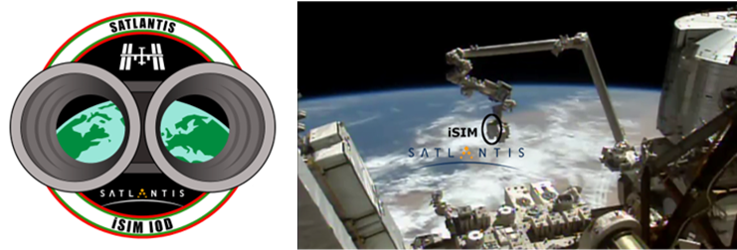

Figure 5. iSIM170 IOD mission patch and a picture from 9th of June 2020 when installed onto the i-SEEP platform of the KIBO module, JAXA.

A second project, called CASPR (Configurable and Autonomous Sensor Processing Research), is currently under development. A multispectral iSIM90 camera was launched on December 21st, 2021, on board the CRS-24 SpaceX mission. The project was part of the Space Test Program - Houston 7 (STP-H7) in collaboration with the U.S. Department of Defence (DoD) within SHREC (Centre for Space, High-Performance, and Resilient Computation) from the National Science Foundation (USA). SHREC is a joint organization led by the University of Pittsburgh and supported by Brigham Young University, University of Florida, Virginia Tech, and over 30 industry and government partners including SATLANTIS. The goal of this on-going mission is to test the multispectral and agility capabilities of iSIM cameras.

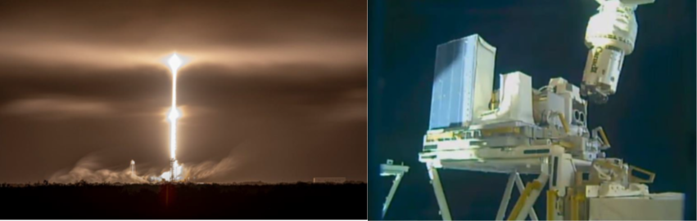

Figure 6. Lift-off of the CRS-24 Space X cargo spacecraft with the camera on board (left) and the iSIM90 mounted on the STP-H7 pallet (right).

These activities are leading to the validation and improvement of the data processing pipelines introduced above and presented in further detail in Section 2.3.

**2.3 Validation of quality improvements**

**2.3.1 Corrections: Dark, flat, and optical distortion corrections**

After cropping the sensor areas corresponding to each filter, dark and flat corrections restore the image from sensor flaws. Dark frame corrections subtract the contribution of generated charges in the image due to the sensor’s temperature and readout patterns. The dark correction applies a master dark to the raw images. The master dark is the sum of frames captured in complete darkness. Flat fielding removes the variability in pixel-to-pixel differential gains, dust, and sensor artefacts. Flat fields are obtained by observing a uniformly illuminated scene. Lab experiments and regular calibration operations provide dark and flat frames. During the IOD mission, dark frames (Figure 7, left) were captured when both the telescope and Earth’s surface were not illuminated by the sun. For flats (Figure 7, right), the camera captured long-exposed images over the cloud-free ocean when the sun was at a low elevation angle.

Figure 7. Examples of dark (left) and flat (right) master frames acquired in orbit during the IOD mission.

The calibration campaign confirmed that the darks obtained in orbit are consistent with the laboratory-derived measurements. After applying the dark and flat corrections the subtraction of overlapped frames yielded a gaussian noise with a zero mean which confirmed the quality of the corrections.

The optical distortion correction consists in reversing the deformations of the image caused by the optical system. Compensating the distortion ensures that the features (structures and objects) in a frame match precisely with the same features captured by previous and subsequent frames, which is critical to avoid artefacts in subsequent steps. To correct the distortion, we use a map that relates the location of a pixel in a raw frame with its actual location in space. This can be achieved with $N$ degree polynomial that translates the row and column location in the raw image ($i,j$) into the additional shift required to move the pixel to its actual location ($Δi, Δj$) (Eq. 1 and Eq. 2):

|  |  |  |
| --- | --- | --- |
|  | $$Δi= \sum_{n=0}^{N}{a_{n}i^{n}}$$ | (1) |

|  |  |  |
| --- | --- | --- |
|  |  | (2) |

Being $a_{n}$ and $b_{n}$ the polynomial coefficients. Lab measurements and regular geometric calibration operations in orbit provide information to fit the coefficients. The algorithms warps the image based on the new pixel locations to resolve the deformation.

The analysis from images taken by the iSIM170 IOD in cities landscapes confirmed the existence of a radial pincushion distortion predicted from the modelling of iSIM’s optics (Figure 8). Once the centre of distortion was found, the distortion profile was well described by a 2-degree polynomial. The distortion was 0.16%, peaking at edges with 4 pixels distance between the actual and the predicted pixel. Raw images were interpolated to remove distortions, translating into fewer artifacts in the final super-resolved image.



Figure 8. IOD image showing the results of the analysis of the optical distortions. The raw IOD image from San Francisco with the region of interest (left) and the detected distortion patterns in modulues and angles (right).

**2.3.2 Alignment**

Co-registration is the spatial alignment of frames in a sequence so that features in one image match their footprint on others. A misregistration can cause artifacts when fusing several images (next step, Section 2.3.6). Therefore, the alignment of images with a sub-pixel accuracy is essential. The co-registration method involves shifting and rotating a reference image over a search image and check iteratively the similarity between the two. Similarity can be defined by the following Euclidean norm:

|  |  |  |
| --- | --- | --- |
|  | $$d\left(r,s\right)=\sqrt{{\sum_{\left(i,j\right)∈Z}{(S\left(i+r,j+s\right)-R(i,j)})}^{2} }$$ | (3) |

Being $S$ and $R$ the search and reference images respectively, and $r$ and $s$ are the distances to be summed to the row and column direction because of a shift or a rotation. Images are aligned when $r$ and $s$ minimize Eq. 3. With large images, the search process can be time consuming, and strategies shall be implemented to find the solution efficiently. Among other strategies, our registration method uses ancillary data of the satellite ephemeris to generate a first guess and reduce the search space of the final solution. The outcome is a set of shifts and rotations to be applied to each frame so that they are aligned with the first frame of the sequence.

The iSIM170 of the IOD mission had the two channels unsynchronized, rotated one from another (1.61 degrees) and slightly different focal lengths (Figure 9). Several tests under different circumstances revealed that the alignment achieves sub-pixel accuracies.

Figure 9. Aligned and scaled images recorded by the two channels of the iSIM170. Sequence of images from one channel (left) and the aligned and scaled images of the second channel (right).

**2.3.3 Fusion**

Fusion is the process of combining several low-resolution images to reconstruct the information at smaller spatial scales. The number of images to be fused is key to improve the quality of the information in the final image. The fusion leverages on the high frame rate of the iSIM cameras, where the same spot on the surface is measured several times as the satellite travels. The fusion combines information from several pixels in overlapping areas. The result is a fused strip for the overlapping area between frames. This strip has lower noise and higher spatial resolution.

The improvement in resolution was verified in the airport image shown in Figure 10. White bars at the beginning and end of the runway have a standardized separation of 1 m. The GSD of a native pixel is around 1.5m because of the orbital height of the ISS. After the combination of images, a ground resolution distance of <1m was achieved, confirming the capability of the fusion algorithm to reach an up-scaling factor of 2-3.

Figure 10. A fused and deconvolved image of an airport in Saint Tropez, France. The GSD is approximately 0.5 and the ground resolution distance is <1m. Blue and red contours show the comparison befor and after processing.

**2.3.4 Mosaicking**

Mosaicking is the process of assembling several overlapping strips to build an extended frame. Mosaicking is intended to generate regularly shaped tiles that ease the file storage and sharing. A mosaic combines several strips using the shifts and rotations resulting from the frame alignment process described in Section 2.3.2. When combined, the algorithm smooths the edges of intersecting strips to obtain a seamless splice.

In the IOD mission, the movement of the ISS was not parallel to the sensor axes of the iSIM170. Additionally, the travelling angle changed during the mission due to manoeuvres of the stations, which allowed to test alignment and mosaicking algorithms under different conditions. The mosaicking algorithm was tested with images over San Tropez, France and Huelva, Spain captured with 7.4 and 7.8 degrees to the left respectively (Figure 11). The misalignment between iSIM170 sensor axis and the traveling direction reduced the swath of the composite image. The results showed the ability of the mosaicking algorithm to fully integrate super resolved strips.

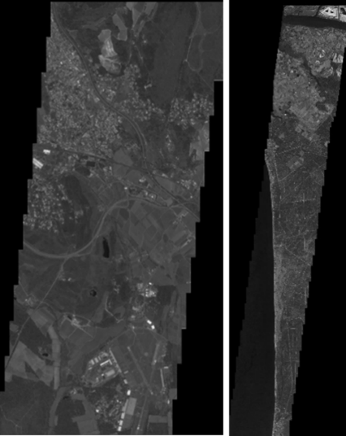

Figure 11. Mosaicked images near San Tropez, France (left) and Huelva, Spain (Right).

**2.3.5 Deconvolution**

The deconvolution attempts to recover the original scene from a degraded image which has been blurred due to the diffraction of light and defocus. Deconvolution is key to improve the ability to distinguish between close objects, gaining contrast and resolution. In general, the deconvolution pursues finding the unblurred image $F$ from a degraded image $G$, considering the distortion function $h$ as described Eq. 5:

|  |  |  |
| --- | --- | --- |
|  | $$F*h=G$$ | (5) |

Where $h$ is the point spread function (PSF). The PSF is a model that describes the response of the optical system to a point source. On ground, the PSF is characterized by pointing a light source from infinity towards the telescope. In orbit, the PSF is inferred from spatial calibration campaigns. Solving for $F$ is an ill-posed problem in which the solution must be found iteratively. Our algorithm automatically finds the number of iterations to properly balance the increasing level of contrast with the noise amplification.

We assessed the impact of several methods and iterations on the modulation transfer function (MTF) curves using the IOD images (Figure 12). In all cases, the deconvolution improved the contrast. After several test, the optimal algorithm and parameters were selected.

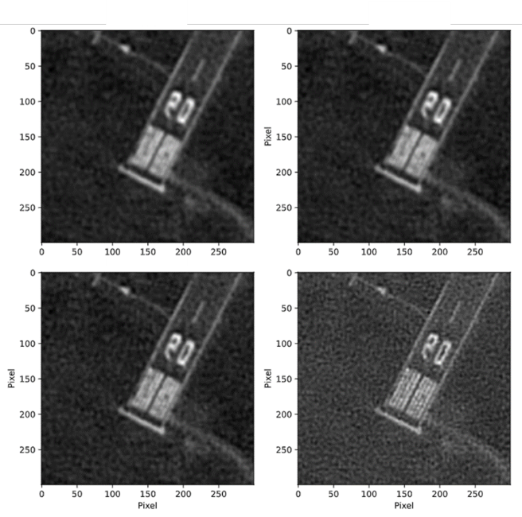

Figure 12. Testing the effect of the number of iterations during deconvolution.

**2.3.6 Compression**

Compression algorithms apply a variety of methods to reduce the size of image files. Compression makes it possible to save disk space in orbit and allows a faster transmission of files through the downlink. A proprietary algorithm for data compression enables lossless compression by finding statistical redundancy in image arrays and save space. This kind of compression is reversible, so the compression-decompression process does not loose information. The current implementation achieves a compression factor of 2 and can be used to save Level 1A scenes.

Fusion is fine process that requires highly accurate data. Once the process is completed, the pipeline can apply a JPEG compression algorithm. This compressor is lossy and can be used in the last stage of the on-board processing pipeline to reach higher compression factors (up to 10). The compression can improve the downlink transmission without significantly compromising data quality.

**2.4 Memory budgets**

We tested the memory efficiency and downlink optimization premises by doing estimates of memory budgets for each data product listed in Table 1. Table 2 shows the results of those estimates. The calculations consider the parameters of a multi-spectral VNIR iSIM90 similar to the one described in Section 1. The scenario considers that the camera is pointing nadir, traveling at an altitude of 500 km and perpendicular to the largest axis of the sensor. The results concern a sequence of 1000 frames considering the layout of filters in current missions.

Table 2. Summary table of the memory budget of the several data products in the processing pipeline of an iSIM90. The columns show the size of a file, the size of the entire dataset (1000 frames), and the size of the dataset per unit area, respectively. Values between parenthesis show the memory size after compression.

|  |  |  |  |
| --- | --- | --- | --- |
| **Data product** | **File size**  **(MB)** | **Total size**  **(GB)** | **Per unit area**  **(MB/km2)** |
| Level 0 | 18.87 | 37.75 | 9.21 |
| Level 1A | 12,75 (6.371) | 25.5 (12.751) | 6.94 (3.471) |
| Level 1B | 5.40 (0.542) | 21.6 (2.162) | 5.77 (0.572) |
| Level 1C | 199953 | 19.52 | 5.72 |

Note 1: After Ziptlantis lossless compression, factor 2

Note 2: After JPEG lossy compression, factor 10

Note 3: for a hypothetical file storing a single mosaic with all the frames

Table 2 shows that the set of Level 1A files requires nearly 32% less memory space than the Level 0 imagery (62% less after Ziptlantis). This is due to filter cropping. Processing up to Level 1B saves 42% of memory compared to Level 0 (94% after JPEG) and 10% compared to Level 1A (83% after JPEG). The difference between L1A and L1B is less pronounced as the fusion not only combines multiple frames (data reduction) but also increases the number of pixels when reducing the pixel size by a factor 2-3 (data increase). The major contribution to reduce the data volume comes from the compressor. The last data product, L1C, has roughly the same memory size as L1B.

**2.5. Electronics**

On-board processing is supported by the development of new electronics for the camera computer. The design of the On-Board Computer System (OBC) for SATLANTIS cameras is based on lessons learned during the iSIM170 IOD mission and the new demands for higher computational resources for the on-board processing. The newest version of the OBC, called Spock v1.3, increases the power efficiency, the computational and storage capability, and the speed of the data transfer for the acquisition and storage of the camera data.

Figure 13. Spock v1.3, newest iSIM's camera on-board computer.

Energy efficiency is achieved thanks to a very low power consumption in standby (0.25W) of the OBC between acquisitions. High-speed devices are powered off only keeping the opto-mechanics thermally controlled. Regarding the computational capacities and storage, the system contains two redundant processing units comprising an FPGA and CPUs with separate storage memories. It has a 4GB RAM memory for the processor system and 2GB RAM of memory for the FPGA. Two cores give support to the acquisition of more than 52 frames per second (if needed). The memory drive has a sequential speed of ~1500MB/s. The computer has a versatile architecture ready to apply the processing algorithms, through software and FPGA co-working. Also, the real-time compressor of images in the FPGA is supported. The data transfer is reinforced by Gigabit ethernet links for science data.

**3 CONCLUSIONS**

On-board processing represents an opportunity to achieve higher data quality earlier in the process and improve the payload memory efficiency and the downlink usage. However, it poses major challenges on the computational resources of the on-board computer. Based on the proven image processing pipeline, SATLANTIS proposes a mixed and flexible pipeline architecture that splits the processing chain between on-board and on-ground processes. To achieve this goal, the development of smart and light-weight algorithms are coupled with improved electronics that make the on-board computer more energy efficient and provide better computational resources. The design of the pipeline distributes the data chain between space and the ground segment in a way that maximize data quality and resource availability.