
ABSTRACT TEMPLATE

Abstract Title

A. Smith^{1*}; B. Smith², etc..
¹Institution, City, Country, *Primary author contact details: emailaddress@email.com
²Institution, City, Country, etc..

- Theme
Please indicate which of the following themes fits the topic of your presentation best:
- Cost analysis and modelling
- Design-to-Cost
- Affordability analysis
- Earned Value Management
- Technical and Cost Data Acquisition and Storing
- Cost evolution trends
- Impact of and lessons learned from New Space approaches
- Cost reduction vs risk taking
- Cost engineering in feasibility studies, concept studies and running projects
- Other

- Introduction
This is the introduction section of your abstract. Abstracts are not to exceed 1 page of this template.
Abstracts and papers (as an optional addition to an oral presentation or poster) are to be based on this template.
All section headings are in a size 10 Arial bold font. Sections can be with or without numbering. Paragraphs and headings should have trailing vertical whitespace of 6pt. The correct page settings, 200 mm (height) x 190 (width) mm, are set for this document. Page size and page margins should not be altered.
  - Sub-section
This is an example of a sub-section.
- This is a bullet point.
- This bullet point is equally important.

- Figures
To insert figures, you should use the “Figure_caption” auto formatting style for the caption. Please do not insert large image files (> 1MB) into the document.
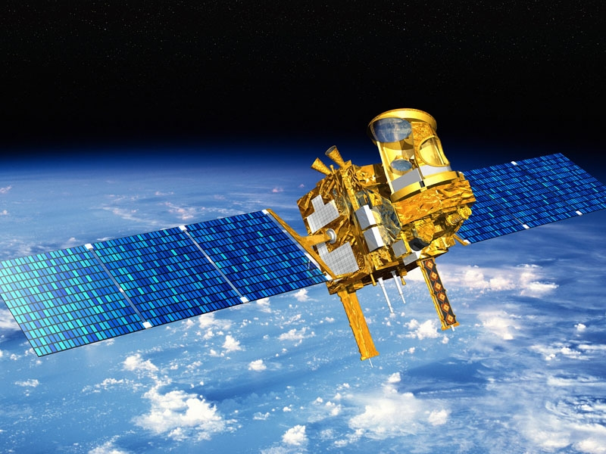
Figure 1: This is an example of a figure.
- Tables
Column 1 | Column 2 | Column 3
Line 1 | Line 1 | Line 1
Line 2 | Line 2 | Line 2
Line 3 | Line 3 | Line 3
Table 1: This is an example of a table
- Equations
To insert equations use either formatted text (for simple equations that do not require complex symbols), the built-in MS Word equation editor, or pictures of typeset equations. The equation number should be placed at the right side of the column and all equations should be consecutively numbered.
(1)
- File format
When you have finished your abstract, please convert it into PDF and upload it via the conference website.
Please put in the header: Abstract

Before you submit please carefully check your abstract is as you intend, and without mistakes. We are unable to accept updates after the abstract submission deadline.
- References
[1] Author, A., Author, B., and Author, C.: First example of a cited article title, First Example Journal, Vol. 1, pp. 1-100, 1999.
[2] Author, D. and Author, E.: Second example of a cited book, Example Publishing House, 2000.

