MINI-SPACESTAR: A SUCCESSFUL PRODUCT UPDATED TO ADAPT TO THE NEEDS OF NEW SPACE MARKETS

Mr. Franco Boldrini⁽¹⁾, Mr. Rossano Bettarini⁽²⁾), Mr. Dorico Procopio⁽³⁾, Mr. Gianni Berrighi⁽⁴⁾

⁽¹⁾ Leonardo S.p.A, franco.boldrini@leonardo.com, +390558050518
⁽²⁾ Leonardo S.p.A, rossano.bettarini@leonardo.com, +390558050416
⁽³⁾ Leonardo S.p.A, dorico.procopio@leonardo.com, +390558050416
⁽⁴⁾ Leonardo S.p.A, gianni.berrighi@leonardo.com, +39 3351805278

ABSTRACT
Leonardo is continuing to renew its Star Tracker portfolio to match Customers needs starting from the well consolidated flight heritage. In a perspective of product updating, a review of the SPACESTAR Multi-Head Star Tracker has been undertaken with the aim of minimizing the envelope and mass, leaving the electrical and interfaces SW unchanged.
The new SPACESTAR MINI Multi-Head Star Tracker allows Customers to benefit from the advantages of reduced size and mass without any sacrifice in reliability and performance with respect to the successful and flight proven SPACESTAR MHSTR in its “Legacy” configuration. SPACESTAR MINI will be fully equivalent in terms of electrical I/F and data I/O with respect to the predecessor, allowing for a “pin-to-pin” replacement of the SPACESTAR product in small satellites.
SPACESTAR MINI, today at detailed design phase maturity level, will be available using Grade 1 (QML-V), Grade 2 (QML-Q) as the "legacy" configuration. As a future evolution of Spacestar Mini, Leonardo is currently conducting internal studies aiming to offer an autonomous product (autonomous SPACESTAR MINI) and a “New Space” configuration is planned (NS SPACESTAR MINI).
This paper will discuss the SPACESTAR MINI features and its future evolution.

INTRODUCTION
The SPACESTAR Multi-Head Star tracker system (MHSTR) design was started in 2011 and successfully qualified in 2013 The first unit was launched on 2017 in the frame of a large LEO Constellation Satellites.

SPACESTAR is suited for those mission in which proton and heavy ions are the dominating radiation sources. It was designed to be robust to natural environments in LEO, MEO and GEO orbits, for typical commercial, GNSS and telecommunication satellites.
Today more than 500 OHs have been produced or under production. 300 Optical Heads are flying in LEO, GEO in different missions (communication, Earth observation…) accumulating a large flight experience.

Originally developed for a high volume constellation Program, SPACESTAR introduced the innovative concepts of having up to three independent OHs managed by a SW hosted and running as a specific task within the attitude control system software ("MHSTR system"). The MHSTR system, reducing the electronics design complexity, allowed tangible benefit on unit cost and mass by using computation resource available on SpaceCraft. The results of these efficiencies enable to utilize high performance star tracking systems on small satellites that were previously unable to accommodate the size, weight, and power of legacy architectures.

A review of the Optical Head configuration has been started, with the main objective of further reducing size, mass of the sensor, keeping the high accuracy performance and mechanical robustness of the current MHSTR system.
Engineered to fulfil the needs of small platforms and of the “New Space” market, the new SPACESTAR MINI Multi-Head Star Tracker allows Customers to benefit from the advantages of reduced mass and size maintaining same electrical, data I/F and processing SW of the previous SPACESTAR configuration.

The evolution of the product is deeply discussed in next sections.

SPACESTAR SYSTEM OVERVIEW
Overall system
The SPACESTAR MHSTR system (Figure 1) consists of up-to three Optical Heads (each one containing a baffle, optical system, focal plane and proximity electronics) and a SW hosted and running in the Spacecraft Computer.
The SPACESTAR Optical Head (Figure 2) delivers “compressed sky images” and is used with a dedicated SW module provided by Leonardo, hosted in the spacecraft computer.
The SW performs all the computation necessary to convert the information coming from the Optical Heads, up to the attitude solution delivery.

Optical Head
The SPACESTAR Optical Head (OH) is comprised of the detection module (optics plus focal plane), the OH electronics, and the baffle (Sun shield) attached to the Optical Head Structure.
The optical system assembly concept adopts suitable design solution, allowing good optics performance stability over a wide temperature range.
Optics is produced with special radiation resistant glasses, suitable to cope with the natural radiation environment present in space.
The focal plane assembly includes the APS detector and the thermoelectric cooler (TEC) needed to maintain the detector below a prefixed temperature, to minimize the detector dark current. Temperature loop control is managed via SW.
The SPACESTAR can be provided with an alignment cube for alignment purposes on the S/C.

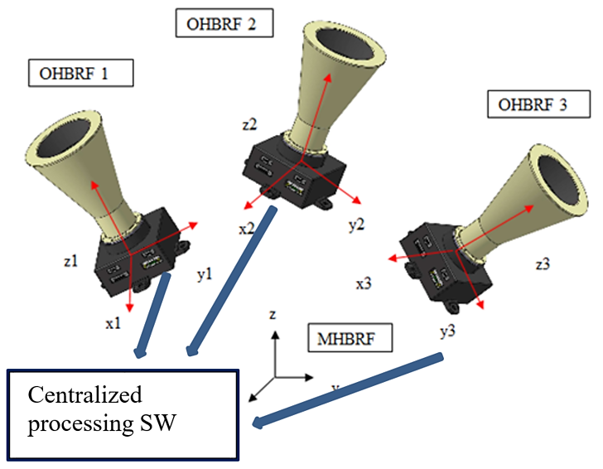
Figure 1 – SPACESTAR Product Architecture

The full OH electronics is integrated to minimize PCB size, including some bias and filter circuitry for the APS detector, and using a radiation hardened FPGA performing APS timing control, signal pre-processing, as well as data I/F management with the external computer, via SpaceWire I/F.
The OH is provided with two (redundant) SpaceWire connectors (for data exchange with the on board computer), one power connector and a test connector, directly assembled on the external case.
The sensor layout and subassembly designs are conceived in order to minimize the manufacturing and assembly cost, while maintaining low mass and size.
The original configuration that was designed for constellations applications (low cost, low mass, medium accuracy), has been then adapted to suit more demanding missions (telecommunications and Earth observation), where accuracy, reliability, resistance to radiation and to mechanical loads are of primary importance.
In this respect, the mechanical design has been improved to provide higher radiation shielding to components and more stiffness. Also, some EEE components have been replaced with more radiation hardened components
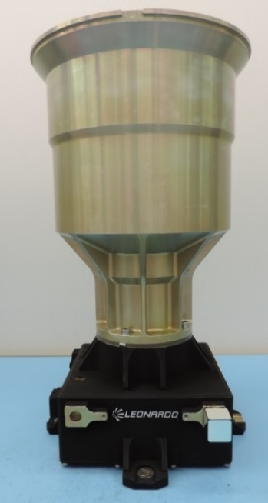
Figure 2 – SPACESTAR Optical Head

SoftWare
The initial configuration was aimed to minimize the CPU execution time. The SW elaboration should be kept as low as 22 mesec on a LEON3 CPU at 48 MHz. This to allow AOCS computer to perform also all the other tasks within a 8 Hz period.
For this purpose, also the OH management were kept as simple as possible: the multi head SW is in charge to select the best OH to be used for attitude measurement among the ones that are currently usable.
With the availability of more powerful computers (Leon4, multicore…) the initial need of minimizing computational effort has been relaxed, thus additional features have been introduced.
The SW was modified to deal with increased number of stars (to improve accuracy) and improved filters functions have been introduced, enhancing operations in harsh radiation environment.
Some design provisions have been as well introduced to deal with increased angular rate acceptable range. This includes (among other) data fusion with possibility to combine measurements of single stars taken from different OHs.

SPACESTAR MINI
As reported in the previous section, the SPACESTAR MHSTR is now a well consolidated, flight proven product (both from HW and SW prospective), widely employed on many platforms and applications.
Anyway the market is requiring products with always reduced mass, size and costs.
The first step undertaken for the SPACESTAR HW design updating is mainly oriented to reduce the size of the sensor and to some extent the relevant mass, maintaining the same level of component quality, for more demanding missions in terms of quality and screening of components.
Materials and processes are kept unchanged, to guarantee maximum flight heritage to SPACESTAR MINI.
To accomplish this size and mass reduction, the Optics (section 3.1) and Mechanical lay out (section 3.2) have been submitted to modification, while electronics (3.3) has been maintained essentially the same of the previous Spacestar configuration. Although modern computing capabilities can improve algorithms and maintain performance even in case of detector radiation degradation, SPACESTAR MINI is still equipped of a thermo electric cooler module, allowing a robust hardware recovery by cooling.

The comparison between SPACESTAR MINI and its “Legacy” configuration is reported in Figure 3.
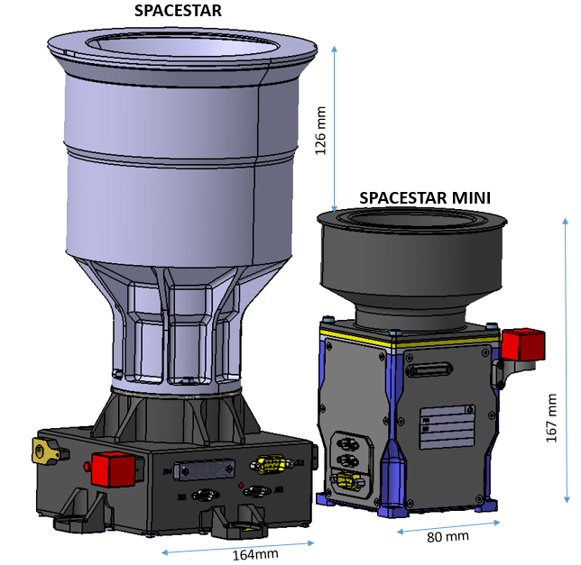
Figure 3 – SPACESTAR "legacy" versus Spacestar Mini

Optics
The original optical system composed by spherical lenses has been replaced by a system with a reduces number of lenses including an aspherical lens. When compared to the former design, the updated optical barrel is 26 mm shorter than the original configuration. Figure 4 shows the achieved size reduction. The reduction of elements does not lead to reduction of performance, the design improvement is achieved maintaining the same optical characteristics and performance.
The reduction of the optics dimensions allows also for a reduction of the baffle size.

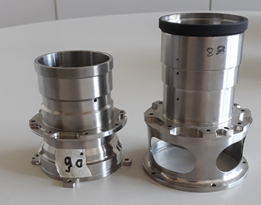 | 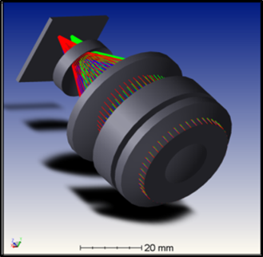
Updated Optical Barrel (on the left) vs Previous Optical Barrel (on the right) | Optics CAD Model
Figure 4 – Optics architecture and size

Engineering Model of the Optical system has been already manufactured and successfully tested on a full Star Tracker EM that has been developed under a GSTP ESA Contract. The Optical head was successfully submitted to interferometer test, star spot quality and single star accuracy were checked (Figure 5) at ambient temperature and minimum and maximum operating temperature.
Accuracy measurement performed a star levels confirmed values expected by analysis, showing results in line or better than the former Optical head.
- FOV error (3σ): < 8 arcsec
- High Frequency spatial error (3σ): < 9 arcsec
- Temporal error (3σ): < 4 arcsec

Figure 6 reports the star spot energy distribution, while Figure 7 provides the intra-pixel error at different FOV locations.

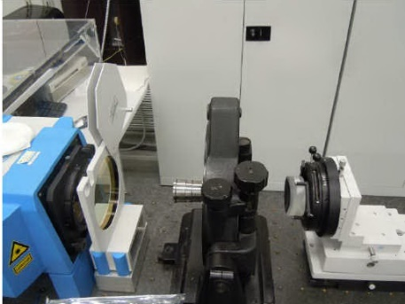
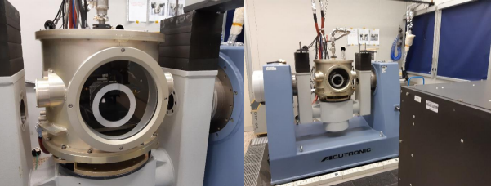
Figure 5 –OH interferometer test; OH assembled on full star tracker for performance test

Figure 6 Star spot energy at FOV=0° (left); FOV= 9° (middle), FOV=10 (right)

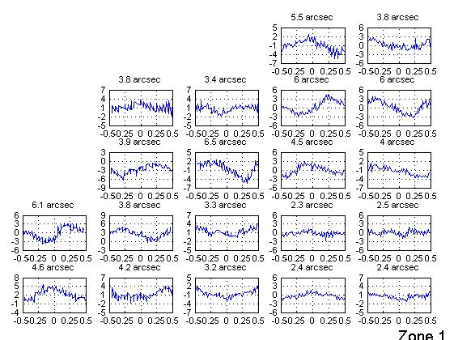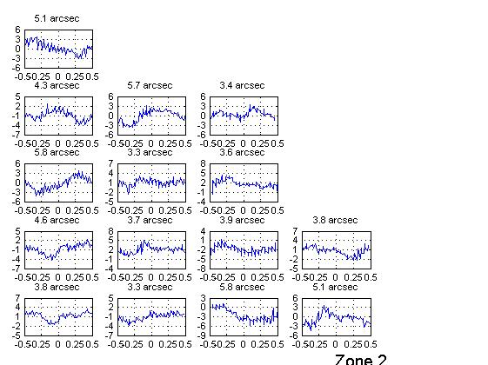
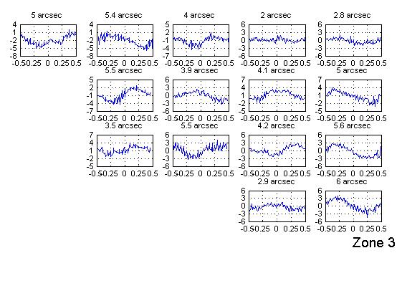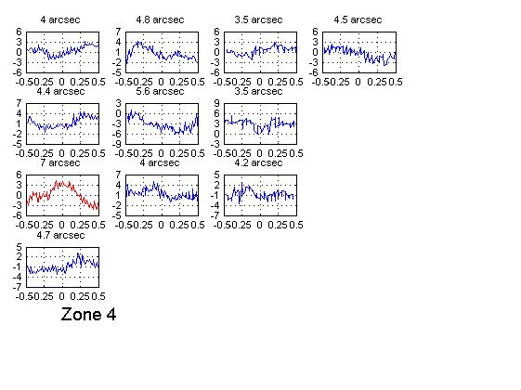
Figure 7. intra-pixel error distribution vs FOV

Mechanical layout
The mechanical configuration has been significantly revised. The mechanical structure forms a load-bearing cage that supports internally the optical barrel and the four PCBs containing the electronics (Figure 8). The top side of the structure supports also the baffle. A baseline baffle for 35 deg Sun exclusion angle (SEA) and 30 deg Earth exclusion angle (EEA) has been conceived as baseline.
Design is flexible to host baffles for different SEA available on request.
The structure supports also external PCB covers. This solution allows a more modular approach with respect to the previous SPACESTAR configuration for what concern radiation. In fact, the standard SPACESTAR is provided with a housing (black part of Figure 2) that includes internally the PCB and support baffle. Changing thickness of the housing (to increase or reduce radiation shielding) means that the entire structure must be modified with significant impacts in terms of redesign and analysis. In SPACESTAR MINI, the structural part of the remains always the same, while different thicknesses of the external covers or specific local shielding may be adopted to deal with needs of increased or reduced shielding to radiation. This design allows to further reduce mass when radiation environment is relaxed, while high design flexibility is achieved with higher standardization of parts and reduced amount of mechanical analyses to be executed, as the structural part of the sensor remains unchanged.
The housing can host an alignment cube that can be easily removed after SpaceCraft integration activities when it is needed to reduce mass.

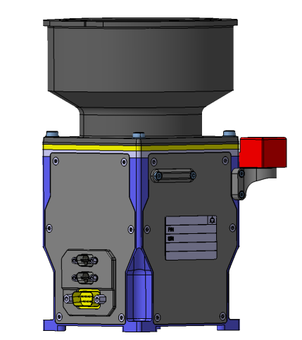 | 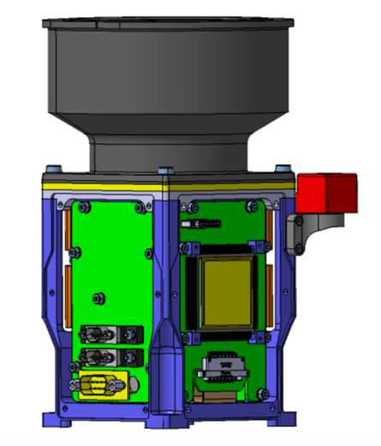
External layout | PCB view without external covers
Figure 8 – Mini Spacestar layout

Electronics
The electronics has been maintained essentially the same of the previous Spacestar configuration, so that the large heritage of already flown electronics is maintained. Electronics will be available with Grade 1 (QML-V) or Grade 2 (QML-Q) component. A “New Space” configuration is also planned to be realized (NS Mini Spacestar).
Only the accommodation on PCB has been changed to fit the different layout. In fact, to minimise the height of the sensor and the footprint, the large PCB positioned under the focal plane of the former Spacestar has been replaced with 4 smaller PCBs folded around the structure. In this way can be kept while minimizing the product footprint and overall size.

The focal plane is inherited from the previous flown units.

The Spacestar Mini configuration is fully equivalent to that of the legacy configuration: the same Spacewire I/F (two spacewires are available), power and test I/F are used in the two types of sensors.
The same data I/F is maintained, so that the SW versions already developed in the past are fully compatible with the Spacestar Mini.
A customer that has already used the SPACESTAR will be able to adopt the MINI configuration without any change. The Electrical Stimuli Generator (ESG) used on ground to perform avionics validation test are the same as well. This results in no needs of additional procurement of support EGSE for customers who already adopted the SPACESTAR. Only the type of connector has been changed for miniaturisation purposes, however the already procured EGSE can be used without any effort by using a connector adaptor provided by Leonardo.

SW UPGRADES AND IMPROVMENT
Different SW configurations have been produced following the customer needs since the SPACESTAR development was started.

The initial configuration was aimed to minimise the CPU load and included a smart OH management consisting in providing higher computational capability to a single OH to be used for attitude measurement (primary OH), reduced computational capability to a secondary OH to be promoted as primary OH in case of performance degradation or temporary outage of the primary OH (Sun/Earth blinding), while a third OH was maintained thermally regulated in standby as “ready to be used”.
The multi head SW is in charge to promote the secondary OH as primary OH as soon as performance degradation of the primary OH is detected (reallocating thus computational resources) or starting to use the OH in stand by either as primary or secondary OH, accordingly to a management logic implemented in the SW.
This initial configuration allows for a smart management of OH and thus robustness of the whole system, still minimizing the computational resources.
A successive version has increased the computational capability of both primary and secondary OH, allowing for each OH to track 15 targets, including quaternion fusion and intra-misalignment estimation. In additions, several settings in SW parameters have been changed, to allow processing of increased number of targets and increased filtering functions has been introduced, to deal with more complex images affected by large amount of SEU, enhancing operations in harsh radiation environment of EOR phase.
The most recent SW release developed in the frame of Copernicus ESA Program, thanks to the exploited full computational capability of last CPU generation, allows to further improve the SW:
- Flat field compensation algorithms (dark signal non uniformity removal) for improved star position measurement accuracy
- Improved star detection algorithms to enhance angular rate range
- Improved in flight focal length calibration processing for low frequency error reduction
- In flight optical distortion calibration allowing to skip on ground calibration (or performing a raw calibration) and fully rely in in flight calibration, thus minimizing the on-ground tests duration and costs.
- Attitude fusion at star level to improve attitude tracking robustness in high dynamic conditions
The introduction of the autonomous in-flight calibration procedure allows for high accuracy achievement or low cost calibration /testing depending on parameters setting and adopted on ground testing flow. For example, a sensor that was subjected to on ground calibration has (typically) a FOV error of 4 arcsec. Updated focal length in flight calibration allows to achieve the same levels of accuracy with sensors that weren’t subjected to any on ground calibration.
On the other side, when improved focal length calibration is instead applied to a sensor that was calibrated on ground, a FOV error as low as 0.8 arcsec can be achieved.
A large portfolio of SW will be available for SPACESTAR MINI: from the already flown SW to the latest SW release which allow exploiting performance as for demanding mission as Copernicus. All MHSTR SW releases developed for the "legacy" configuration can be used in SPACESTAR MINI upon Customer request.

SENSOR CHARACTERISTICS
The Spacestar Mini datasheet is reported in Table 1
Table 1
SPACESTAR MINI datasheet
GENERAL
Detector | CMOS APS radiation hardened, ECSS qualified
Field of view | 20 x 20° full cone
Number of tracked stars | Up to 15 per OH
Lost in space rate | Up to 3 deg/sec
Tracking rate | Up to 4 deg/sec
Time for attitude initialization | 6 sec (typ) 30 sec (max)
SEU tolerance | South Atlantic anomaly, EOR; Solar Flare
Update rate | 8 Hz, (10 Hz option)
Sun Exclusion Angle /Earth Exclusion angle | 35 deg / 30 deg [ Spacestar 26 deg /20 deg]
ACCURACY (EOL, data fusion with 2 OH)
Bias (3 σ) | 9.2 arcsec (x,y) 11.8 (z)
Low Frequency Error (3 σ) | < 0.9 arcsec (x,y,z)
Random error (3 σ) | 4.4 arcsec (x,y,z)
DATA INTERFACE
Toward On board computer | SpaceWire 48 Mbit/sec
EGSE I/F (electrical stimulation / monitoring) | Custom
ELECTRICAL I/F
Power supply | 4.5 to 5.5Vdc
TEC driving | 0 to 3.3Vdc
Power consumption | <1.5W
TEC Power consumption | 0÷ 3W
MECHANICAL I/F
Size | 80mm x 80mm  [SPACESTAR: 164 mm x 164mm ]
Height | 167mm @ SEA 35deg  [SPACESTAR: 293 mm @ SEA 26deg]
Mass | < 1kg  [SPACESTAR 1.84 kg]
ENVIRONMENTAL CONDITION
Operational temperature | -30°C to +60°C
Survival temperature | -40°C to +70°C
Vibrations levels (qual.) | 20.2g RMS all axes  [Spacestar 17.5g RMS (x,y) , 20.2g RMS (z)]
Shock | 2300g  [SPACESTAR 1500 g]
Lifetime | 18 years in GEO orbit  Latch-up free  100 Krad tolerance components  Grade 1 (QML-V or S grade)  Grade 2 (QML- Q)  New Space for LEO [not available for SPACESTAR]

SENSOR INTEGRATED ON PAYLOAD
The direct allocation of star trackers on instruments requiring high accuracy and high stability pointing (i.e. hyperspectral instruments and high resolution optical payloads), allows to reduce the misalignment errors and thermo-mechanical instability between star tracker measurements and actual instrument pointing.
The reduced size and mass of the SPACESTAR MINI allows allocation on the instrument bench, in many configurations where the current SPACESTAR could not fit due to the current dimensions.
A preliminary study of the accommodation of three Spacestar Mini on a Very High-Resolution Camera as under development for PLATiNO 3 program is ongoing
Performed architectural study demonstrated that the mounting of the standard Spacestar would have significantly penalised the overall mass and size of the instrument. Instead, a compact configuration can be achieved when Mini Spacestar is allocated.
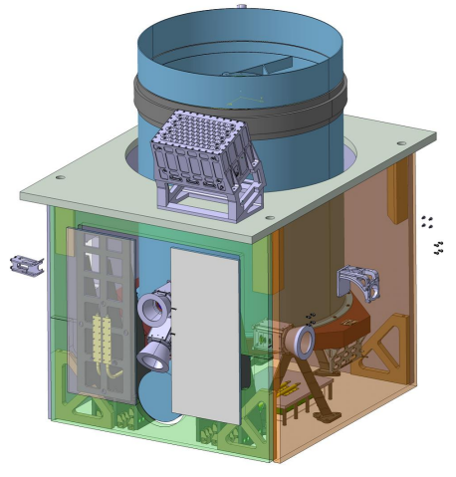
Figure 9 –Spacestar Mini mounted on a Very High Resolution Optical Camera (PLATiNO 3)

SPACESTAR MINI: future Evolution
Today, the SPACESTAR MINI is in the detailed design phase, Flight Models are expected to be available on the market in 2024.
In addition to the above SPACESTAR MINI configuration, Leonardo is studying future evolutions towards a "New Space" configuration ("NS SPACESTAR MINI") and a full autonomous configuration ("Autonomous SPACESTAR MINI").

NS SPACESTAR MINI
Many satellite programs require space-grade, ceramic, hermetically sealed Qualified Manufacturers List (QML) V or QML Q certified electronics for enhanced reliability and radiation-hardness.
PCB manufacturing and assembly is as well required to be performed accordingly either to ECSS or MIL equivalent standards.
This of course has impacts in procurement time and cost of star sensor manufactured according to these stringent rules. On the other side, with the emergence of commercial space, using of plastic-encapsulated microcircuits (PEMs) also defined as Space-Enhanced Plastics (SEP) component is becoming more frequent.
Therefore, further to the above-mentioned configuration required to cover the “conventional” market, a “New Space” configuration is planned to be realized.
In this configuration, the PCB’s will be of the same mechanical shape of the ECSS equivalent version, so that they can fit exactly on the same structure, but they will be procured and assembled at IPC level 3 standard.
Selection of components is performed to include above mentioned SEP components, with emphasis to traceability, reliability, and radiation tolerance.
The aim of this work is to realise a version of the sensor providing the same performance of the Grade1/Grade2 configuration, but with a reduced cost and suitable for LEO mission of moderate duration.

Autonomous SpaceStar Mini
As a future evolution of Spacestar Mini, Leonardo is now conducting internal studies aiming to offer an autonomous product. The aim is to demonstrate that mini Spacestar can evolve into an autonomous sensor that includes the processing electronics embedding the flight SW. Each electronic unit will be capable to provide independent attitude measurement. It is under study the capability (when it is enabled by the proper TC) to be able to communicate with other two units via CAN I/F in order to perform intra-alignment estimation and attitude fusion exploiting the advantages of multi head configuration and autonomous capabilities.

The autonomous Mini will be powered through a +5V power supply.

By leveraging on the increased computational and data storage capabilities available today on the market, it is possible to integrate all the digital electronics (EEE grade-1 or grade-2) in the PCB envelope of the SPACESTAR MINI, while the available processing and memory capability allows including multi-head features in Flight SW.
In other words, the autonomous SPACESTAR MINI, having a compact envelope and reduced mass, will include the full autonomous attitude & tracking features and performance of the latest autonomous star tracker generation extended with the Multi-Head capability.

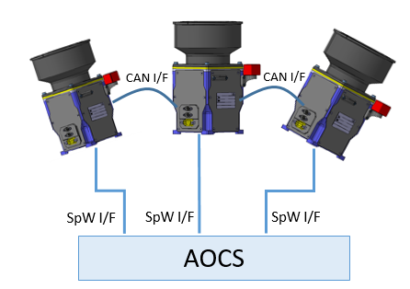
Figure 10 Autonomous SPACESTAR Mini configuration

CONCLUSIONS
SPACESTAR MINI is the next step in the evolution of the successful SPACESTAR product.
The new SPACESTAR MINI Multi-Head Star Tracker allows reducing size and mass without any reduction in reliability and performance with respect to the successful and flight proven SPACESTAR MHSTR in its “Legacy” configuration.
SPACESTAR MINI, being fully equivalent in terms of electrical I/F and data I/O with respect to the predecessor, allows for a “pin-to-pin” replacement of the SPACESTAR. Thanks to the full capability, with SPACESTAR, Customer can easily extend the high performance and reliability of the SPACESTAR product to the small satellites.
The flight proven SW or the latest SW releases available for SPACESTAR can be indifferently used.
In order to satisfy the broadest range mission requirements, Spacestar Mini will be available using Grade 1, Grade 2 and New Space components guaranteeing adequate quality and resistance to radiations.
Finally, Leonardo is evaluating the evolution of the SPACESTAR MINI to a mini autonomous star tracker that, having a compact envelope and reduced mass, will implement the latest autonomous star tracker feature extended with the Multi-Head capability.

The first SPACESTAR Mini will be ready in flight version in 2024.

