The Infrared Sounder (IRS) delivers its first hyperspectral infrared observations from geostationary orbit

Pierre Dussarrat*, Guillaume Deschamps, Dorothee Coppens
EUMETSAT, Eumetsat Allee 1, 64295 Darmstadt, Germany

*pierre.dussarrat@eumetsat.int

Abstract
The Infrared Sounder (IRS) onboard the Meteosat Third Generation Sounding satellite (MTG-S) is the first European hyperspectral infrared sounder operating from geostationary orbit (GEO). Following a successful launch in July 2025 and a one-year commissioning phase, the first IRS instrument is now delivering operational data, processed by EUMETSAT and disseminated to weather centres and the scientific community. This new European asset is expected to significantly enhance weather forecasting capabilities by enabling the early detection of conditions favourable to extreme events development, thereby increasing lead times for warnings. The novel capabilities of IRS also hold transformative potential for medium-term numerical weather prediction, air quality monitoring, and climate research.
IRS is an imaging Fourier Transform Spectrometer (iFTS) based on a Michelson interferometer, providing thermal infrared measurements with unprecedented spatial and temporal sampling. The instrument scans the full Earth disc with a spatial resolution of 4 km at nadir and a revisit time of 30 minutes over Europe. It records nearly 2000 channels in the long-wave and mid-wave infrared, enabling the retrieval of temperature, humidity, and ozone profiles at temporal and spatial scales not previously achieved.
This paper describes the functioning of IRS and showcases new imagery highlighting the instrument’s outstanding technological performance from EUMETSAT’s perspective.
OHB leads the consortium developing the MTG-S satellites, and Thales Alenia Space has supplied the IRS instrument. The project is coordinated by ESA and EUMETSAT, with EUMETSAT responsible for the in-flight operations, ground processing and monitoring of IRS throughout its mission lifetime.

Keywords: Hyperspectral infrared, Fourier transform spectrometry, geostationary orbit, infrared sounder.

INTRODUCTION
The Infrared Sounder (IRS) on board the Meteosat Third Generation Sounding satellite (MTG-S) is the first European hyperspectral infrared sounder to operate from geostationary orbit (GEO). MTG-S1 was launched on the 1 July 2025; its in-orbit commissioning phase was formally closed on 2 July 2026, and EUMETSAT started delivering pre-operational IRS Level 1 data to all users on the 30 July 2026.
The MTG system is built on three-axis stabilised platforms operated close to the 0° longitude orbital position, and the nominal operational constellation consists of two imaging satellites (MTG-I) and one sounding satellite (MTG-S) flying simultaneously [1]. At the time of writing, one MTG-I satellite is operational and has been renamed Meteosat-12; MTG-S1 will likewise be renamed Meteosat-13 upon entering operational service.
IRS provides information on the water vapour and temperature structure of the atmosphere, as well as on several atmospheric trace gases. Infrared sounding from geostationary orbit at 0° longitude is a genuinely new operational capability for EUMETSAT: it has no predecessor in the Meteosat Second Generation era. The instrument is an imaging Fourier transform spectrometer (iFTS) built around a Michelson interferometer [2], and it delivers thermal infrared measurements with an unprecedented combination of spatial and temporal sampling. The full Earth disc is scanned with a spatial sampling of 4 km at nadir, the European region is revisited every 30 minutes, and close to 2000 spectral channels are recorded in the long-wave and mid-wave infrared.
IRS is also a new contributor to the sounding capability of the GEO ring. It complements the Chinese GIIRS instruments flown on the Fengyun-4 series [3] and anticipates the hyperspectral sounders planned for the American GeoXO programme [4] and for the Japanese Himawari-10 mission [5]. Together with the polar-orbiting sounders IASI [6], HIRAS [7] and CrIS [8], these instruments will progressively provide a near-continuous, global hyperspectral infrared coverage of the atmosphere.
The four-dimensional information on humidity, temperature and wind provided by IRS — the so-called ‘4D weather cube’ — is expected to support nowcasting applications first and foremost [9]. The detection of pre-convective situations and of convective initiation should give rise to improved warnings on the location and intensity of convective storms, while vertically resolved atmospheric motion vectors with improved height assignment are of particular benefit over tropical areas. A better depiction of the hydrological cycle in models is also anticipated, through the observation of tropospheric moisture structures and of their variation in time. Beyond nowcasting, the rapid repeat cycle of soundings in the temperature- and humidity-sensitive parts of the infrared spectrum is expected to have a significant impact on numerical weather prediction.
Atmospheric composition applications will benefit as well. Estimates of the diurnal variation of the tropospheric contribution of trace gases such as O₃, NH₃ and CO will support pollution forecasting and information on the composition and density of ash clouds will improve volcanic ash prediction.
Finally, IRS fills spatial and temporal gaps in the current observing system. Its 30-minute repeat cycle over Europe fills the large voids left by the twelve-hourly standard radiosonde network, and it provides a natural interpolation, in both space and time, of the moisture and temperature observations acquired by polar-orbiting sounders.
The remainder of this paper is organized as follows. Section 2 describes the instrument, the measurement principle and the content of the level 1 products. Section 3 reports the in-flight radiometric, spectral and noise performance. Section 4 summarizes the main outcomes and outlines the next steps.

Instrument description and level 1 products
  - Optical layout and viewing directions
As pictured in Figure 1, the light path through IRS starts at the scan mirror, which feeds the front telescope towards the Michelson interferometer. The interferometer comprises a beam splitter and two arms with corner cubes, one fixed and one mobile. The back telescope then guides the light into the cryostat, through the focusing optics and a dichroic that splits the LWIR and MWIR bands. The interferograms are finally recorded at the focal plane by a 160 × 160-pixel detector array in each band [11].
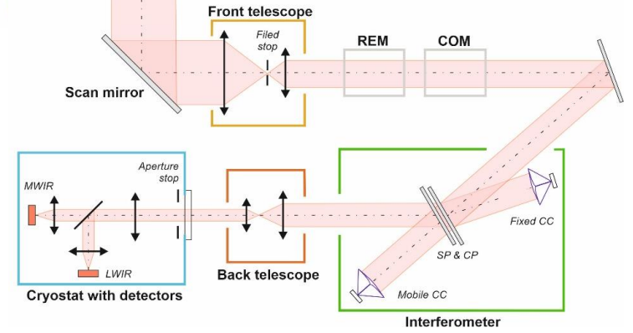
Figure 1. MTG-S IRS instrument optical design (adapted from [11]).
  - Interferograms
The primary acquisitions of IRS are interferograms, an example of which is shown in Figure 2. Optical interferences are generated as a function of the displacement of the mobile corner cube, which changes the relative optical path difference (OPD) between the two arms of the interferometer. During one acquisition, the mobile corner cube covers a total stroke of approximately 8.25 mm in 9.7 s; owing to the double pass on the retroreflector, this generates a symmetric OPD range of ±8.25 mm. The 160 × 160 interferograms of the array are recorded simultaneously, one per pixel.

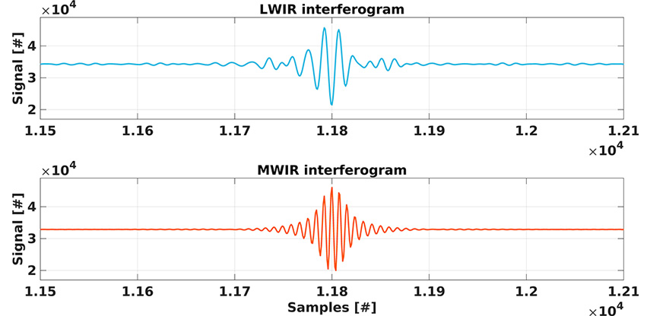
Figure 2. Example of LWIR and MWIR interferograms acquired on the blackbody calibration target (adapted from [12]).

  - Spectral radiances
The radiances, so called level 1 products, are retrieved by Fourier transform of the interferograms. They are provided on 877 spectral samples in the LWIR band and 1076 in the MWIR band, as illustrated in Figure 3, and are delivered in SI units, W m⁻² sr⁻¹ (m⁻¹)⁻¹. One dwell therefore represents a data cube of 160 × 160 × (877 + 1076) values. The main spectral and spatial characteristics are summarized in Table 1.

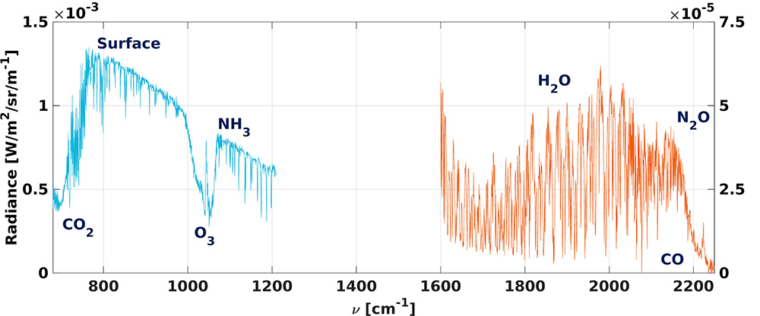
Figure 3. Example of calibrated LWIR and MWIR radiances, with different visible atmospheric components (adapted from [12]).
The spectral sampling of IRS is coarser than that of IASI (0.25 cm⁻¹) or IASI-NG (0.125 cm⁻¹) [13], which limits its application in atmospheric chemistry; it has, however, been optimized for weather forecasting. The exact definition of the spectral grids is given in the IRS Level 1 data guide [14].

Table 1. Main spectral and spatial characteristics of the IRS Level 1 radiances.
Parameter | LWIR band | MWIR band
Spectral coverage | 680 – 1210 cm⁻¹ | 1600 – 2250 cm⁻¹
Number of spectral samples | 877 | 1076
Spectral sampling δν | 0.6056 cm⁻¹ | 0.6051 cm⁻¹
Detector array | 160 × 160 pixels | 160 × 160 pixels
Spatial sampling at nadir | 4 km | 4 km

  - Scanning strategy
The instrument scans the Earth in a ‘stop and stare’ mode. IRS images an area of the Earth covered by its field of view, called a dwell, collecting in 9.7 seconds the 160 × 160 interferograms. Moreover, broadband images in 480 × 480 are acquired for each spectral band, before moving to the next adjacent area. The sequence is illustrated in Figure 4.
The Earth disc is divided into four regions of interest called Local Area Coverages (LACs), numbered 1 to 4 from south to north. LAC 4, the northernmost one, covers Europe and is scanned every 30 minutes; LACs 1, 2 and 3 are imaged in between, successively. A full-disc view reconstructed from the individual dwells is shown in Figure 5.

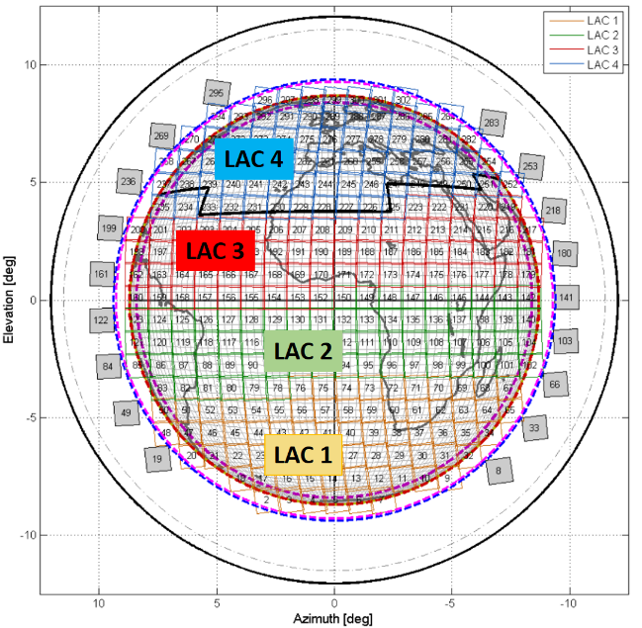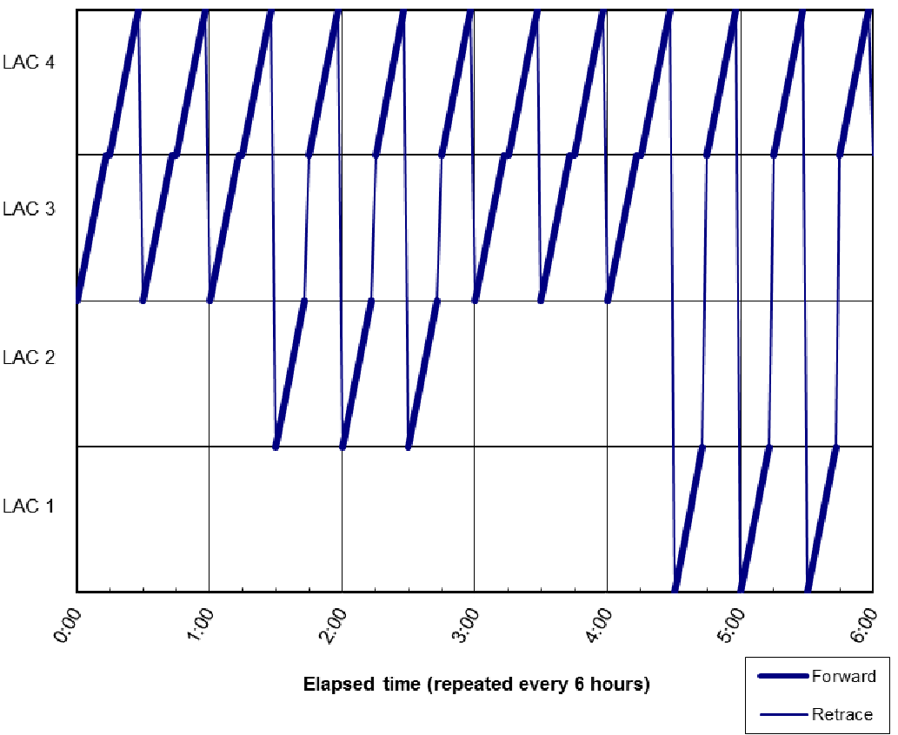
Figure 4. Illustration of the “stop and stare” acquisition sequence and of the four LACs covering the Earth disc.

IRS provides unprecedented spatial coverage, with contiguous spatial sampling at 4 km at nadir. Figure 6 compares the sampling obtained from a single IRS full-disc scan with that of a single IASI overpass acquired at the same time. Such contiguous and fine sampling is expected to be extremely powerful for the detection of point sources of NH₃, SO₂ and CO, in the spirit of the analyses already performed with polar-orbiting sounders [15].
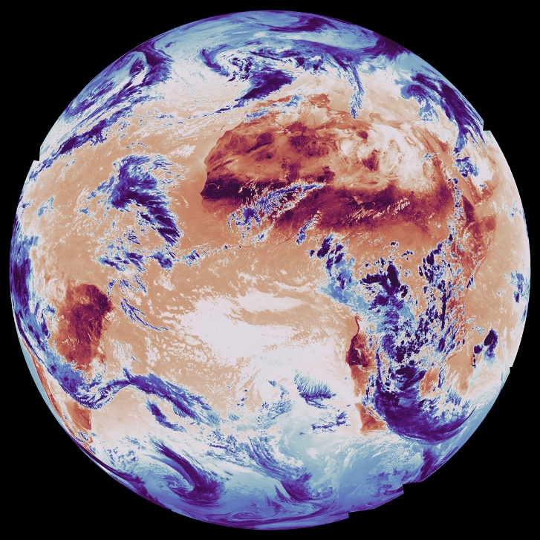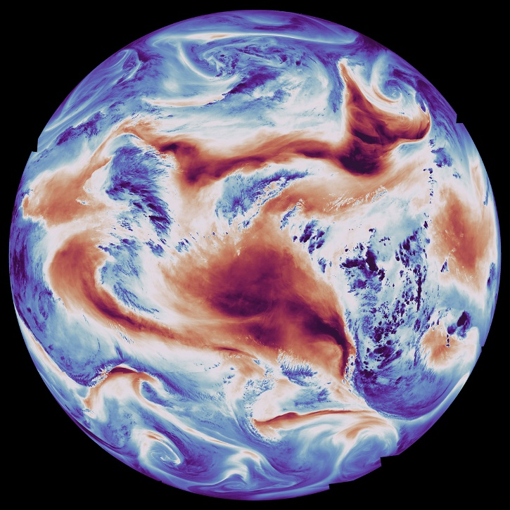
Figure 5. Example of full-disc imagery at 1200 and 1600cm⁻¹ reconstructed from 280 IRS dwells in the LWIR and MWIR bands (adapted from [12]).

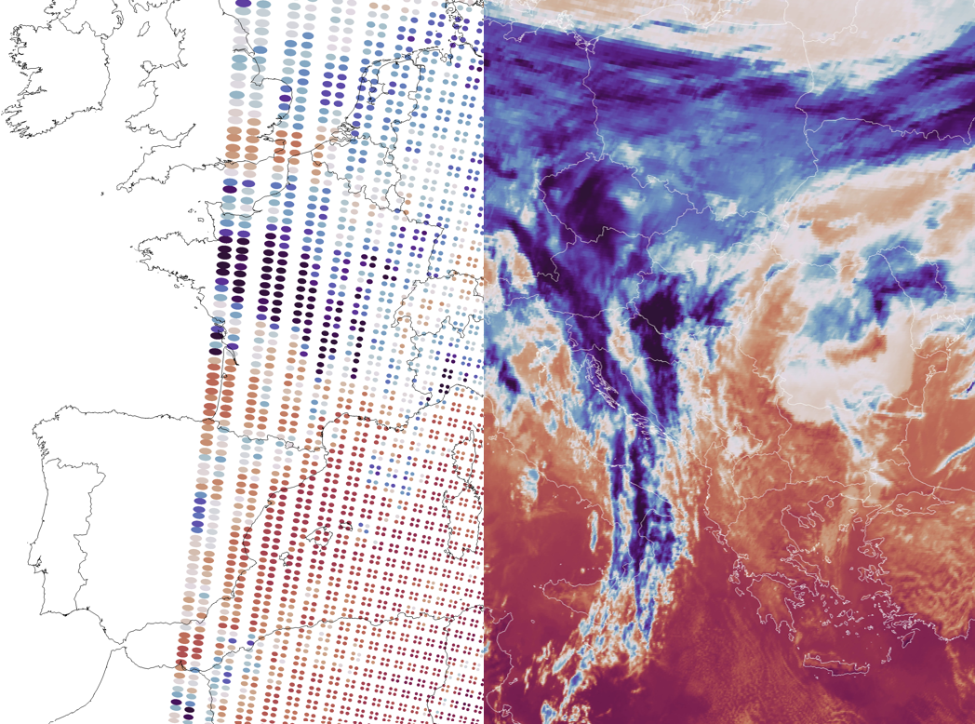
Figure 6. Comparison of the spatial sampling of one IRS full-disc scan (right) and of one IASI overpass (left) acquired at the same time at 850 cm⁻¹ wavenumber.
  - In-flight calibration scheme
As represented on Figure 7, the deep space views DS2, are acquired beyond the Earth’s rim and are used to determine the instrument offset. Actioning the flip-in mirror (labelled COM on Figure 1) between LACs allows acquiring internal blackbody views BB and complementary deep space DS1, yielding the instrument gain.
The DS2 acquisitions are performed at the end of every scanning line, at approximately 3-minute intervals. The eight preceding DS2 acquisitions are used to predict the background over the interval by linear interpolation. The most demanding conditions occur close to local midnight during the eclipse season, when the Sun illuminates the instrument directly and is then briefly eclipsed behind the Earth: the background evolves rapidly, but the interpolation remains adequate, with residual errors of at most 50 mK.
The BB and DS1 views are acquired every 15 minutes, between two LACs, to compute the current instrument gain. It is then averaged with the eight previous evaluations to reduce the noise. The gain of the instrument has proven to be extremely stable and is only affected by a slow decrease caused by icing in the cryostat. Decontamination operations are expected to be carried out every six months during the first year of operation.

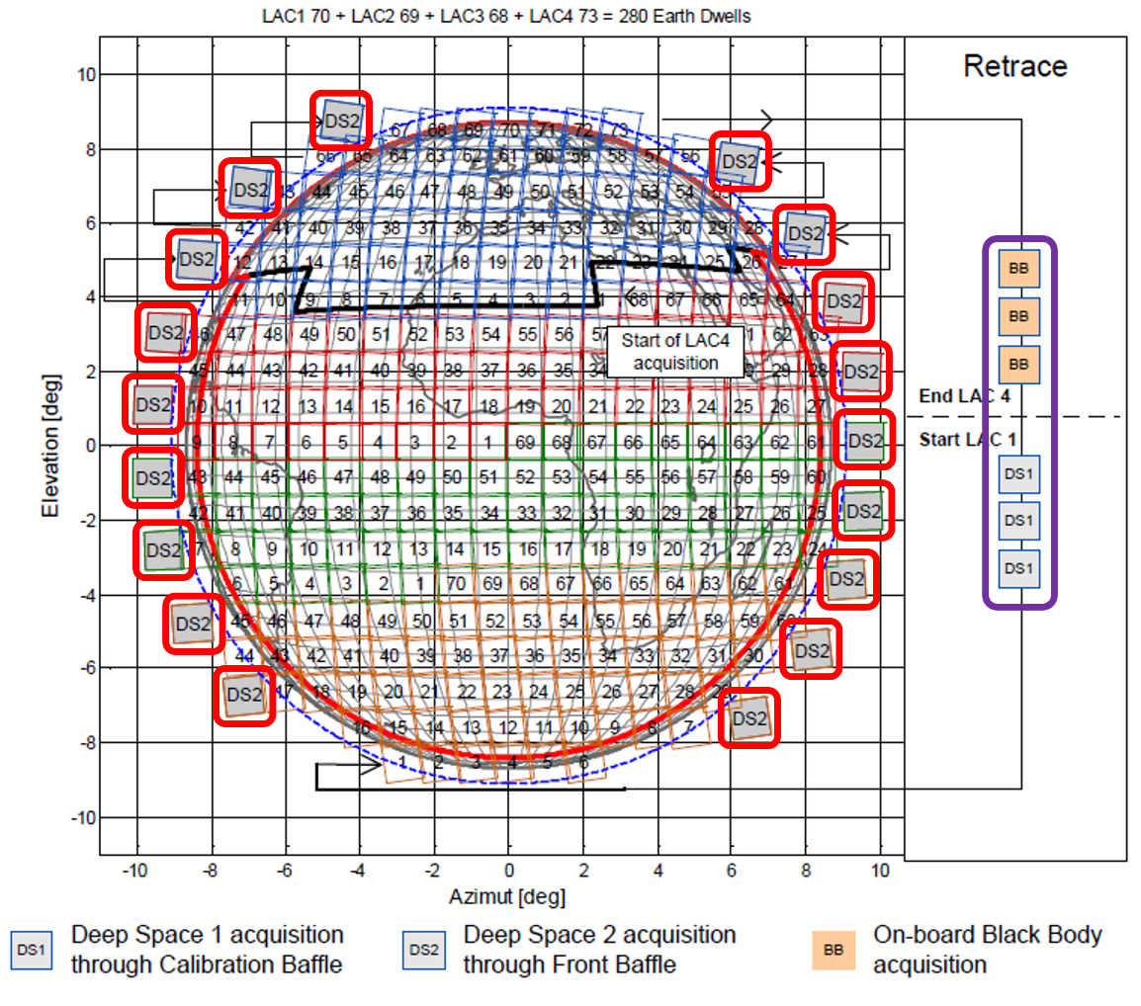
Figure 7. Representation of the calibration views DS2, BB and DS1 (adapted from [14]).

  - Principal Component
The IRS level 1 products consist of signal — the radiances of 1953 spectral samples — and noise. Strong spectral correlations exist between channels, meaning that each spectrum carries a large amount of redundant information. Mathematically, the effective rank of the subspace spanned by the signal within the measurements is much lower than the number of channels; in other words, the number of independent pieces of information contained in the IRS measurements is much smaller than 1953. These independent pieces of information are the principal component scores (PCS), computed with the leading eigenvectors, called the principal components (PC), that represent the natural variance of the noise-normalized measurements [16]. In Figure 8, the radiance covariance along with the first three principal components are represented for the two bands of IRS.

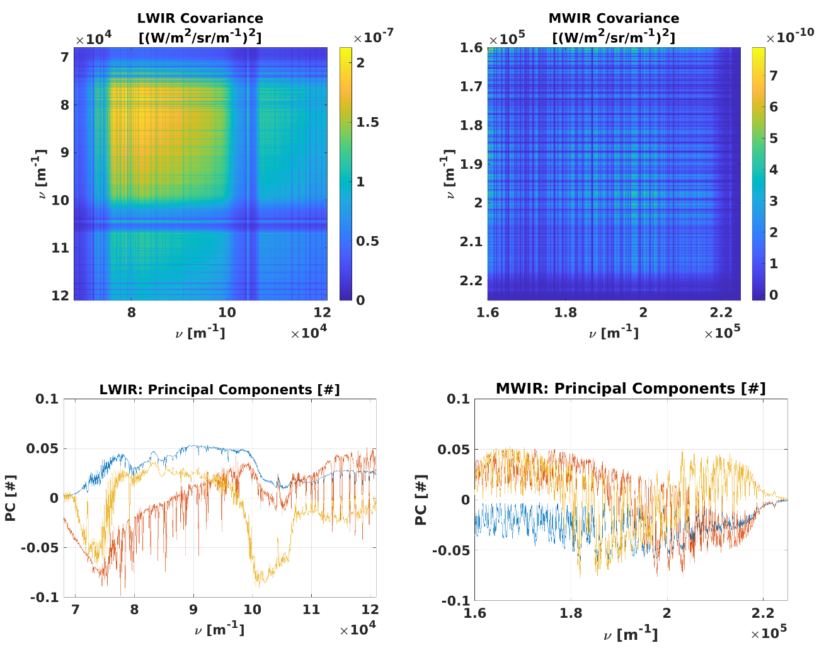
Figure 8. IRS radiance covariance (up) and principal components (down) per band; the first three principal components are represented (in order blue, red, yellow).

The radiances of each IRS band are compressed into 150 PCS by projecting the radiances onto the PC. Keeping a compression per band ensures that, in the event of a failure or a degradation affecting one of the two bands, the other one remains unaffected. The price to pay is a slightly lower overall compression rate than would be achieved by processing the full spectrum at once, since the inter-band correlations are not exploited.
On the user side, the radiances can be reconstructed from the PCS by re-projecting onto the PC. The difference between the original and the reconstructed radiances mainly consists of random instrument noise. An example of reconstruction code is presented in the IRS Level 1 data guide [14].
The IRS global principal components are supplemented by 5 local principal components and corresponding scores, derived from the noise-normalized residuals of the current dwell after reconstruction with the global components — the so-called hybrid approach [14]. It is left to the end user to decide whether to include the additional local PC scores in the radiance reconstruction. Doing so results in reconstructed radiances that are closer to the original ones, but for the vast majority of dwells this is achieved only by re-introducing a little more of the original noise. The local PC feature is therefore mainly of interest for users targeting atmospheric composition applications.
Data users may also use the global PCS directly in their applications, thereby avoiding the reconstruction of the radiances altogether. The direct processing of PCS is, for instance, common practice in artificial intelligence and machine learning applications.

Calibration performances
  - Radiometric calibration
Radiometric performance is verified using colocations with the Metop-B and C IASI [6], which are recognized as international references. We gathered 138,000 collocations over the first seven days of pre-operational dissemination of IRS, from 30 July to 5 August 2026. The collocation criteria are the following: a difference of footprint centre locations lower than 6 km, a difference of the secants of sounding zenith angles lower than 3%, and a difference of acquisition times lower than 5 min.
The geo-localisation of the colocations is represented on Figure 9. The spatial pattern is produced by the synchronization of the IASI orbits with the scan pattern of IRS. The colours represent the spectrally averaged difference in equivalent brightness temperature (edT) evaluated at a reference temperature of 280 K between IRS and IASI in LWIR.

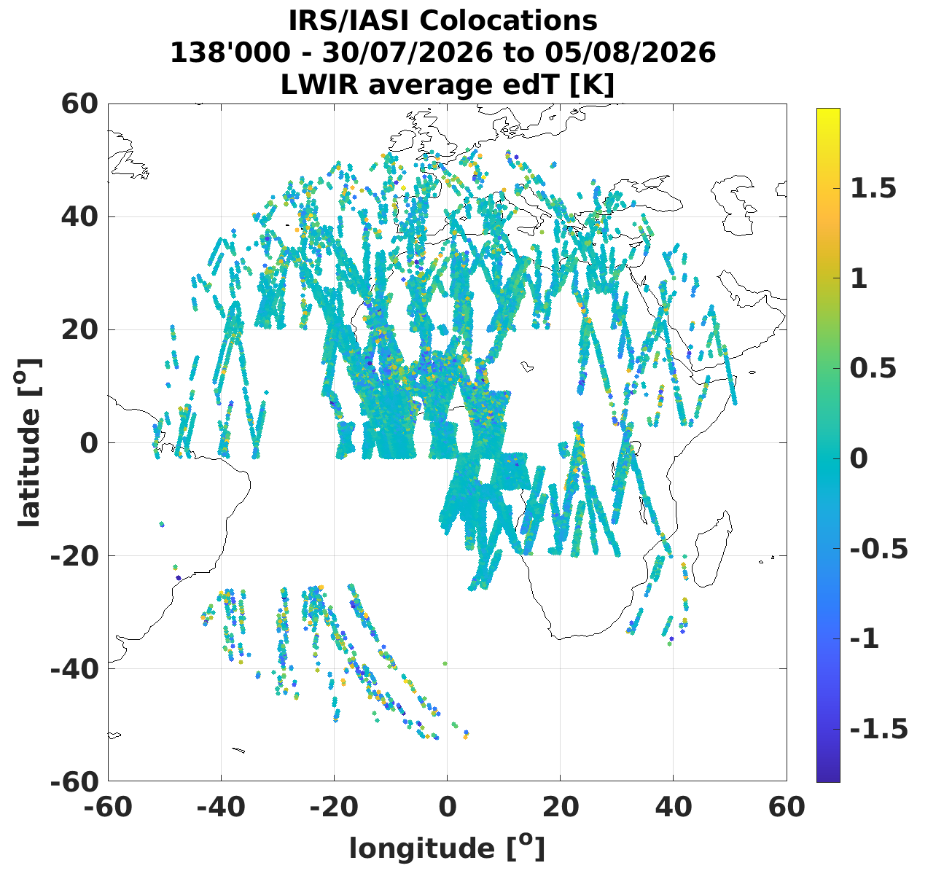
Figure 9. Spatial distribution of colocations between IRS and IASI, spectrally averaged edT at 280K [K]
The edT are represented spectrally for both bands on Figure 10. The characterization is split into five classes of scene temperature, determined from the average IASI spectrum per band and defined so as to contain an equal number of elements.

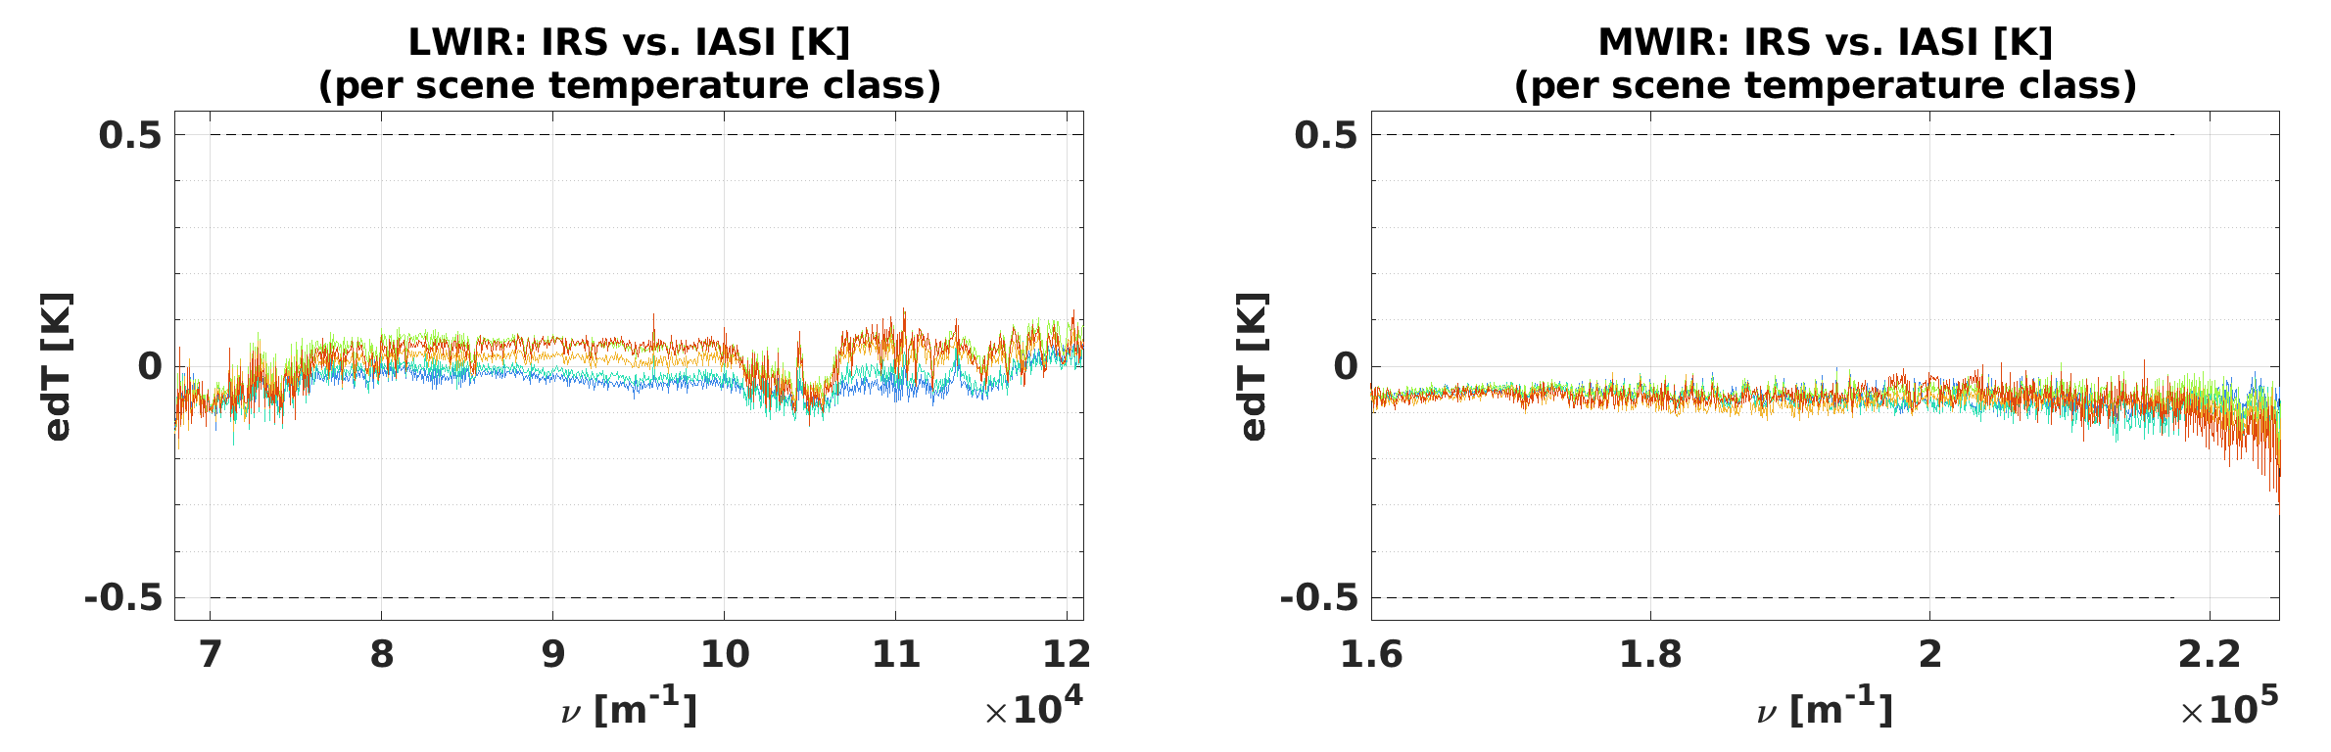
Figure 10. Radiometric calibration comparison between IRS and IASI, per class of scene temperature (cold to hot, blue to red).

The differences show a small dependency of maximum 0.1K on the scene temperature that will be investigated further. The difference nevertheless remains below 0.2 K, and for most of the spectral range below 0.1K, which demonstrates the remarkable consistency of the IRS and IASI missions. This is also well within the absolute radiometric calibration specification of IRS, which is 0.5 K [10].

  - Spectral calibration
The spectral calibration is likewise evaluated against the IASI instruments. Assessed per spectral sub-band, the comparison shown in Figure 11 exhibits a maximum difference of 1 and 0.5 ppm of the spectral scales, below the IRS spectral calibration specifications of 3 ppm in the LWIR band and 1 ppm in the MWIR band [10].

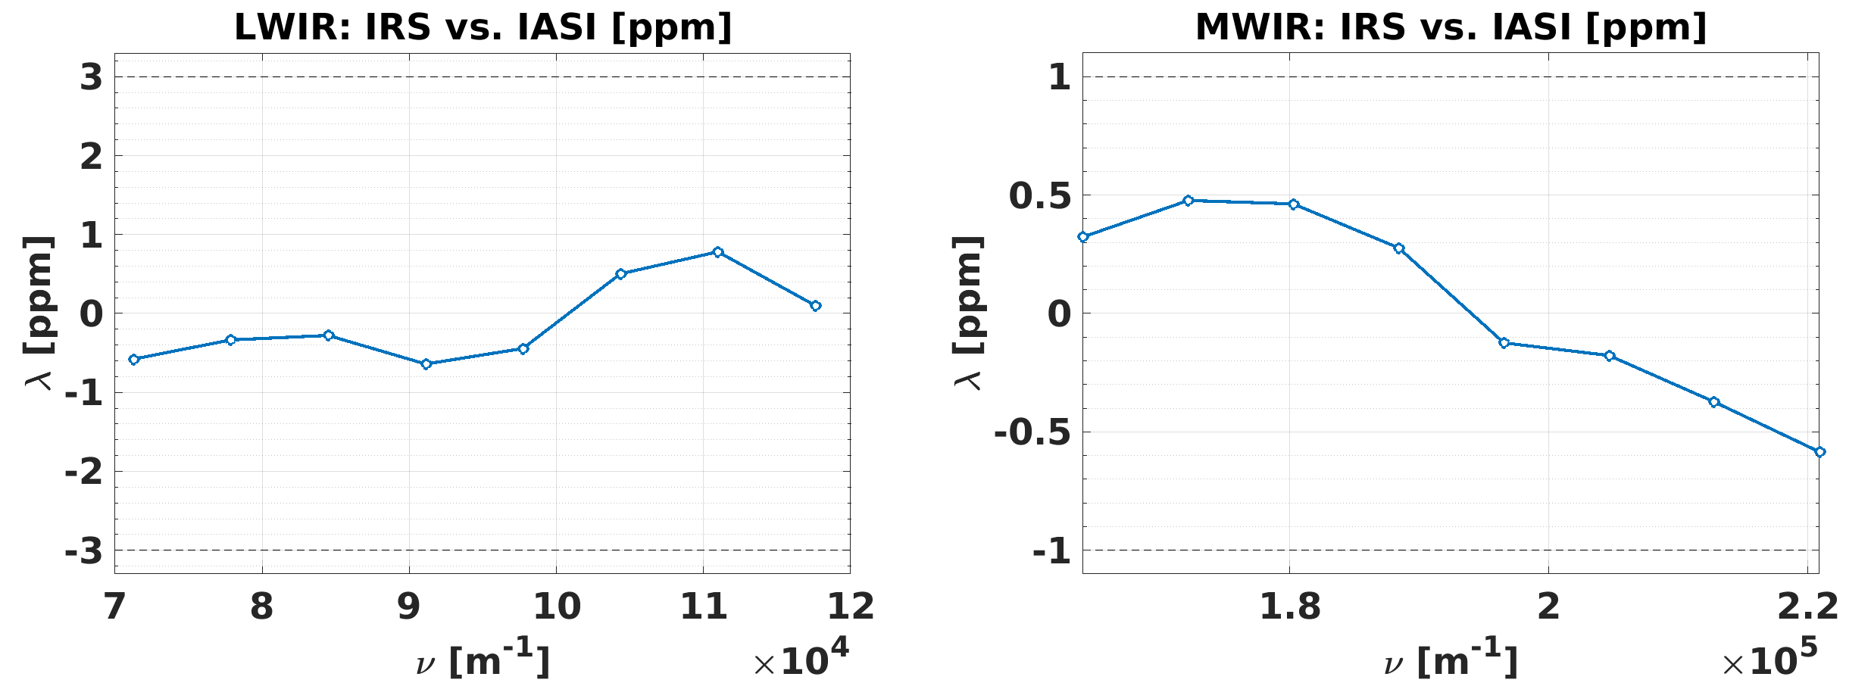
Figure 11. Spectral calibration comparison between IRS and IASI

  - Radiometric noise
The noise is evaluated using a principal component decomposition of the Earth-view spectra, following the approach already applied to IASI [18] and to HIRAS [19], and evaluated at a reference temperature of 280 K. As represented on Figure 12, the noise is overall within specifications except around 800 and 1100 cm⁻¹, because of silicon contamination and coating degradation. Both effects are stable at present and are kept under monitoring.

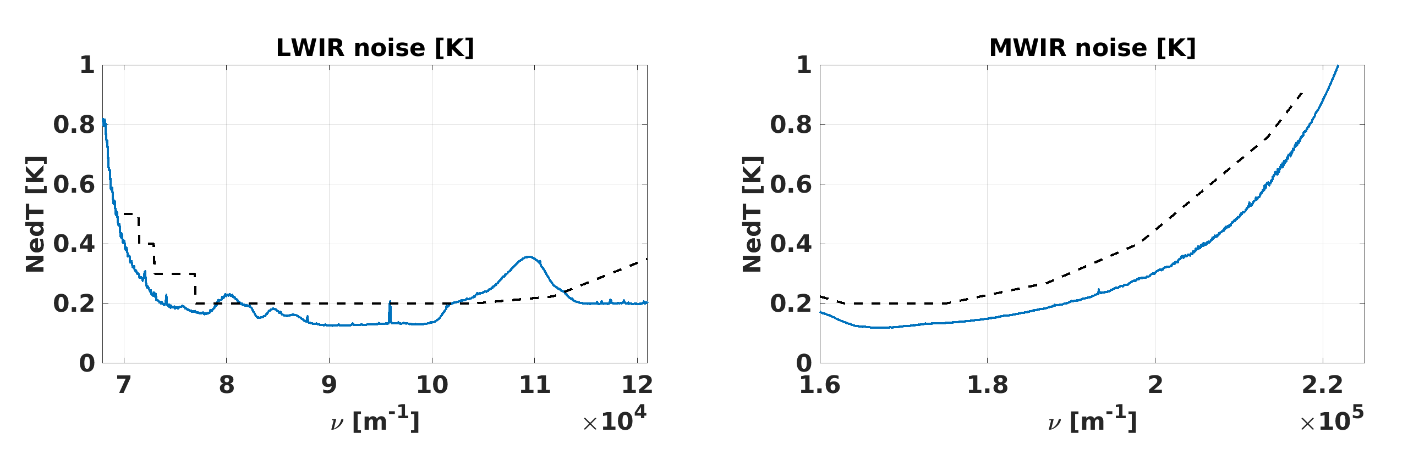
Figure 12. Radiometric noise of IRS estimated via principal component analysis.

Conclusion
IRS is the first European hyperspectral infrared sounder operating from geostationary orbit, and the commissioning of the first flight model has confirmed that the instrument meets, and in most respects exceeds, its design expectations. The radiometric differences with respect to the IASI reference sounder remain below 0.2 K, against a specification of 0.5 K, and the spectral scale agrees with this reference to better than 1 and 0.5 ppm, against specifications of 3 ppm in the LWIR and 1 ppm in the MWIR. The radiometric noise is within specification over most of the spectral range, with the exception of two regions affected by silicon contamination and coating degradation, which are now stable and monitored routinely.
With a contiguous 4 km sampling at nadir, a 30-minute revisit over Europe and close to 2000 spectral samples, IRS provides a combination of spatial, temporal and spectral sampling that has no equivalent in the European observing system. The pre-operational level 1 data were released to all users on 30 July 2026 and are disseminated as principal component scores, from which radiances can be reconstructed or which can be used directly in the users’ applications. Practical information on data access and product content is available from the IRS Level 1 data guide [14] and the EUMETSAT User Portal [20].
The next steps concern the consolidation of the products towards full operational status and the extension of the monitoring to longer time scales in order to characterise the long-term stability of the instrument. The forthcoming exploitation of the data by numerical weather prediction centres and by the atmospheric composition community will be the ultimate demonstration of the value of this new capability.

Acknowledgements
The authors thank the MTG-S1 and IRS commissioning teams at EUMETSAT, ESA, OHB System AG and Thales Alenia Space for their work in bringing the instrument to operational readiness. The IRS mission is a joint undertaking of ESA and EUMETSAT, carried out on behalf of the EUMETSAT Member States.
The authors acknowledge the use of a generative artificial intelligence assistant (Anthropic's Claude) for language editing and for support in structuring and drafting parts of this manuscript. The tool was not used to generate, analyse or interpret any of the scientific results presented here. All content has been reviewed and validated by the authors, who take full responsibility for the accuracy and integrity of the paper.

References
[1] Holmlund, K., Grandell, J., Schmetz, J., Stuhlmann, R., Bojkov, B., Munro, R., Lekouara, M., Coppens, D., Viticchiè, B., August, T., Theodore, B., Watts, P., Dobber, M., Fowler, G., Bojinski, S., Schmid, A., Salonen, K., Tjemkes, S., Aminou, D. and Blythe, P., “Meteosat Third Generation (MTG): continuation and innovation of observations from geostationary orbit,” Bull. Amer. Meteor. Soc. 102(5), E990–E1015 (2021). https://doi.org/10.1175/BAMS-D-19-0304.1
[2] Abdon, S., Gardette, H., Degrelle, C., Gaucel, J.-M., Astruc, P., Guiard, P., Accettura, A., Lamarre, D., Aminou, D. M. and Miras, D., “Meteosat Third Generation Infrared Sounder (MTG-IRS), interferometer and spectrometer test outcomes, demonstration of the new 3D metrology system efficiency,” Proc. SPIE 11852, International Conference on Space Optics — ICSO 2020, 118521F, 583–594 (2021). https://doi.org/10.1117/12.2599240
[3] Yang, J., Zhang, Z., Wei, C., Lu, F. and Guo, Q., “Introducing the new generation of Chinese geostationary weather satellites, Fengyun-4,” Bull. Amer. Meteor. Soc. 98(8), 1637–1658 (2017). https://doi.org/10.1175/BAMS-D-16-0065.1
[4] NOAA/NESDIS, “GeoXO Sounder (GXS) — GeoXO infrared sounding,” (accessed 31 July 2026). https://www.nesdis.noaa.gov/our-satellites/future-programs/geoxo/geoxo-infrared-sounding
[5] Bessho, K., Andou, A., Sumida, Y. and Abe, M., “Himawari-10 project overview,” SOLA 21, 251–257 (2025). https://doi.org/10.2151/sola.2025-031
[6] Clerbaux, C., Boynard, A., Clarisse, L., George, M., Hadji-Lazaro, J., Herbin, H., Hurtmans, D., Pommier, M., Razavi, A., Turquety, S., Wespes, C. and Coheur, P.-F., “Monitoring of atmospheric composition using the thermal infrared IASI/MetOp sounder,” Atmos. Chem. Phys. 9(16), 6041–6054 (2009). https://doi.org/10.5194/acp-9-6041-2009
[7] Qi, C., Wu, C., Hu, X., Xu, H., Lee, L., Zhou, F., Gu, M., Yang, T., Shao, C., Yang, Z. and Zhang, P., “High spectral infrared atmospheric sounder (HIRAS): system overview and on-orbit performance assessment,” IEEE Trans. Geosci. Remote Sens. 58(6), 4335–4352 (2020). https://doi.org/10.1109/TGRS.2019.2963085
[8] Han, Y., Revercomb, H., Cromp, M., Gu, D., Johnson, D., Mooney, D., Scott, D., Strow, L., Bingham, G., Borg, L., Chen, Y., DeSlover, D., Esplin, M., Hagan, D., Jin, X., Knuteson, R., Motteler, H., Predina, J., Suwinski, L., Taylor, J., Tobin, D., Tremblay, D., Wang, C., Wang, L., Wang, L. and Zavyalov, V., “Suomi NPP CrIS measurements, sensor data record algorithm, calibration and validation activities, and record data quality,” J. Geophys. Res. Atmos. 118(22), 12734–12748 (2013). https://doi.org/10.1002/2013JD020344
[9] EUMETSAT, “MTG-S IRS science plan,” (accessed 31 July 2026). https://user.eumetsat.int/s3/ope-eup-strapi-media/MTG_S_IRS_Science_Plan_47145497b0.pdf
[10] EUMETSAT, “MTG end user requirements document (EURD),” EUMETSAT, Darmstadt (accessed 31 July 2026). https://user.eumetsat.int/s3/eup-strapi-media/pdf_mtg_eurd_d7b503ecc4.pdf
[11] Lucas Carbó, F. et al., “The MTG-IRS instrument: technical overview and measured performances during environmental and thermal vacuum test campaigns,” EUMETSAT Meteorological Satellite Conference (2023). https://www-cdn.eumetsat.int/files/2023-10/7.%20Francesc%20Lucas%20Carbo%2012.15.pdf
[12] EUMETSAT, “See into Earth’s atmosphere like never before — first images from the MTG-S1 Infrared Sounder,” (2026). https://www.eumetsat.int/features/see-earths-atmosphere-never
[13] Crevoisier, C., Clerbaux, C., Guidard, V., Phulpin, T., Armante, R., Barret, B., Camy-Peyret, C., Chaboureau, J.-P., Coheur, P.-F., Crépeau, L., Dufour, G., Labonnote, L., Lavanant, L., Hadji-Lazaro, J., Herbin, H., Jacquinet-Husson, N., Payan, S., Péquignot, E., Pierangelo, C., Sellitto, P. and Stubenrauch, C., “Towards IASI-New Generation (IASI-NG): impact of improved spectral resolution and radiometric noise on the retrieval of thermodynamic, chemistry and climate variables,” Atmos. Meas. Tech. 7(12), 4367–4385 (2014). https://doi.org/10.5194/amt-7-4367-2014
[14] EUMETSAT, “MTG IRS Level 1 data guide,” (accessed 31 July 2026). https://user.eumetsat.int/resources/user-guides/mtg-irs-level-1-data-guide
[15] Van Damme, M., Clarisse, L., Whitburn, S., Hadji-Lazaro, J., Hurtmans, D., Clerbaux, C. and Coheur, P.-F., “Industrial and agricultural ammonia point sources exposed,” Nature 564, 99–103 (2018). https://doi.org/10.1038/s41586-018-0747-1
[16] Huang, H.-L. and Antonelli, P., “Application of principal component analysis to high-resolution infrared measurement compression and retrieval,” J. Appl. Meteorol. 40(3), 365–388 (2001). https://doi.org/10.1175/1520-0450(2001)040<0365:AOPCAT>2.0.CO;2
[18] Serio, C., Masiello, G., Camy-Peyret, C., Jacquette, E., Vandermarcq, O., Bermudo, F., Coppens, D. and Tobin, D., “PCA determination of the radiometric noise of high spectral resolution infrared observations from spectral residuals: application to IASI,” J. Quant. Spectrosc. Radiat. Transfer 206, 8–21 (2018). https://doi.org/10.1016/j.jqsrt.2017.10.022
[19] Serio, C., Masiello, G., Mastro, P. and Tobin, D. C., “Characterization of the observational covariance matrix of hyper-spectral infrared satellite sensors directly from measured Earth views,” Sensors 20(5), 1492 (2020). https://doi.org/10.3390/s20051492
[20] EUMETSAT, “Meteosat Third Generation resources — data access and user guides,” EUMETSAT User Portal (accessed 31 July 2026). https://user.eumetsat.int/data/satellites/meteosat-third-generation/resources

