MBSE Best Practices for ESA Projects
Hans Peter de Koning, Jose Lorenzo, Harold Metselaar
European Space Agency, ESTEC, Noordwijk, The Netherlands

The use of Model-Based Systems Engineering (MBSE) has been steadily increasing at ESA since 2012 with full application in a number of projects – in particular Euclid and e.Deorbit – as well as in the early concept and feasibility studies in the Concurrent Design Facility (CDF). The proposed paper outlines a number of best practices and guidelines that have been derived with the early adopters and are now being implemented for (future) ESA projects.

MBSE is part of the ongoing transformation towards a full digital engineering support across all disciplines and lifecycle phases of the projects. Since this is clearly a complex improvement process involving many choices concerning methodology, standards and tools, as well as involving many different actors, ESA decided it is timely and useful to develop a ‘living’ best practices guide. The guide serves as a common knowledge resource shared between projects, studies and research & development work. It is not only meant for internal use at ESA, but also to be shared with the European space sector. The goals are:
To facilitate and promote efficient and effective use of MBSE on space system projects
- To share practical knowledge on what works well and what does not
- To harmonize use of MBSE standards and methodologies, from the beginning
- To build up shareable resources: model libraries, profiles, usage patterns, repositories
An overview of examples from real projects and studies is given in the diagram below.
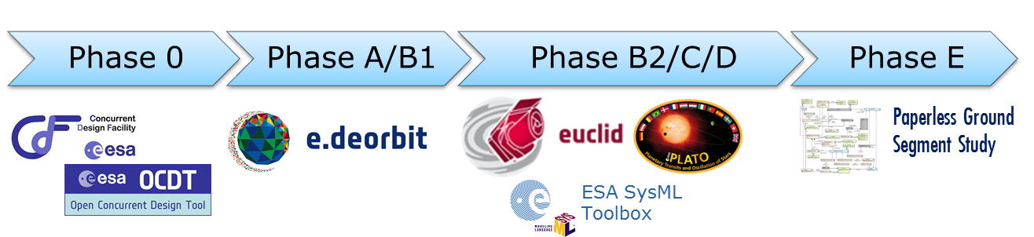

The focus is on standards and methodologies rather than tools, in particular:
- OMG Systems Modeling Language (SysML), current version 1 and future version 2
- ECSS-E-TM-10-23 “System engineering - Space system data repository”
- ECSS-E-TM-10-25 “System engineering - Engineering design model data exchange (CDF)”
- ESA SysML Toolbox, including a metamodel/profile, as developed for Euclid and PLATO
- ARCADIA methodology from the Thales Group
- ESA Architectural Framework (ESA-AF) for System-of-Systems (SoS) architectures

Nevertheless implementation examples with actual tools will be shown, although ESA naturally takes a neutral standpoint w.r.t. tools, avoiding endorsement of specific ones.

