Development and Validation of a CFD optimized integrated Pitot Sensor - Produced by Selective Laser Melting and Abrasive Flow Machining

J. Ferchow^{1*}; D. Kläusler², M. Meboldt²

¹Inspire AG, Zurich, Switzerland, *Primary author contact details: ferchow@inspire.ethz.ch
²ETH Zurich, Zurich, Switzerland

Additive manufacturing (AM), offers the possibility to produce complex internal structures that are otherwise difficult to manufacture. In particular the powder bed based and layer by layer process Selective Laser melting (SLM) offers a large design freedom for internal structures. The limitation here is still the rough surface quality of the SLM parts. The surface needs to be smooth and should show a low surface roughness to avoid sticking rest powder and to ensure good flow characteristics, in order to use it for gas applications in aerospace industry. Hence a suitable post-processing procedure is needed to smooth the rough surface of internal SLM structures.
In this paper, a lightweight volume flow sensor was sought which can be integrated into an existing SLM valve design. In addition, the sensor is selected in a way that the surfaces of the internal structures can be post-processed. As a measuring principle, a pitot tube was determined, plotted in Figure 1, which was subsequently constructed in two printing directions. The abrasive flow machining (AFM) process should be used as a post-processing method. Based on a CFD analysis, the measuring sensor design was therefore flow optimized in order to obtain a regular removal by the AFM.
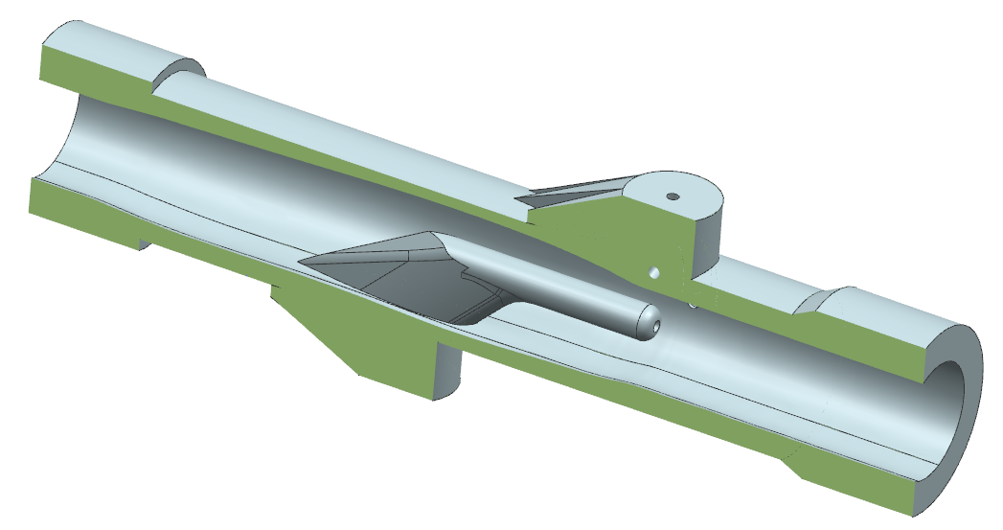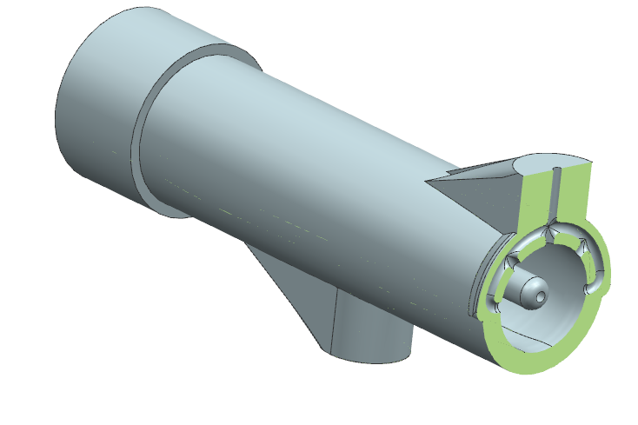
Figure 1: Horizontal oriented integrated pitot tube.
The optimized sensor design was then manufactured using selective laser melting (SLM) and post-processed with the mentioned AFM. With the help of a test bench, the pressure loss and the volume flow were measured. The results of the developed sensor were compared with an established sensor and further validated, plotted in Figure 2.
Figure 2: Volume flow measurement results.
The results of the volume flow measurement show that the chosen measuring principle is suitable for AM in particular for SLM. Furthermore, the surface roughness can be improved by the AFM post-processing.

