miniature Two axis scan mechanism for microlibs instrument

Lionnel Escolano ⁽¹⁾, Sébastien Lalaque ⁽¹⁾, Laurent Ropert ⁽¹⁾, Laurent Cadiergues ⁽²⁾ , Chloé Bertogna ⁽²⁾, Bruno Dubois ⁽³⁾
⁽¹⁾ ISP System, Vic-en-Bigorre, France
⁽²⁾ CNES, Toulouse, France
⁽³⁾ OMP, Toulouse, France

ABSTRACT
To demonstrate feasibility and performance, an engineering model of a miniature 2-axis scan mechanism was developed and tested. Key characteristics include a 230° azimuth range, a 20° elevation range and 20µrad repeatability. The design challenges addressed were extreme miniaturization (⌀50x100mm, <150g), use of miniature gearmotors, custom twist capsules for power transmission, specific wire interconnections, and 3D-printed validation mock-ups. An anti-backlash solution enabled precise rastering; dust protection was achieved through a dynamic seal. The development approach, focused on early breadboard validation, enabled faster scheduling and provided high confidence in performance. The results and lessons learned will support future improvements to raise TRL.

INTRODUCTION
The MicroLIBS instrument [1] for in situ elemental micro-mapping is being developed by CNES with IRAP (FR) and LANL (US) laboratories. It meets the need for lightweight, low-cost instruments that can be rapidly developed. With a weight of only 1.5kg and a size volume of 200 x 150 x 100 mm, this miniaturized version of ChemCam/SuperCam (10kg) is designed to be mounted on a helicopter or a drone on Mars. It can also be installed on a tripod for use by astronauts on the lunar surface, or mounted on a small surface rover for near-real-time analysis of surrounding rocks.

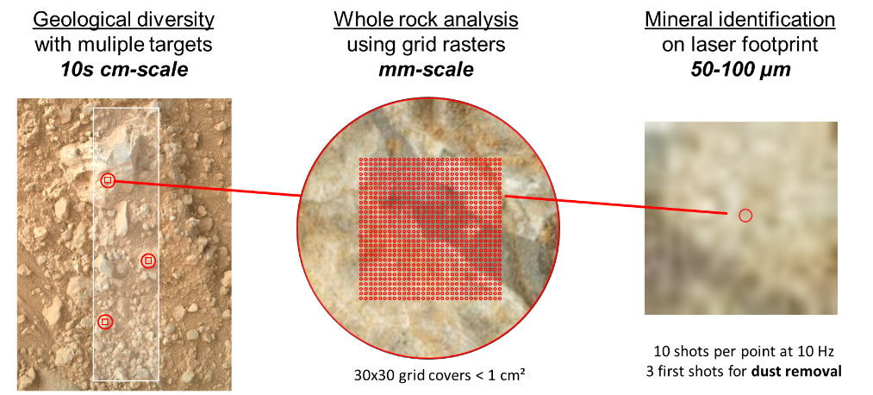
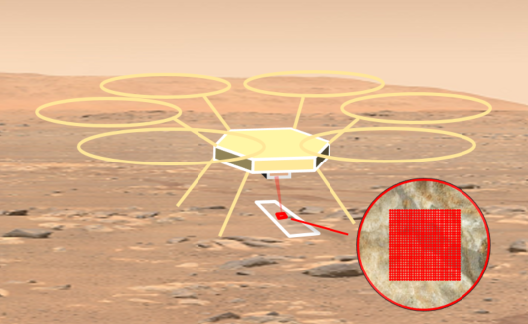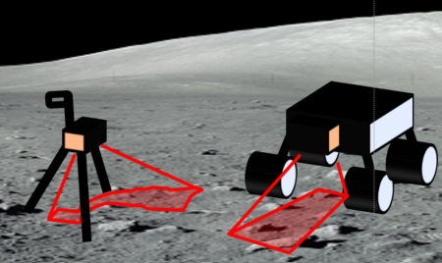
Figure 1: Conceptual view of MicroLibs on a Mars helicopter, on a Moon tripod or rover

The LIBS (Laser Induced Breakdown Spectroscopy) vaporises rocks and soils with a very high-energy pulsed laser. This creates a plasma that emits light, which is analysed back in the instrument by a set of spectrometers. By comparing the spectra with a database of rocks analysis on Earth, one can obtain the elemental composition of the sample shot and identify the rock with the same composition (e.g. olivine, hematite, clay, etc.).

The development of a prototype version of MicroLIBS (fig 2) started in 2022. The first phases of the development were focused on the design of the instrument and the technical challenges the team would face when the need to develop a flight version of the instrument would appear.

One of these challenges is the design of the new pointing system for the laser beam. The prototyping presented in this paper therefore aims to validate the feasibility of a compact 2-axis pointing mechanism, with a mass limited to 15.
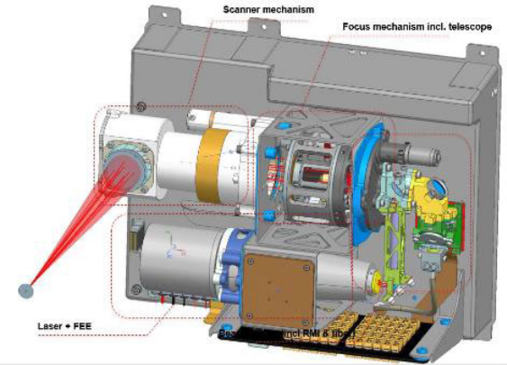
Figure 2: The MicroLIBS design

This 2-axis actuated scanning mirror shall be able to point a target’s location within an area below the platform (fig 3a). Then the instrument will start a raster of laser shots on the selected target (fig 3b). A raster is defined by a 30x30 grid of 10 shots at 10Hz on each of the 900 points of the grid. The requirement on the MicroLIBS instrument is to perform that 30x30 grid raster within 1 hour, including the displacement duration between each location.

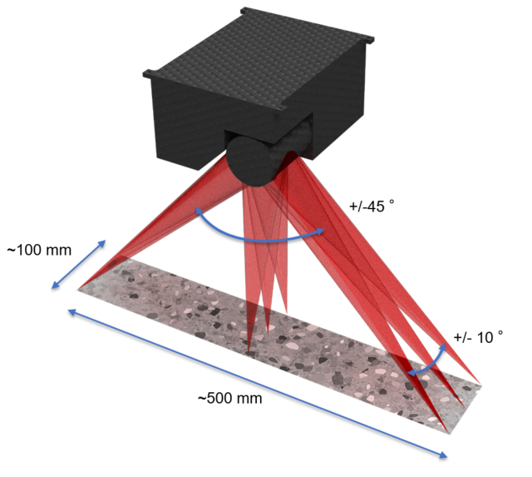(a)

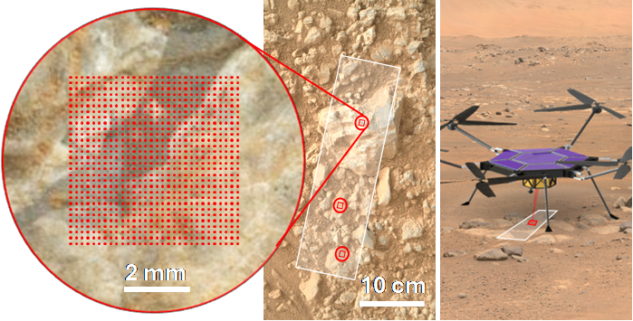(b)
Figure 3: (a) workspace area, (b) raster grid on a target

DESIGN DESCRIPTION
The main function of the µLIBS scanner mechanism is to point a laser beam along 2 axes: azimuth +/-45° and elevation +/-10°.
The mechanism is mainly composed of:
- Azimuth axis sub-assembly:
- housing interfacing with the instrument, holding all components
- Hollow shaft
- bearings assembly, guiding the hollow shaft in rotation
- gear motor + spur gears stage + anti-backlash device
- dynamic seal + optical exit window for dust protection

- Elevation axis, mounted on the azimuth axis:
- housing interfacing with the hollow shaft
- mirror
- flexure pivots to guide the mirror
- gear motor + worm gear + anti-backlash device
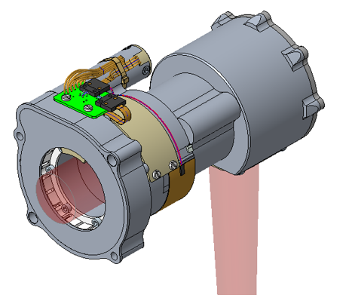
(a)
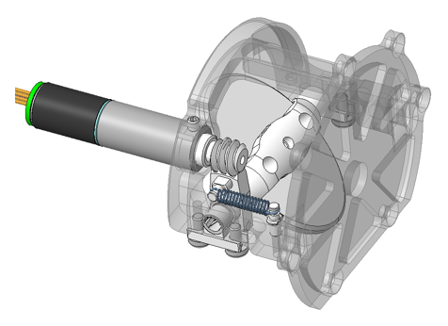
(b)
Figure 4: (a) workspace area, (b) raster grid on a target

To minimize the mass of the mechanism, the choice of structural material is critical.
The overall dimensions and mass were compatible with the specification: respectively 50 x 50 x 94mm and about 141g.
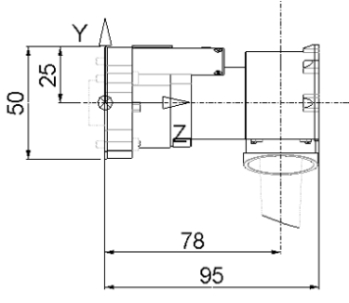

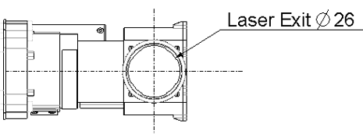

Figure 5: Overall dimensions

Based on this design, the typical operating sequence can be estimated as below for the raster mode:
- Movement to the target point: 56s
- Position validation with imager: 1s
- Movement to the raster center: 4s
- Movement for 1 line: 35s
- Movement for full grid: 1024s
- Return to central position: 4s
- Movement to stacking position: 50s
Total : 1 139s (19min)

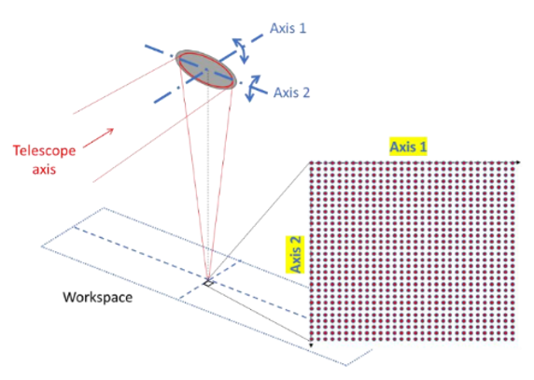
Figure 6: Workspace

Actuation CHARACTERIZATION

Gearmotors

The challenge lay in determining the usable control current range: on one hand, it is necessary to set a minimum current to ensure the required motorization margin, and on the other hand, a maximum allowable current had to be defined to prevent overheating of the winding.

Initially, a thermal behaviour test under vacuum was performed at various current levels. Two models of each reference were tested in a vacuum chamber. The gearmotors were clamped at their ends, with temperature measured at the interface. Another thermocouple was placed between the motor and the gearbox. Due to the small size of the product, it was impossible to instrument the inside of the motor close to the heat source. The chosen solution was to monitor the winding impedance. The increase in resistance reflects the temperature rise (with the copper thermal coefficient: α = 0.0039 K⁻¹). Although this indirect measurement is less precise, it provides an observable value as close as possible to the power dissipation area.
The measurements show that, at 40% of the nominal current, the winding temperature increases by +11K ±7 relative to the interface, while the case temperature rises by only +4K. At 90% of the nominal current, the temperature increases are +43K ±7 for the winding and +15K for the case.
These results highlighted the criticality of the control current. They also made it possible to define the parameters for a nodal thermal model of the gear motor, which is used for the thermal analysis of the mechanism.

Motorization margin tests were conducted in a climatic chamber.
Minimum starting currents were measured at different temperatures from -40°C to +20°C
Ultimately, these tests made it possible to define the allowed range for the motor drive current, which is limited both by motor heating and by compliance with motorization margins (see Fig. 7).

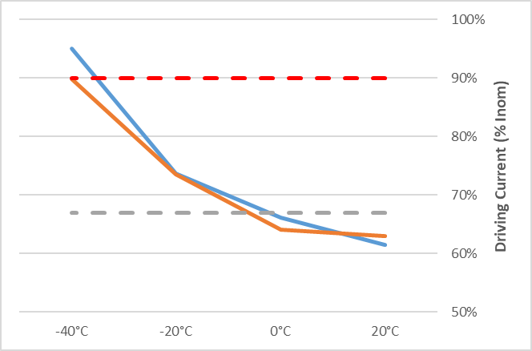
Admissible current wrt motorization margin for motor1 & 2
Admissible current wrt Self-heating
Figure 7: Driving current range identification

At the minimum operating temperature of -40°C, it was not possible to find an operating point that meets both criteria. Therefore, additional heating is required. Since the thermal resistance of the gear motor is too high, the heat generated by the winding during power-up is insufficient to reliably warm up the gearbox. As a result, a heater was added to the mechanism to ensure that the gearbox temperature remains above 0°C.

Spur gear and worm gear
As the precision specified for the rotation movement was very tight, tests were performed on miniature stages developed by ISP system with representative spur gear and worm gear.
Rotation angles were measured with optical encoders.

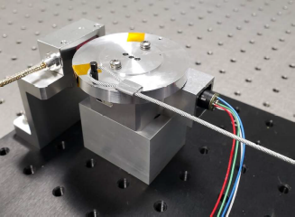
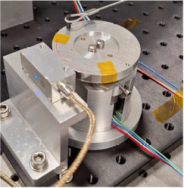
Figure 8: Breadboard test configuration
The precision and repeatability measured with this configuration were about 12µrad RMS, for 20µrad max specified for the pointing stability during raster mode. These results integrate defects induced by the gear motor, the bearings and the gear stage. Even if slight improvements could be considered by better quality machined parts, the precision obtained was slightly above the specified limit.

SCAN MECHANISM TEST RESULTS
After machining and assembly in a clean room, the scanner mechanism was tested to validate the performance conformity according to the specification.
First of all, the mass of the mechanism was controlled, and the result was close to the theoretical value: 139g (150g max specified).
Performance characterization was planned on a specific test bench using optical encoders for angle measurements and EGSE (Electrical Ground Support Equipment) with associated software for axes driving.
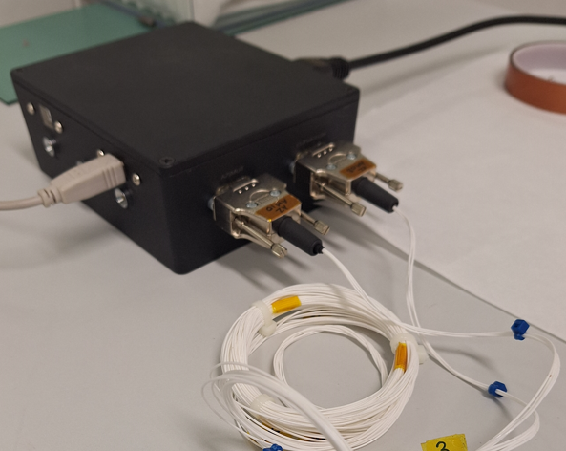

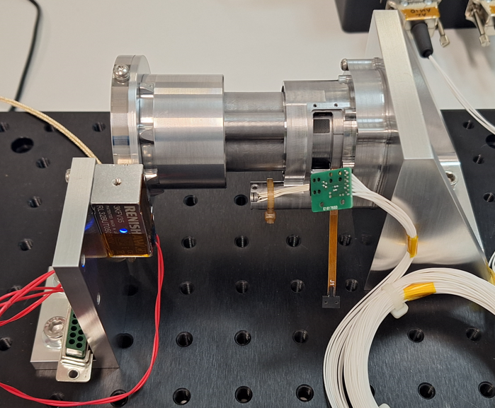

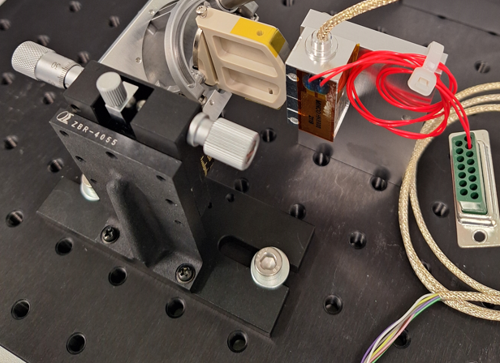

Figure 9: Mechanism test configuration

The main results showed that, as foreseen during tests on breadboards, the most difficult was to reach the repeatability on raster steps, specified at +/-20µrad max.
Angular strokes and repeatability of referencing on mechanical end stops were in accordance with the specification for the two axes. Precision on raster steps was also conform for both axes (< 50µrad).
The graphs below present the typical results obtained on raster step repeatability for azimuth and elevation axes.
The maximum shifts on raster step value within a line are presented for each raster point and for 5 consecutive lines.
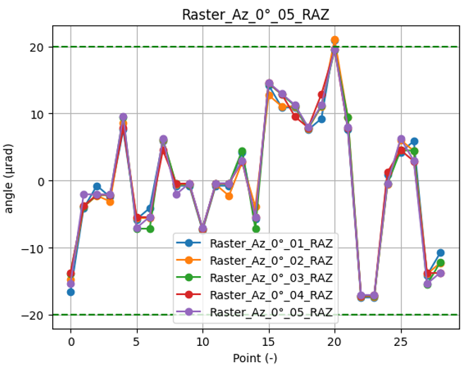
Figure 10: Azimuth raster test results
The repeatability is in conformance, but close to the maximum specified for the azimuth axis: +/-20µrad.
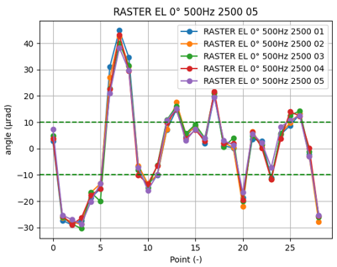
Figure 11: Elevation raster test results
On the elevation axis, the repeatability was above the maximum value specified: +40/-30µrad for +/-20µrad maximum.
NOTA: Observation under microscope of the worm gear showed an issue with tooth geometry. A discontinuity was detected on meshing when contact was changing from one tooth to the following one.

LESSONS LEARNED
The early use of 3D-printed prototypes greatly facilitated convergence towards the final design. This approach made it possible to verify the assembly of the mechanism. Given the small size of the parts, SLA 3D printing was necessary to achieve the required resolution.
The machining time for the mechanical parts (especially the gears) was twice as long as initially estimated. Since these components are within the field of micromechanics, the number of manufacturers capable of producing them is limited and subject to availability constraints.

Experience and results obtained with the first prototype showed areas for improvement.
Design and manufacturing of a second prototype is in progress with the aim of:
- Improving the gears' quality and therefore the precision and repeatability of the raster grid
- Keeping all wires and PCB inside the mechanism (or main instrument)
- Moving the interface flange with the instrument as close as possible to the mechanism center of gravity

CONCLUSION
At the beginning of the project, maximum mass and overall dimensions, associated with high precision specification in raster mode, were identified as technical challenges and considered as critical design drivers. The first prototype is compliant with the mass and dimensions specified and, above all, test results on axis precision and repeatability are very close to the expected level.
The development of this miniature scanning mechanism will continue as part of the Microlibs project. The prototype will be integrated with an instrument demonstrator to validate end-to-end pointing performance. Mechanical and thermal environmental tests will also be conducted. Design and manufacturing of a second prototype is in progress with expected improvements.
All these activities will help to further mature the product and prepare it for a potential flight opportunity.

ACKNOWLEDGMENT
The authors would like to thank the French space agency (CNES) for supporting the study.

REFERENCES
- Charles Yana & al. (2025). MicroLIBS Operations concept of a miniaturized LIBS for planetary exploration. International Conference on Space Operations
- M. T. Lemmon & al. (2022). Lifting and Transport of Martian Dust by the Ingenuity Helicopter Rotor Downwash as Observed by High-Speed Imaging From the Perseverance Rover. Journal of Geophysical Research: Planets
- Irebert R. Delgado, Michael J. Handschuh. (2010). Preliminary Assessment of Seals for Dust Mitigation of Mechanical Components for Lunar Surface Systems. Aerospace Mechanisms Symposium
- Milo Silverman, Justin Lin (2020). Mars 2020 Rover Adaptive Caching Assembly: Caching Martian Samples for Potential Earth Return. Aerospace Mechanisms Symposium

