Optical High-Speed Serial Links (HSSLs) in Airbus Space Systems Payloads, Platforms, and Products

Stéphane Mariojouls*ª, Anna Salomonª, Tania Antoniniª, Marjorie Morvanª, Marc Malagoliª, Manuel Armbruster^{b}, Julian Bozler^{b}, Otto Graf^{b}, Jérôme Lachaizeª
ªAIRBUS DS, 31 Rue des Cosmonautes, 31400 Toulouse, France, ^{b}AIRBUS DS, Claude-Dornier-Straße, 88090 Immenstaad am Bodensee, Germany

Abstract
This paper explains why it is now urgently necessary for space platforms and payloads to implement high-speed optical serial links. By leveraging well-established terrestrial photonic solutions, it highlights why Airbus DS, as a large-scale system integrator, is actively driving the development and adoption of MT ferrule formats and MPO connectors as key building blocks for future space optical harnesses and high-speed serial links. Airbus DS also supports equipment manufacturers in their implementation, and the results of the technology assessment of intra-equipment optical routing solutions are presented.
At European level, standardization is also being pursued, covering technologies, protocols and test specifications, notably within the framework of a GSTP activity, the first results of which are presented here.
To conclude, key enablers and new perspectives for optical HSSLs are discussed.

Keywords: optical HSSLs, redundancies, protocol, MT ferrule, MPO connectors, transceivers, ribbons, standardization.
*stephane.mariojouls@airbus.com; phone +33 562199823

introduction
The usage of optical high-speed links on-board a spacecraft brings a number of advantages (such as higher data-rates, less power and mass per transferred bit, less/no cross-talk or EMC issues, longer allowed harness length, …), but it also means some extra-effort due to a (currently) reduced selection/availability of components, more complex protocols and the need for more capable electronics (FPGAs/ASICs) in order to implement such an interface.
Therefore, typical applications of this technology would make most sense in applications, where high amount of data needs to be transferred from one equipment to another, requiring data-rates in the Gbps range. This is typically the case for interconnections between payload elements, storage devices, processing units and communication systems. Depending on the respective viewpoint, such elements can all be regarded as payload items, or at least belonging to the payload and payload downlink subsystem.
Earth Observation payloads typically produce large amount of data, coming from passive imagery (panchromatic, multi-spectral, hyper-spectral etc.), active imagery (SAR or other radar observations, LIDAR etc.) or gravity field measurements. These are also the predestined “natural” candidate missions for a deployment of high-speed optical interfaces, as their payload data-rates are very high, while stringent requirements ask for low cross-talk, weight reducing (focal plane stability), and EMC cleanliness. In this regard, the CO3D Mission (“Constellation Optique en 3D”), a French Earth-observation satellite constellation launched in July 2025 by CNES and Airbus DS, was the first Airbus DS use case of optical HSSLs ; it features four 300 kg mini-satellites designed to capture high-resolution stereoscopic optical data to produce a global 3D Digital Surface Model (DSM) of Earth with metric altimetric precision ; 10 Gbps per channel optical links are implemented between instrument Front End Electronics (FEE) and processing units.
The acceleration of global demand for high-throughput satellite (HTS) communication is also pushing for continuous innovation and development in the telecom satellite payload design. Modern satellites’ payload platforms, such as recent development of the flexible Airbus DS OneSat platform, require a massive on-board processing capability to support advanced payload solutions like dynamic beamforming, large user capacity and sophisticated signal routing. And where copper-based solutions face inherent bottlenecks related to data rate limits, cable length restriction, high mass and considerable power consumption, particularly in complex, high-speed backplane architectures, Airbus DS overcomes these limitations by implementing the state-of-the-art high speed serial optical transceivers and fiber optic links (28 Gbps per channel) for digital inter-processor data exchange. Indeed, the next generation Hyperion Digital Processor on the OneSat platform demonstrates a significant increase in payload data capacity and efficiency [1].
A similar trend is observed in communication satellite constellations. As Optical Inter-Satellite Links (OISL) facilitate massive data repatriation via high-bandwidth laser terminals, there is an increasing demand for optimized, high-capacity data transfer to payload processors, necessitating the implementation of HSSLs.
Science & exploration missions typically leave earth’s orbits and operate in a rather remote distance, the achievable data-rate for the downlink to any ground-station is limited to few hundreds of Mbps, or even less. This means that for the interface to the data downlink system the usage of high-speed optical links is less envisaged, as also the sensors on-board such a science mission would typically not produce very high amounts of data in short time. However, for rendezvous purposes, specific cameras might require high data rates. Furthermore, the need for such monitoring cameras—in a broad sense— which are increasingly being offered with 10 Gbps optical Ethernet data outputs, will likely constitute a future requirement for our satellite platforms, usually and historically less demanding in data rates.

USE of optical links for various purposes and their requirements
This section outlines the potential implementation of optical links for various purposes, the resulting hardware and protocol requirements, and the benefits this technology offers for satellite architecture.

Unidirectional high-speed links
One or several – potentially redundant - Instruments transmit data unidirectional to a redundant Data Processing Unit (DPU) or Mass Memory and Formatting Unit (MMFU), without cross-strapping between the two chains (see Figure 1), so a permanent failure on either side forces a complete switch-over. Because instrument data streams are continuous and too voluminous to buffer for retransmission, this configuration requires very high data rates (several Gbit/s per sensor) and long harness runs (the payload compartment is typically separated from the DPU or MMFU). A substantial EMC margin is advantageous, given that many instruments can transmit simultaneously while remaining susceptible to interference due to the analog signals internally employed. Deterministic, synchronous operation is also beneficial, as it allows the different sensor streams to be time-correlated. High reliability is desired but the loss of some data during a short outage (typically several lines) can usually be accepted up to a certain level if not resulting in a permanent loss of data during the acquisition. This often makes it possible to avoid a handshake that would result in a bidirectional connection. This is of critical importance, as reduction of “intelligence”, power consumption, PCB area, and connector space are key design factors for instruments.
Accordingly, a simple - possibly proprietary - protocol with functionality reduced to the absolute minimum is very often the best choice. However, if the aforementioned design factors are not the deciding factors and higher link reliability and availability are desired instead, a protocol offering better Quality of Service (QoS) such as SpaceFibre represents an option.

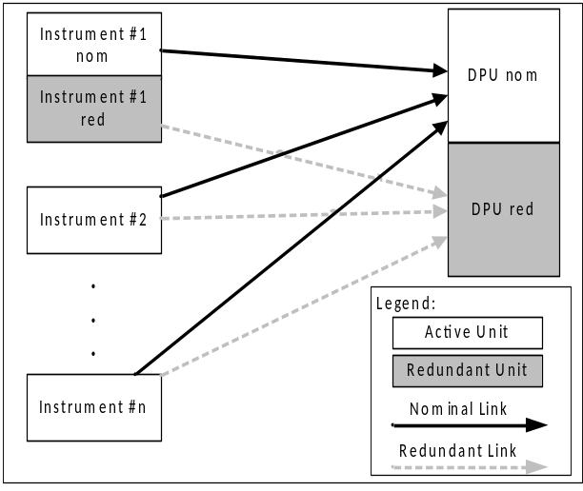

Figure 1: Unidirectional optical Link in the payload chain

Bidirectional high-speed links
This use case forms a network linking e.g. the mass memory bidirectionally with a data-processing unit (e.g. for compression, data processing, cloud detection, image recognition and/or other functionalities), while forwarding data onward — via an RF downlink transmitter and/or a laser communication terminal supporting an inter-satellite link, possibly through an encryption device — to a ground station or relaying satellite. That downstream link is unidirectional for user data but a return link can carry a flow control, limiting the transmitted rate to what the receiver can process; the same terminal can also serve as an uplink from a neighboring satellite. A router – in Figure 2 shown, realized within the mass memory - manages the resulting data streams, and cross-strapping, which is usually implemented, can avoid a full switch-over on failure. Data rates remain very high (several Gbps per link); reliability and quality-of-service (QoS) requirements are stringent, since payload data must reach the ground without loss or errors, motivating retransmission or bandwidth-allocation mechanisms; EMC demands are moderate to high; and determinism/synchronicity constraints are somewhat relaxed relative to the unidirectional use case of the instrument above.
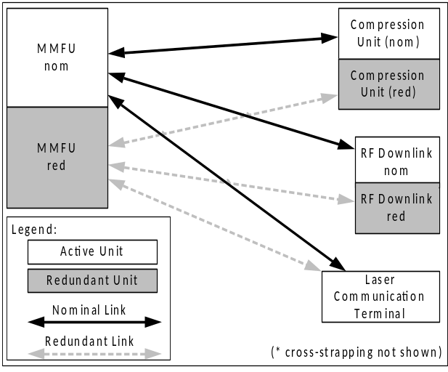

Figure 2: Bidirectional optical Link used in the platform

Replacement of command-and-control interfaces
Legacy bus protocols such as MIL-STD-1553B or CAN, as well as point-to-point links like UARTs and SpaceWires, can be replaced by point-to-point optical links connecting the former bus slaves (remote terminal units, sensors, actuators) directly to the former bus master, typically the on-board computer, which then requires additional interfaces (see Figure 3). Partial cross-strapping avoids a full switch-over after a single-unit failure. Data rates remain moderate, comparable to the original bus (up to roughly 1 Mbps); harness lengths stay long; EMC requirements are relaxed, since bus-connected equipment already tolerates substantial noise; but determinism and synchronicity requirements remain very high, reflecting the tight timing needs of closed-loop control functions such as attitude and orbit control. The links are bidirectional and the protocol needs to provide a high level for Quality of Service (QoS) such as SpaceFibre or TSN.
Such a transition - particularly for buses - entails the significant disadvantage that implementing optical connections requires specific resources, such as the optical transmission link itself and intelligence integrated into FPGAs or ASICs; this could have an adverse effect on SWaP and costs.
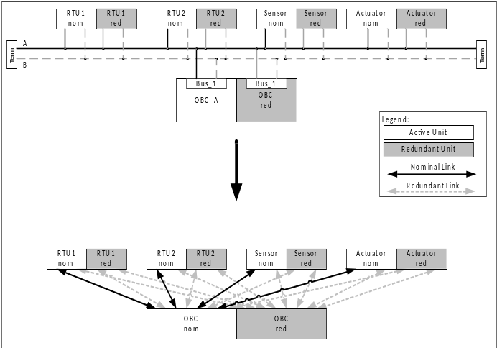

Figure 3: Replacement of command-and-control interfaces
Point-to-point discrete links such as status signals, binary command lines and analog signals can also be digitalized and integrated in the command-and-control link, see Figure 4. Data rates are low, harness lengths remain long, EMC requirements are relaxed, and determinism/synchronicity needs range from moderate to high depending on the connected equipment.
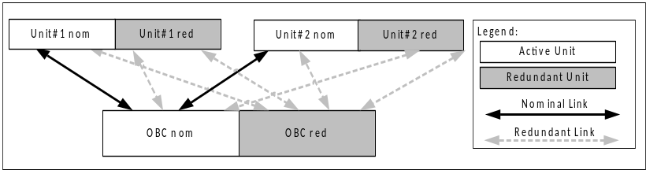

Figure 4: Replacement of discrete interfaces

Optimization of redundancy schemes
Optical technology also enables redundancy schemes beyond simple dual-string or full cross-strapping architectures such as fibre-optic fan out cables, splitters and combining couplers.
Instead of doubling or even quadrupling – in the case of complete cross-coupling – the interface connectors and cable harness, or using X-point switches, which comes with data rate limitations and negative effects on SWaP, the optical technology opens the possibility to use a fan-out: to separate the different channels into individual fibers and distribute them to two (nominal and redundant) equipment units. This is the case where inter-equipment optical link is based on a single multi-fiber optical cable with an MT interface over the first part of the link (see §3.2). Thus, some channels can be allocated to equipment A and the remaining channels to equipment B, while retaining a single common multi-fiber cable upstream. An alternative is to use a splitter: in this case, the same optical channel is sent simultaneously to both nominal and redundant equipment units. But signal duplication introduces the optical losses associated with the splitting. It is worth noting that the usage here is inherently better suited to individual fibers or individual fiber cables, since the splitting function is performed on a single optical channel. The use of optical fan out, splitters and combining couplers will increase link availability and reliability while reducing complexity, SWaP, AIT effort and overall, the resulting cost. The use of these components is agnostic to the protocol employed. See example in Figure 5.
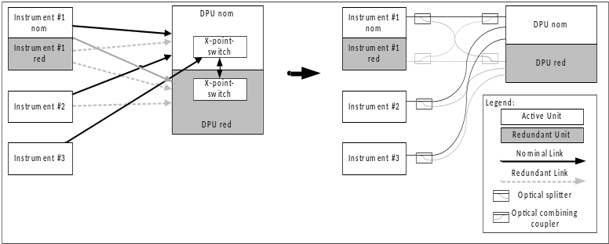
Figure 5: Architecture with splitters or combining coupler

Impact of optical links for future satellite missions
The use cases previously presented demonstrate the wide range of applications for optical links. It has become clear that different requirements regarding hardware and protocols apply depending on the specific use case. Nevertheless, while standardized hardware usage is both feasible and desirable, a standardized protocol appears likely to drive up costs. For example, SpaceFibre or TSN protocols require a bidirectional connection; particularly for units without memory (such as the instrument), this entails added complexity and cost while enabling the use of only a limited number of features.
Not all use cases will be implemented immediately and simultaneously, because legacy designs, implementation costs, and the maturity of the technology mean that not every implementation is yet feasible and/or cost-effective. Nevertheless, the transition is already evident in many areas, and analyses indicate that the widespread adoption of this technology will yield enormous savings in terms of both complexity and cost in the medium term.
The diagram below in Figure 6 illustrates the significant reduction of interconnection complexity by digitalization and optical links.
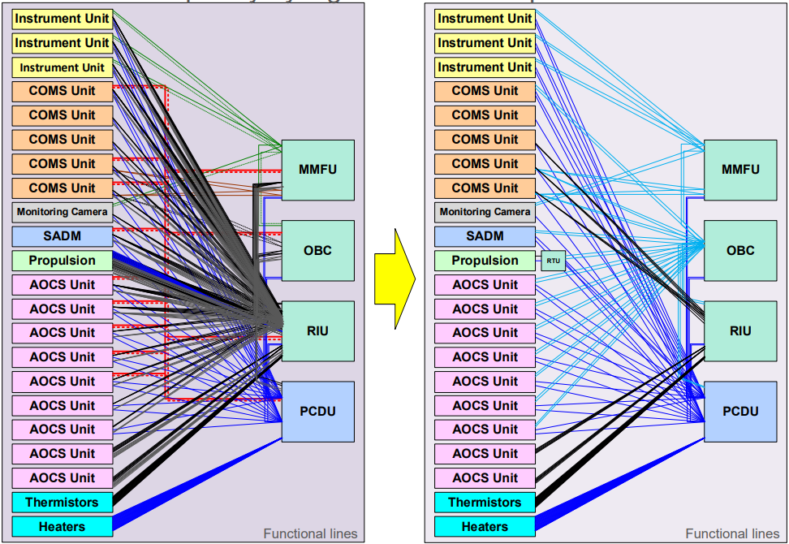
Figure 6: Significant reduction of interconnection complexity by digitization and optical links

availability of Technological Solutions and Key Challenges
The key technological building blocks required to implement high-speed optical links, particularly optical and photonic components, have been developed and industrialized over the past two decades in the terrestrial telecommunications and networking sectors. Their development has been supported by a comprehensive set of industry standards, notably the IEEE 802.3 Ethernet family [2], which defines the corresponding Physical Layer (PHY) specifications for increasingly high data rates, including 100 Gbps and beyond.
For optical High-Speed Serial Links (HSSLs), the rapid development of data centers has been a major driver of technology maturation and large-scale deployment. Modern data-center architectures routinely rely on optical interconnects operating at hundreds of gigabits per second between equipment, switches, and racks, with Ethernet standards now supporting 400 Gbps and 800 Gbps operation.
As the space industry is increasingly required to handle and process data at comparable rates, it is therefore natural for it to leverage this mature terrestrial technology heritage. Reusing existing optical and photonic hardware, standards, interfaces and manufacturing capabilities can significantly reduce development effort and cost, while benefiting from a mature and increasingly consolidated supply chain.
This section describes the available technology in light of the architectural specificities presented above in chapter 2, as well as the Airbus DS strategy and current development activities, while taking into account the constraints imposed by the space environment. This work extends the activities already presented [3].

Optical transceivers
From a space-industry perspective, the question arose as to which option to choose between the generic edge-board transceivers (i.e QSFP type), largely deployed in datacenters, and the more specific mid-board optical transceiver family. And it should not be driven by performance alone.
It is a system-level trade-off involving signal integrity, power consumption, mass and volume, thermal management, reliability, radiation tolerance, maintainability, qualification effort and, ultimately, supply-chain maturity.
For current high-speed intra-satellite links, mid-board transceivers offer a significant technical advantage by bringing the electro-optical conversion much closer to the FPGA or ASIC, and reducing insertion loss, signal degradation and needs for equalization, pre-emphasis or retiming. This can translate into lower I/O total power consumption.
Mid-board transceivers also provide greater freedom in board-level architecture and higher optical port density. The optical interfaces are no longer constrained to the edge of the PCB and can be positioned close to the processing devices.
Finally, the need to redesign and qualify the electronic chips (laser drivers, transimpedance amplifiers -TIA-) embedded within the transceivers (to withstand the radiation environment of space) significantly mitigating the expected benefits of adopting generic off-the-shelf solutions (i.e edge-board transceivers), led us to select mid-board optical transceivers at the moment (See other considerations in chapter 5).
For CO3D program (see §1) Airbus DS qualified the Smiths Interconnects 10Gbps 12Tx and 12Rx SpaceAble® Meg Array [4].

Optical routing and connectors
The use of an MT ferrule is driven by several key advantages that make it particularly well suited for future high-density optical architectures. MT ferrules provide high fiber density by accommodating multiple fibers within a compact and precisely aligned interface, significantly reducing the footprint compared with individual fiber connectors. Their excellent passive alignment accuracy ensures low insertion loss (0.3dB typical) and good channel-to-channel repeatability. As they also benefit from a mature industrial ecosystem, it therefore appears to be the natural choice in this context.
Similarly, for the same reasons, and because from a system integration perspective, they facilitate simpler assembly, reduced integration time, and easier maintenance, the highly cost effective MPO type connector is the baseline that Airbus DS intends to develop and promote for optical HSSLs.
It is worth noting here that, for some specific architectures also mentioned in Chapter 2, but which do not require very high-speed data transfer (as described in 2.3 for instance), other types of connectors may be more appropriate.
See pictures of an MT ferrule and an MPO connector in Figure 7.

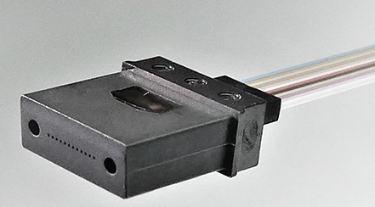 | 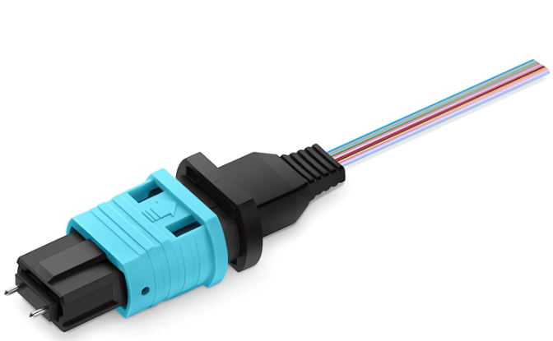
Figure 7: MT ferrule and MPO connector
As a large-scale integrator, Airbus DS must retain full control over the technology of multi-fiber optical harnesses for inter-unit interconnections. To achieve this objective, a co-engineering program was initiated in 2023 with one manufacturer (A) of OM3/OM4 multi-fiber optical cables and with 2 different MPO connector references (manufacturer B and C) in 2025. The aim is to develop a family of solutions compliant with the environmental and reliability requirements of space applications, with a target maturity of TRL 6 by the end of 2026.
The first results are highly encouraging. Environmental testing, including thermal cycling, mechanical tests, radiation, and outgassing has demonstrated technology readiness levels of TRL 5 for the whole inter equipment optical harness early 2026. See a summary of the tests in Figure 9.
At equipment level, the optical interfaces but also the internal optical routing technologies (using fiber ribbons, optical flex circuits, etc.) must be fully compatible with these previous external harnesses. Consequently, beyond its role as system integrator, Airbus DS is working with the previous connector manufacturers B and C to support:
- the development of MPO to MT (M2M) adapters harshened for space environments. Space grade designs passed EMI tests in May 2026.
- the development (with the help of manufacturer D) of fiber ribbons and optical flex assemblies. Coupons-level testing (Figure 8) has enabled the technology to reach TRL5.
Tests summary is described in Figure 9.
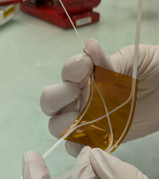
Figure 8: Picture of an optical flex (TRL5)

Building Block | Tests Performed | TRL5
Optical Harness | OM4 Fiber (manufacturer A):  • Gamma irradiation on fiber: 100 krad & 20 Mrad @-40°C, 25°C, 80°C (RIA measurement)  Cable (manufacturer A):  • Outgassing of the cable  • Thermal cycling (-40°C/85°C; 100 cycles) + shrinkage measurement  • Mechanical tests (Torsion, kink, bending)  • Electron irradiation up to 20MRad + Thermal cycling  Cable (manufacturer A) + COTS MPO:  • Harsh routing  • Thermal cycling  MPO (assembled):  • Outgassing  • Electron irradiation up to 20MRad + Thermal cycling  • Construction analysis | 2025 and May 2026
M2M adapter | Space grade M2M adapter (manufacturer B and C):  • EMI tests (200MHz to 30 GHz) | May 2026
Internal optical routing (flex & ribbons) | Flex and ribbons coupons (manufacturer D):  • Constructional analysis  • Outgassing  • Torsion  • Peeling, adherence tests  • Damp heat, TVAC, Thermal cycling | May 2026
Figure 9: Summary of the tests carried out on optical harnesses and routing solutions

All these building blocks, providing together a consistent end-to-end optical data handling architecture, should be considered as a complete technology stack and therefore also qualified through a common system-level qualification approach, as illustrated in the following Figure 10. A full evaluation campaign will be conducted end of 2026 where the device under test (DUT) will be a ribbon (or flex) structure + M2M adaptor + external optical harness. TRL6 is targeted.
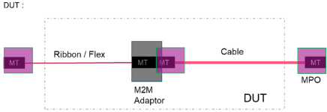
Figure 10: DUT description of a full End to End (E2E) optical harness solution for optical HSSLs
These high-performance, cost-effective optical harnesses are intended to become the baseline solution for future Airbus DS programs.
All the technical details of these activities are presented here [5].

An ESA GSTP initiative for a unified approach

Context and motivation
An ESA GSTP named “End-to-end on-board data handling architecture based on optical high-speed links”[6] has been initiated in 2025. It is a two-year activity managed by Airbus DS GmbH, with support from Thales Alenia Space, OHB, TESAT Spacecom, Airbus Space Electronics France, and DSI Aerospace.
By convening key European stakeholders: large system integrators, relevant unit manufacturers, optical component providers, and protocol IP developers, this initiative proposes to develop a unified standardization approach (establishing common ground for future generations of high-speed, optical data handling architectures). The goal is also to build a flight-ready prototype, demonstrating the practical advantages of optical communication and validating the proposed standardization approach.

Breadboard Architecture
The proposed breadboard incorporates the standard architecture of an Earth observation satellite payload, with a front end electronic (FEE) unit (OHB Systems), a Mass Memory functional unit (MMFU) (DSI Aerospace), a downlink modulator (MOD) (TESAT Spacecom), and an On-Board Computer (OBC) (Airbus Space Electronics France). This is described in Figure 11. The proposed unit emulators are based on existing development and demonstrator boards from the associated suppliers.
Each emulator can be operated and controlled (remotely as needed) via a separate personal computer. Consequently, no centralized EGSE is foreseen.
The emulator’s primary object is to facilitate the study of the physical (bitstream) and data link (frame) layers. Consequently, as an output, each emulator generates representative dummy frames, including dummy packets, to enable Quality of Service protocol functionalities. As an input, the emulator performs protocol and content checks on the received data frame. It is not intended to implement upper layer functionalities such as packet routing. All emulators are capable of supporting data rates of 1.25 Gbps, 2.5 Gbps, 6.25 Gbps and 10 Gbps per lane.

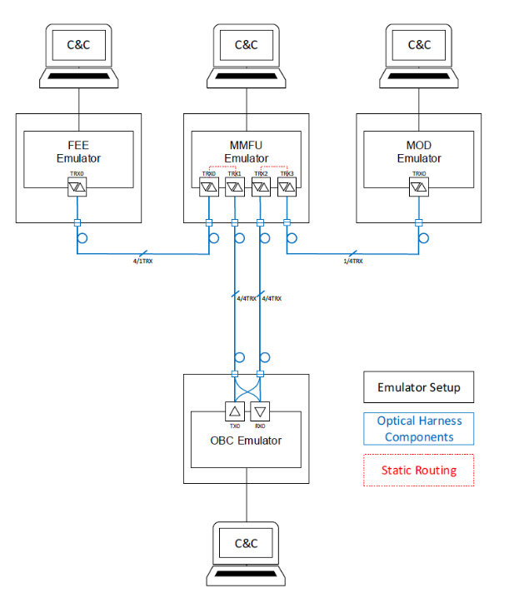
Figure 11: GSTP Breadboard architecture

Choice of protocol
The protocol selected for this study is SpaceFibre, as it is a part of the space ecosystem and is well-suited to sciences needs in high end spacecraft. Developed with funding from the European Space Agency (ESA), SpaceFibre is a primary choice for science missions. While Ethernet with a subset of Time-Sensitive Networking (TSN) features (such as redundancy, QoS, and time distribution) was considered, SpaceFibre was ultimately chosen.
The objective of this work is to prepare for the evaluation of higher-level protocols featuring Quality-of-Service (QoS) capabilities, including priority management, bandwidth reservation, and self-healing. The SpaceFibre implementation within the demonstrator aims to showcase equipment interoperability without the need for tuning. It supports asymmetric links (varying numbers of TX and RX lanes) of up to 16 lanes, with lane speeds ranging from 1.25 to 10 Gbps.
Furthermore, SpaceFibre dynamically auto-detects lane configurations; if a lane fails, it is automatically bypassed. The protocol also incorporates packet retries to ensure link resilience during lane failures. The ultimate goal is to verify data integrity during transfers under various error conditions, such as link disconnection or a Bit Error Rate (BER) exceeding 10⁻⁸.

Choice of optical hardware
In contrast to the versatile approach of the emulator hardware (use of existing boards for each stakeholder), the prototype aims for commonalities between the optical transceivers, optical interfaces, connectors and interconnecting cable assemblies. Indeed, having single connectors, cable assemblies, optical transceivers types available reduces the risk for integration and testing, enhances flexibility in the configuration and lowers overall costs. It also finally strengthens the case for standardizing such families of components and their implementation across equipment manufacturers.
Consistent with the Airbus DS strategy described in paragraph 3, the following references were selected and implemented onto the breadboards (see Figure 12). All of them have reached a Technology Readiness level (TRL) ranging from 5 to 9.

Type | Transceiver | Optical Harness | Optical Adaptor | Internal Optical solutions
Description | 12Tx, 12Rx, 4TRx @ 10Gbps and 28Gbps [4] [7] [8][11] | MPO Cable  Type B definition[9]; custom length | MPO to MT adapter | Optical Flex, optical ribbons, MT ferrules based  Custom designs
Manufacturer | Smith Interconnect | Manufacturer A  (Space Development in progress) | Manufacturer B & C (Space Development in progress) | Manufacturer D
Figure 12: Optical hardware references for GSTP breadboarding

Emulator design: The OBC case study
The OBC Emulator electronics is built by Airbus Space Electronics France with Airbus DS SAS support, from a VCK190 eval board [10] and an FMC+ connected custom mezzanine board equipped with a 10Gbps 12Tx and a 10Gbps 12Rx Smith transceiver [7]. See Figure 13.
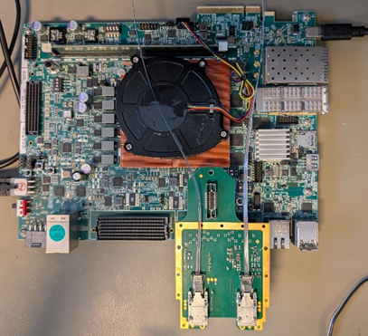
Figure 13: VCK board with its ‘optical mezzanine’
The electrical bock diagram is described in Figure 14. The source and sink could be selected between DMA and PRNG generator. The selection shall be done by a software running on the Platform System (PS). The PS hardware interface are the Ethernet 1 GBit Base-T interface provided by the board and a USB interface USB 2 serial converter component on the VCK 190 interfacing a PS UART I/F built-in the PS. The CPUs provide the commanding system and the test management features. A JTAG Interface allow access the programmable logic and the diagnostic features of the GTY. It is also accessible through an USB to serial converter.
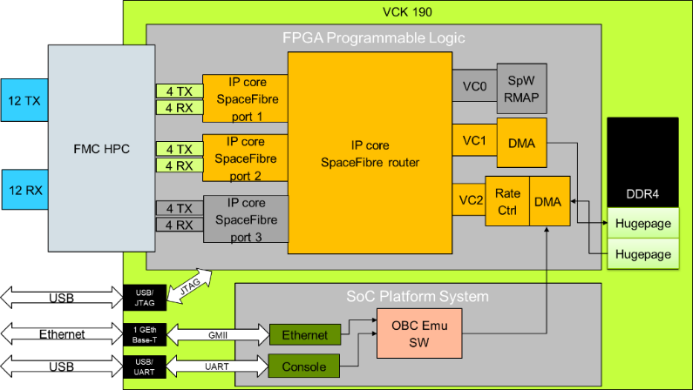
Figure 14: OBP electrical block diagram
The need for the OBC to communicate with the MMFU's duplex transceivers (4TRx) provides the opportunity to implement a custom optical flex that allows both OBC transceivers (12Tx & 12 Rx) to communicate with each 4TRx. See OBC’s optical channels routing scheme in Figure 15.
It is worth mentioning here that one of the interests of implementing an optical flex is also to demonstrate its ability to offer redundancy solutions: in particular, here to ensure that if one of the two MMFU’s transceivers is out of order, the OBC can still communicate in full duplex. Beyond this demonstration of functionality, it will allow evaluating the potential impact of its addition on the link budget and on the possible degradation of the BER, compared to a direct link. A mock up view of the OBC’s optical channel routing management is shown in Figure 16.
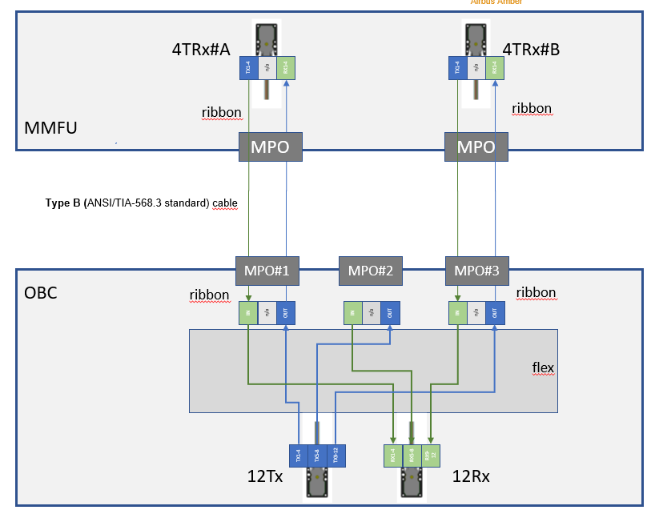
Figure 15: OBP optical channels routing
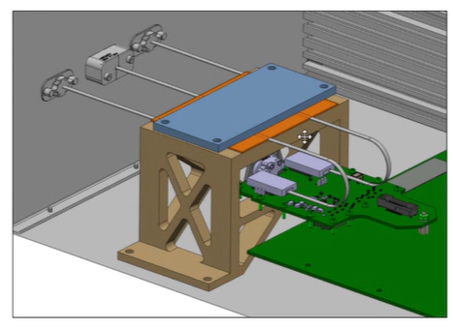
Figure 16: Mock-up view of the optical flex holder and the 3 OBC’s optical interfaces.
Acceptance testing will be performed at the OBC emulator level.
The optical eye diagram of the emitter will be characterized for each of the 12 emitter channels and compared against a predefined eye mask. Standard optical eye-diagram parameters, such as mean one, mean zero, DER, SNR, EA, JPP, etc., will be measured. Tests will be conducted at data rates ranging from 1.25 Gbps to 10 Gbps. For each data rate, the GTY parameters, including output swing, pre-cursor, and post-cursor, will be optimized to maximize the optical signal quality and ensure compliance with the eye mask. The measurements will be performed using a Digital Communication Analyzer (DCA), which is an equivalent-time oscilloscope. Unlike a real-time oscilloscope, a DCA requires a clock signal at the same frequency as the data rate. This clock is directly recovered from the data using a Clock Recovery (CR) function. The optical interface between the OBC emulator and the DCA is implemented using a 12-channel fibre-ribbon breakout, with an MPO connector on one side and an FC/APC connector on each of the 12 channels.
A receiver characterization test will also be performed to assess the optical receiver sensitivity and, consequently, the available optical link budget. The receiver sensitivity will be determined by measuring the Bit Error Rate (BER) as a function of the Received Optical Power (ROP). For this purpose, two 12-channel fiber-ribbon breakout assemblies, each featuring an MT connector on one side and an FC/APC connector on each of the 12 channels, are required to interface the receiver with a Variable Optical Attenuator (VOA), an optical splitter, and an optical power meter.
Using the Xilinx IBERT IP and Vivado software, the BER will be measured as a function of the ROP. As for the emitter characterization, tests will be conducted at data rates ranging from 1.25 Gbps to 10 Gbps, using the previously optimized GTY parameters. For each data rate, the ROP will be varied in 1 dB steps, and the corresponding BER will be recorded. The BER measurement range will extend from 5 × 10⁻¹² to 5 × 10⁻², with the upper confidence limit (UCL) set at 95%.

Way forward
The prototype comprising unit emulators and flight representative optical components, will allow for the testing of different use case scenarios on the physical and data link layer. Furthermore, it will enable the demonstration of key indicators for data handling based on optical links, such as data rates, throughput, quality of service and fault detection, isolation and recovery functionalities. In addition to the standard test scenarios, range of failure cases will be tested, including Fibre breakage, Increased attenuation, frame errors, or network/link congestion.
The demonstration plan and procedure of the test campaign is planned to be issued in Q3 2026, while the prototype integration and testing will be conducted by Airbus DS GmbH in a standard, laboratory environment in Q4 2026.

Key enablers and new perspectives FOR optical hssls
One of the first challenges to be addressed is the consolidation of a photonics supply chain, covering both optical transceivers building blocks and harness solutions in the broader sense. Achieving European technological sovereignty is also a key objective. Particular attention must also be paid to ensuring interoperability between the different solutions.
The widespread deployment of photonic technologies in future End to End payloads architectures, together with the growing number of stakeholders, will rapidly make standardization activities essential. These efforts should address not only test and validation procedures but also qualification methodologies. In this respect, space agencies are expected to play a leading role in driving and coordinating these standardization initiatives.

Beyond these considerations, additional technological challenges remain to be addressed.
The increasing complexity of optical routing requirements driven by emerging space architectures—such as the growing number of channels, redundancy management, and the development of optical transport networks—makes the development of new solutions, like integrated optical switches (including Photonic Integrated Circuit (PIC)-based switches) and passive optical switch boxes (or shuffle boxes), some of the next key technological challenges.
Also, the deployment of optical HSSLs will soon face increasingly stringent cost constraints. To overcome the challenges associated with mid-board transceivers—such as photonic technology ownership, solution interoperability, complex acceptance testing, and maintenance or repair—alternative architectures should be considered. In particular, edge-board transceivers have already addressed these issues in the telecom and data-centre industries. For moderate data rates (10–28 Gbps per lane), this trade-off deserves careful consideration. Based on mature pluggable form factors, edge-board transceivers benefit from standardized interfaces, a well-established supply chain, multi-vendor availability, and simplified testing and replacement at equipment level. These advantages reduce procurement and industrialization risks while providing greater flexibility for technology upgrades and component replacement during development. On the other hand, for future high-performance processors (56 Gbps, 112 Gbps per lane and beyond), where power consumption and PCB signal integrity become dominant constraints (target to only a few pJ/bit), Co-Packaged Optics (CPO) solutions will deserve to be investigated. For the time being, the mid-board architecture remains a pragmatic intermediate solution between conventional pluggable edge-board transceivers and fully integrated CPO. It captures many of the benefits of bringing optical conversion closer to the ASIC while preserving the modularity and maintainability required for space equipment.

AKNOWLEDGEMENT
The authors gratefully acknowledge Airbus Space Electronics France for its contribution to this work and for authorizing the publication of the OBC emulator design and test plan.
They authors would like to thank ESA and Bruce Yu for their support with GSTP [6].

REFERENCES
- Haymen Shams, Lee Birch, Matthew Widenka, Frederick Guyon, “Enhancing Satellite Data Capacity through High-Speed Serial Optical Links on the OneSat Platform,” ICSO, (2026)
- IEEE Standard for Ethernet, IEEE Std 802.3-2022 (revision of IEEE Std 802.3-2018), IEEE, 2022
- Tania Antonini, Marc Malagoli, Julien Aubin, Vincent Carreau, Stéphane Mariojouls, “Photonic Digital Data Handling at Airbus: From High End Definition to Component Technologies,” Airbus Defence and Space, EDHPC, (2023)
- SpaceABLE® 10G SL Series Meg Array; SMT12P5183330F2 and SMR12P5183301F2
- Tania Antonini, Stéphane Mariojouls, Anna Salomon, Stéphane Gauchy, Pauline Burgniard, Christophe Grandcoing, Mathilde Nimper, Julien Drozd, “Design-to-cost optical harness development for optical High Speed Serial Links (HSSLs),” poster session, ICSO, (2026)
- GSTP “End-to-end on-board data handling architecture based on optical high-speed links”, ESA Contract No. 4000146858/24/NL/CRS
- SpaceABLE® 10G SL Series LGA, SLT12P9185330F4 and SLR12P9185301F4
- SpaceABLE® 10G 4TRX LGA, SLX04P9185321F4
- Telecommunications Industry Association (TIA), ANSI/TIA-568.3-E: Optical Fiber Cabling and Components Standard, ANSI/TIA-568.3-E, Arlington, VA, USA, (September 2022)
- VCK190 description, https://www.amd.com/en/products/adaptive-socs-and-fpgas/evaluation-boards/vck190.html
- SpaceABLE® 28G SL Series LGA; SLT12P928533001 and SLR12P928530101

