PDC2021
Vienna, Austria

Please submit your abstract at https://atpi.eventsair.com/7th-iaa-planetary-defense-conference-2021/abstractsubmission

You may visit https://iaaspace.org/pdc

(please choose one box to be checked)
(you may also add a general comment - see end of the page)

Key International and Political Developments
Advancements and Progress in NEO Discovery
NEO Characterization Results
Deflection and Disruption Models & Testing
Mission & Campaign Designs
Impact Consequences
Disaster Response
Decision to Act
Public Education & Communication

NASA/Double Asteroid Redirection Test: Orbital perturbation by the ejecta-collision driven reshaping of Didymos after the impact event

Ryota Nakano⁽¹⁾ and Masatoshi Hirabayashi⁽²⁾
⁽¹⁾⁽²⁾ Department of Aerospace Engineering, Auburn University, 211 Davis Hall, Auburn, AL 36849-5338, rzn0040@auburn.edu

Keywords: DART, Didymos, Dimorphos, Reshaping, Orbital perturbation

ABSTRACT

NASA/Double Asteroid Redirection Test (DART) is the first deep exploration mission that explores the capability of kinetic impact asteroid deflection for purely scientific purposes by targeting the binary asteroid 65803 Didymos, where a smaller secondary (Dimorphos) orbits a larger, fast rotating, top-shaped primary (Didymos). After the spacecraft impact experiment, which is planned to be on Dimorphos, surface materials are ejected from the impact site, having variation in ejection speeds. While the majority of ejecta come back to Dimorphos’ surface, some may reach Didymos. Given the reported spin period of 2.26 h, Didymos may be structurally sensitive to reshaping. If the ejecta cloud delivers kinetic energies enough to induce such a process, Didymos may reshape although its mode and magnitude are uncertain. There is a small chance that Didymos’ reshaping process is energetic enough that ground-based observations may detect orbit perturbation driven by this reshaping process. In this case, the observed orbital period requires careful assessments to determine the momentum transfer coefficient.

As part of the DART Dynamics working group, we have assessed how Didymos’ reshaping mode influences the orbital perturbation and thus the orbital period after the DART impact. Here, applying a finite element modeling-based mutual dynamics model [Yu et al., 2019; Nakano et al., 2020], we extended our previous study, which was limited to an axisymmetric reshaping process, to characterize various reshaping conditions, including asymmetric processes. Based on knowledge about possible reshaping processes of top-shaped asteroids, we make a reshaping generator package to determine the shape(s) after the reshaping event, given its magnitude. We have run 6,000 simulation sets (12 different reshaping magnitude cases, and 500 runs for each reshaping case). The results show that for a shape change of less than 10% along the shortest axis, the reshaping-driven orbital period change is characterized to be linear. The results also show that for the head-on spacecraft impact, the orbital period becomes shorter than the original period.

This process can be decoupled from the determination of the momentum transfer efficiency. Given the angular momentum conservation during the reshaping event, Didymos’ spin period also changes. Therefore, detailed observations of the change in the spin period constrain the magnitude of the reshaping event. From Figure 1, which shows the spin period change vs. orbital period change, we predict the following relationship: ∆P_{orb} = -1.0162∆P_{spin} + 3.4057, where ∆P_{orb} is the change in orbital period in sec, and ∆P_{spin} is the change in spin period in sec. We note that this linear model is an approximation; it seems to predict ∆P_{orb} well for small ∆P_{spin}, while the uncertainty increases for large ∆P_{spin}.

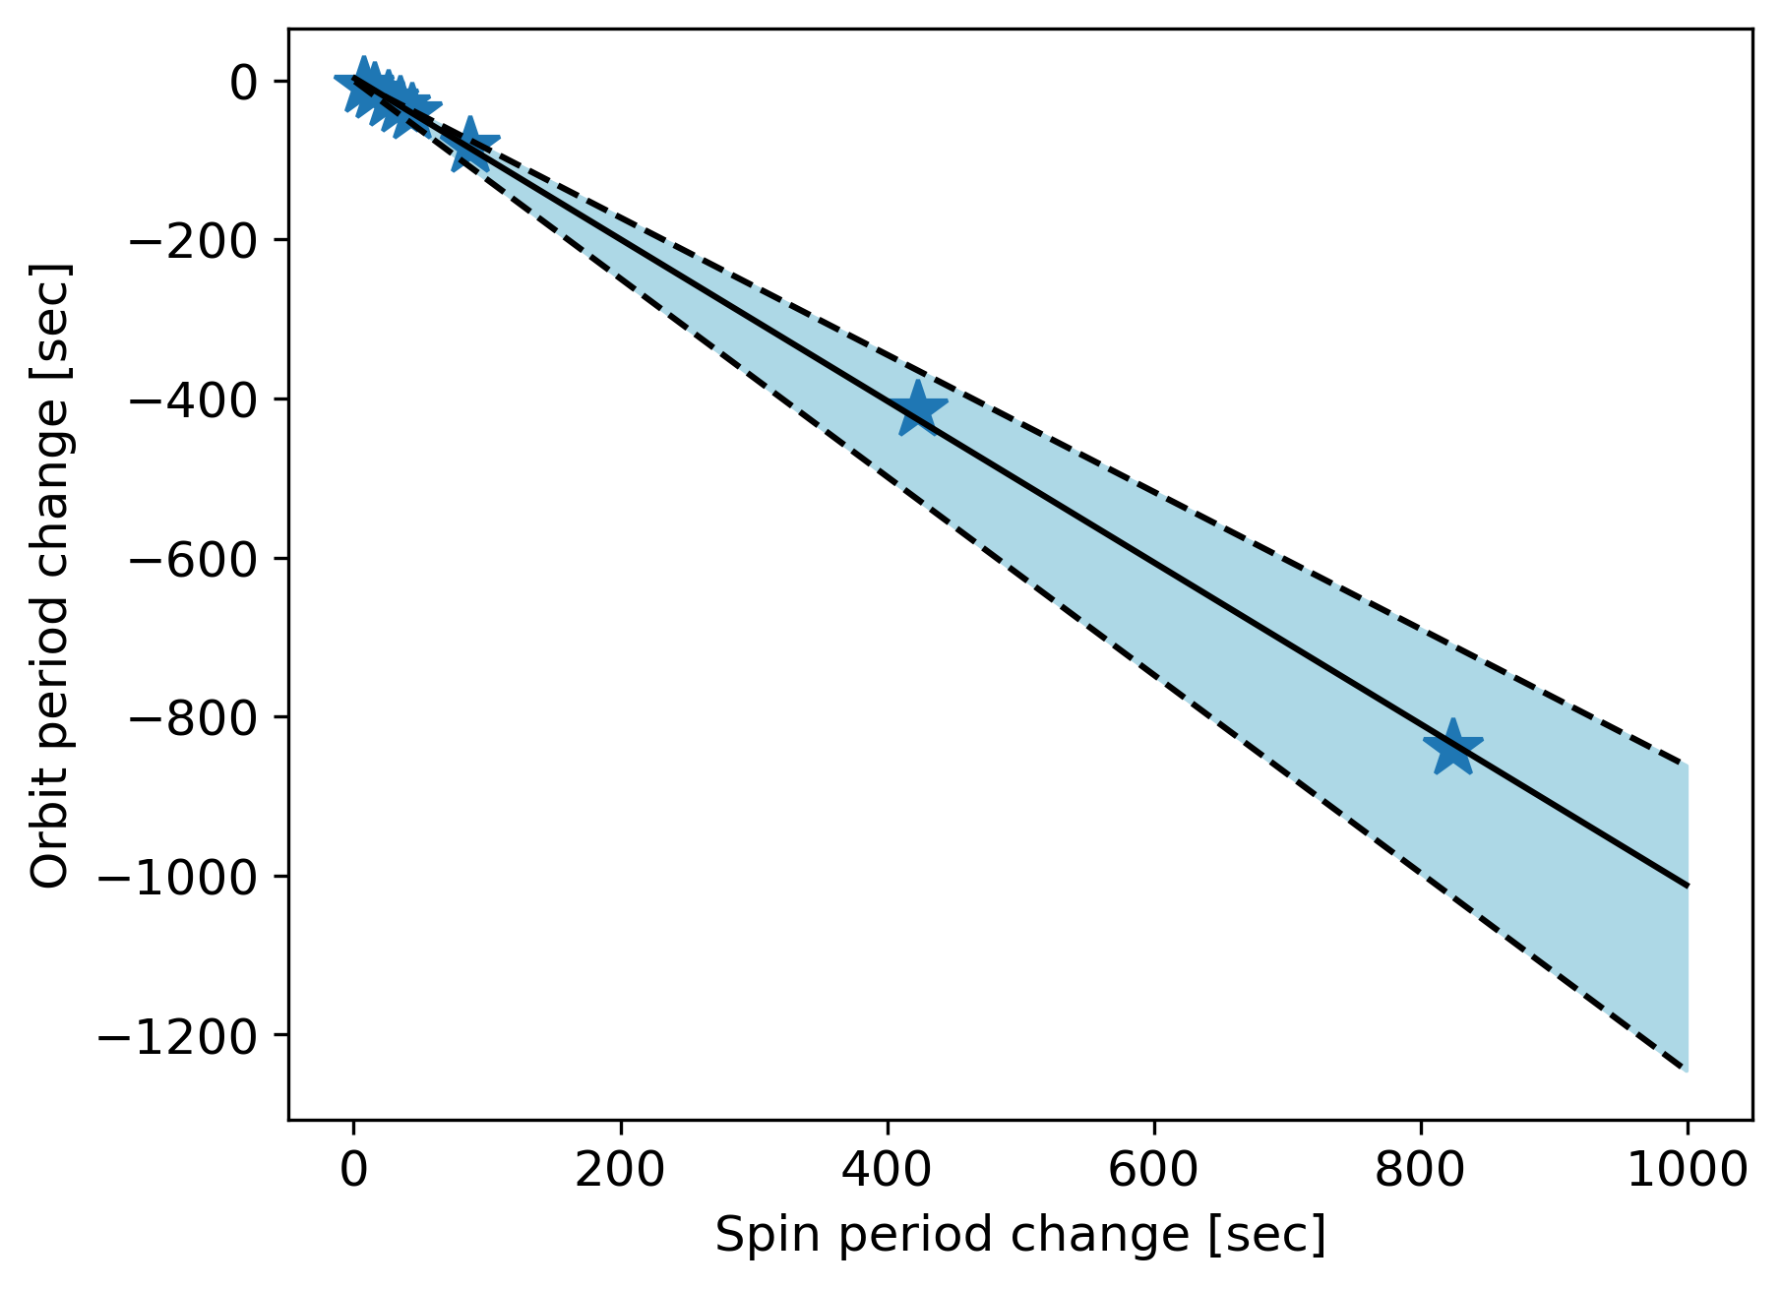
Figure 1. Spin period change vs. Orbital period change.
The stars indicate the results obtained by the simulations conducted in this study. The solid line and blue region represent the predicted linear relationship and the 1-sigma error in the orbital period change, respectively.

References
- Nakano et al. (2020), AGU Fall Meeting, NH037-0004, 2020.
- Yu et al. (2019), Celest. Mech. Dyn. Astron., 131, p.51

**************************************

Comments:

(Alternative session, Time slot, Oral or Poster, Etc…)

