Title

Principal author name^{1,*}, Co-author name², and Co-author name^{1,2}
¹Affiliation, Address, Country
²Affiliation, Address, Country
*Corresponding author: email@address.com

ABSTRACT
This document gives the guidelines to write the paper for the 13th International ESA Conference on Guidance, Navigation & Control Systems (GNC) and 10th International Conference on Astrodynamics Tools and Techniques (ICATT), it has been formatted accordingly and can be used as an example. Please, provide an informative abstract of no more than 200 words. The abstract should stand alone as a summary of the paper, not as an introduction (i.e., no numerical references).

- Submission procedure
The papers shall be delivered in PDF. The file shall be named as follows:

Abstract#Family_Name.pdf (example: 123456Smith.pdf)
The Proceedings will be published on a digital support. Papers should be handed in via the abstract submission portal, using PDF format only, before 31 July, 2026. The following are some guidelines for preparing the article in accordance with the standards for conference proceedings.

Contact details
If you have any questions about preparing your paper, please contact the editor:

ESA Conference Bureau
Reference: Proceeding Editor GNC and ICATT 2026
Email: esaconferencebureau@atpi.com
- General specifications
All papers should be in English. The number of pages should not exceed 15.
  - L^{A}T_{E}X specific instructions
The L^{A}T_{E}X file shall be compiled with pdflatex.
  - Microsoft Word specific instructions
Please install the STIX Two Text font before using this template. The STIX Two Text font can be downloaded from https://fonts.google.com/specimen/STIX+Two+Text.
- Page layout, fonts, headings
This template has been typeset in accordance with the style to be followed for the page layout, fonts, and headings.
- Title and author affiliation
The paper title, author(s) name(s), affiliation(s), address, and e-mail should be provided as displayed in this template. If there are several authors, the complete affiliation should be given for each of them using superscripts in the authors list to refer to them.
- Equations
Equations are to be numbered consecutively throughout the paper. Each equation number must be unique (i.e., do not use "Equation 2bis" or "4"). Equations should be centred, with the equation number in parentheses, as shown in the following example

 | $$\frac{v^{2}}{2}-\frac{μ}{r}=ε$$ | (1)

Always refer to equations by number, as Eq. (1), not as "above" or "below".
- Figures and tables
Responsibility for the inclusion of good quality figures/illustrations (black and white or colour) resides with the author. Figure captions should be below the figures, as in Fig. 1; table captions should be below the tables, as in Table 1.

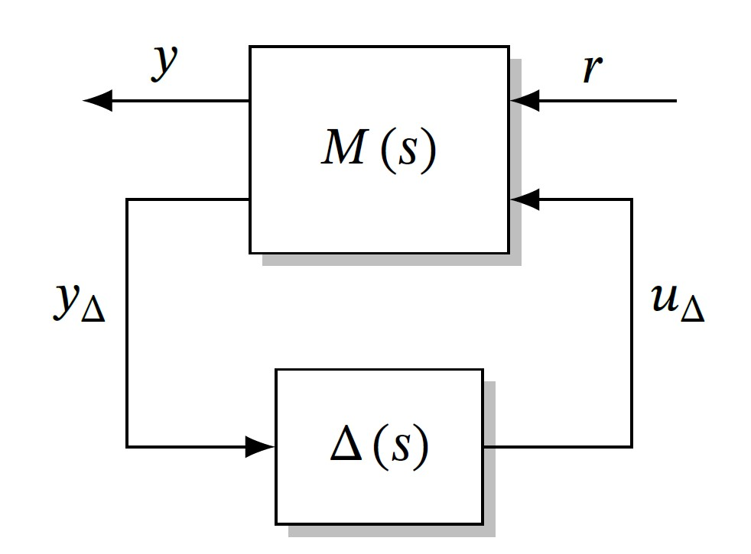
Figure 1 Title of the figure

First | Second
A | 0.1
B | 0.1

Table 1 Title of the table
  - Abbreviations and acronyms
Define abbreviations and acronyms the first time they are used in text, even after they have been defined in the abstract. Abbreviations such as TTC, TM, TC, do not have to be defined. Do not use abbreviations in the title.
- Citations and references
Number citations consecutively in square brackets [1]. Refer simply to the reference number, as in [2]. Do not use "Ref. [2]" or "reference [2]" except at the beginning of a sentence: "Reference [2] was the first..." The title of the book or of the journal shall be in italic script.

References
- R. E. Kalman, "A New Approach to Linear Filtering and Prediction Problems". Journal of Basic Engineering, 82(1): 35–45, March 1960, https://doi.org/10.1115/1.3662552.
- P. Apkarian, D. Noll, "Nonsmooth H∞ Synthesis". IEEE Transactions on Automatic Control, vol. 51, no. , pp.
71–86, January 2006, https://doi.org/10.1109/TAC.2005.860290.

