**A simulation study comparing methane emissions from dairy cow farming in Greece at three reference years**

**Application:** Overall methane emissions from dairy cattle in Greece decreased significantly the last 20 years due to considerable increases in productivity.

**Introduction:** Ruminant production is considered a major contributor of anthropogenic methane emissions that affect global climate change. However, the constant increase in cow productivity, a common feature of the dairy industry in the developed countries, leads to more efficient use of natural resources and to a mitigation of environmental burdens. The aim of the present study was to assess and compare methane emissions from dairy cow farms in Greece at three different time-points representing the evolution of the local dairy sector.

**Material and methods:** Daily direct (enteric) and indirect (manure) methane emissions were estimated using the equations proposed in NASEM (2021).The reference years chosen were 1985, 2003 and 2022, due to similar overall annual milk production (650,000-660,000 tons). Number of dairy cows kept were based on EUROSTAT and FAO data (219,000, 170,000 and 88,000, for the three reference years, respectively); 85 percent of those were considered to be lactating and 15 percent being dry at any time of the year.Heifer inventory (2-6mo, 7-12mo and 12-1st calving) was calculated considering replacement rates of 0.20, 0.25 and 0.30 while age at first calving was set at 30, 28 and 26 months, for the three reference years, respectively. For all the aforementioned animal groups, available data from surveys and PhD projects were used to formulate typical rations for each reference year, meeting net energy and metabolizable protein requirements (INRA 2007). Cow bodyweights were set at 500kg, 600kg and 700kg; daily milk yields were set at 10.0kg, 12.5kg and 25.0kg; and heifer average daily gains were set at 600g, 700g and 800g for the three reference years, respectively. Feedstuffs used included: 1985, alfalfa hay, wheat straw, corn grain, wheat bran, cottonseed cake and supplements; 2003, corn silage, alfalfa hay, wheat straw, corn grain, soybean meal, sunflower meal, molasses and supplements; 2022, corn silage, grass silage, alfalfa hay, wheat straw, corn grain, soybean meal, canola meal, molasses, rumen-inert fat and supplements. For 1985, restricted feeding was considered while for 2003 and 2022, rations were formulated for ad libitum intake. For all rations, dry matter and gross energy intake, as well as crude fat, crude protein, neutral detergent fiber, digestible neutral detergent fiber and hemicellulose content (percent dry matter) were calculated, as they are required in NASEM 2021 equations for the estimation of methane emissions (enteric, Mcal/d; manure, digestible volatile solids, kg/d). Year 1985 was used as baseline and estimations for 2003 and 2022 are reported as a percentage of 1985 emissions.

**Results:** Direct daily methane emissions (Mcal/d) were 959,606, 976,107 and 577,176, for years 1985, 2003 and 2022, respectively; indirect methane emissions (digestible volatile solids, kg/d) were 1,174,305, 1,125,365 and 650,230, respectively. There was little change in methane emissions between 1985 and 2003. The transformation/modernization of the dairy sector was well under way in 2003 but cow numbers had not been substantially reduced at that point and milk output per cow had just started to increase. However, 2022 methane emissions were approx. 40 percent (enteric) and 45 percent (manure) lower than those of 1985 (Figure 1), due to the considerable increase in cow productivity (x2.5) which led to a decrease in cow numbers by 60 percent. To put it in another way, under current dairy farming conditions almost 1,000,000 tons of cow milk can be produced in Greece (an increase of 33 percent) with methane emissions at 1985 levels.

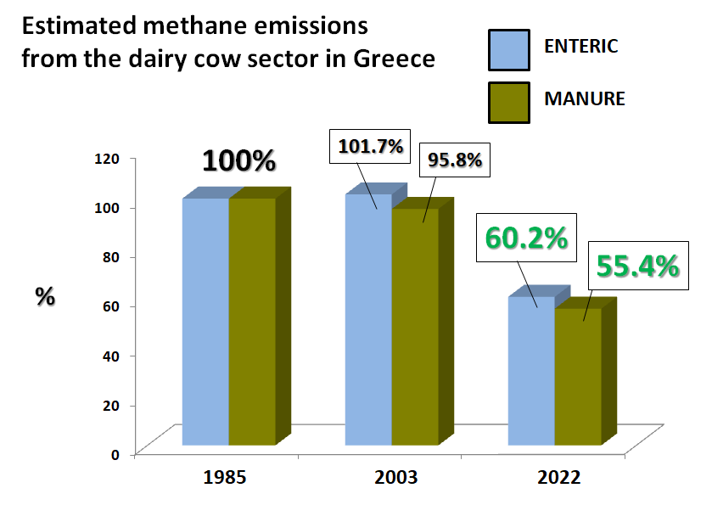

**Figure 1.** Estimated methane emissions from the dairy cow sector in Greece, at three reference years with similar annual milk production.

**Conclusion:** Enhanced cow productivity and efficient use of natural resources allow the production of increased amounts of human food with methane emissions similar to those of 40 years ago. This was achieved without the application of specific methane emission mitigation strategies which are now at the verge of widespread adoption by the dairy industry. A communication campaign must be developed, to present these facts to consumers and legislators alike.

**References:**

National Academies of Sciences, Engineering, and Medicine 2021. The National Academy Press.

Institut National de la Recherche Agronomique 2007. Quae éditions, Versailles.