**Application**

Subfertile mares are a common challenge, with both conception failure and early embryo loss frequently reported (Petroski-Rose 2018), causing stress and financial loss.

Poor fertility is often age related (Carnevale et al 2020), as horses are unusual within livestock being frequently primiparous in teenage years following an earlier, ridden, career. There is an unmet need for practical, commercial solutions to maximize mare reproductive success, particularly in older primiparous mares, and in competition mares where embryo collection needs to be timed within a competition schedule.

For competition mares the convenience of a single appointment around her competition schedule, which can include outside the breeding season, makes ovum pick-up an attractive option. Assisted Reproductive Technologies are established in broodmares both to optimize success in sub-fertile females, and to offer convenient options for competition mares.

**Introduction**

Previous research has shown the benefit of supplementing the diet for mare fertility as a simple, practical option for owners and stud managers alike (Cantandi et al 2022). Complementary feeds specifically targeting broodmare fertility are limited, yet there is a window of opportunity for dietary interventions, from eight weeks prior to covering through to first pregnancy confirmation scan.

The project aimed to test a dietary approach to mare sub-fertility. The novel feed trialled is a unique complex of key micronutrients, including digestibility enhancers, omega fatty acids, chelated trace elements, together with vitamins recognised for oestrus and reproduction as detailed in EU and UK regulations on feed for particular nutritional purposes (EU Commission Regulation. 2020).

**Materials and Methods**

The trial used mares recruited to an ovum pick-up and intracytoplasmic sperm injection programme as a way to quantify oocyte numbers and successful blastocyst formation, not easily possible in the naturally covered mare.

All mares (Treatment group n=28, No-treatment group n=31), were fed a standard broodmare basal diet. Treatment group also received the novel feed daily. How long they received the feed was dependent on when they entered the programme, and whether more than one three-week cycle was required. Mares were housed either at a veterinary clinic, commercial stud or in private yards. All mares were non-lactating and predominantly Warmblood breed. Ages ranged from 14 to 22 years Treatment, and 4 to 24 years No-treatment.

Average number of oocytes, maturation rate, cleavage rate, blastocyst rate, percentage successful sessions (ovum pick-up > 1 embryo) and average freeze day following sperm injection were assessed by in vitro analysis.

Statistical analysis used an unpaired t-test for average oocyte numbers, ages and freeze days. Fisher’s exact tests were used to analyse maturation, cleavage and blastocyst rate between groups.

**Result**

Data were split into three groups for analysis. Firstly, total ovum pick-up sessions in each group (Treatment n=31, No-treatment n=34). Secondly, sessions with mares over 15 years old (Treatment n=22, No-treatment n=12) to reflect the particular challenge in older mares. Finally, data from mares over 15 years old receiving the diet for a minimum of four weeks (n=15) to see effect of time on treatment. For no-treatment, the final group were sessions where age-group and a minimum of four weeks in the programme aligned, but no specific dietary change (n=10).

No significant difference (p<0.05) was found between groups in any parameters. However, a clearly higher proportion of successful sessions were seen in the Treatment group compared to No-treatment. This trend strengthened for mares over 15 years, and further for the group over 15 years and after four weeks of diet (Figure 1).

**Fig.1 Successful sessions** (Ovum pick-up = >1 embryo)

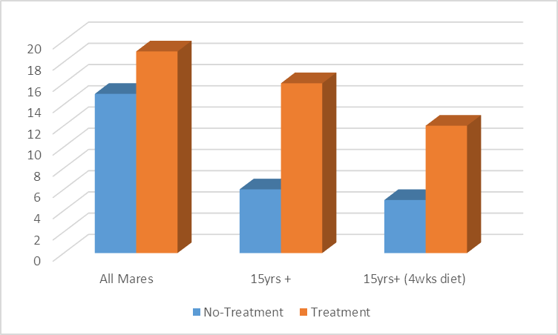

One limitation of the trial was recognised in that the two mare groups were not matched by age, weight, breed, fertility history, semen choice or, importantly, basal diet. It was not possible to implement these controls within a commercial setting, and it was recognised that the No-treatment, particularly, may have greater variation in basal diet, as they were privately housed.

**Conclusions**

Despite no statistical significance, clear trends for improvement in parameters were seen, and these increased with mare age and time on the diet. For proportion of successful sessions, the greatest difference was seen in mares over 15 years who had received the diet for a minimum of four weeks (80% Treatment vs 50% Non-treatment). In the study by Catandi et al (2022) trial diet was fed for 8-17 weeks, and results in this trial also support a longer feeding rate. Future research would look at feeding the novel feed for a minimum of 8 weeks, and ideally with more control over mare variables, such as age, breed and diet.

Trial results suggest that it is recommended to feed the novel feed, NAF OvuCycle, for a minimum of four weeks before ovum pick-up, and eight weeks may be preferable.

Although further research is recommended, these early results show a clear commercial application for feed supplementation, particularly for owners of older mares. Not limited to Assisted Reproductive Technologies alone, the improvement trend also has commercial relevance for the wider equine stud sector, and all broodmares, where only a single successful embryo is required, and a simple dietary approach is easily implemented.

**References**

Catandi G.D., LiPuma L., Obeidat Y.M., Maclellan L.J., Broeckling C.D., Chen T., Chicco A.J. and Carnevale E.M. 2022. Oocyte metabolic function, lipid composition, and developmental potential are altered by diet in older mares. Reproduction. Jan 28;163(4):183-198.

Carnevale E.M, Cantandi G.D and Fresa K. 2020. Equine aging and the oocyte: A potential model for reproductive aging in women. Journal of Equine Veterinary Science. Jun 89. 103022

EU Commission Regulation 2020/354. 2020. Establishing a list of intended use of feed intended for particular nutritional purposes. <https://eur-lex.europa.eu/legal-content/EN/TXT/PDF/?uri=CELEX:32020R0354&from=EN>

Petroski-Rose L. Kentucky Equine Research. 2018. Conception failure in mares: seven causes. Accessed 25.10.2024 from <https://ker.com/equinews/conception-failure-mares-seven-causes/>