**Application**

This study contributes valuable insights into the optimization of wind tunnel methodologies for ammonia emission research. The findings provide practical recommendations to improve data reliability and quality for future applications.

**Introduction**

Ammonia is a significant atmospheric pollutant contributing to soil acidification, the indirect production of nitrous oxide, and the formation of particulate matter (PM2.5). In Ireland, over 99% of ammonia emissions originate from agriculture, with manure storage and spreading alone responsible for more than 75% of these emissions.

Ammonia volatilization from animal manure depends on factors such as pH, surface area, temperature, and moisture. Numerous mitigation techniques, including acidification, covering manure during storage, and employing low-emission slurry spreading methods, have been developed to reduce emissions. Farmers are also encouraged to apply manure under cooler, slightly damp conditions rather than during hot, dry weather to minimize volatilization.

Measuring and quantifying ammonia for emission inventories remains challenging. “Silver standard” micrometeorological methods, such as integrated horizontal flux and eddy covariance, provide accurate measurements but operate over large areas (40 m² to several hectares), complicating the comparison of treatment effects. For smaller-scale, qualitative measurements, wind tunnels are a more practical alternative. These systems typically cover a surface area of 0.5–3 m² and utilize either acid scrubbers or laser measurement techniques to capture ammonia emissions.

Wind tunnels consist of two main components: a transparent canopy placed over the experimental area and a fan-enclosed metal body. These components are connected and sealed during experiments to minimize gas leakage. Ammonia measurements are taken from ambient air entering and exiting the tunnel.

**Materials and Methods**

For this study, wind tunnels were constructed based on Lockyer’s (1984) design. An ammonia recovery experiment was conducted at Teagasc Johnstown Castle in August 2024 over a 24-hour period. The study addressed three key questions:

1. Is a boundary required between the emission source and the ambient sampling port?
2. Does the calculation method for canopy volume (elliptical vs. integration) affect the recovery rate?
3. What is the effect of low vs. high airflow rates on ammonia recovery in wind tunnels?

Trays containing ammonium buffer solution were placed at three distances (0.02 m, 0.15 m, and 0.5 m) from the ambient sampling ports in separate wind tunnels (n=3). Canopy surface areas were measured, and the area of the irregular elliptical tunnel openings were calculated using either the elliptical area formula (Equation 1) or integration (Equation 2). Figure 1 illustrates the basic measurements of both methods. The ammonia recovery rate (ARR) was calculated using Equation 3. High airflow wind tunnels averaged 3.22 m s⁻¹, while low airflow tunnels averaged 1.21 m s⁻¹ over the experimental period.

Equations:

* Equation 1 – $A=(πab)/2$

where A is the area, a is the length of the longest axis, b is the length of the shortest axis.

* Equation 2 - $A=(\int_{0}^{50}{f\left(x\right)dx)*2}$

where A is the area, integration upper and lower limits are 0 and 50, f(x) is the curve produced after measuring the out edge of the canopy to the centre line which varied among each canopy, dx denotes differential.

* Equation 3 – ARR = (AE/RA)*100

where ARR is the ammonia recovery rate, AE is the ammonia emitted in 24 hours and RA is the recovered ammonia.

Statistical Analysis

Data were analyzed using GraphPad Prism (v9.1.0). NH₄⁺ concentrations and recovery rates were compared using a two-tailed unpaired parametric t-test with Welch’s correction to account for differing variances. Results with P<0.05P < 0.05P<0.05 were considered significant.

**Results:**

* Sampling ports located within 15 cm of the emission source exhibited significantly higher ammonia concentrations than those placed further away at 0.15m and 0.5m. A minimum boundary of 0.15cm is therefore recommended to prevent contamination of ambient air samples during recovery experiments.
* There was approx. a 6.5% difference between volume estimates (Elliptical – 0.208 m2; Integration – 0.223 m2). The method of canopy volume calculation did not significantly influence emission estimates (P>0.05). The elliptical area method however is recommended due to its simplicity and practicality in field applications.
* Low airflow wind tunnels recovered 77% ± 2.17% of ammonium, while high airflow tunnels recovered 67% ± 0.79%, a statistically significant difference (P<0.05).

**Conclusions:**

Wind tunnels provide a reliable method for measuring ammonia emissions across different treatments, and experimental designs should account for this capability. This study demonstrates that while both methods for calculating the tunnel opening are valid, the elliptical method is more practical and robust for field applications. For accurate results, future studies using wind tunnels should maintain a boundary layer of at least 0.15 m between the emission source and the ambient sampling port. Additionally, low-airflow wind tunnels recover more ammonia than high-airflow tunnels, making them a preferred option for precise measurements, though they may not fully reflect ambient conditions.

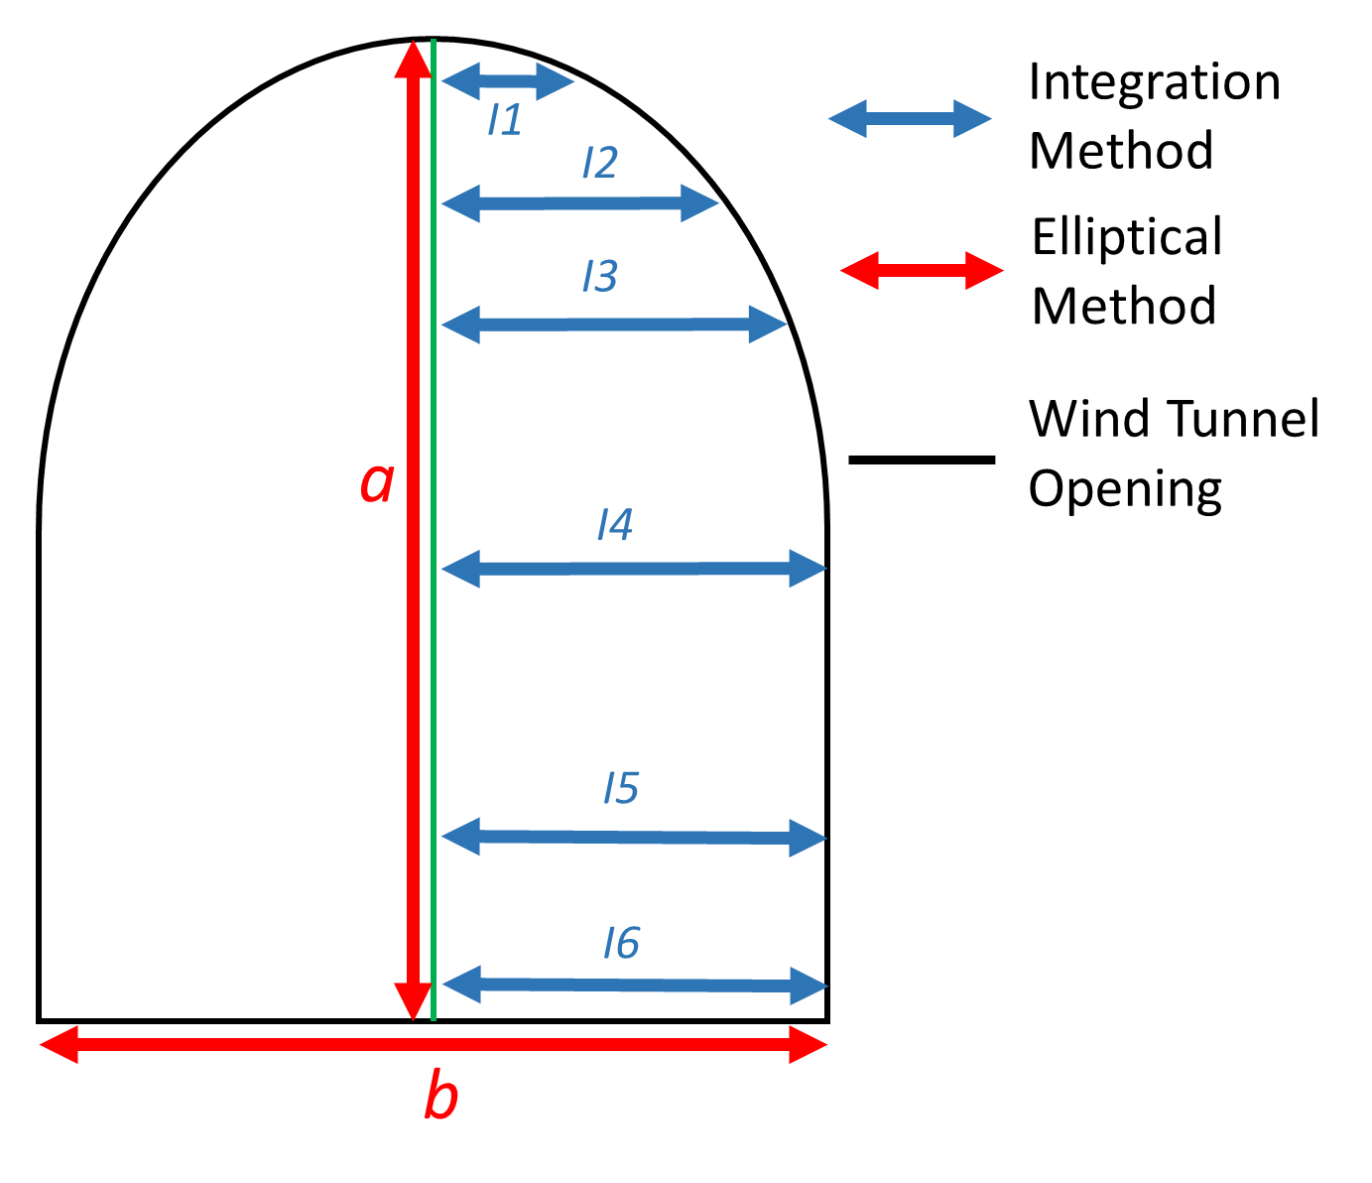

Figure 1: Illustration of the basic measurements needed to estimate wind tunnel opening area. Red lines demonstrate the elliptical method (Equation 1) while the blue lines demonstrate the integration method (Equation 2).

Bibliography

Lockyer D.R. 1984. A system for the measurement in the field of losses of ammonia through volatilisation. J. Sci. Food Agric. **35**: 837–848.